1. Problem Statement
Aadhaar plays a critical role in enabling access to government services, financial inclusion, and digital identity in India. Understanding enrolment and update patterns can help identify operational gaps, regional disparities, and demographic trends.
The objective of this project is to analyze Aadhaar demographic enrolment data to uncover:
- Regional variations in enrolment demand
- Age-wise enrolment behavior
- Seasonal trends
- Data anomalies at pincode and district levels
The insights aim to support UIDAI in improving service delivery efficiency, data quality, and policy planning.

2. Dataset Description
This analysis uses datasets officially provided by UIDAI for the Data Hackathon 2026.
Key Attributes Used:
- State and District
- Pincode
- Date / Month
- Age Group (5–17, 17+)
- Total Enrolment Count
The dataset spans multiple years and enables analysis at state, district, month, and pincode granularity.

3. Methodology
The analysis was conducted using a structured data analytics workflow:
Data Preprocessing
- Removal of null and duplicate records
- Standardization of state and district names
- Aggregation of enrolment data at district, month, and pincode levels
Feature Engineering
- Creation of total enrolment metrics
- Age-wise enrolment segmentation
- Identification of pincode–district conflicts
Tools and Technologies
- Python (Pandas, NumPy) for data processing
- Excel for visualization and exploratory analysis

4. Data Analysis & Visualisation
4.1 District-wise Aadhaar Enrolment Distribution
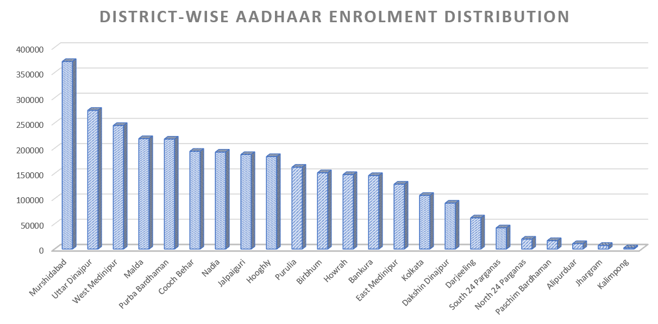
Observation:
A small number of districts contribute a disproportionately high share of Aadhaar enrolments in West Bengal.
Impact:
This indicates uneven service demand and suggests the need for targeted infrastructure and staffing in high-burden districts.

4.2 Monthly Aadhaar Enrolment Trends
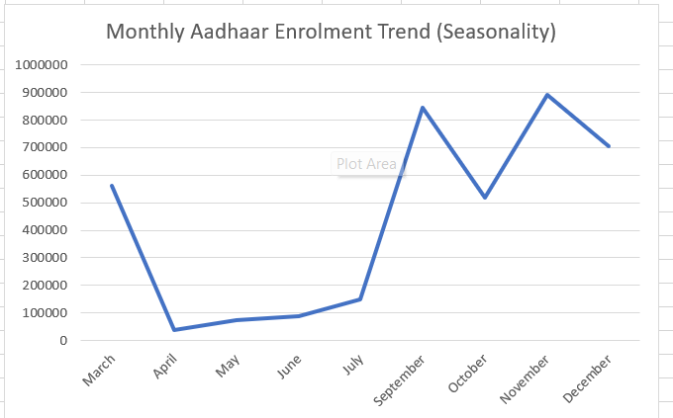Observation:
Monthly enrolment trends remain relatively stable with mild seasonal variations.
Use Case:
These trends can help UIDAI forecast enrolment demand and optimize operational planning during peak periods.

4.3 Age-wise Aadhaar Enrolment Analysis
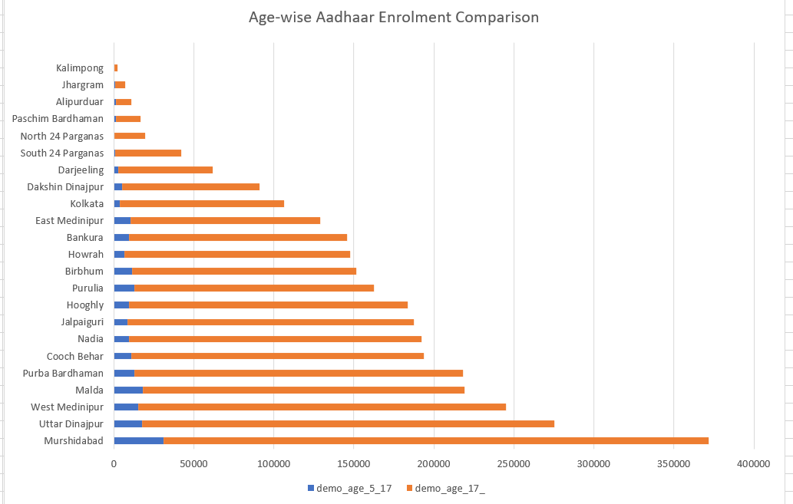Observation:
The 17+ age group accounts for the majority of Aadhaar enrolments compared to the 5–17 age group.
Insight:
This suggests that Aadhaar adoption increases significantly in adulthood due to employment, education, and financial service requirements.

4.4 Pincode–District Mapping Conflicts (Anomaly Detection)
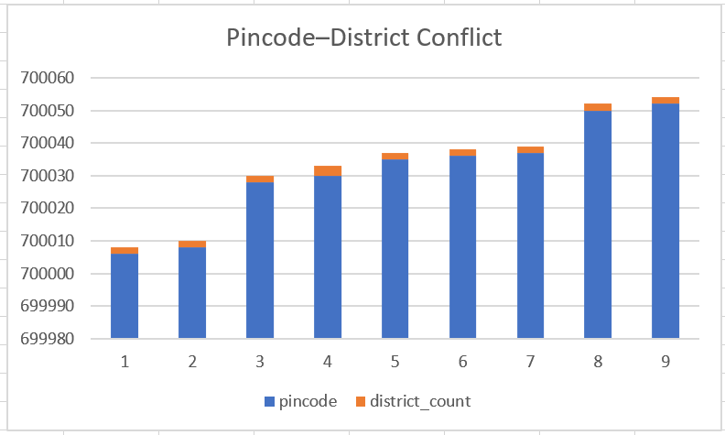Observation:
Several pincodes are associated with multiple districts, indicating potential mapping inconsistencies.
Impact:
Such anomalies can lead to data inaccuracies and service delivery challenges.
Recommendation:
Regular validation of pincode–district mappings can improve Aadhaar data quality and operational efficiency.
4.5. Pin code-level Aadhaar Enrolment Analysis
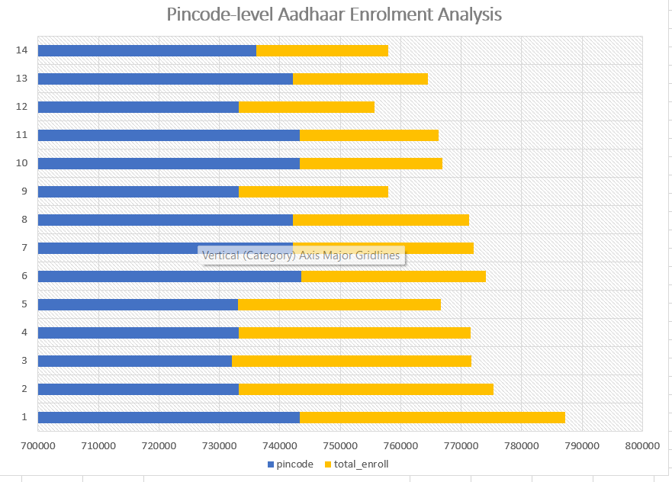
Observation:
Aadhaar enrolment is concentrated in a limited number of pincodes, while many pincodes show lower enrolment volumes.
Insight:
High-enrolment pincodes reflect localized demand, primarily driven by the 17+ age group.
Impact:
This helps UIDAI identify enrolment hotspots and plan targeted infrastructure deployment.

5. Key Insights Summary
- Aadhaar enrolment demand is unevenly distributed across districts
- Adult enrolment dominates Aadhaar registration
- Monthly enrolment patterns show predictable stability
- Pincode–district conflicts reveal data quality improvement opportunities

6. Impact and Applicability
Administrative Impact
- Improved resource allocation
- Identification of operational hotspots
- Enhanced data accuracy
Social Impact
- Supports inclusive Aadhaar coverage
- Enables better access to welfare schemes
- Encourages early-age enrolment awareness

7. Conclusion
This project demonstrates how Aadhaar demographic data can be leveraged to derive meaningful societal and administrative insights. The findings can support UIDAI in data-driven decision-making, operational planning, and policy formulation.

