Documentation (Churn Analysis)

Data Preprocessing
The DataPreprocessing class is designed for preprocessing a customer churn dataset. The class includes methods to handle missing values, convert data types, and perform basic data cleaning operations to prepare the dataset for further analysis or modeling.

Dataset Description
The dataset contains customer information for a telecommunications company and includes the following columns:
- customerID: A unique identifier for each customer.
- gender: The gender of the customer (Male/Female).
- SeniorCitizen: Whether the customer is a senior citizen (1) or not (0).
- Partner: Whether the customer has a partner (Yes/No).
- Dependents: Whether the customer has dependents (Yes/No).
- tenure: Number of months the customer has stayed with the company.
- PhoneService: Whether the customer has phone service (Yes/No).
- MultipleLines: Whether the customer has multiple lines (Yes/No/No phone service).
- InternetService: The type of internet service (DSL/Fiber optic/No).
- OnlineSecurity: Whether the customer has online security service (Yes/No/No internet service).
- OnlineBackup: Whether the customer has online backup service (Yes/No/No internet service).
- DeviceProtection: Whether the customer has device protection service (Yes/No/No internet service).
- TechSupport: Whether the customer has tech support service (Yes/No/No internet service).
- StreamingTV: Whether the customer has streaming TV service (Yes/No/No internet service).
- StreamingMovies: Whether the customer has streaming movies service (Yes/No/No internet service).
- Contract: The contract term of the customer (Month-to-month/One year/Two year).
- PaperlessBilling: Whether the customer uses paperless billing (Yes/No).
- PaymentMethod: The payment method (Electronic check/Mailed check/Bank transfer (automatic)/Credit card (automatic)).
- MonthlyCharges: The amount charged to the customer monthly.
- TotalCharges: The total amount charged to the customer.
- Churn: Whether the customer churned (Yes/No).
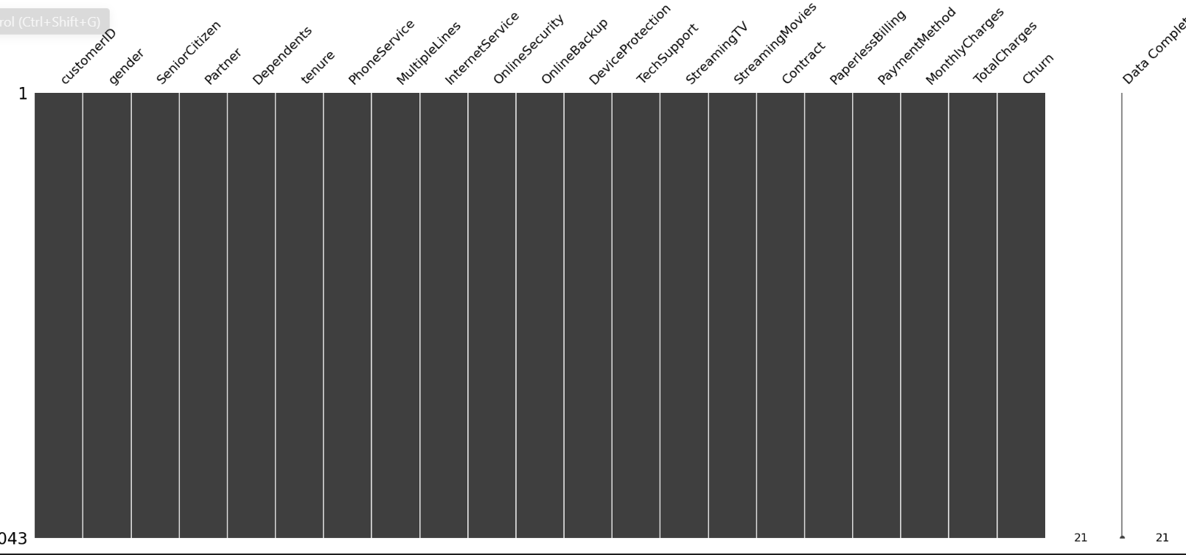

Initialization

__init__(self)
The constructor method initializes an instance of the DataPreprocessing class. Currently, it does not take any parameters or perform any actions during initialization.

Methods

forward (self, path)
This method performs a series of preprocessing steps on the dataset located at the specified file path.

Parameters:
- path (str): The file path to the dataset in CSV format.

Returns:
- df (DataFrame): The preprocessed DataFrame.

Processing Steps:
- Read the Dataset:
  - The dataset is read from the CSV file specified by the path parameter using pd.read_csv(path).
- Check for Missing Values:
  - Missing values in the dataset are visualized using the msno.matrix function from the missingno library.
- Drop 'customerID' Column:
  - The 'customerID' column is dropped from the DataFrame using df.drop(['customerID'], axis=1).
- Convert 'TotalCharges' to Numeric:
  - The 'TotalCharges' column is converted to numeric type using pd.to_numeric(df['TotalCharges'], errors='coerce'), coercing invalid values to NaN.
- Remove Rows with 'tenure' == 0:
  - Rows where the 'tenure' column is 0 are removed using df = df[df['tenure'] != 0].
- Fill NaN Values in 'TotalCharges':
  - NaN values in the 'TotalCharges' column are filled with the mean of 'TotalCharges' using df['TotalCharges'].fillna(df['TotalCharges'].mean(), inplace=True).
- Map 'SeniorCitizen' Column:
  - The 'SeniorCitizen' column values are mapped from 0 and 1 to 'No' and 'Yes', respectively, using df['SeniorCitizen'].map({0: 'No', 1: 'Yes'}).

Churn Analysis (Exploratory Data Analysis of Labelled Data and Data Visualization)
The ChurnAnalysis class provides a suite of methods for visualizing and analyzing churn distribution within a customer dataset for labelled data in the dataset. It leverages the Plotly library for interactive and insightful visualizations, facilitating the exploration of various factors influencing customer churn.

Initialization

__init__(self, df)
This constructor method initializes the ChurnAnalysis class with a given DataFrame containing customer data. The DataFrame is passed as a parameter during instantiation and stored as an instance attribute for use in various analysis methods.

Parameters:
- df (DataFrame): The DataFrame containing the customer churn dataset.

Methods

Contract_churn
This method analyzes the distribution of customer churn based on contract types. It generates a histogram that groups churn data by different contract types, allowing for the visualization of how different contract terms influence churn rates.

PaperlessB_Churn
This method examines the impact of paperless billing on churn. It creates a histogram to show the distribution of churn among customers who use paperless billing versus those who do not. A colour map is applied for visual distinction.

PhoneS_Churn
This method investigates the relationship between phone service subscription and customer churn. It produces a histogram to illustrate churn distribution based on whether customers have a phone service. A colour map is used to differentiate the categories.

TechS_Churn
This method evaluates how the availability of tech support services affects customer churn. It creates a grouped histogram to display churn distribution among customers with and without tech support.

OnlineS_Churn
This method analyses the influence of online security services on churn rates. It generates a grouped histogram showing churn distribution based on whether customers have subscribed to online security services. A colour map is applied for clarity.

SeniorC_Churn
This method explores the churn distribution among senior citizens. It produces a histogram to compare churn rates between senior and non-senior customers, using a colour map for better visual separation.

partners_Churn
This method investigates the effect of having a partner on customer churn. It generates a grouped histogram to show churn distribution based on partnership status, with a colour map for distinction.

Dependents_Churn
This method analyses how having dependents influences customer churn. It creates a grouped histogram to illustrate churn distribution among customers with and without dependents, using a colour map for clarity.

InternetS_Gender_Churn
This method examines the churn distribution considering both internet service type and customer gender. It generates a bar plot with multiple bars for each combination of churn status and gender, separated by internet service type, providing a comprehensive view of these factors' interplay.

Payment_churn
This method assesses the impact of payment methods on churn rates. It produces a histogram to show the distribution of churn among customers using different payment methods, enabling a comparative analysis of how payment options affect customer retention.

Churn_Gender
This method visualizes the distribution of churn and gender using pie charts. It creates two subplots: one showing the gender distribution and another showing the churn distribution. This dual-chart approach provides a clear comparison between the proportions of male and female customers and their respective churn rates.

run_all_analyses
This method sequentially executes all the defined analysis methods. It's a convenient way to generate all visualizations at once, providing a comprehensive overview of the dataset's churn-related insights.

Churn Analysis (Exploratory Data Analysis of Numerical Data)

Class Overview
DataVisNum is a Python class designed for visualizing the relationship between customer churn and various numerical attributes in a given dataset. The class utilizes popular visualization libraries such as Plotly, Seaborn, and Matplotlib to create informative and aesthetically pleasing plots.

Initialization
__init__(self, df)
The class constructor initializes the DataVisNum object with a pandas DataFrame containing the data to be visualized. The DataFrame should include columns named 'Churn', 'tenure', 'MonthlyCharges', and 'TotalCharges'.
Parameters:
- df: A pandas DataFrame containing the dataset.

Methods
Tenure_Churn(self)
This method creates a box plot to visualize the distribution of customer tenure with respect to their churn status using Plotly Express. The box plot helps in understanding how the tenure varies between customers who have churned and those who have not.
- Visualization Details:
  - X-axis: Churn status ('Yes' or 'No')
  - Y-axis: Tenure in months
  - Customizations:
    - Y-axis title set to 'Tenure (Months)'
    - X-axis title set to 'Churn'
    - Plot size set to 750x600 pixels
    - Title set to 'Tenure vs Churn' with font family 'Courier' and size 25
MonthlyC_Churn(self)
This method creates a Kernel Density Estimate (KDE) plot to visualize the distribution of monthly charges with respect to customer churn using Seaborn. The KDE plot shows the density of monthly charges for customers who churned versus those who did not, providing insights into how monthly charges might influence churn.
- Visualization Details:
  - Density plots for monthly charges of customers who churned (colored blue) and those who did not (colored red)
  - Legend indicating 'Not Churn' and 'Churn'
  - Y-axis labeled 'Density'
  - X-axis labeled 'Monthly Charges'
  - Title set to 'Distribution of monthly charges by churn'
TotalC_Churn(self)
This method creates a Kernel Density Estimate (KDE) plot to visualize the distribution of total charges with respect to customer churn using Seaborn. Similar to the MonthlyC_Churn method, this KDE plot shows the density of total charges for churned and non-churned customers.
- Visualization Details:
  - Density plots for total charges of customers who churned (colored green) and those who did not (colored gold)
  - Legend indicating 'Not Churn' and 'Churn'
  - Y-axis labeled 'Density'
  - X-axis labeled 'Total Charges'
  - Title set to 'Distribution of total charges by churn'

forward(self)
This method runs all the visualization methods in sequence. It is a convenient way to generate all the plots with a single method call.
- Workflow:
  - Calls Tenure_Churn() to visualize tenure distribution by churn
  - Calls MonthlyC_Churn() to visualize monthly charges distribution by churn
  - Calls TotalC_Churn() to visualize total charges distribution by churn
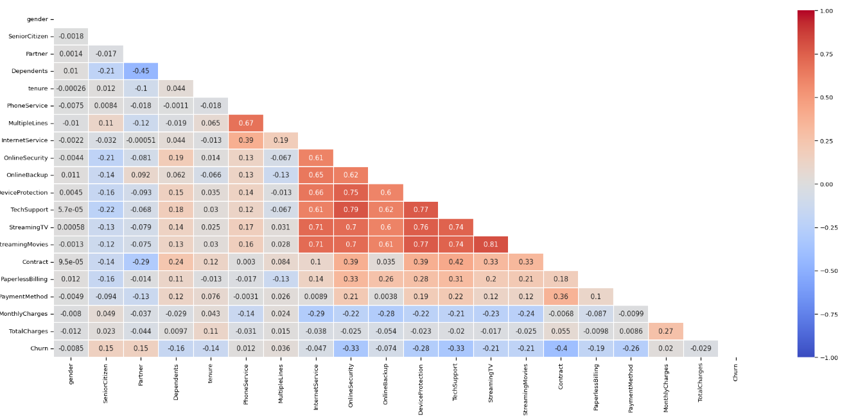

Feature Engineering
- Convert Categorical to Numerical:
  - The first step involves converting categorical columns to numerical values. This is achieved by checking the data type of each column. If the data type is object, the column is transformed using LabelEncoder.
- Calculate Correlation:
  - Calculate the correlation matrix of the dataframe to identify how each feature correlates with the target variable, Churn. This helps in understanding the relationships and importance of each feature in relation to the target variable.
- Separate Features and Target:
  - Split the dataframe into features (X) and target (y). The target variable, Churn, is separated from the feature set to prepare for model training.
- Distribution Plotting:
  - Plot the distribution of key numerical features to understand their underlying distributions. This step helps in visualizing the data and identifying any potential issues such as skewness or outliers. Specific features such as tenure, MonthlyCharges, and TotalCharges are plotted to examine their distributions
- Standardization:
  - Standardize the numerical features to have a mean of zero and a standard deviation of one. This step is crucial for algorithms that are sensitive to the scale of the data. The standardized features are then plotted to check their
  - distributions post-standardization.

Model Evaluation Procedure
- Prediction:
  - Predictions are made on the test set using the trained models.
- Accuracy:
  - Calculate accuracy as the proportion of correctly classified samples out of the total test samples. This provides an initial measure of overall model performance.
- Classification Report:
  - Generate a detailed classification report including:
    - Precision: Measures the accuracy of positive predictions. It is the ratio of true positive predictions to all positive predictions.
    - Recall (Sensitivity): Measures the proportion of actual positives that are correctly identified. It is the ratio of true positive predictions to all actual positive instances.
    - F1-score: The harmonic means of precision and recall, providing a single metric that balances both precision and recall.
    - Support: The number of actual occurrences of the class in the specified dataset.
  - This report offers a comprehensive view of the model's performance across different classes.
- Confusion Matrix:
  - Visualize model performance through a confusion matrix:
    - True Positives (TP): Correctly predicted positive instances.
    - True Negatives (TN): Correctly predicted negative instances.
    - False Positives (FP): Incorrectly predicted as positive when they are actually negative.
    - False Negatives (FN): Incorrectly predicted as negative when they are actually positive.
  - Display the confusion matrix using a heatmap for clear visualization.
- ROC Curve and AUC:
  - Plot the ROC curve to assess classifier performance across various thresholds:
    - True Positive Rate (TPR) vs. False Positive Rate (FPR).
    - Calculate the Area Under the Curve (AUC), where a higher AUC indicates better model performance.
  - Compare the ROC curve against the baseline (random classifier) diagonal line for context.
SHAP Analysis:
- Initialization:
SHAP (SHapley Additive exPlanations) is initialized using shap.initjs() for JavaScript visualizations.
- Background Sample:
A background sample from the training data is created using shap.sample(X_train, nsamples=100) for the SHAP explainer.
- Kernel Explainer:
A SHAP Kernel Explainer is created using shap.KernelExplainer(knn_model.predict_proba, background) to explain the KNN model's predictions.
- SHAP Values:
SHAP values for a specific test sample (X_test.iloc[0, :]) are computed and visualized using a force plot. This helps in understanding the contribution of each feature to the prediction.
Additional SHAP values are computed for a sampled subset of the test data (X_test_sampled) and visualized using another force plot.

K-Nearest Neighbors (KNN)
The K-Nearest Neighbors (KNN) algorithm is a simple, instance-based learning algorithm used for classification and regression. It classifies a data point based on the majority class of its 'k' nearest neighbors in the feature space.

How KNN Works
- Choose k: Select the number of nearest neighbors (k).
- Calculate Distance: Compute the distance between the new data point and all training points (typically using Euclidean distance).
- Identify Neighbors: Find the 'k' closest training points to the new data point.
- Voting Mechanism:
  - Classification: Assign the class with the majority vote among the 'k' neighbors.
  - Regression: Take the average or weighted average of the neighbors' values.
- Return Result: The new data point is classified or a regression value is predicted based on its nearest neighbors.

Choosing k
- Small k (e.g., k=1): Can lead to overfitting and sensitivity to noise.
- Large k: Can oversimplify the model, ignoring local patterns.
Optimal 'k' is typically chosen using cross-validation.
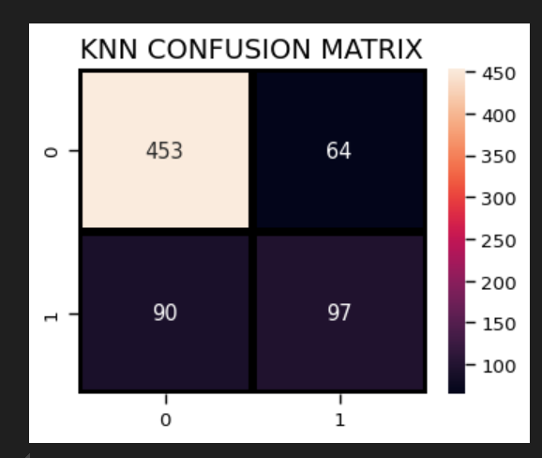
Support Vector Machine (SVM)
Support Vector Machines (SVM) are powerful supervised learning models used for classification and regression tasks. They excel in finding complex decision boundaries by maximizing the margin between different classes.

How SVM Works
- Find the Optimal Hyperplane: SVM finds the optimal hyperplane that best separates classes in the feature space.
- Maximize Margin: It maximizes the distance (margin) between the hyperplane and the nearest data points from each class (support vectors).
- Kernel Trick (for Non-linear Data): SVM can handle non-linear boundaries by transforming the original feature space into a higher-dimensional space using kernel functions (e.g., polynomial, radial basis function (RBF)).
- Classification:
  - Linear SVM: For linearly separable data, SVM finds a straight-line boundary (hyperplane).
  - Non-linear SVM: For complex data, SVM uses kernel functions to map the data into a higher-dimensional space where a linear separation is possible.
- Support Vectors: The data points closest to the hyperplane are support vectors, which determine the decision boundary and are critical for the model's performance.
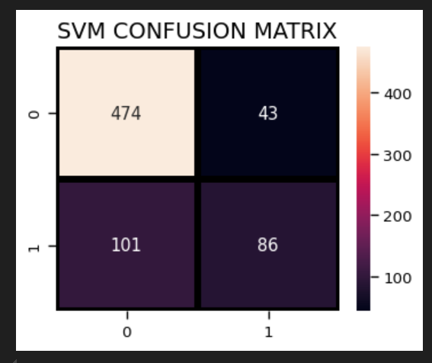
Logistic Regression
Logistic Regression is a statistical method used for binary classification tasks, predicting the probability of occurrence of an event by fitting data to a logistic function.

How Logistic Regression Works
- Model Representation:
  - Logistic Regression models the probability of a binary outcome based on one or more predictor variables. It uses a logistic (sigmoid) function to map input features to a probability score between 0 and 1.
- Decision Boundary:
  - A decision boundary is established by the logistic function. For a binary classification problem, this boundary separates the classes based on the probability threshold (typically 0.5).
- Training:
  - The model is trained using the maximum likelihood estimation method, which optimizes the parameters (coefficients) to best fit the observed data. The goal is to minimize the difference between the predicted probabilities and the actual outcomes.
- Prediction:
  - Once trained, Logistic Regression predicts the probability of a new sample belonging to a certain class. A threshold (often 0.5) is applied to convert these probabilities into class labels (0 or 1).

- Regularization:
  - Regularization techniques like L1 (Lasso) and L2 (Ridge) can be applied to prevent overfitting by penalizing large coefficients.

Grid Search

Purpose
Grid Search is a technique used to find the optimal hyperparameters for a machine learning model by evaluating all possible combinations of hyperparameter values within a predefined grid.

How Grid Search Works
- Define Hyperparameter Grid:
  - Specify a grid of hyperparameter values to evaluate. For example, different values of learning rate, number of trees, and maximum depth for a Random Forest model.
- Cross-validation:
  - Perform cross-validation on each combination of hyperparameters. This involves splitting the training data into multiple subsets (folds), training the model on several combinations of training and validation sets, and evaluating the model's performance on the validation set.
- Select Optimal Parameters:
  - Identify the combination of hyperparameters that gives the best performance metric (e.g., accuracy, F1-score, etc.) on the validation set. This combination is chosen as the optimal set of hyperparameters for the final model.
Random Search

Purpose
Random Search is an alternative hyperparameter optimization technique that samples hyperparameter values randomly from a specified distribution. It is more efficient than Grid Search for high-dimensional search spaces.

How Random Search Works
- Define Hyperparameter Distribution:
  - Specify a probability distribution from which hyperparameters are sampled randomly. For example, uniform distribution for continuous parameters or discrete choices for categorical parameters.
- Cross-validation:
  - Similar to Grid Search, perform cross-validation on each randomly sampled set of hyperparameters to evaluate model performance.
- Select Optimal Parameters:
  - After evaluating a predefined number of random samples (iterations), select the set of hyperparameters that yield the best performance metric on the validation set.

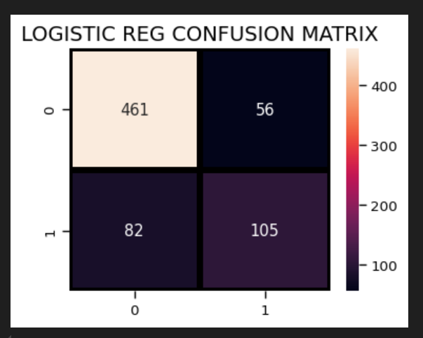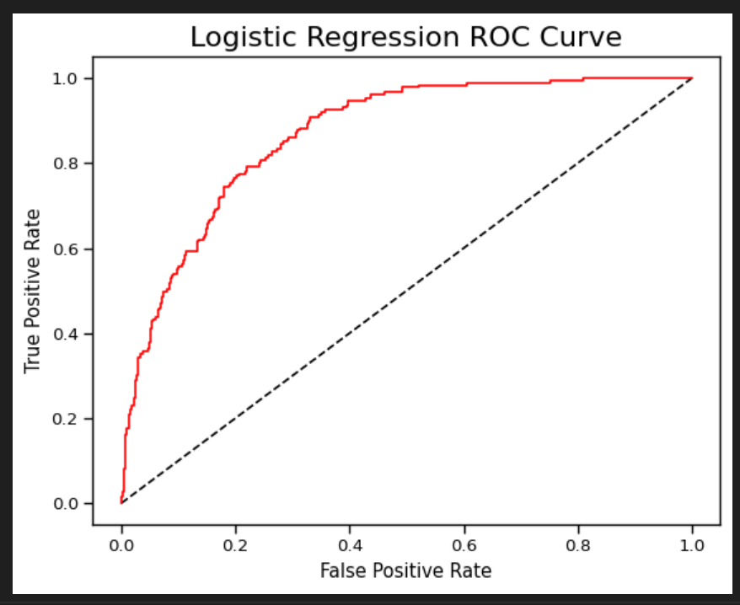

Random Forest
Random Forest is an ensemble learning method used for both classification and regression tasks. It builds multiple decision trees and combines their predictions to improve accuracy and robustness.

How Random Forest Works
- Ensemble of Decision Trees:
  - Random Forest constructs a collection of decision trees during training. Each tree is trained independently on a subset of the data and uses a subset of the features.
- Bootstrap Sampling (Bagging):
  - Each tree is trained on a bootstrap sample of the training data (sampling with replacement). This creates variations in the training set for each tree.
- Feature Subsetting:
  - At each node of the decision tree, a random subset of features is considered for splitting. This introduces diversity among the trees and reduces the correlation between them.
- Voting Mechanism:
  - For classification tasks, the final prediction of the Random Forest is determined by majority voting of all individual trees. For regression tasks, it averages the predictions of all trees.
- Advantages:
  - Ensemble Effect: Combining multiple trees reduces overfitting and improves generalization performance.
  - Robustness: Less sensitive to outliers and noise compared to individual decision trees.
  - Feature Importance: Can measure the importance of each feature in the prediction process.
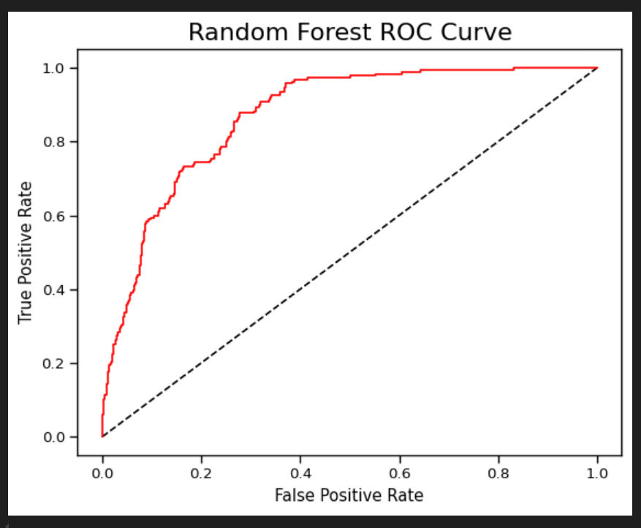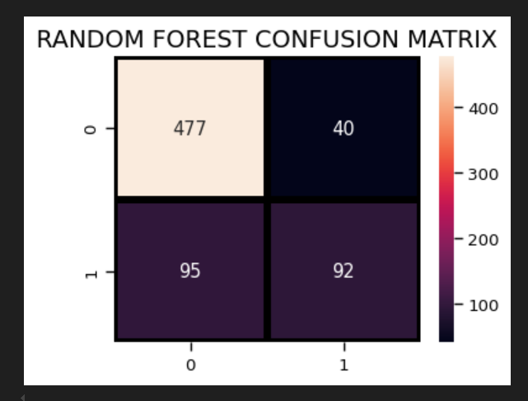

Decision Tree
Decision Trees are versatile supervised learning models used for both classification and regression tasks. They predict the value of a target variable by learning simple decision rules inferred from the data features.

How Decision Trees Work
- Tree Structure:
  - A Decision Tree is a hierarchical structure consisting of nodes and edges. Each internal node represents a decision based on a feature, and each leaf node represents a class label or a numerical value.
- Splitting Criteria:
  - Decision Trees recursively split the data based on feature values to maximize the homogeneity (purity) of the target variable within each subset. Popular splitting criteria include Gini impurity (for classification) and variance reduction (for regression).
- Decision Making:
  - At each internal node, the algorithm selects the feature that best separates the data into subsets that are most homogeneous with respect to the target variable. This process continues until the tree reaches a stopping criterion, such as a maximum depth or minimum number of samples per leaf.
- Predictions:
  - To make a prediction for a new data point, it traverses the tree from the root to a leaf node based on the feature values of the data point. The predicted class or value at the leaf node is then assigned to the new data point.
- Advantages:
  - Interpretable: Easy to interpret and visualize decision rules.
  - Handles Non-linear Relationships: Capable of capturing complex interactions between features.
  - No Assumptions about Data Distribution: Non-parametric and robust to outliers.
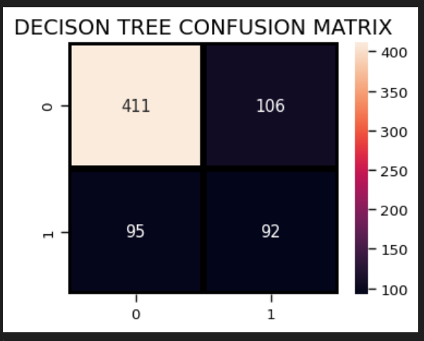

Voting Classifier Ensemble

Purpose
The code snippet demonstrates the use of a Voting Classifier, an ensemble learning technique that combines multiple individual machine learning models to improve predictive performance.

Components
- Importing Libraries
  - The code imports necessary modules from the sklearn.ensemble and sklearn.metrics libraries to create and evaluate ensemble models.
- Individual Classifiers
  - Six different classifiers (clf1 to clf6) are initialized:
    - GradientBoostingClassifier
    - LogisticRegression
    - AdaBoostClassifier
    - RandomForestClassifier
    - DecisionTreeClassifier
    - SVC (Support Vector Classifier)
- Voting Classifier Initialization
  - VotingClassifier (eclf1) is instantiated with the following parameters:
    - estimators: A list of tuples where each tuple contains a name and a classifier instance.
    - voting: Specifies the type of voting mechanism. Here, 'soft' voting is used, where predicted probabilities are averaged across all classifiers.
- Model Training
  - The VotingClassifier (eclf1) is trained on the training data (X_train, y_train) using the fit method.

- Prediction and Evaluation
  - Predictions are made on the test data (X_test) using the predict method of eclf1.
  - Accuracy: The accuracy score (accuracy_score) between predicted labels and actual labels (y_test) is calculated and printed.
  - Classification Report: A detailed classification report (classification_report) is generated, showing precision, recall, F1-score, and support for each class.
  - Confusion Matrix: A heatmap of the confusion matrix is plotted using Seaborn (sns.heatmap), visualizing true positives, true negatives, false positives, and false negatives.
  - ROC Curve: The Receiver Operating Characteristic (ROC) curve is plotted to evaluate the model's performance, showing the trade-off between true positive rate (sensitivity) and false positive rate (1-specificity).

Practical Application
- Business Use: Such ensemble methods are beneficial in scenarios where model robustness and accuracy are crucial, such as customer churn prediction, fraud detection, or medical diagnostics.
- Decision Support: The ensemble approach helps in making more informed decisions by leveraging the combined wisdom of multiple models, reducing the risk of relying on a single model's performance.
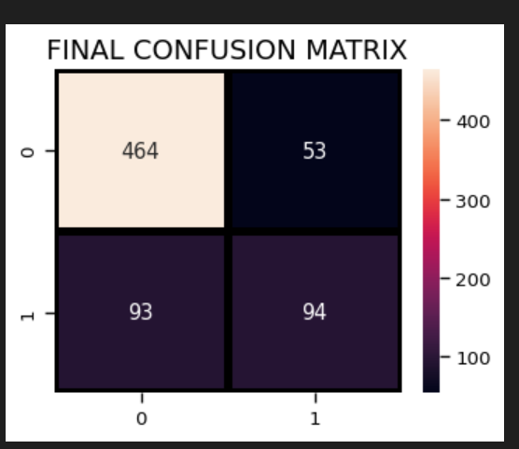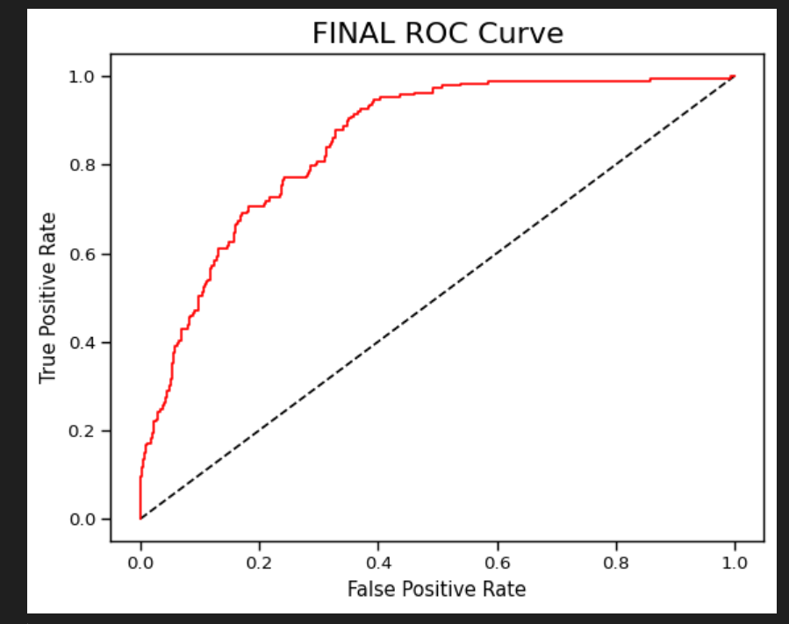
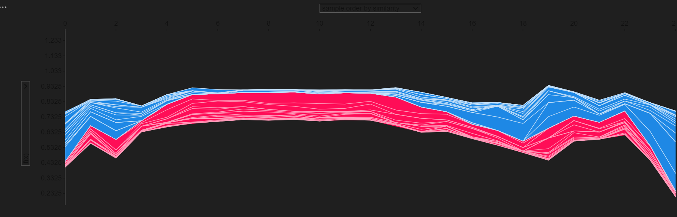
How a Firm can take advantage of above method?

1. Understanding Customer Behavior and Predicting Churn
- Model Development: Train a KNN classifier using historical customer data where churn (customers leaving) is labeled. Use features such as customer demographics, usage patterns, transaction history, and customer service interactions.
- Prediction: Use the trained model to predict which customers are likely to churn based on current behavior and attributes. This helps in proactive identification of at-risk customers.

2. Insights from Classification Reports and Confusion Matrix
- Classification Report: Analyze precision, recall, and F1-score from the classification report. Focus on metrics for predicting churn accurately, balancing between correctly identifying churners (recall) and minimizing false alarms (precision).
- Confusion Matrix: Visualize performance with a confusion matrix. Identify patterns where the model may be misclassifying customers (e.g., false positives). This helps in refining strategies for targeted retention efforts.

3. Feature Importance with SHAP
- SHAP Analysis: Use SHAP values to understand which features contribute most to predicting churn. Features with high SHAP values indicate stronger influence on churn predictions.
- Actionable Insights: Identify actionable insights such as:
  - High Impact Features: Features (e.g., customer support interactions, usage intensity) that strongly influence churn predictions.
  - Customer Segmentation: Segment customers based on predictive features to tailor retention strategies.
  - Intervention Points: Determine where proactive interventions (e.g., personalized offers, proactive customer service) could potentially reduce churn.

4. Implementing Retention Strategies
- Personalized Retention: Use insights to craft personalized retention strategies for at-risk customers identified by the model.
- Targeted Marketing: Deploy targeted marketing campaigns based on customer segments identified through churn analysis.
- Improving Customer Experience: Address pain points identified through churn analysis (e.g., service quality issues, pricing concerns) to enhance overall customer experience and satisfaction.

5. Monitoring and Iteration
- Continuous Improvement: Monitor model performance over time and iterate based on new data and changing customer behaviors.
- Feedback Loop: Incorporate feedback from retention efforts into model refinement, improving predictive accuracy and strategy effectiveness.

