README: K-Nearest Neighbors (KNN) Classifier Documentation
1. Introduction
Heart disease is a leading cause of death worldwide, making early prediction and diagnosis crucial. The K-Nearest neighbors (KNN) algorithm is a simple yet effective method for classification tasks, such as predicting the presence of heart disease. This document provides an overview of implementing a KNN classifier to predict heart disease based on a dataset of patient records, detailing the steps involved in data preprocessing, model training, and evaluation.
2. Code Explanation
Data Reading and Preprocessing
- Age: Represents the age of the patient.
- Sex: Indicates the gender of the patient (1 = male, 0 = female).
- Chest Pain Type: Describes the type of chest pain experienced by the patient. This feature typically categorizes chest pain into several types (e.g., typical angina, atypical angina, non-anginal pain, asymptomatic).
- Resting Blood Pressure: Shows the resting blood pressure of the patient in mm Hg.
- Serum Cholesterol: Denotes the serum cholesterol level in mg/dl.
- Fasting Blood Sugar: Indicates whether the fasting blood sugar level of the patient is greater than 120 mg/dl (1 = true, 0 = false).
- Resting ECG Results: Describes the results of the resting electrocardiogram (ECG) in terms of different categories (e.g., normal, abnormal ST-T wave, left ventricular hypertrophy).
- Maximum Heart Rate Achieved: Represents the maximum heart rate achieved during exercise.
- Exercise-Induced Angina: Indicates whether exercise induced angina (chest pain) in the patient (1 = yes, 0 = no).
- ST Depression: Measures the depression of the ST segment on the ECG during exercise relative to rest.
- Slope of Peak Exercise ST Segment: Describes the slope of the peak exercise ST segment (upsloping, flat, downsloping).
- Number of Major Vessels Colored by Fluoroscopy: Represents the number of major blood vessels (0-3) colored by fluoroscopy. This can indicate the presence of narrowing or blockages.
- Thalassemia: Describes a type of blood disorder (3 = normal; 6 = fixed defect; 7 = reversible defect).
- Target Variable: Indicates the presence or absence of heart disease. Typically, this is binary (1 = presence, 0 = absence).
Importance in Heart Disease Prediction:
- Clinical Relevance: These features are commonly used in clinical settings to assess the risk and presence of heart disease.
- Diagnostic Value: Each feature provides insights into different physiological aspects (e.g., cardiovascular health, ECG readings, exercise tolerance) that contribute to the overall diagnosis of heart disease.
- Prediction Model: By using machine learning algorithms like K-Nearest Neighbors (KNN), these features can help predict whether a patient is likely to have heart disease based on patterns learned from historical data.
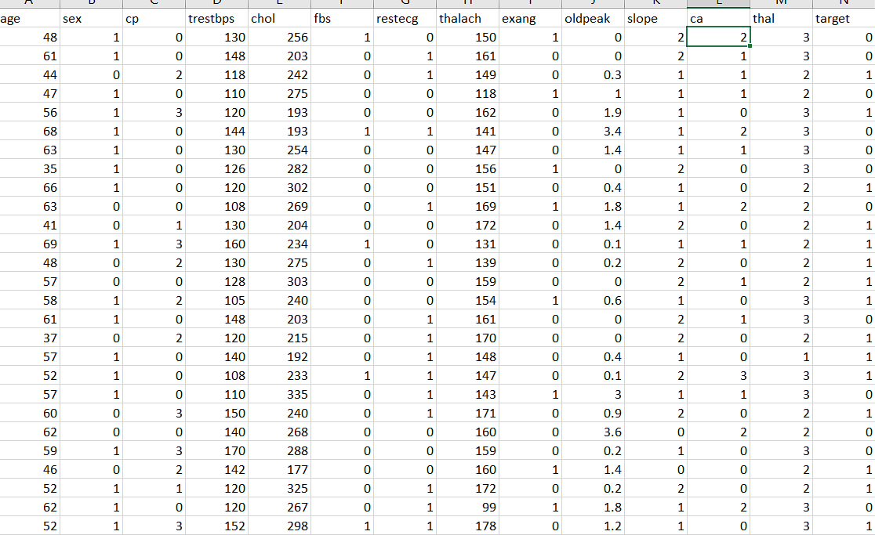
The provided juypter notebook performs the following steps:
- Reads a CSV file ('heart_disease_data.csv') containing input features and output labels.
- Splits the dataset into input features (X) and output labels (Y).
- Standardizes the input features using StandardScaler to scale features to have mean of 0 and variance of 1.
- Splits the dataset into training and testing sets using train_test_split.

Model Training
Initializes a KNN classifier (KNeighborsClassifier) with 4 neighbors.
Fits the model using the training data (x_train and y_train).
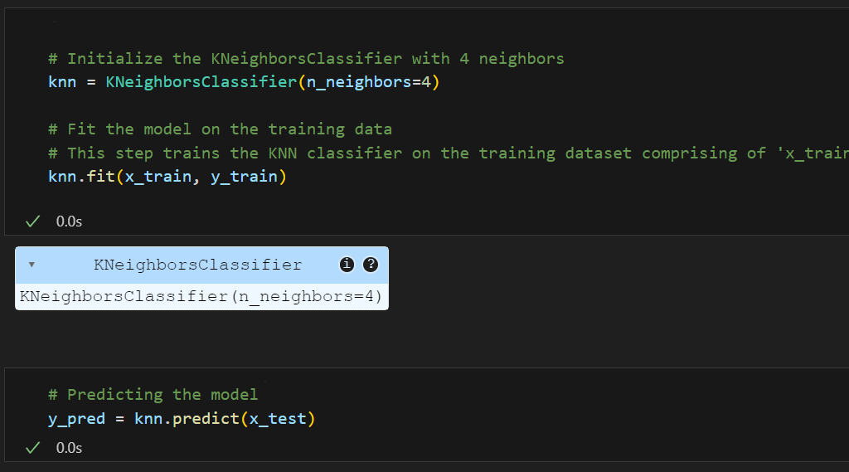
Model Evaluation
The performance of the KNN classifier is evaluated using several metrics:
- Accuracy Score: Measures the proportion of correctly predicted instances out of the total instances.
- Recall Score: Measures the ability of the classifier to identify all positive instances. It is calculated as the number of true positives divided by the sum of true positives and false negatives.
- Precision Score: Measures the proportion of true positive instances among the predicted positive instances. It is calculated as the number of true positives divided by the sum of true positives and false positives.
These metrics provide a comprehensive understanding of the classifier's performance, especially in the context of imbalanced datasets.
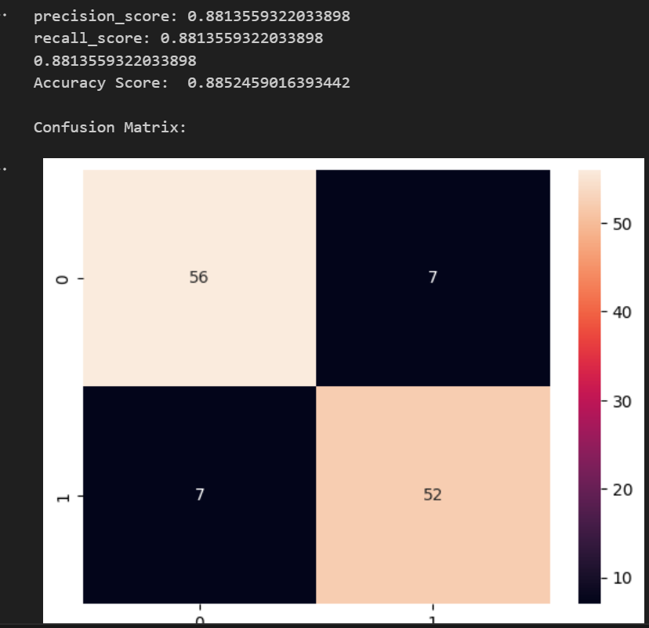

3. K-Nearest Neighbors (KNN) Algorithm
The K-Nearest Neighbors (KNN) algorithm is a popular machine learning technique used for classification and regression tasks. It relies on the idea that similar data points tend to have similar labels or values.
During the training phase, the KNN algorithm stores the entire training dataset as a reference. When making predictions, it calculates the distance between the input data point and all the training examples, using a chosen distance metric such as Euclidean distance.
Next, the algorithm identifies the K nearest neighbors to the input data point based on their distances. In the case of classification, the algorithm assigns the most common class label among the K neighbors as the predicted label for the input data point. For regression, it calculates the average or weighted average of the target values of the K neighbors to predict the value for the input data point.
The KNN algorithm is straightforward and easy to understand, making it a popular choice in various domains. However, its performance can be affected by the choice of K and the distance metric, so careful parameter tuning is necessary for optimal results.
Key Steps in KNN:
Choose K: Determine the number of neighbors (K) to consider.
Calculate Distance: Compute the distance between the new instance and all training samples.
Select K Neighbors: Select the K samples closest to the new instance based on distance.
Majority Vote: For classification, assign the class label by majority voting among the K neighbors.
Prediction: Predict the class label of the new instance based on the majority class of its neighbors.

