README: K-Means Clustering Algorithm Documentation
1. Introduction
This document describes the implementation of K-Means clustering to analyze power generation data. K-Means clustering is an unsupervised machine learning technique that groups data points into a predefined number of clusters based on their similarities. The purpose of this code is to segment power generation data into clusters using features such as cloud opacity, air temperature, and other relevant factors. This helps identify patterns and potential relationships between these factors and power generation.

2. Code Explanation
The dataset contains the following columns:
- TimeStamp: Represents the timestamp of the data point.
- Power Generated: Indicates the amount of power generated at each timestamp.
- GTI (Global Tilted Irradiance): Provides the solar irradiance received on a surface tilted at a certain angle to the horizontal.
- cloud_opacity: Measures the extent to which clouds obscure the sun, affecting solar irradiance.
- air_temp: Denotes the ambient air temperature at the time of measurement.
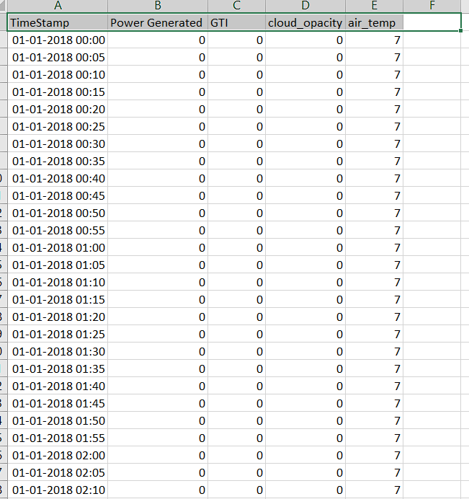

Data Loading and Preprocessing:
- Reads the Dataset: Reads an Excel file ('C:/Users/haZAR/Desktop/Clustering.xlsx') containing the dataset.
- Dataset Splitting: Splits the dataset into training (20%) and testing (80%) sets using the train_test_split function from the sklearn library. This process involves shuffling and uses a fixed random state for reproducibility.
- Date and Time Extraction: Extracts date and time components (year, month, day, hour, minute, second) from the 'TimeStamp' column in both the training and testing datasets.
- Columns Dropping: Drops specific columns ('TimeStamp', 'second', 'year') from both datasets to exclude them from further analysis.
- Data Filtering: Filters the rows in both datasets to include only those where the 'Power Generated' column has values greater than zero.
Model Training:
- KMeans Algorithm Initialization: Initializes the KMeans algorithm with 4 clusters and a fixed random state (77) for reproducibility.
- Model Fitting: Trains the KMeans algorithm on the training dataset (df). The fit method optimizes the positions of the centroids (cluster centers) to minimize the within-cluster sum of squares, iteratively adjusting the centroids to find the best clustering.
- Cluster Label Assignment: Adds a new column cluster to the training dataset (df), which contains the cluster labels generated by the KMeans algorithm.
- Visualization of Training Data: Creates a scatter plot of cloud_opacity vs. Power Generated, coloring the points by their cluster assignment to visualize the clustering results on the training data.
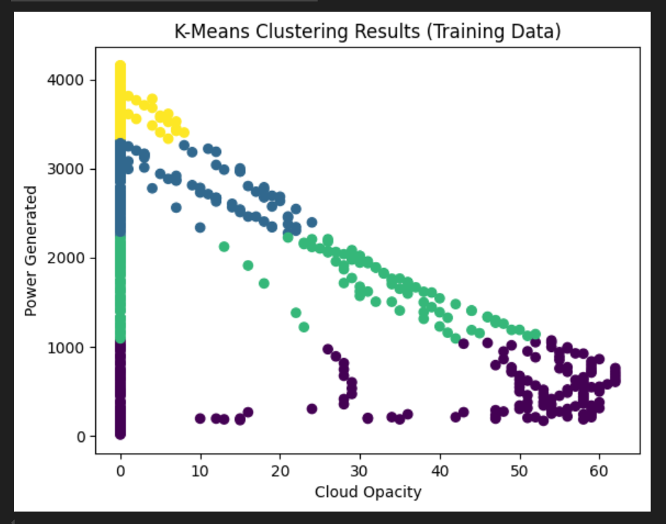
Model Evaluation:
- Metrics Importing: Imports necessary metrics (silhouette_score and davies_bouldin_score) from sklearn.metrics for evaluating the clustering performance.
- Silhouette Score Calculation: Computes the Silhouette Score for the validation dataset, which measures how similar an object is to its own cluster compared to other clusters. The score ranges from -1 to 1, with a high value indicating good clustering.
- Davies-Bouldin Index Calculation: Computes the Davies-Bouldin Index for the validation dataset, which measures the average similarity between each cluster and its most similar cluster. Lower values indicate better clustering.
- Metrics Output: Prints the calculated Silhouette Score and Davies-Bouldin Index for the validation dataset.
- Visualization of Validation Data: Creates a scatter plot of cloud_opacity vs. Power Generated, coloring the points by their cluster assignment to visualize the clustering results on the validation data.

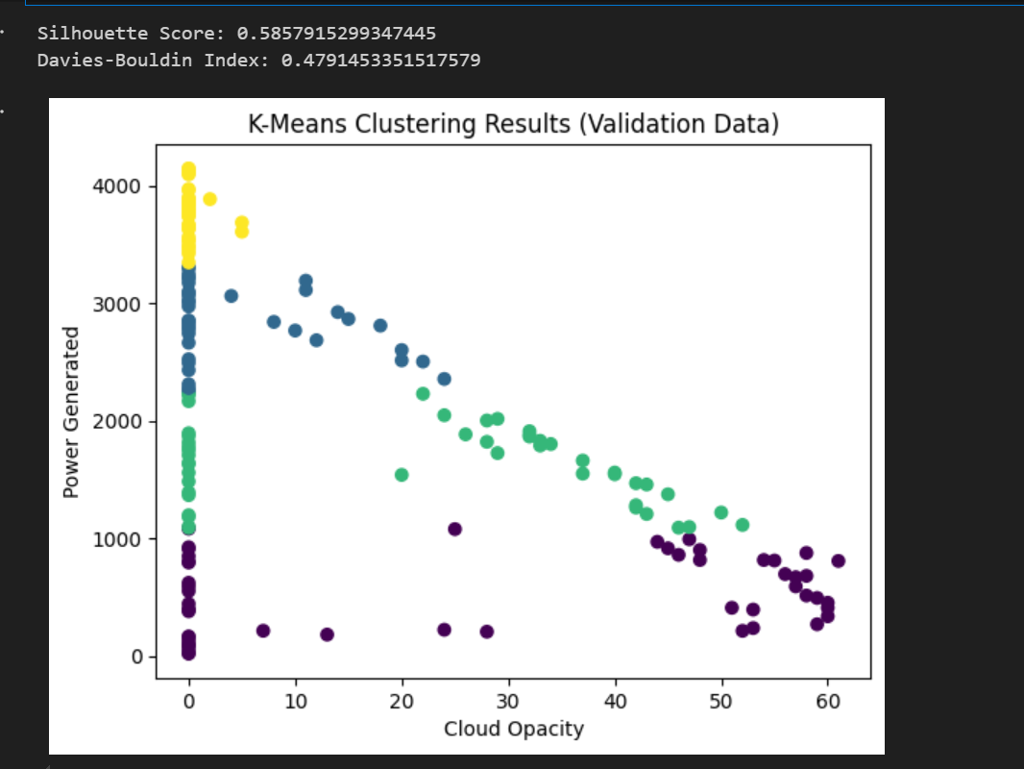

3. K-Means Clustering Algorithm
K-Means Clustering is an unsupervised learning algorithm that groups an unlabeled dataset into different clusters based on similarities among data points. Here, 'K' defines the number of predefined clusters created in the process. For example, if K=2, there will be two clusters; if K=3, there will be three clusters, and so forth.
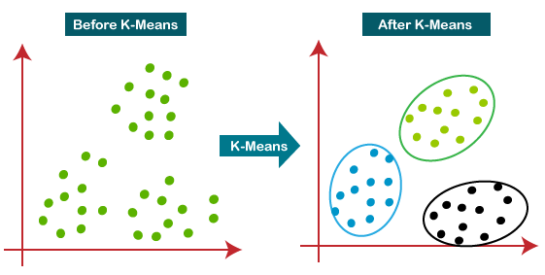

Algorithm Overview:
- Initialization (Step-1 and Step-2):
  - Select the number 'K' to determine the number of clusters.
  - Randomly select 'K' points or centroids from the dataset. These initial centroids can be any data points or randomly generated points.
- Cluster Assignment (Step-3):
  - Assign each data point to the nearest centroid, forming 'K' clusters. Data points are assigned to the cluster whose centroid is closest in terms of distance (usually Euclidean distance).
- Centroid Update (Step-4):
  - Calculate the mean (centroid) of each cluster based on the data points assigned to it. This new centroid becomes the center of the cluster.
- Iteration (Step-5):
  - Repeat Steps 3 and 4 until the centroids no longer change significantly or a maximum number of iterations is reached. If any data point changes its cluster assignment, the algorithm recalculates centroids.
- Convergence (Step-6):
  - Once centroids stabilize (no or minimal reassignments), the algorithm converges, and the final cluster assignments are determined.
- Output (Step-7):
  - The model is ready, with each data point assigned to a cluster based on its similarity to other data points within the same cluster.

