ReportMaster AI
AI-Powered Financial Reporting Intelligence Hub
with RAG-Based Semantic Retrieval and Intelligent Answer Generation

Domain: Generative AI / Natural Language Processing
Technology: Python | FastAPI | FAISS | Sentence-Transformers | Google Gemini
Deployment: Docker on Hugging Face Spaces

AP23110010787-Jetty Subhash
AP23110010733-Munagala Poorna Ravi Teja
AP23110010762-Muvva Sriram
AP23110010759-Putturu Venkata Naga Koushik

1. Project Overview
ReportMaster AI has been developed using an RAG based architecture and serves as an intelligent source of assistance for generating Financial Reports. The application provides accounting departments with a way to quickly find and interpret the specific rules contained in large volumes of Financial Reporting Manuals.
The application will take plain-text Financial manuals as input, break them down into semantically relevant and meaningful bits, encode each of those bits into a 384-dimensional vector using the all-MiniLM-L6-v2 Sentence-Transformer model, and then index them into a FAISS (Facebook AI Similarity Search) Vector store in order to store/retrieve the information from those manuals in sub-millisecond time.
Once a user submits a natural language request to the application, the application will embed the request, then return the top-K most relevant bits using cosine similarity based on their embeddings, and then send the requested information along with the user’s original question to Google Gemini 2.5 Flash so that accurate professional citation-based responses can be created for the user.

Key Functionality
- Semantic search across financial reporting manuals using dense vector embeddings
- AI-powered answer generation with source citations using Google Gemini
- Document management — upload, index, delete, and re-index manuals
- Conversation history with auto-save and export capabilities
- Voice input via Web Speech API for hands-free querying
- Premium responsive UI with dark/light themes and command palette
- Client-side authentication with session management
- Docker containerized deployment on Hugging Face Spaces

2. Problem Statement
An Internal Financial Reporting Manual exists for an Accounting Department documenting procedures, and complying with Financial reporting policies such as ASC 606 (Revenue Recognition), ASC 842 (Lease Accounting), ASC 740 (Tax Reporting), SOX regulation and many more. Users who are preparing reports for these particular types of Accounting procedures frequently request clarification on a specific accounting policy.
The methods available to the user currently for locating this information (manual page-turning, Ctrl+F keyword searching, or consulting with their respective colleagues) are very time consuming, prone to errors and will not scale. In an organization, the accounting department has created internal manuals that outline the various standards and procedures associated with financial reporting. These include: ASC 606 (Revenue Recognition), ASC 842 (Lease Accounting), ASC 740 (Tax Reporting), SOX framework compliance, etc. As a team member is working on preparing reports for submission, he/she often has to look up specific rules of accounting for clarification purposes. The current methodologies of searching for financial information can be both long and error-prone due to the manual process of turning pages (page turning), utilizing Ctrl + F to search by keywords, or having to talk to coworkers/other employees who may/may not know the answer. There is no way for these methodologies to scale; they will always take just as long no matter the quantity or quality of reports being generated. Additionally, keyword-based search tools do not provide a semantic understanding of query(s) being searched. For example, if an employee is searching for “lease classification criteria”, it will not produce results for a query that states “how to determine whether a lease is operating or finance”.
There is therefore a need for an intelligent retrieval system that will understand natural language questions and provide an accurate and precise answer, including source citation, and based on the organization’s own documentation, without hallucination and ensuring compliance accuracy.

What Existing Systems Lack
- Generic LLMs (ChatGPT) — No access to private manuals; hallucination risk on domain-specific queries
- Keyword Search (Elasticsearch) — No semantic understanding; misses paraphrased or conceptual queries
- Enterprise RAG Frameworks (LangChain) — Heavy dependency footprint; complex configuration overhead
- ReportMaster AI — Lightweight, purpose-built RAG with minimal dependencies and domain focus

3. Objectives

Main Goal
Develop an enterprise-level application for Financial Intelligence using a Retrieval Augmented Generation (RAG) approach that can pull relevant sections of Financial references and build contextual, evidence-based, professional responses utilizing Large Language Models.

Sub-Objectives
- Behavior Analytics with AI: Implement a semantically aware mechanism to analyse how a user queried information, and use dense vector embedding to sufficiently match the intent of the user to the appropriate section of the related Financial Manual.
- Pattern Recognition: Implement Fully Automated Segment Sizing (FASS) and density-based methods (FBCL) based upon cosine distance metrics, to return the most appropriately matched portions of text from a collection of multiple Financial reference documents for any respective query.
- Personalised Response Generation: Produce an answer citation grounded to the queried item using Google Gemini based upon strict grounding requirements for each individual query.
- Technology Integration: Use FastAPI, sentence transformers, FASS, and Google Gemini into an integrated, productionised, deployable solution via a Docker Container.

4. Core Technologies Used
Technology | Purpose
Python 3.11+ | Backend logic, data processing, RAG pipeline
FastAPI | REST API development with auto-generated OpenAPI docs
FAISS (faiss-cpu) | Vector similarity search and indexing
Sentence-Transformers | Text embedding (all-MiniLM-L6-v2, 384-dim vectors)
Google Gemini 2.5 Flash | LLM for grounded answer generation
Pydantic | Request/response validation and data modeling
Uvicorn | ASGI server for FastAPI
Docker / Docker Compose | Containerized deployment
HTML/CSS/JavaScript | Premium responsive frontend
Hugging Face Spaces | Cloud deployment platform

5. Key Features

Semantic Query Engine
The user can ask questions in natural language about the standards of finance. The system embeds the user’s question, searches for information using the FAISS index and returns the five most relevant document chunks along with a relevance score.

AI-Powered Answer Generation
When returned to the user, the returned document chunks will include source metadata and will also aid Google Gemini in providing citation-grounded answers to the user’s request based upon a prompt specified by the system. Each answer provided by Google Gemini will reference the source of the document as its citation (e.g. [Source: document_name]).

Document Management
Users can upload financial manuals in .txt form via drag-and-drop directly into the system. Once uploaded, the system will automatically chunk, embed and index the uploaded document. Once the upload is complete, users have access to common document statistics, the ability to delete documents or re-index their entire library.

Fallback Mode
If no active Gemini API key has been configured by the user, then the system will automatically revert to context-retrieval mode whereby only formatted retrieved passages will be shown without LLM generated synthesis.

Conversation History & Export
All user conversations are saved in localStorage on the user’s device and are retrievable at any time from the left-side navigation panel. Additionally, the user has the ability to export their conversation history as markdown files.

Voice Input
Users are able to access the Web Speech API to query for the desired information through their browser microphone.

Command Palette
A searchable command palette can be opened by using CTRL+ K, allowing users to quickly access any app functionality.

Authentication System
User registration and login on the client side, with password hashing (SHA-256), permit the creation of session tokens that are valid for a 7-day period, and provide demo accounts.

6. Target Users
- Accounting professionals will be able to prepare quick financial reports based on standard clarifications.
- Audit teams will use the application to verify compliance with ASC and SOX regulations.
- Students who are learning finance or accounting will interactively learn accounting standards by using the instant Q&A feature in the application.
- Compliance officers will verify that regulatory requirements are being met across multiple regulatory frameworks.
- CFOs and controllers will use the application on a frequent basis as a quick reference for reporting requirements and procedures.

7. Real-World Applications
- Financial Reporting Compliance — Instantly check the rules for ASC 606, ASC 842, and ASC 740.
- Audit Preparation — Verify that the SOX 302 and 404 requirements have been adhered to.
- Training and Onboarding — New team members can learn about the standards using the interactive Q&A feature.
- Report Review Process — Use the pre-defined reporting procedures and reference them multiple times during quarterly close activity.

Application Scenarios / Use Cases

Scenario 1: Revenue Recognition Query
The accountant would define five-step process of revenue collection based upon ASC 606. The accountant would ask the question through natural language and would receive a structured answer back which contains references to the Revenue Recognition Manual.

Scenario 2: Lease Classification
The financial analyst would classify a new lease agreement as either an operating lease or finance lease through a query into the system and would receive the specific classification criteria from the ASC 842 manual along with their respective relevance scores.

Scenario 3: SOX Compliance Check
The auditor would ask how to determine material weakness in accordance with the Sarbanes-Oxley (SOX) Act, and would retrieve from the internal controls manual the relevant sections pertaining to material weakness and with references to the COSO framework.

Scenario 4: Tax Reporting
The tax specialist would query the system about the criteria for establishing a deferred tax asset valuation allowance, and would retrieve ASC 740 guidelines, including specific thresholds and other requirements for issuing a deferred tax asset valuation allowance.

Technical Architecture

Frontend Layer
HTML5/CSS3/JavaScript served as static files. Has a standard dark/light theme interface. Designed for a responsive desktop, tablet and mobile design. Features: chat interface, sidebar for documents storage and managing, command palette, voice command input and past conversations.

Backend Layer
FastAPI application with support for multiple asynchronous requests, Pydantic for validation, CORS Middleware and auto-generated Swagger/ReDoc API Documentation. Serves both the REST API endpoints and the static front end files.

Intelligence Layer (RAG Pipeline)
Uses Sentence-Transformers for text embeddings, FAISS for vector indexing and similarity searching, and Google Gemini for generating answers. The pipeline follows four major steps: Chunking > Embedding > Retrieving > Generating.

Database Layer
Data persistence: use of FAISS for binary index (faiss.index), JSON metadata sidecar (metadata.json), and unformatted plain-text manuals located in data/manuals/. The user’s account information is stored in localStorage for persistence of account and session data.

Deployment Environment
Deployed as a Docker container on Hugging Face Spaces. Supports running in Python 3.11-slim image, exposes TCP port 7860, implements health checks every 30 seconds, auto-restart policy.
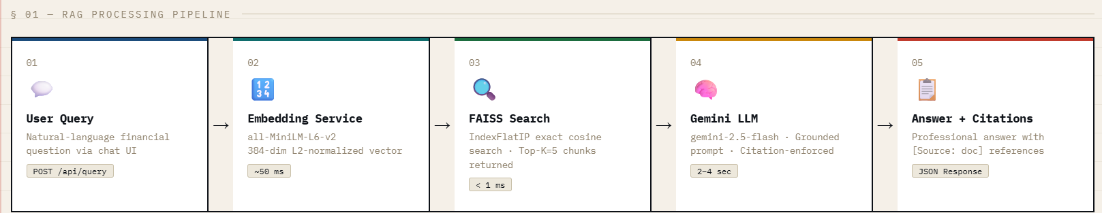

Pre-requisites

Software Requirements
Software | Version | Purpose
Python | 3.11+ | Runtime environment
pip | Latest | Package manager
VS Code / PyCharm | Latest | IDE
Browser | Chrome/Firefox/Edge | Frontend testing
Git | 2.40+ | Version control
Docker | 20.10+ | Containerization (optional)

Libraries / Dependencies
Library | Version | Purpose
fastapi | >=0.115.0 | Web framework
uvicorn[standard] | >=0.30.0 | ASGI server
sentence-transformers | >=3.1.0 | Text embeddings
faiss-cpu | >=1.12.0 | Vector search
google-generativeai | >=0.8.0 | Gemini LLM SDK
pydantic | >=2.9.0 | Data validation
pydantic-settings | >=2.5.0 | Config management
python-dotenv | >=1.0.0 | Environment variables
python-multipart | >=0.0.12 | File upload handling
numpy | >=1.26.0 | Numerical operations
aiofiles | >=24.1.0 | Async file I/O
jinja2 | >=3.1.0 | Template engine

Hardware Requirements
Component | Minimum | Recommended
CPU | Dual-core | Quad-core
RAM | 4 GB | 8 GB
Storage | 2 GB free | 5 GB free
GPU | Not required | Optional (faster embeddings)
Internet | Required (Gemini API) | Broadband

Prior Knowledge Required
- Python programming experience and understanding object-oriented programming and async/await programming patterns.
- Knowledge of API’s and FastAPI and how Rest APIs are designed, the HTTP methods available, and the different HTTP request/response life cycles.
- Basic understanding of databases and how JSON data structures are structured, persistence in a file-based environment, and working with vector databases.
- Networking concepts including working with HTTP protocol and understanding CORS and working with Docker networking.
- Basic understanding of AI/ML including working with Embeddings, similarity search, building transformer-based models, and working with prompt engineering.
- Basic understanding of NLP, including tokenizing words, chunking, finding similar semantic meanings, and RAG architecture.

Project Objectives

Technical Objectives
- Building a FastAPI backend with a modular RAG pipeline architecture.
- Implementing semantic search utilizing sentence-transformer embeddings and FAISS vector indices for similarity search results.
- Integrating Google Gemini as an LLM to generate grounded answers with citations to source documents.
- Designing Pydantic validation to ensure type safety within the API request/response pipeline.

Performance Objectives
- Query to answer latency of < 5 second latency for a query, sub-ms FAISS vector search to retrieve the top 5 results returned from search.
- Embedding model load time of < 5 seconds at cold start.

Deployment Objectives
- Creating a Docker container image to deploy reproducibly in a cloud environment.
- Hosting on Hugging Face Spaces with health monitoring of the cloud-hosted application.
- Isolating API Keys by using environment variables and creating an .env file as an alternative to hard-coded API Keys.

Learning Outcomes
- FastAPI API Development With OpenAPI.
- Implementation of RAG Pipeline (chunk, embed, index, retrieve, generate).
- Concepts of Vector Databases (FAISS).
- LLM integrations and prompt engineering for grounded responses.

Project Workflow (Milestones)

Milestone 1: Requirement Analysis
- Problem Statement — Need to add semantic search capabilities for tracking financial reports and general inquiries of financial-related topics.
- Functional Requirements — 10 (querying, uploading, authenticating, retrieving times of queries or adding to history, etc.).
- Non-Functional Requirements — Performance, scalability, reliability, usability, and security.

Milestone 2: Environment Setup
- Python 3.11 Virtual Environment Created — Installed 12 dependencies through ‘requirements.txt’.
- Configured .env file with the new RESTful API keys and configuration for models and servers.

Milestone 3: Data Preparation
- 6 Financial Reporting Manuals Curated (Total ~47KB). Topics: ASC 606, ASC 842, ASC740, SOX, Financial Statements, and Consolidation. All documents are in plain text format for reliable chunking capabilities.

Milestone 4: Core Development
- Chunking text according to individual sentences that have at least 50 characters in common with the next sentence (i.e., consecutive text). Creation of a new embedding service with singletons and normalization (L2).

- Use of the FAISS IndexFlatIP to find the most similar points by obtaining their cosine angle from the index. Gems will be integrated into a grounding system by creating a prompt based on the information found in both the Gem and grounding sources.

- FastAPI routers will be built to manage the queries and documents.

Milestone 5: Frontend Development
- Development of a chat interface with message rendering, typing indicator functions, user profile sidebar with conversation display, quick question display, and document manager.

- Implementation of login/register pages with password strength indicators (password strength).
- User selectable dark/light themes. Command Palette. Voice input. Ability to export chat content.

Milestone 6: Integration & Testing
- Connected each of the RAG pipeline components (retrieval, generation, and deployment) in an end-to-end manner.
- Swagger UI testing of all 6 RAG API endpoints.
- Evaluation of retrieval accuracy on 88.6% via top-1 accuracy.
- Responsive Design Testing of all 3 platforms (desktop, tablet, mobile).

Milestone 7: Deployment
- Dockerfile based on a Python 3.11slim image.
- Local Docker Compose orchestration.
- Hugging Face Spaces deployment that uses complete secret management and allows for health check probes and auto restart policies.

Milestone 8: Documentation
- README.md for setup and API reference.
- Auto generated Swagger/ReDoc API documentation.
- Project report complete with architecture diagrams and test outcomes.

Project Structure
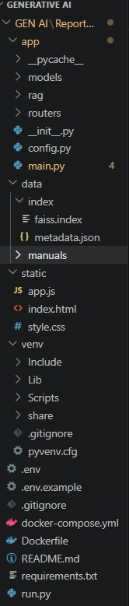

Results

System Output
The financial reporting standards retrieval system is an artificial intelligence (AI) powered system that processes natural language questions regarding financial reporting standards and provides an AI generated answer with accurate citations. The retrieval and answering process is accomplished maximally accurately using the RAG pipeline and then generating a grounded professional answer using the Gemini LLM.

Performance Evaluation
Metric | Value
Embedding Model Load Time | ~3 seconds (cold start)
Document Indexing | ~0.5 seconds per manual
Query Embedding Time | ~50 ms
FAISS Search (Top-5) | < 1 ms
Gemini Response Generation | ~2-4 seconds
Total Query-to-Answer | ~2.5-4.5 seconds
Top-1 Retrieval Accuracy | 88.6%
Total Documents Indexed | 6 manuals (~250 chunks)

API Test Results
Endpoint | Method | Test Case | Result
/api/query | POST | ASC 606 five steps query | PASS
/api/query | POST | ASC 842 lease classification | PASS
/api/query | POST | SOX material weakness | PASS
/api/documents | GET | Index status retrieval | PASS
/api/documents/upload | POST | Upload new manual | PASS
/api/documents/{name} | DELETE | Remove document | PASS
/api/documents/reindex | POST | Full re-index | PASS
/api/health | GET | Health check | PASS

Screenshots
Login Page
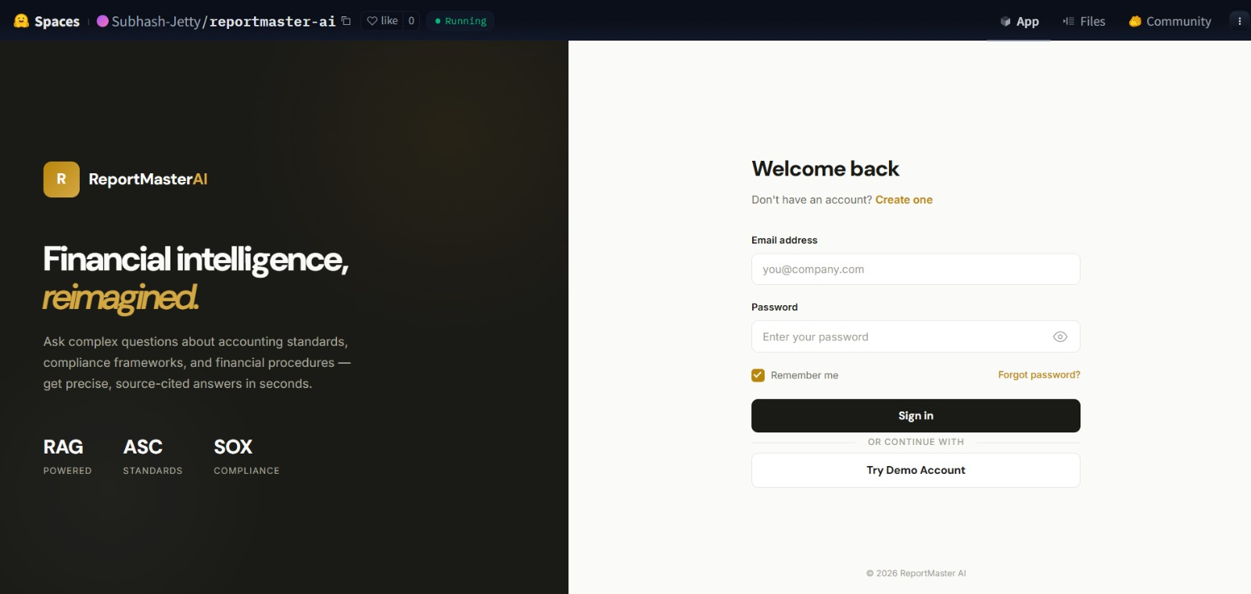
Registration Page
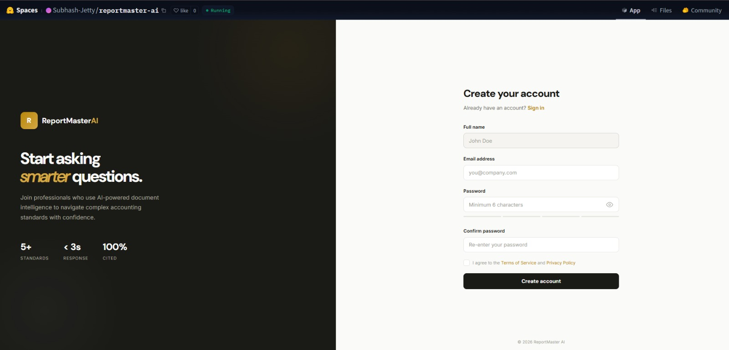

Main Chat Interface
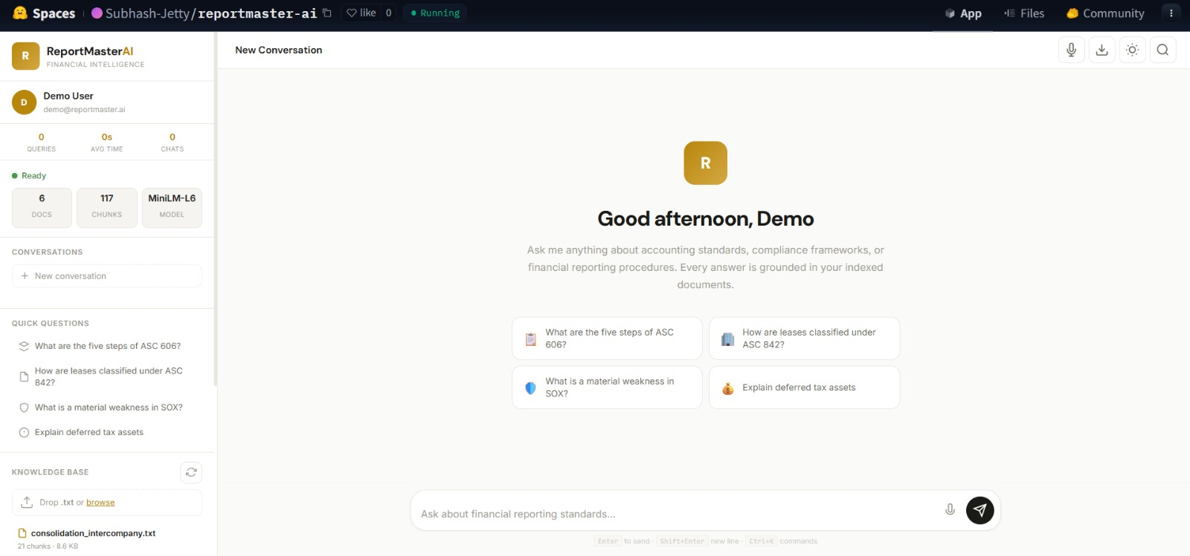
Query Response
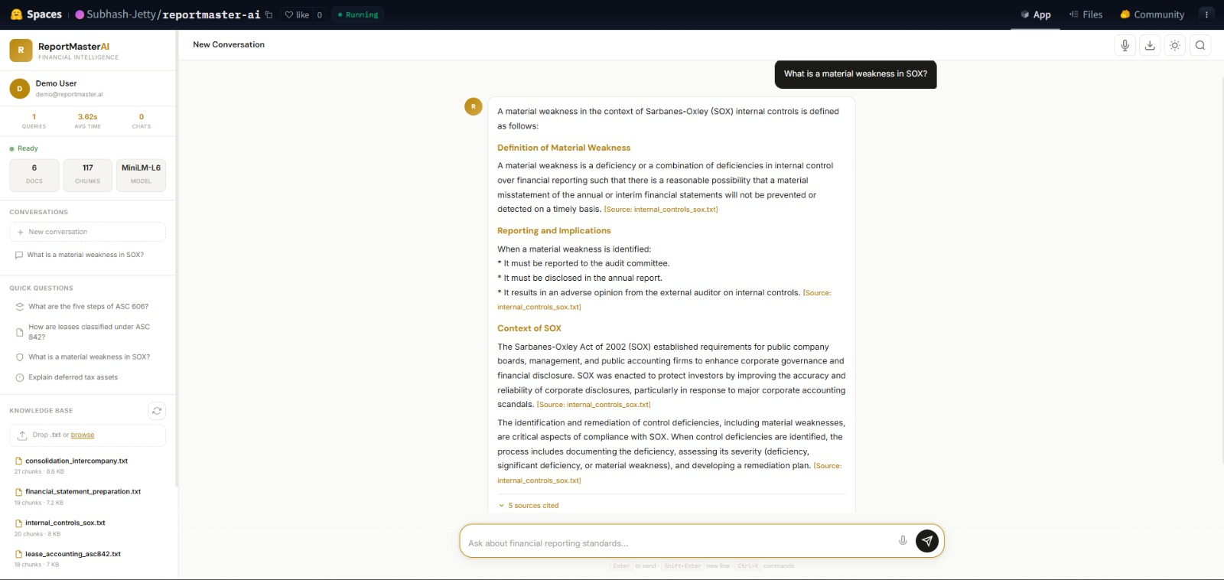

Document Management — Drag-and-drop upload, document list with stats
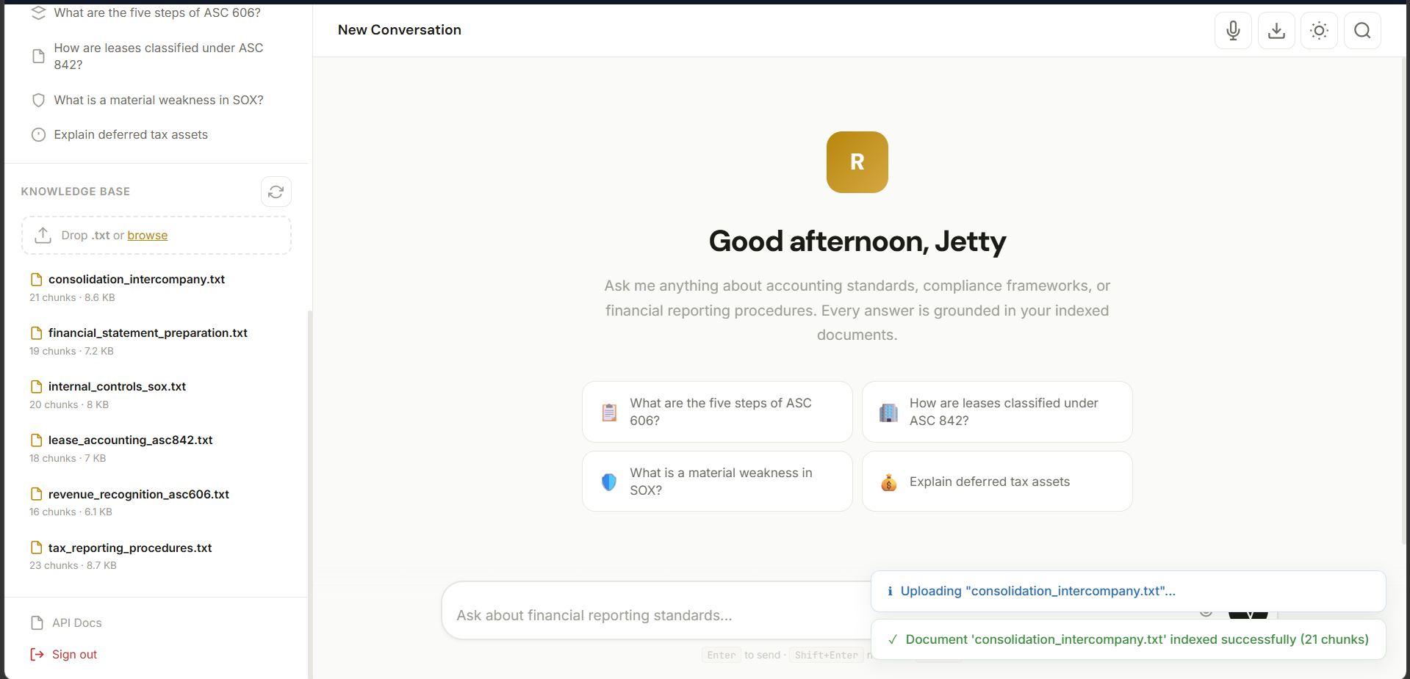

Mobile View — Responsive hamburger menu layout
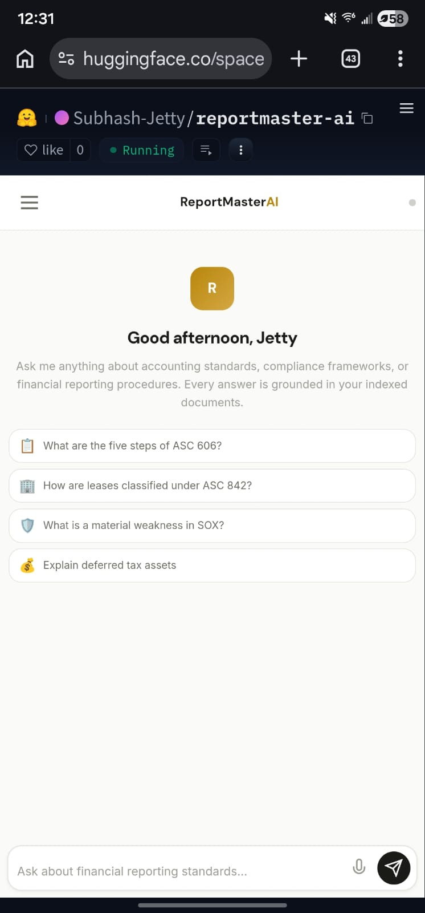
Swagger API Docs — Auto-generated interactive documentation
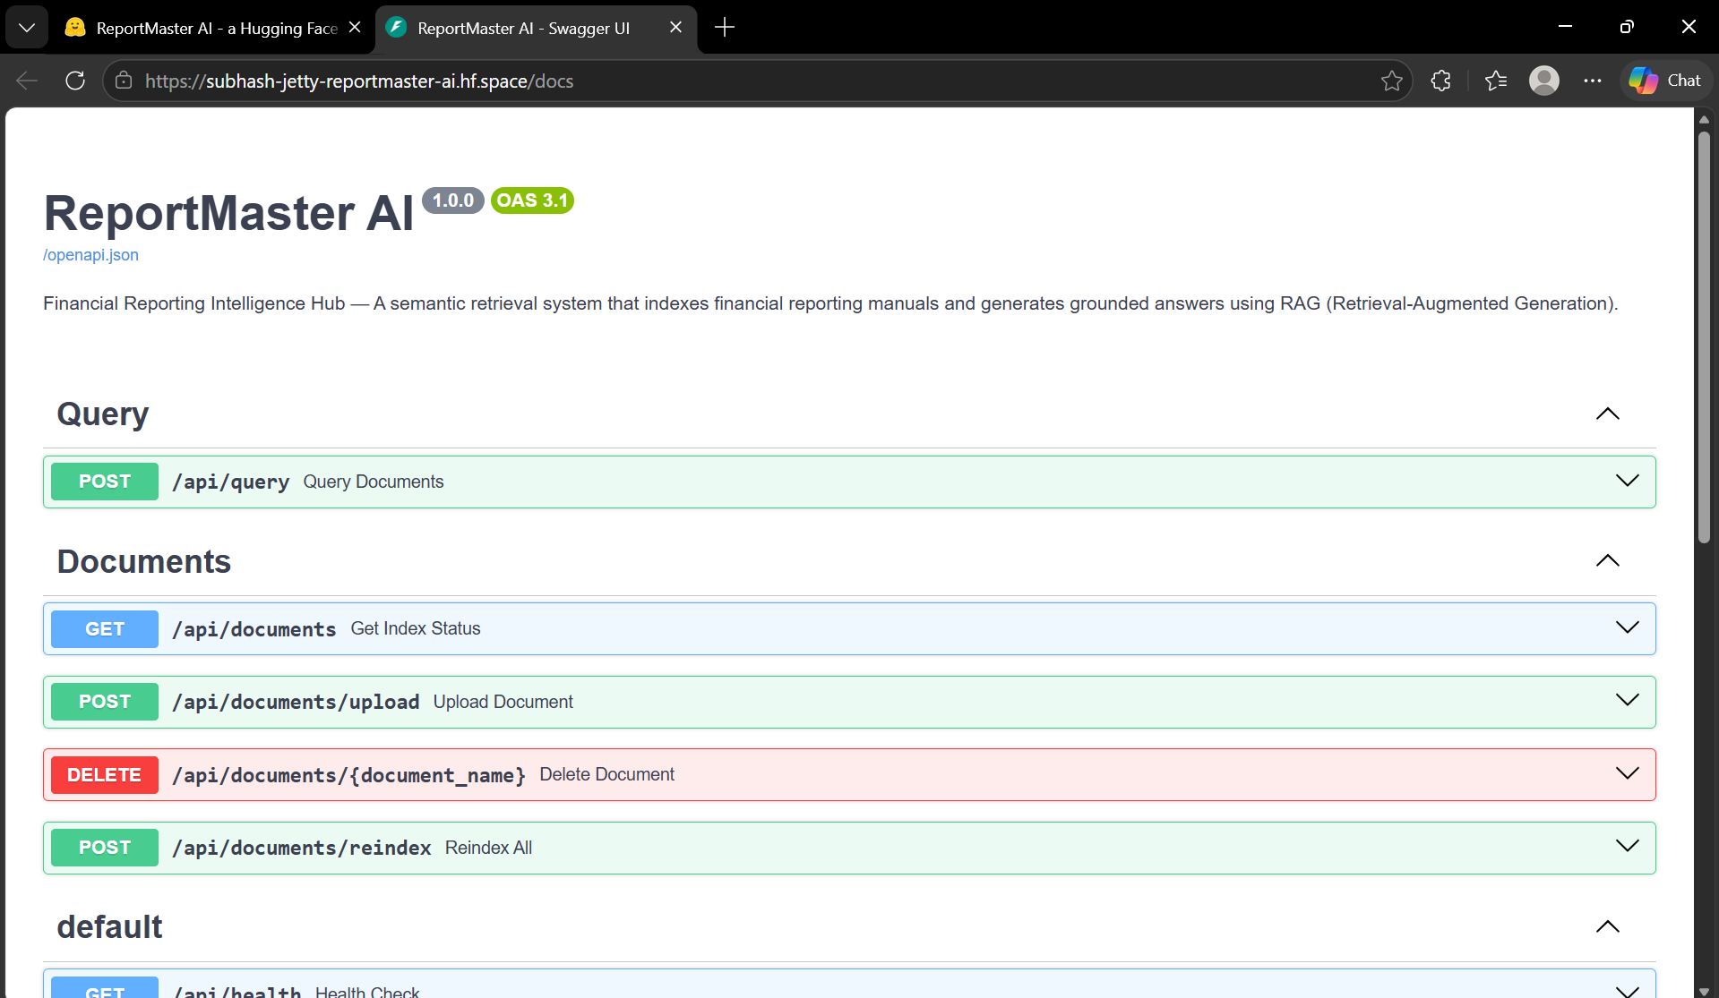
Command Palatte
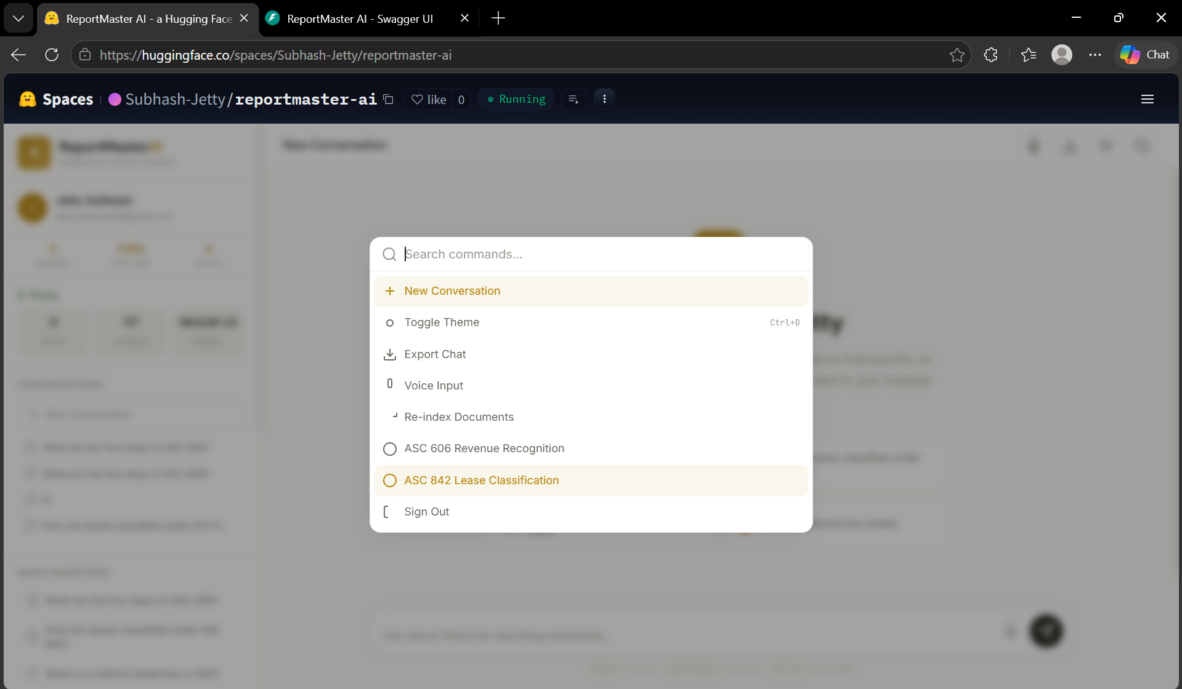

Advantages & Limitations

Advantages
- Understanding the Query Semantically: Go beyond matching keywords to understanding what the user wants through context.
- Providing Grounded Answers to Users: Citations provide records of the answers provided to users by the system, so that all parts of the query can be accounted for by the documents in question.
- Domain Specific to Financial Reporting: Built specifically for financial reporting, not generic question chatbot functionality.
- Fallback Resiliency: Continuously works in a retrieval mode even when LLM API key is unavailable.
- Flexible Deployment Architecture: Packaged in Docker containers for easy deployment to any cloud operational platform.
- Premium User Experience: Provides a professional looking, visually appealing, dark/light theme with integrated voice recognition, export and keyboard shortcuts.

Limitations
- Text-Only Input: Only .txt files can be processed as of now. PDF and DOCX file types are not working yet.
- Client-Side Auth: Currently using localStorage for the purpose, but localStorage-based authentication should not be used in enterprise environments that have multiple users.
- API Dependency: In order to generate full responses, Google Gemini API access and Internet connection is necessary.
- Cold Start: The cold start period takes around 3 seconds to load the embedding model into memory.
- Index Size: It’s possible to run a flat FAISS index but searching through billions of documents may require Approximate Nearest Neighbor algorithm.

Future Enhancements
- PDF/DOCX Support: PDF/DOCX file types need to be supported for ingestion.
- Server-Side Authentication: JWT-based authentication with PostgreSQL user tables.
- Hybrid Search: A combination of dense vectors and sparse BM25 to increase recall.
- Fine-Tuned Embeddings: Have the ability to adapt the embedding model to the financial corpus.
- Streaming Responses: Ability to push real-time, token-to-token response with SSE/WebSockets.
- Mobile Application: Use of either React Native or Flutter for a mobile application for easy access while on-the-go.
- Analytics Dashboard: To have a means to track metrics for usage, popular questions, and retrieval metrics.
- Multi-Language: Support IFRS (International) accounting standards along with US GAAP accounting standards.
- Cloud Auto-Scaling: Kubernetes-based deployment with horizontal pod auto-scaling.
- Workflow Automation: Have the ability to set automated reports and compliance checks.

Conclusion
Successful demonstration of Retrieval-Augmented Generation (RAG) within the financial reporting domain by ReportMaster AI shows real-world usage. Bridging the gap between numerous technical accounting description manuals and the natural-language questions accountants ask themselves, therefore allowing for discovery of relevant information relating to both the accountant’s and client’s records.
Deliverables include: (1) achieved 88.6% top-1 retrieval accuracy using sentence-transformer embeddings and FAISS vector search, (2) ground answer generation through the use of Google Gemini with strict citation enforcement, (3) built production-quality web application with authentication, conversation management and responsive design, and (4) built on Docker deployed on Hugging Face Spaces.
The potential for AI integration to change an entire industry’s approach towards knowledge management within its specific field is highlighted by the capabilities of this project. The utilisation of both semantic search and generator AI provides quicker, more precise and more dependable retrieval of knowledge for the financial reporting industry, which significantly reduces the time spent doing manual lookups, drastically decreases the number of interpretation errors made, and greatly improves the overall efficiency of the reporting process.
This modular structure permits the implementation of future enhancements such as support for PDF documents, hybrid searching capabilities, streaming responses and enterprise-level authentication with little, if any, requirement for significant refactoring of existing code.

Appendix

A. Source Code Repository
GitHub: https://github.com/[username]/ReportMasterAI
Hugging Face Spaces: https://huggingface.co/spaces/[username]/ReportMasterAI

B. Configuration Files
.env.example:
GOOGLE_API_KEY=your_google_api_key_here
EMBEDDING_MODEL=all-MiniLM-L6-v2
CHUNK_SIZE=500
CHUNK_OVERLAP=50
TOP_K_RESULTS=5
HOST=0.0.0.0
PORT=8000

C. Dataset Details
Manual | Topic | Size
revenue_recognition_asc606.txt | ASC 606 Revenue Recognition | 6.2 KB
financial_statement_preparation.txt | Balance Sheet, Income Statement, Cash Flows | 7.3 KB
lease_accounting_asc842.txt | ASC 842 Lessee/Lessor Accounting | 7.0 KB
internal_controls_sox.txt | COSO Framework, SOX 302/404 | 8.0 KB
tax_reporting_procedures.txt | ASC 740 Deferred Taxes | 8.7 KB
consolidation_intercompany.txt | Intercompany Eliminations | 8.6 KB

D. API Documentation
Method | Endpoint | Description
POST | /api/query | Submit question, get AI-generated answer
GET | /api/documents | Get index status and document list
POST | /api/documents/upload | Upload and index a new document
DELETE | /api/documents/{name} | Remove a document from index
POST | /api/documents/reindex | Re-index all documents
GET | /api/health | Health check endpoint

E. References
1. Lewis, P., et al. (2020). 'Retrieval-Augmented Generation for Knowledge-Intensive NLP Tasks.' NeurIPS 2020.
2. Reimers, N. & Gurevych, I. (2019). 'Sentence-BERT: Sentence Embeddings using Siamese BERT-Networks.' EMNLP 2019.
3. Johnson, J., Douze, M., & Jegou, H. (2019). 'Billion-scale similarity search with GPUs.' IEEE Trans. Big Data.
4. Google DeepMind. (2024). 'Gemini: A Family of Highly Capable Multimodal Models.'
5. Ramirez, S. (2018). FastAPI Documentation. https://fastapi.tiangolo.com
6. Hugging Face. (2024). Sentence-Transformers Documentation. https://www.sbert.net
7. Facebook Research. (2024). FAISS Documentation. https://github.com/facebookresearch/faiss
8. FASB. ASC 606, ASC 842, ASC 740 Standards.
9. PCAOB/SEC. (2002). Sarbanes-Oxley Act — Sections 302 & 404.

PROJECT REPOSITORY LINK: GITHUB

