*Name : Subhash Chandra*

*Registration No : 11803315*

*Roll No : A-14*

*Batch : KM088*

*Assignment : CA-1*

*Set - B*

*Subject : :FRONT END WEB DEVELOPER (INT219)*

*Teacher : Miss. Navneet Kaur*

**Que : 1**

Create an HTML form for booking room in a hotel. Perform JavaScript validation on all fields. The user

must be alerted each time a field is left blank. Also add a CSS gradient to the body.

**Ans :** I DONE THIS TASK

* Specifications : This is a registration form for booking a hotel
* I made a button “Try Dummy Data” Which will fill the all details automatically (some dummy details)
* All the * marked details has to be filled , else form will not be submitted and you will get an alert message.
* If all the * details are filled properly , when you submit the form ,it will take you to the welcome page
* The capacha is generated random 6 character length string using javascript, So please fill the capacha code correctly.
* Screen Shots 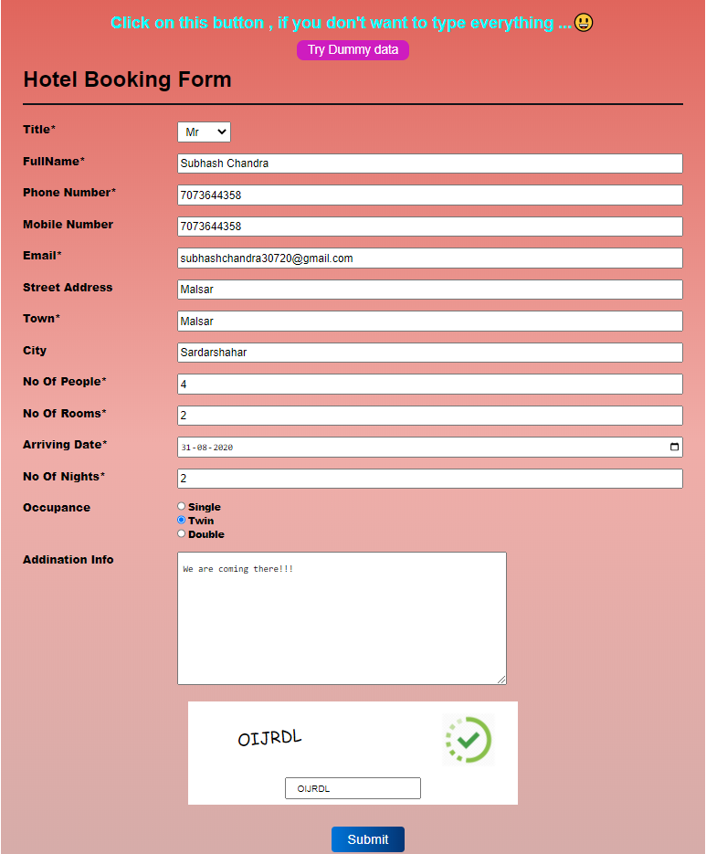

CODE :

index.html

************************************************************************

<!DOCTYPE html>

<html lang="en">

<head>

<meta charset="UTF-8"/>

<meta name="viewport" content="width=device-width, initial-scale=1.0"/>

<meta http-equiv="X-UA-Compatible" content="ie=edge"/>

<link rel="shortcut icon" href="">

<title>Book Your Hotel Online</title>

<link rel="stylesheet" href="./styles.css"/>

</head>

<body>

<div class="container">

<h2 style="text-align: center; color: aqua;">Click on this button , if you don't want to type everything ...😃</h2>

<button id="dummyData">Try Dummy data</button>

<h1 class="header">Hotel Booking Form </h1>

<hr>

<div class="form-outer">

<form action="#">

<div class="form-group">

<label for="title">Title*</label>

<select name="title" id="title" >

<option value="" selected></option>

<option value="Miss">Miss</option>

<option value="Mr">Mr</option>

<option value="Mrs">Mrs</option>

<option value="M"></option>

</select>

</div>

<div class="form-group">

<label for="fullName">FullName*</label>

<input type="text" id="fullName">

</div>

<div class="form-group">

<label for="phoneNumber">Phone Number*</label>

<input type="number" id="phoneNumber">

</div>

<div class="form-group">

<label for="mobileNumber">Mobile Number</label>

<input type="number" id="mobileNumber">

</div>

<div class="form-group">

<label for="email">Email*</label>

<input type="email" id="email">

</div>

<div class="form-group">

<label for="street">Street Address</label>

<input type="text" id="street">

</div>

<div class="form-group">

<label for="town">Town*</label>

<input type="text" id="town" >

</div>

<div class="form-group">

<label for="city">City</label>

<input type="text" id="city">

</div>

<div class="form-group">

<label for="people">No Of people*</label>

<input type="number" id="people" >

</div>

<div class="form-group">

<label for="rooms">No Of Rooms*</label>

<input type="number" id="rooms" >

</div>

<div class="form-group">

<label for="date">Arriving Date*</label>

<input type="date" id="date" >

</div>

<div class="form-group">

<label for="nights">No Of Nights*</label>

<input type="number" id="nights" >

</div>

<div class="form-group">

<label for="occupance">Occupance</label>

<div class="radio-btns">

<input type="radio" id="single" name="occupance" value="single">

<label for="single">Single</label><br>

<input type="radio" id="twin" name="occupance" value="twin">

<label for="twin">Twin</label> <br>

<input type="radio" id="double" name="occupance" value="double">

<label for="double">Double</label>

</div>

</div>

<div class="form-group">

<label for="info">addination info</label>

<textarea name="add-info" id="info" rows="10" placeholder="Additional Inforamtion will help you in our better services"></textarea>

</div>

<div class="no-robot">

<div class="re-capacha-code">

<p class="code"></p>

</div>

<div class="capacha-img">

<img src="https://cdn.iconscout.com/icon/premium/png-512-thumb/in-progress-2-571393.png" alt="">

</div>

<input type="text" id="reCapCode" placeholder="Write above capacha code">

</div>

<div class="submit-btn">

<button type="submit" id="submit">Submit</button>

</div>

</form>

</div>

</div>

<script src="./app.js"></script>

</body>

</html>

Style.css

*{

padding:0;

margin:0;

box-sizing:border-box;

}

body{

display:flex;

justify-content:center;

align-items:center;

min-height:100vh;

font-family:'Montserrat', sans-serif;

}

.container{

min-width:80%;

background:linear-gradient(to bottom,

#e0655c,

#f0ada8,

#d4aca9

);

min-height:80vh;

padding:1rem 2rem;

}

hr{

height:3px;

background-color:#111319;

border:none;

margin:1rem 0;

}

#dummyData{

padding: 0.3rem 1rem;

background-color: rgb(206, 28, 191);

color: white;

margin: 10px 400px;

border: none;

outline: none;

border-radius: 10px;

font-size: 18px;

}

form{

width:100%;

position:relative;

}

.form-group{

padding:0.5rem 0;

display:flex;

/* align-items:center; */

}

.form-group label{

min-width:30%;

margin-right:2rem;

font-weight:800;

text-transform:capitalize;

}

select{

padding:0 0.5rem;

}

select option{

margin-top:5px;

background-color:#111319;

color:white;

}

.form-group input,

.form-group select{

height:30px;

font-size:1rem;

outline:none;

}

.form-group>input{

min-width:50%;

padding-left:0.2rem;

}

.radio-btns input{

height:14px;

}

.radio-btns label{

font-size:14px;

}

.form-group textarea{

min-width:50%;

padding:1rem 0.5rem;

outline:none;

}

.no-robot{

height:150px;

width:50%;

margin:1rem auto;

background:#FFF;

display:flex;

flex-direction:column;

justify-content:space-around;

align-items:center;

position:relative;

}

.no-robot .re-capacha-code{

width:70%;

height:70px;

font-family:cursive;

}

.re-capacha-code .code{

transform:rotate(-5deg);

font-size:1.5rem;

transform-origin: bottom right 10px;

}

.no-robot input{

padding:0.4rem 1rem;

outline:none;

}

.capacha-img img{

height:80px;

object-fit:contain;

position:absolute;

right:2rem;

top:1rem;

cursor:pointer;

}

form .submit-btn{

width:4em;

margin:2rem auto;

}

.error{

border:2px solid red;

}

.submit-btn button{

padding:0.5rem 1.5rem;

background:linear-gradient(to right, #0074d9,#042053,#0a365c,#0b89f0);

outline:none;

border:none;

cursor:pointer;

background-size: 400%;

font-size:1.2rem;

border-radius:5px;

color:white;

transition: background-size 0.5s ease-in;

}

.submit-btn button:hover{

background-size: 100%;

}

@media (min-width:420px){

.form-group>input{

flex: 1;

padding-left:0.2rem;

}

}

@media (min-width:780px){

.form-group label{

min-width:20%;

margin-right:2rem;

font-weight: 800;

text-transform:capitalize;

}

}

@media (min-width:1200px){

.container{

min-width:1000px;

}

form-group textarea{

width: 70%;

}

}

App.js

const submitBtn = document.querySelector('#submit');

const title = document.querySelector('#title');

const fullName = document.querySelector('#fullName');

const phoneNumber = document.querySelector('#phoneNumber');

const mobileNumber = document.querySelector('#mobileNumber');

const email = document.querySelector('#email');

const street = document.querySelector('#street');

const town = document.querySelector('#town');

const numPeople = document.querySelector('#people');

const numRooms = document.querySelector('#rooms');

const arrivingDate = document.querySelector('#date');

const nights = document.querySelector('#nights');

// const occupance = document.querySelector('input')

const addInfo = document.querySelector('#info');

const actualCode = document.querySelector('.code');

actualCode.innerText = generateCapacha();

var allOkay = false;

let errors = 0;

// User data

let userData = {

title : '',

fullName :'',

phoneNumber:'',

mobileNumber:'',

email:'',

street:'',

town:'',

city:'',

numPeople:'',

numRooms:'',

arrivingDate:'',

occupance:'',

nights:'',

addInfo:'',

capachaCode:''

};

document.getElementById('dummyData').addEventListener('click',(e)=>{

useDummyData(e);

});

submitBtn.addEventListener('click',(e)=>{

e.preventDefault();

handleForm();

if(!errors){

window.location.href="userPage.html";

}

})

function handleForm(){

const capachaCode = document.querySelector('#reCapCode').value;

var strUser = title.options[title.selectedIndex].value;

if(strUser!=''){

userData.title = strUser;

}

if(fullName.value===''){

alert('Enter full Name');

errors=1;

}else{

userData.fullName = fullName.value;

}

if(phoneNumber.value===''){

alert('Please Enter Phone Number');

errors=1;

}else{

userData.phoneNumber=phoneNumber.value;

}

if(email.value===''){

alert("Please Provide your Email");

errors=1;

}else{

userData.email=email.value;

}

userData.street=street.value;

if(town.value === ''){

alert("Please enter your Town Name");

errors=1;

}else{

userData.town=town.value;

}

if(city.value!=''){

userData.city=city.value;

}

if(numPeople.value===''){

alert("Please Enter the number of people you are booking for");

errors=1;

}else{

userData.numPeople=numPeople.value;

}

if(numRooms.value===''){

alert("Please Enter the number of rooms you Need");

errors=1;

}else{

userData.numRooms=numRooms.value;

}

if(arrivingDate.value===''){

alert("Please Enter Arrival Date");

errors=1;

}else{

userData.arrivingDate=arrivingDate.value;

}

if(nights.value===''){

alert("Please Enter nights you will stay in Hotel");

errors=1;

}else{

userData.nights=nights.value;

}

if (document.getElementById('single').checked) {

userData.occupance=document.getElementById('single').value;

}

if (document.getElementById('twin').checked) {

userData.occupance=document.getElementById('twin').value;

}

if (document.getElementById('double').checked) {

userData.occupance=document.getElementById('double').value;

}

if(addInfo.value!=''){

userData.addInfo=addInfo.value;

}

if(actualCode.innerText != capachaCode){

alert("Please Enter correct Capacha Code !!");

errors=1;

}else{

userData.capachaCode=capachaCode;

}

console.log(userData);

}

function useDummyData(e){

var d = new Date('sun aug 31,2020'),

month = '' + (d.getMonth() + 1),

day = '' + d.getDate(),

year = d.getFullYear();

if (month.length < 2)

month = '0' + month;

if (day.length < 2)

day = '0' + day;

let curr_date = [year, month, day].join('-');

e.preventDefault();

let uTitle = 'Mr.',

uFullName = "Subhash Chandra",

uPhoneNumber = "7073644358",

uMobileNumber= "7073644358",

uEmail="subhashchandra30720@gmail.com",

uStreet='Malsar',

uTown='Malsar',

uCity='Sardarshahar',

uNumPeople=4,

uNumRooms=2,

uArrivingDate=curr_date,

uOccupance='twin',

uNights=2,

uAddInfo='We are coming there!!!',

uCapachaCode=actualCode.innerText;

title.value = uTitle;

fullName.value = uFullName;

phoneNumber.value = uPhoneNumber;

mobileNumber.value = uMobileNumber;

email.value = uEmail;

street.value = uStreet;

town.value = uTown;

city.value = uCity;

numPeople.value = uNumPeople;

numRooms.value = uNumRooms;

arrivingDate.value = uArrivingDate;

// occupance.value= uOccupance;

nights.value=uNights;

addInfo.value = uAddInfo;

document.querySelector('#reCapCode').value = uCapachaCode;

}

function generateCapacha(){

let chars = "ABCDEFGHIJKLMNOPQRSTUVWXYZ";

code = "";

for(let i = 0; i<6; i++){

code = code+chars.charAt(Math.floor(Math.random()*25));

}

return code;

}

#### That was Que 1

**Que : 2**Using external CSS, design a web page for a restaurant. Also include a relevant full background image, navbar(vertical) and a video slider that consists of few relevant videos related to restaurants in order to depict the theme of the web page.

Ans :

Specifications :

* Created a landing page of restaurant’s website , having a video slider. If there is no video showing , Check if internet connection because video is coming from a link .
* Click on the button on right side in the center , to change the video, it will slide the video and start playing next video.
* To see the menu ,there is a humbergar bar button on left-top , click on it you see a Vertical Menu bar.

**Screen Shots :**

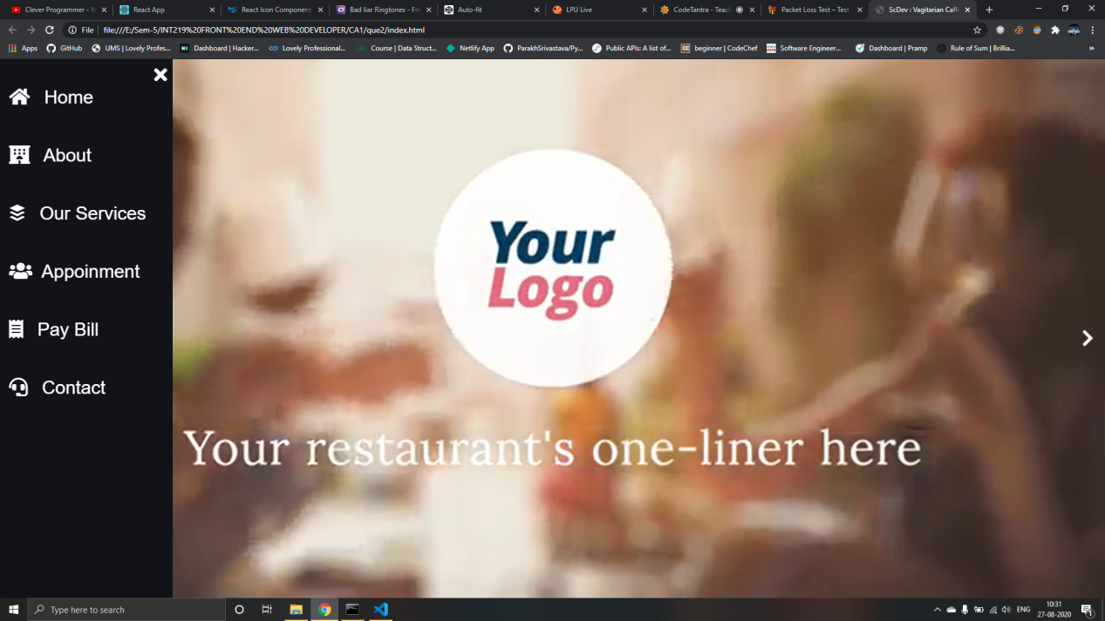



**CODE :**

**Index.html**

<!DOCTYPE html>

<html lang="en">

<head>

<meta charset="UTF-8">

<link rel="shortcut icon" href="favicon.ico" type="image/x-icon">

<meta name="viewport" content="width=device-width, initial-scale=1.0">

<meta http-equiv="X-UA-Compatible" content="ie=edge">

<title>ScDev : Vagitarian Caffe</title>

<link rel="stylesheet" href="https://cdnjs.cloudflare.com/ajax/libs/font-awesome/5.12.1/css/all.min.css">

<link rel="stylesheet" href="./style.css">

</head>

<body>

<i style="color: white;" class="menu-toggle-btn fas fa-bars"></i>

<header>

<nav class="navigation-menu">

<div class="exit"><i class="fas fa-times"></i></div>

<a href="#"><i class="fas fa-home home"></i> Home</a>

<a href="#"><i class="fas fa-hotel"></i> About</a>

<a href="#"><i class="fab fa-buffer works"></i> Our Services</a>

<a href="#"><i class="fas fa-users team"></i>Appoinment</a>

<a href="#"><i class="fas fa-receipt"></i> Pay Bill</a>

<a href="#"><i class="fas fa-headset contact"></i> Contact</a>

</nav>

</header>

<div class="logo-outer">

<a href="#" class="logo"><img src="https://bcassetcdn.com/public/blog/wp-content/uploads/2019/07/18094833/the-red-cafe.png" alt="Logo"></a>

</div>

<video autoplay muted loop id="myVideo">

<source src="https://media-cdn.tripadvisor.com/media/video-v/13/f9/30/98/hotel-sweet-dream-restaurant_360.mp4" type="video/mp4" class="video">

</video>

<div class="home__text">

<h1>Welcome To Our Hotel</h1>

</div>

<div class="btn">

<i class="fas fa-chevron-right"></i>

</div>

<script>

const menuBtn = document.querySelector('.fa-bars');

const navMenu = document.querySelector('.navigation-menu');

const exit = document.querySelector('.exit');

menuBtn.addEventListener('click',()=>{

navMenu.classList.toggle('active');

})

exit.addEventListener('click',()=>{

navMenu.classList.toggle('active');

});

//Play next video

const nextVid = document.querySelector('.btn');

const srcs = [

'https://media-cdn.tripadvisor.com/media/video-v/13/f9/30/98/hotel-sweet-dream-restaurant_360.mp4','https://ak.picdn.net/shutterstock/videos/1052825195/preview/stock-footage-food-delivery-in-the-restaurant-the-chef-prepares-food-in-the-restaurant-and-packs-it-panna-cotta.mp4'

]

let i = 0;

document.querySelector('#myVideo').src=srcs[i];

nextVid.addEventListener('click',()=>{

i++;

if(i>=srcs.length){

i=0;

}

console.log(srcs[i]);

document.querySelector('#myVideo').src = srcs[i];

})

</script>

</body>

</html>

style.css

*{

margin: 0;

padding: 0;

box-sizing: border-box;

font-family: "Open Sans",sans-serif;

}

body{

background-image: url('./img/background.jpg') ;

background-repeat: no-repeat;

background-size:cover ;

display: flex;

}

a{

text-decoration: none;

}

.logo-outer{

height: 70px;

margin: 1rem 2rem;

position: relative;

}

.logo-outer img{

object-fit: contain;

height: 60px;

}

.menu-toggle-btn{

margin: 1rem;

cursor: pointer;

font-size: 3em;

}

.navigation-menu{

position: absolute;

left:-300px;

/* top: 70px; */

width:300px;

display: flex;

min-height: 100vh;

flex-direction:column;

transition: all 0.5s ease-in-out;

z-index: 10;

}

.exit{

font-size: 2rem;

position: absolute;

right: 10px;

top: 10px;

cursor: pointer;

}

.navigation-menu a{

width:100%;

display: block;

/* margin-left: 1rem; */

font-size: 2em;

padding: 1rem 1rem;

margin-top: 2rem;

color: white;

text-transform: capitalize;

}

.navigation-menu a:hover{

color: teal;

}

.navigation-menu a i{

margin-right: 1rem;

}

.active{

left: 0;

display: block;

background-color: #111319;

color: white;

}

#myVideo {

position: fixed;

right: 0;

bottom: 0;

min-width: 100%;

min-height: 100%;

z-index: -1;

object-fit: contain;

}

.btn{

position: absolute;

top: 50%;

right: 20px;

height: 40px;

cursor: pointer;

z-index: 10;

}

.btn i{

font-size: 4em;

color: white;

}

.home__text{

position: relative;

top: 200px;

opacity: 0;

color: #FFF;

font-size: 2em;

animation: fadeIn 3s ease-in-out initial;

transition: opacity 3s ease;

transition-delay: 1s;

}

@keyframes fadeIn{

0%{

opacity: 0.2;

}

20%{

opacity: 0.4;

}

35%{

opacity: 0.6;

}

50%{

opacity: 0.8;

}

75%{

opacity: 0.9;

}

100%{

opacity: 1;

}

}

That was Que 2

**Que : 3** When the user hovers the cursor over the image, a function is triggered that enlarges the size of the image

Specifications :

* This is a simple webpage where there is an image , when you hover over it, It will increases it’s size smoothly.

Screen shots :

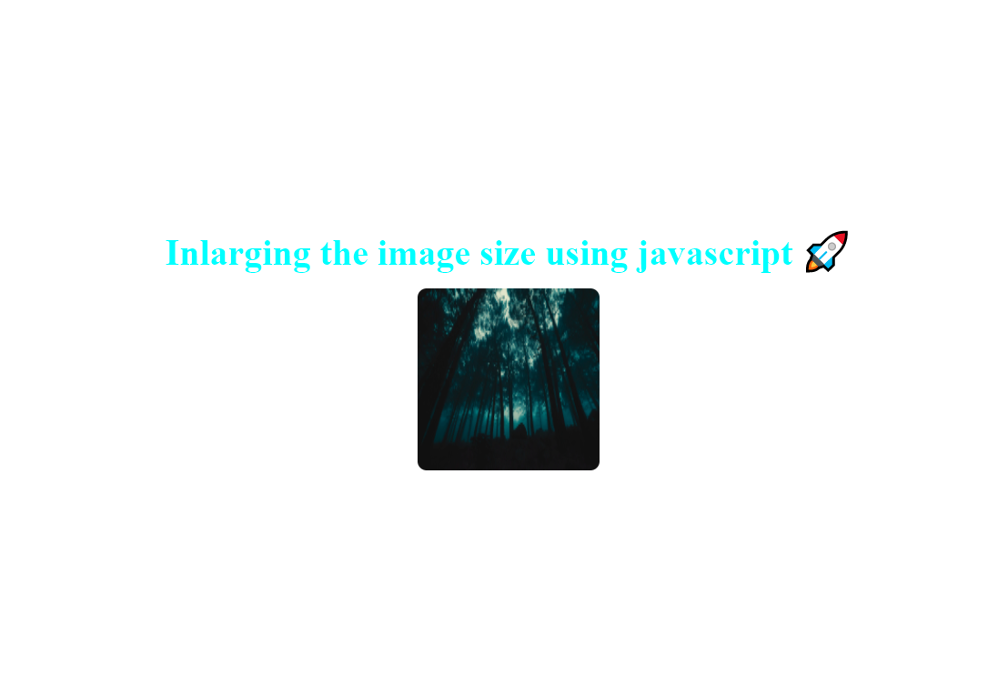

When we hover

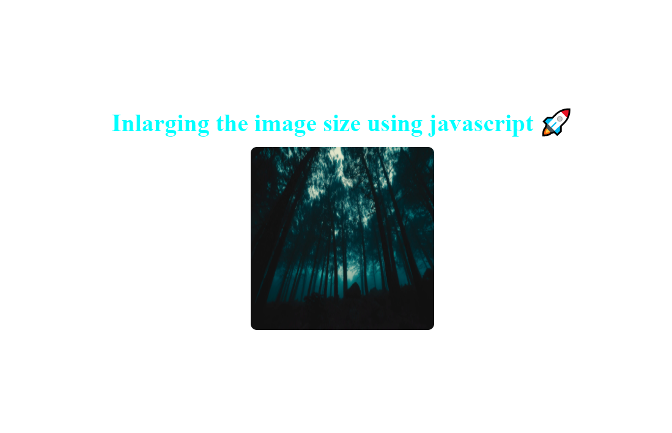

index.html & style.css

<html>

<head>

<title>Question 3 : CA-1</title>

<style>

*{

padding: 0;

margin: 0;

box-sizing: border-box;

}

body{

min-width: 1000px;

display: flex;

justify-content: center;

align-items: center;

flex-direction: column;

min-height: 100vh;

}

h1{

font-size: 2.5em;

color: aqua;

margin: 1rem auto;

}

.container{

display: flex;

justify-content: center;

align-items: center;

flex-direction: column;

}

.img{

border-radius: 10px;

transition:all 0.4s ease-in-out;

}

</style>

</head>

<body>

<div class="container">

<h1>Inlarging the image size using javascript 🚀</h1>

<img class="img" src="https://images.unsplash.com/photo-1517190472963-bea8f5abdb3b?ixlib=rb-1.2.1&ixid=eyJhcHBfaWQiOjEyMDd9&auto=format&fit=crop&w=1350&q=80" height="200" width="200">

</div>

<script type="text/javascript" >

const image = document.querySelector('.img');

image.addEventListener('mouseover',function handleMouseOver(){

image.style.height="300px";

image.style.width="300px";

});

image.addEventListener('mouseout',function handleMouseOver(){

image.style.height="200px";

image.style.width="200px";

});

</script>

</body>

</html>