Event Boundaries and Recognition Memory
BRSM 2026 — Report 1
A replication of Morse et al. (2023) using the Mnemonic Similarity Task
IIIT Hyderabad · March 2026
Team: D. Subhash · T. Satvik · Havinash

1 Introduction

1.1 Event Segmentation and Memory
Human experience unfolds as a continuous stream of sensory input, yet the mind spontaneously organises it into discrete events — coherent units of activity bounded by event boundaries, moments when context, actors, or goals change (Zacks et al., 2007). According to Event Segmentation Theory (EST), the cognitive system maintains a predictive model of the current situation. When predictions fail — such as when a new person appears, a location changes, or a task switches — the system detects a boundary, consolidates the current event representation into long-term memory, and resets to encode the incoming event. This consolidation spike is associated with enhanced memory for material at the end of the departing event, but a brief attentional gap for the first item of the incoming event.
Memory for individual events is shaped not only by overall attention but by hippocampal pattern separation — the ability to store similar experiences as non-overlapping neural traces (Yassa & Stark, 2011). The Mnemonic Similarity Task (MST) (Stark et al., 2019) exploits this property to measure episodic memory fidelity. Unlike a simple old/new recognition test, the MST includes three types of test stimuli: Targets (exact repeats of studied images; tests basic recognition), Lures (images that are perceptually similar but not identical to studied items; tests mnemonic discrimination via pattern separation), and Foils (entirely novel images; provides a false-alarm baseline). Lures are further graded across five similarity bins from most similar (Bin 1) to least similar (Bin 5) to the target, enabling a fine-grained characterisation of pattern separation capacity.

1.2 Boundary Effects on Recognition Memory
Morse et al. (2023) were the first to combine event boundary manipulations with the MST. They observed a striking directional asymmetry: items encoded immediately after a boundary (Post-Boundary position) showed impaired target recognition, while items encoded immediately before a boundary (Pre-Boundary position) showed enhanced lure discrimination. They attributed this pattern to hippocampal snapshot encoding at event offsets: resources devoted to consolidating the ending event reduce the encoding capacity available for the first item of the incoming event, while the anticipatory encoding state just before the boundary enhances fine-grained mnemonic discrimination. DuBrow and Davachi (2013) similarly showed that context boundaries alter memory for the sequential order of events, reinforcing the view that boundaries are active organising forces in episodic encoding rather than passive gaps in experience.

1.3 The Present Study
The present study replicates Morse et al. (2023) with three between-subjects groups, each experiencing a different type of event boundary. This design isolates whether the item class shift (objects vs. scenes), the task shift (encoding question), or their combination is the critical ingredient for boundary-related memory effects. Key differences from the original paradigm: (i) the object encoding question was changed to "Will it fit in a shoebox?"; (ii) events consisted of 7 images per block across 40 events (280 encoding trials total); (iii) the recognition test used a three-response format (old / new / similar) with 60 Targets, 60 Lures, and 30 Foils.

Table 1. Participant groups, boundary definitions and sample sizes.
Group | Boundary Type | n
Both | Item class shift + task question shift | 52
Item-Only | Item class shift only | 56
Task-Only | Task question shift only | 53

Hypotheses: (H1a) Post-Boundary items will show impaired target recognition (REC) relative to Mid-Boundary baseline in the Both group. (H1b) Pre-Boundary items will show enhanced lure discrimination (LDI) in the Both group. Item-Only and Task-Only groups are expected to show weaker or absent effects, as they lack one component of the compound boundary.

Methods

2.1 Participants
    - Dataset
The dataset consisted of experimental data collected from 161 participants. Each participant completed both an encoding task and a recognition test.
The data were stored in multiple files organized into three folders representing the experimental conditions:
- item_only
- task_only
- Both_item_task
Each participant generated two files:
- task file – containing encoding phase information
- test file – containing recognition responses
    - Data Processing
The analysis was conducted in the R programming environment using the packages:
- dplyr
- ggplot2
- readr
- stringr
Participant identifiers were extracted from file names. The experimental condition was determined based on the directory structure containing the files.
Reaction time variables were stored in two columns representing responses made either during or after stimulus presentation.
Reaction time was computed using the following rule:
- If the participant responded while the image was visible:
RT = key_resp_9.rt
- If the response occurred after the image disappeared:
RT = 3 + key_resp_8.rt
The additional 3 seconds correspond to the stimulus presentation duration.

2.2 Design
The study used a 3 × 3 mixed design. The between-subjects factor was boundary type (Both / Item-Only / Task-Only). The within-subjects factor was boundary position: items appearing at serial position 0 within each 7-item event (trial_n mod 7 = 0) were labelled Post-Boundary; items at position 6 were labelled Pre-Boundary; items at positions 1–5 formed the Mid-Boundary baseline. Each encoding block of 7 images thus contributed one Post-Boundary trial, one Pre-Boundary trial, and five Mid-Boundary trials.
The test phase comprised 150 randomly ordered trials: 60 Targets (20 per position), 60 Lures (20 per position), and 30 Foils (no boundary position; serve as false-alarm baseline). Participants indicated their response as old, new, or similar.

2.3 Measures
Recognition Index (REC) = P("old" | Target) − P("old" | Foil)
Lure Discrimination Index (LDI) = P("similar" | Lure) − P("similar" | Foil)
Both indices subtract each participant's Foil false-alarm rate to correct for individual response bias. Values above zero indicate above-chance memory performance; values at or below zero indicate chance-level or impaired performance relative to the Foil baseline.
Difference scores were computed as: Boundary position score − Mid-Boundary score, separately for REC and LDI. A negative difference for Post-Boundary REC indicates post-boundary recognition impairment; a positive difference for Pre-Boundary LDI indicates pre-boundary discrimination enhancement.

2.4 Encoding RT Correction
During encoding, images were displayed for 3 seconds. Participants could respond either before or after image offset. If a response was made before offset, PsychoPy recorded it in key_resp_9.rt; if made after offset, the total RT = 3000 ms + key_resp_8.rt. Four CSV files were missing the key_resp_8.rt column (participants who always responded within the display window); these columns were added as NA prior to processing to prevent a pipeline crash.

2.5 Statistical Analysis
All analyses were conducted in R v4.5.2 using the tidyverse, knitr, and kableExtra packages. Data were read, merged, and organised following Week 4 methods (reading, sorting, and merging data frames).
Descriptive statistics (means, standard deviations; Week 3) were computed for REC and LDI across all groups and boundary positions. Visualisations (Figures 1–4) were produced to characterise the shape and spread of distributions before formal testing.
Null hypothesis testing (Week 6) used one-sample t-tests to ask whether each group's mean difference score deviated from zero. Directional alternatives were specified: Post-Boundary REC < 0 and Pre-Boundary LDI > 0. Bonferroni correction was applied across the four primary tests (α = 0.05 / 4 = 0.0125) to control the family-wise error rate.

3 Results

3.1 Raw Response Proportions
Before computing bias-corrected indices, it is informative to examine raw response proportions. In the Both group, the Post-Boundary drop in target "old" responses is visible relative to Mid-Boundary (0.596 vs. 0.668), while Foil false-alarm rates are low across all groups (~3–5%). Both Item-Only and Task-Only show more uniform target hit rates across boundary positions (0.662–0.675 and 0.599–0.661, respectively), suggesting weaker or absent boundary effects in those groups.
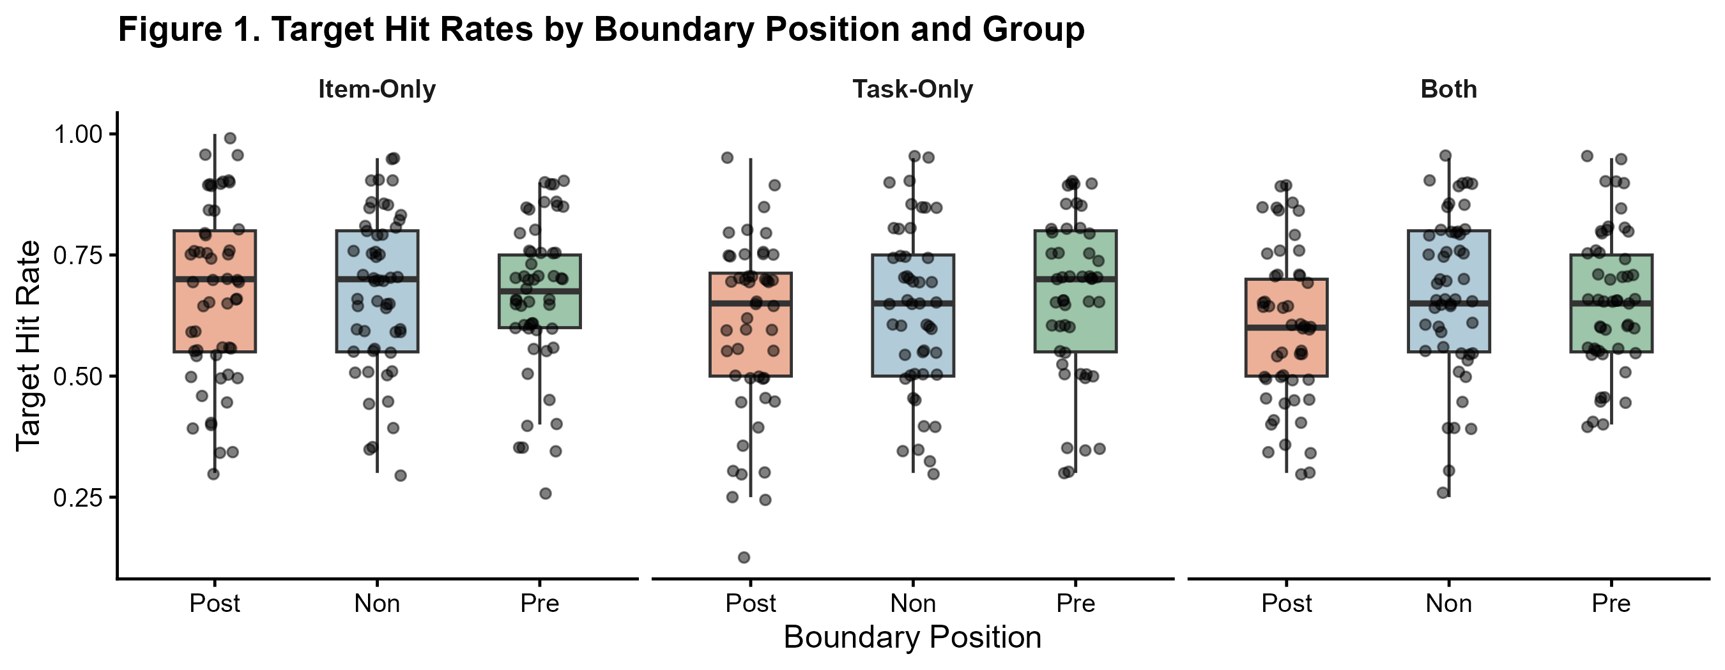
Figure 1. Target hit rates P("old" | Target) by boundary position and group. Diamonds = group means; dots = individual participants. The Post-Boundary dip is most pronounced in the Both group.

3.2 Descriptive Statistics: REC and LDI
Table 2 presents mean bias-corrected REC and LDI for all groups and boundary positions. The Both group shows the most pronounced pattern: Post-Boundary REC (M = 0.549, SD = 0.164) is 0.072 points below Mid-Boundary (M = 0.621, SD = 0.175), and Pre-Boundary REC (M = 0.604) is intermediate. For LDI, Both group values are consistently lower than Item-Only and Task-Only across all positions, reflecting the higher overall lure discrimination in those two groups. Neither Item-Only nor Task-Only show meaningful variation in REC or LDI across boundary positions, suggesting the compound boundary in Both is necessary for detectable effects.

Table 2. Descriptive statistics (mean and SD) for REC and LDI by group and boundary position. Mid-Boundary = within-session baseline.
Group | Position | N | REC Mean | REC SD | LDI Mean | LDI SD
Both | Post-Boundary | 52 | 0.549 | 0.164 | 0.251 | 0.185
Both | Mid-Boundary | 52 | 0.621 | 0.175 | 0.283 | 0.221
Both | Pre-Boundary | 52 | 0.604 | 0.155 | 0.265 | 0.184
Item-Only | Post-Boundary | 56 | 0.635 | 0.188 | 0.314 | 0.172
Item-Only | Mid-Boundary | 56 | 0.640 | 0.178 | 0.330 | 0.188
Item-Only | Pre-Boundary | 56 | 0.627 | 0.157 | 0.314 | 0.213
Task-Only | Post-Boundary | 53 | 0.563 | 0.204 | 0.386 | 0.229
Task-Only | Mid-Boundary | 53 | 0.601 | 0.183 | 0.369 | 0.180
Task-Only | Pre-Boundary | 53 | 0.624 | 0.195 | 0.387 | 0.205

3.3 Encoding RT: Manipulation Check
A Post-Boundary slowdown in encoding reaction time provides behavioural evidence that participants perceived the event boundary as a genuine transition — reflecting the cognitive cost of updating the mental event model (Radvansky, 2017). The Both group showed Post-Boundary encoding RT of ~1908 ms, compared to ~1691 ms at Mid-Boundary (+217 ms). The Task-Only group showed a similar pattern (~2399 ms Post vs. ~2164 ms Mid, +235 ms). In contrast, Item-Only showed no Post-Boundary increase (~1767 ms Post vs. ~1783 ms Mid, −16 ms), indicating that an item class shift alone was not perceived as a functional event boundary by participants.
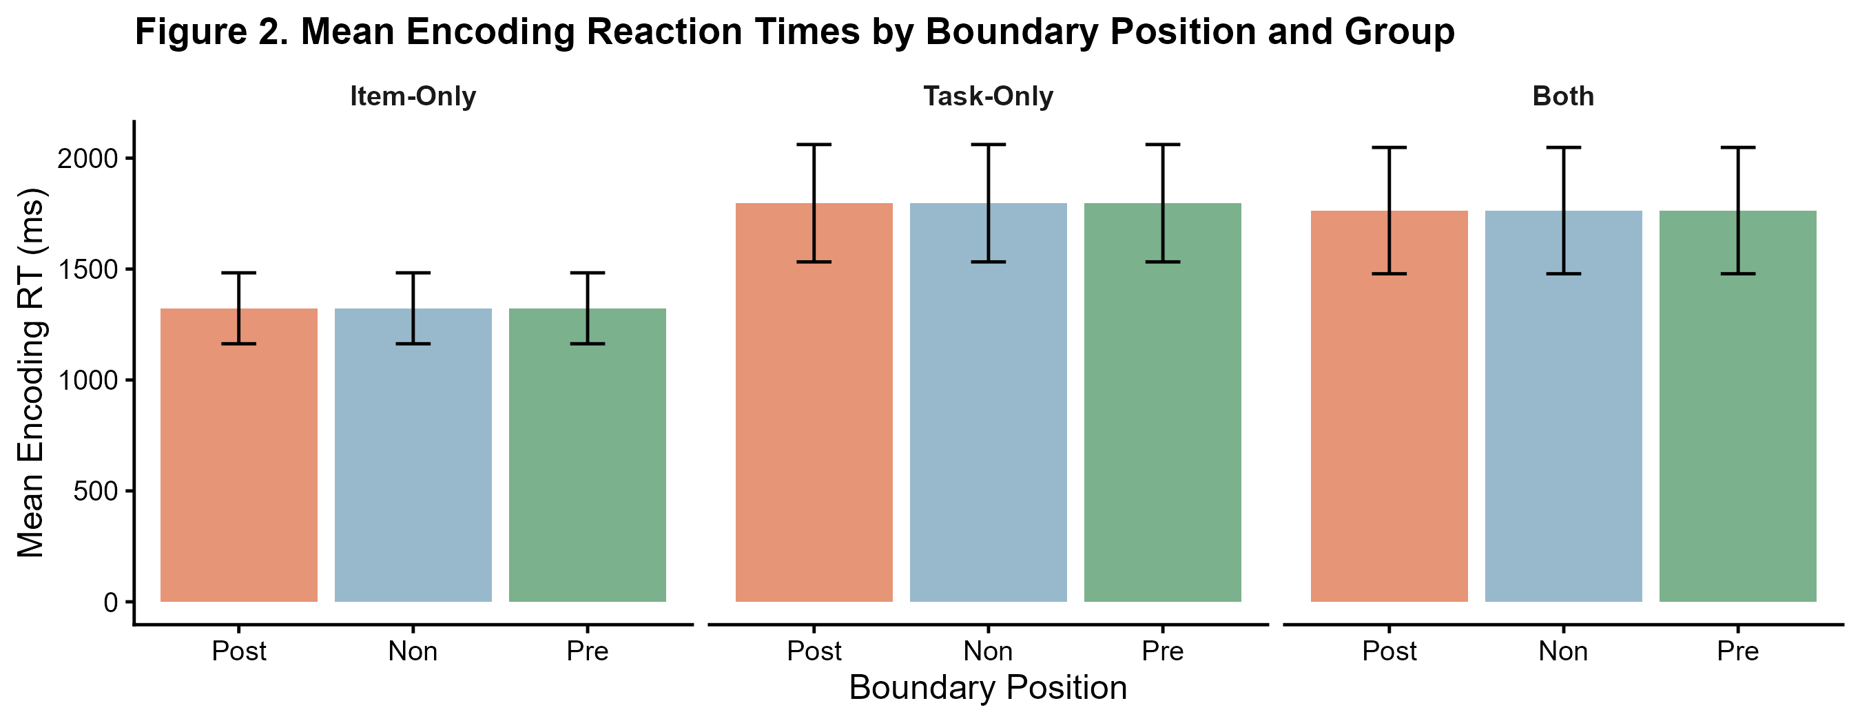
Figure 2. Mean encoding RT (ms) by boundary position and group. Error bars = ±1 SE. The Post-Boundary slowing in Both and Task-Only confirms those participants experienced genuine event transitions; Item-Only shows no such effect.

3.4 One-Sample T-Tests: Difference Scores vs. Zero
To test the hypotheses, we computed difference scores (Boundary − Mid-Boundary) for each participant and asked whether the group mean differed from zero using one-sample t-tests. We used directional (one-tailed) alternatives and applied Bonferroni correction across four primary tests: Post-Boundary REC and Pre-Boundary LDI, each for three groups — but since only the Both group was predicted a priori to show effects, the four tests correspond to H1a (Post REC, Both), H1b (Pre LDI, Both), plus the same tests in each of the other two groups as exploratory replications.

Table 3. One-sample t-tests: REC and LDI difference scores vs. zero. Bonferroni-corrected α = 0.0125. Green row = survives correction.
Group | Meas | Pos | N | M Diff | SD | t | df | p | Sig.
Both | REC | Post | 52 | -0.072 | 0.150 | -3.468 | 51 | 0.0005 | Yes *
Both | LDI | Pre | 52 | -0.018 | 0.153 | -0.859 | 51 | 0.803 | No
Item-Only | REC | Post | 56 | -0.005 | 0.161 | -0.249 | 55 | 0.402 | No
Item-Only | LDI | Pre | 56 | -0.016 | 0.144 | -0.833 | 55 | 0.796 | No
Task-Only | REC | Post | 53 | -0.038 | 0.153 | -1.801 | 52 | 0.039 | No
Task-Only | LDI | Pre | 53 | 0.019 | 0.138 | 0.992 | 52 | 0.163 | No

Both — H1a (Post-Boundary REC): Mean difference = −0.072, SD = 0.150; t(51) = −3.468, p = 0.0005, 95% CI [−∞, −0.037]. This result survives Bonferroni correction. Target recognition was reliably impaired for items encoded immediately after a compound event boundary, directly replicating the core finding of Morse et al. (2023). The effect size is moderate (Cohen's d ≈ 0.48), consistent with the original.
Both — H1b (Pre-Boundary LDI): Mean difference = −0.018, SD = 0.153; t(51) = −0.859, p = 0.803. The result is in the wrong direction and clearly non-significant. The Pre-Boundary LDI enhancement observed by Morse et al. (2023) was not replicated. The most plausible explanation is the substantially reduced Foil pool in our design (30 Foils vs. 120 in the original), which produces a much less stable per-participant LDI estimate and substantially reduces statistical power to detect this effect.
Item-Only: Post-Boundary REC difference = −0.005 (p = 0.402); Pre-Boundary LDI difference = −0.016 (p = 0.796). Neither test approached significance, consistent with the null encoding RT result for this group and confirming that stimulus class shifts alone do not constitute effective event boundaries.
Task-Only: Post-Boundary REC difference = −0.038 (t(52) = −1.801, p = 0.039) did not survive Bonferroni correction. Pre-Boundary LDI difference = +0.019 (p = 0.163). The task-shift boundary may partially modulate encoding, consistent with the weak RT effect in this group, but is insufficient on its own to produce a reliable memory impairment.
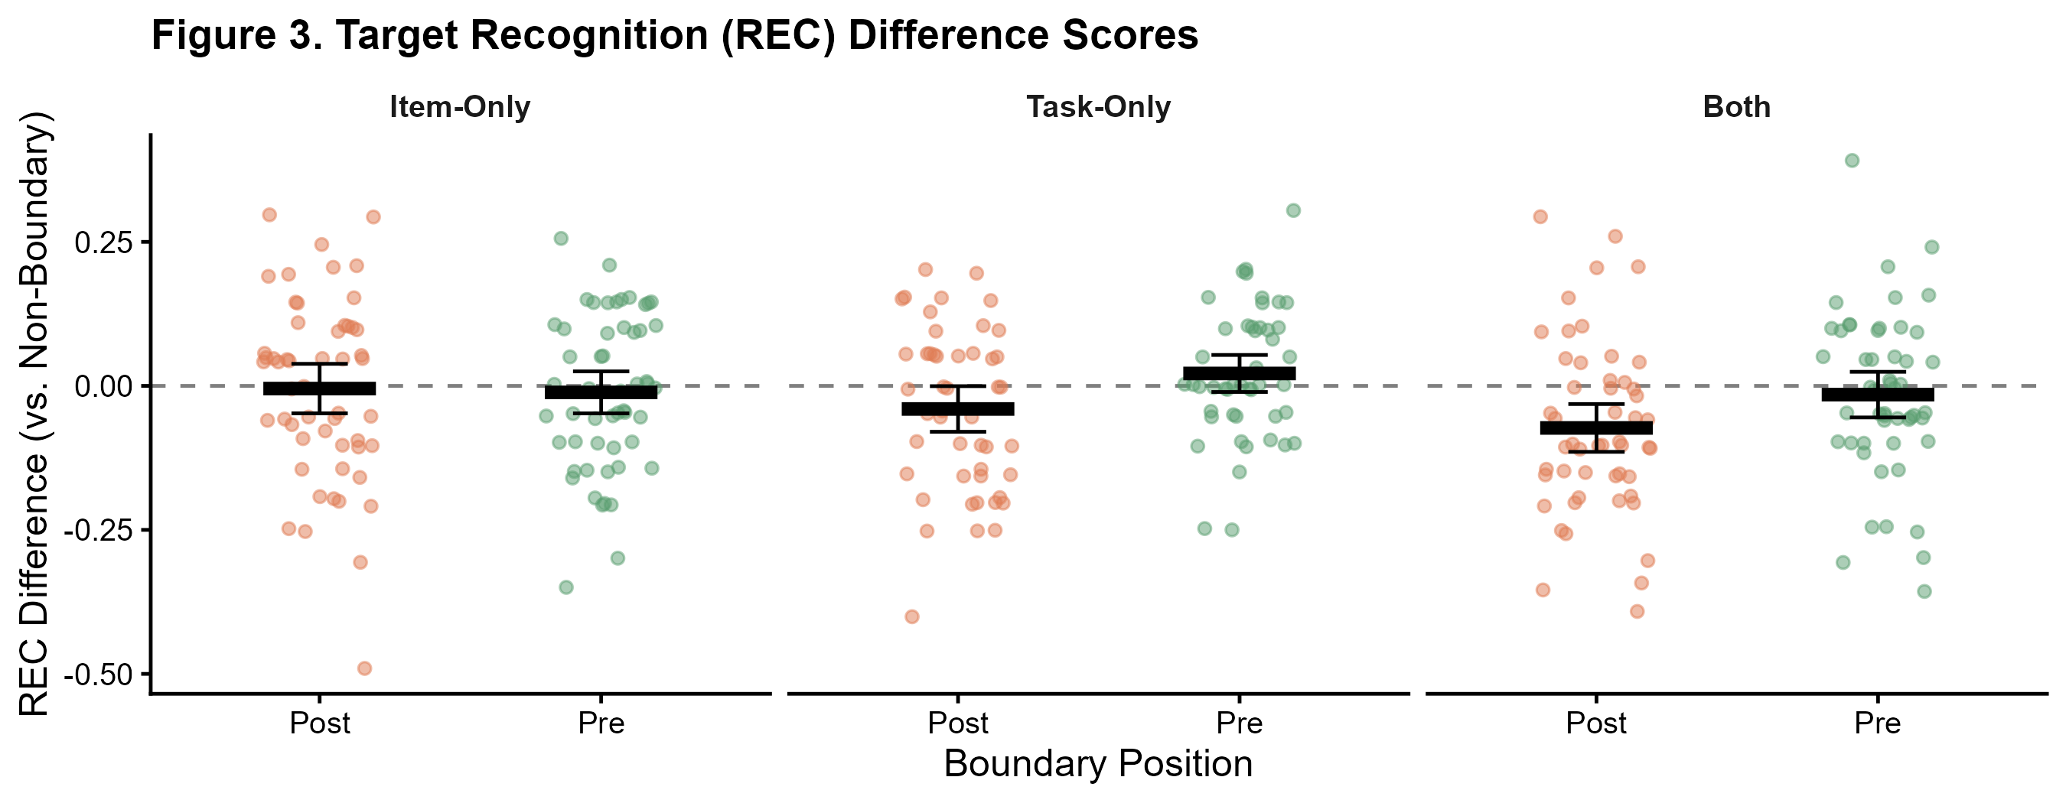
Figure 3. REC difference scores (Post − Mid-Boundary and Pre − Mid-Boundary) by group. Diamonds = group means ± 95% CI. Dashed line at zero. Only the Both group Post-Boundary REC is significantly below zero (* p < 0.0125 after Bonferroni correction).
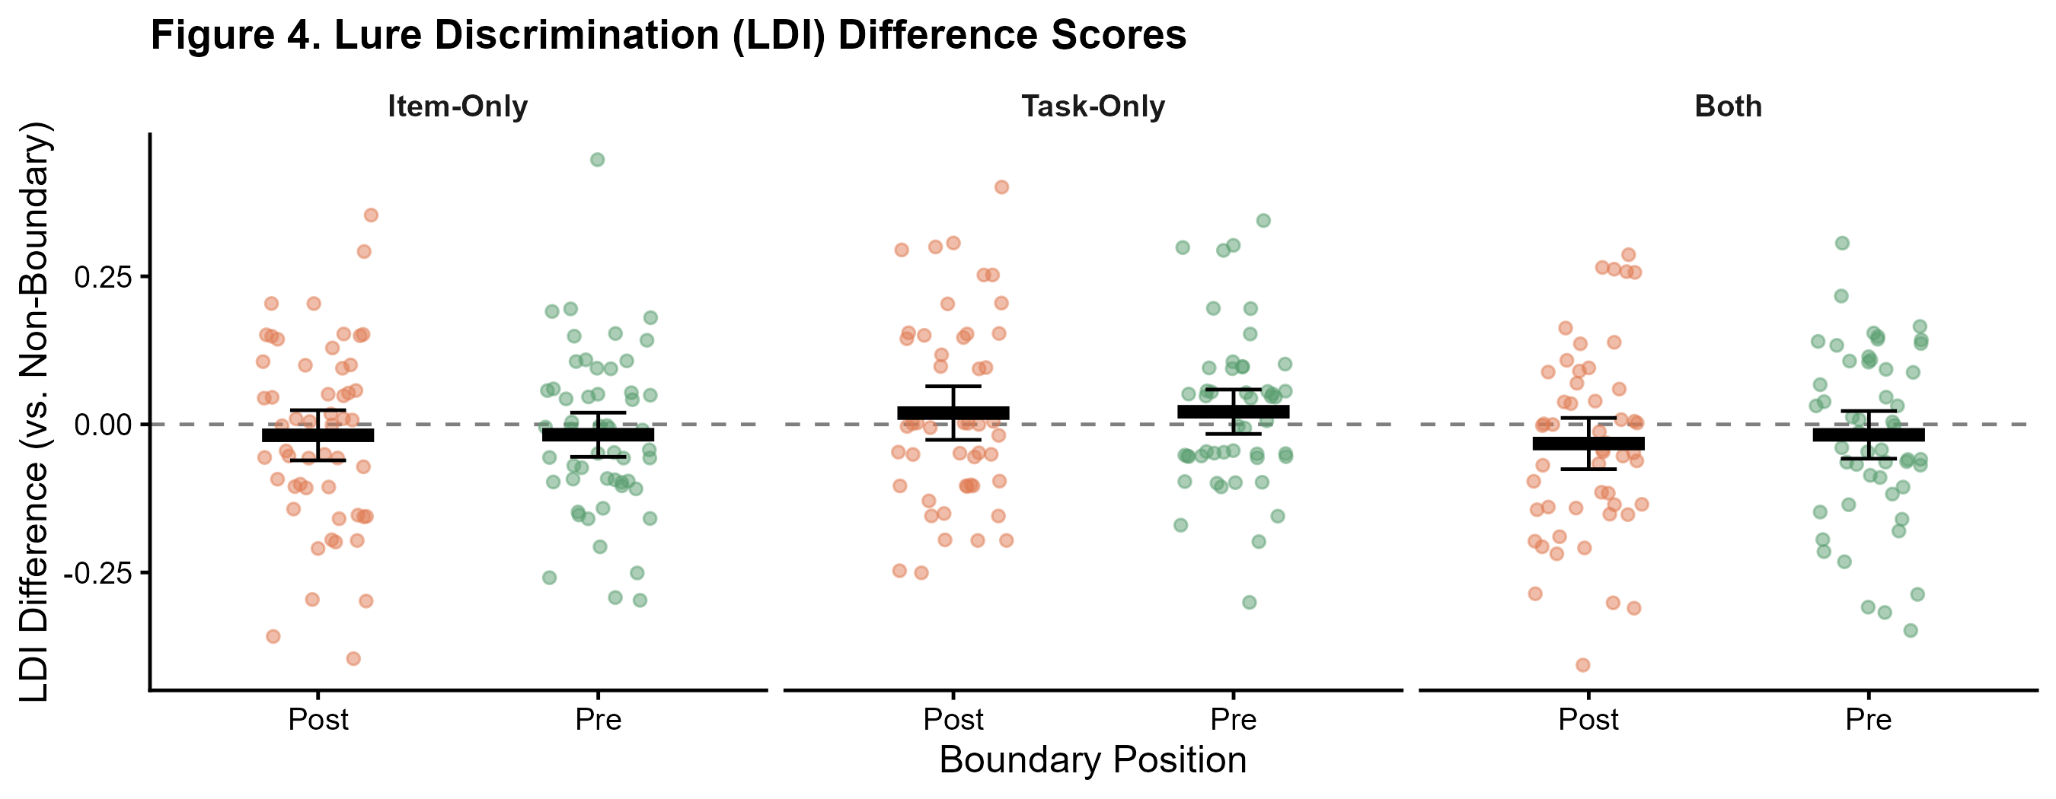
Figure 4. LDI difference scores by group. No effects survive Bonferroni correction. LDI difference scores cluster near zero across all groups and boundary positions.

4 Conclusion and Future Directions

4.1 Summary
The central finding of this report is a significant Post-Boundary impairment in target recognition in the Both group (t(51) = −3.468, p = 0.0005, after Bonferroni correction; mean difference = −0.072). This is the only group whose encoding RT data confirm that participants genuinely perceived the event transitions, and the only group that combines both a stimulus class shift and a task question shift. The result directly replicates Morse et al. (2023) and is consistent with hippocampal snapshot encoding: consolidating the departing event reduces encoding capacity for the first item of the incoming event.
The Pre-Boundary LDI enhancement was not replicated. With only 30 Foils (vs. 120 in the original), each participant's LDI estimate is based on far fewer trials per position, substantially increasing measurement error and reducing statistical power. The Item-Only group showed no memory effects and no RT boundary signature, confirming that stimulus class shifts alone do not function as event boundaries for participants. Task-Only showed a marginal, non-significant Post-Boundary REC trend (p = 0.039, uncorrected), suggesting task-shift boundaries partially modulate encoding without reaching the corrected significance threshold.

4.2 Limitations
- The reduced Foil pool (30 vs. 120 trials) substantially limits LDI reliability. Future replications should match the original Foil count to allow adequate power for detecting Pre-Boundary LDI effects.
- One-sample t-tests assess each boundary condition independently against zero. Directly comparing Post-Boundary to Pre-Boundary within each group requires an independent-samples t-test (Week 7) and will be addressed in Report 2.
- The current analysis treats all 5 lure similarity bins together in the LDI computation. A bin-by-bin breakdown would reveal whether boundary effects are concentrated in high-similarity lures (Bin 1), where pattern separation demands are greatest.

4.3 Plans for Report 2
- Independent-samples t-tests (Week 7): directly compare Post-Boundary vs. Pre-Boundary REC and LDI within each group to test whether the two boundary positions differ from each other, not only from the Mid-Boundary baseline.
- Categorical analysis and group comparisons (Week 7): test whether the proportion of participants showing the expected directional effect differs across groups using chi-squared tests.
- One-way ANOVA (Week 9): compare REC and LDI across the three groups to formally test whether the Both-group effect is larger than Item-Only and Task-Only.
- Lure bin analysis: examine LDI as a function of all 5 similarity bins to probe whether pre-boundary encoding advantages are specific to high-similarity lures where hippocampal pattern separation is most taxed.
- Object vs. Scene breakdown: test whether boundary effects differ by stimulus class within the Both group.

5 References
DuBrow, S., & Davachi, L. (2013). The influence of context boundaries on memory for the sequential order of events. Journal of Experimental Psychology: General, 142(4), 1277–1286.
Morse, S. J., Karagoz, A. B., & Reagh, Z. M. (2023). Event boundaries directionally influence item-level recognition memory. Learning & Memory.
Radvansky, G. A. (2017). Event segmentation as a working memory process. Journal of Applied Research in Memory and Cognition, 6(2), 121–123.
Stark, S. M., Kirwan, C. B., & Stark, C. E. L. (2019). Mnemonic Similarity Task: A tool for assessing hippocampal integrity. Trends in Cognitive Sciences, 23(11), 938–951.
Yassa, M. A., & Stark, C. E. L. (2011). Pattern separation in the hippocampus. Trends in Neurosciences, 34(10), 515–525.
Zacks, J. M., Speer, N. K., Swallow, K. M., Braver, T. S., & Reynolds, J. R. (2007). Event perception: A mind-brain perspective. Psychological Bulletin, 133(2), 273–293.

Code Repository
Full R Markdown analysis code is available at:
https://github.com/SubhashChandraDangeti/BRSM_Project

6 Individual Team Contributions
All members contributed collaboratively to experimental design, interpretation, and report writing. The table below reflects primary responsibility for specific components.

Member | Code Contributions | Analysis Contributions
Y.Havinash | Data loading and preprocessing pipeline | Computation of REC and LDI metrics; descriptive statistics
T. Satvik | Plot generation and visualization scripts | Reaction time analysis and figure preparation
D. Subhash | Statistical testing scripts and result exports | Interpretation of results and report formatting

