Microservices with API Gateway
Step 1: Create Eureka Discovery Server
Created a Spring Boot application for Eureka Discovery Server and configured it to run on port 8761. The Eureka Server is used for service registration and discovery.
Added the @EnableEurekaServer annotation in the main application class and started the application successfully.
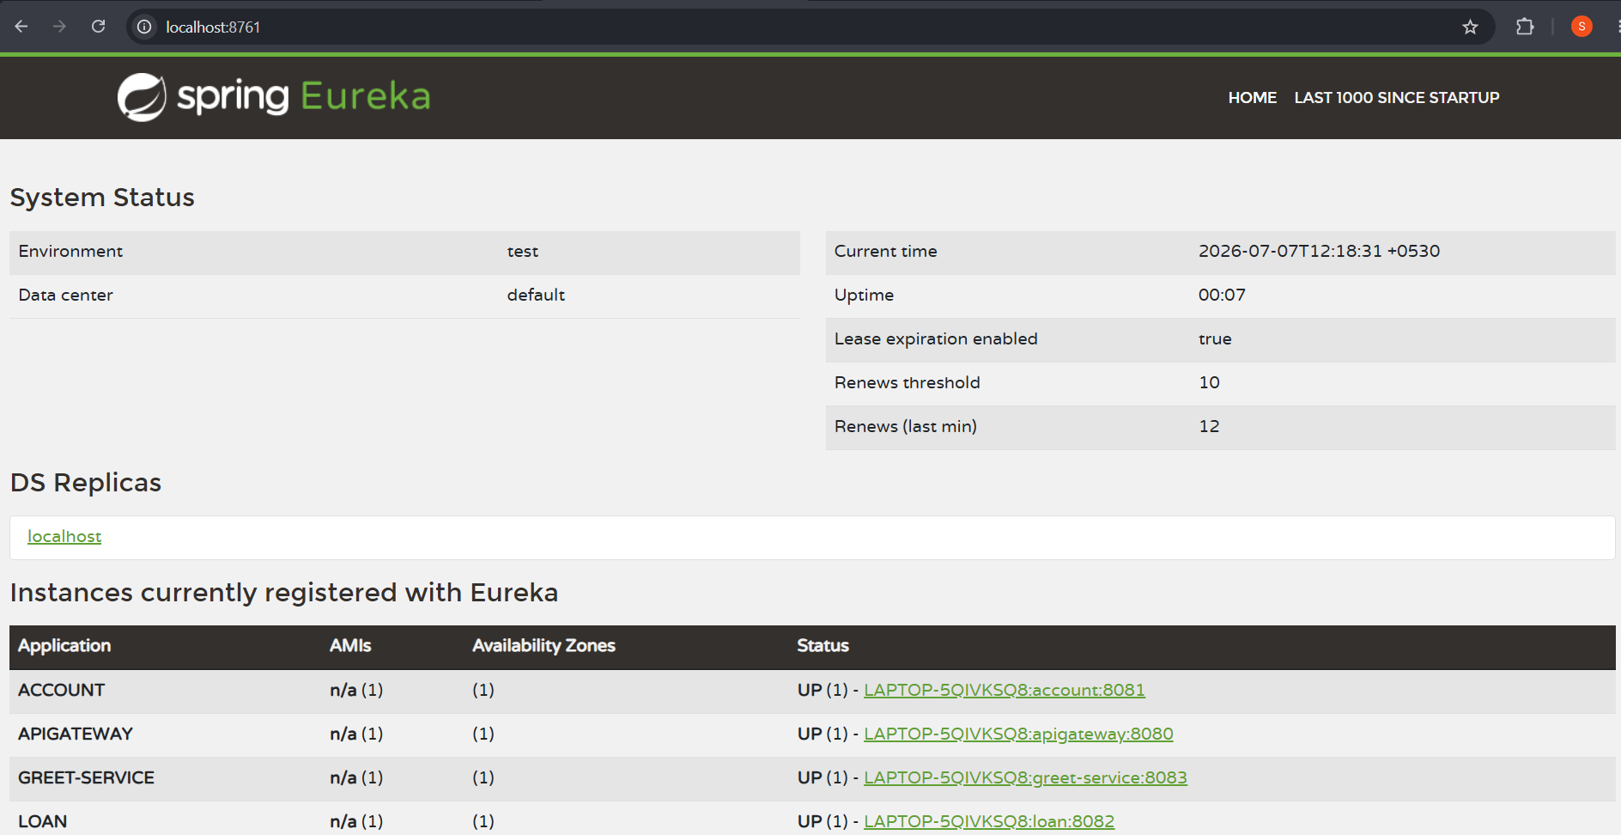
Step 2: Verify Eureka Discovery Server
Opened the Eureka Dashboard in the browser using port 8761 to verify that the Eureka Discovery Server was running successfully..

Step 3: Configure Account Microservice
Added the Eureka Client dependency to the Account Microservice and configured the application to register with the Eureka Discovery Server.
The Account Microservice runs on port 8081.

Step 4: Configure Loan Microservice
Added the Eureka Client dependency to the Loan Microservice and configured the application to register with the Eureka Discovery Server.
The Loan Microservice runs on port 8082.
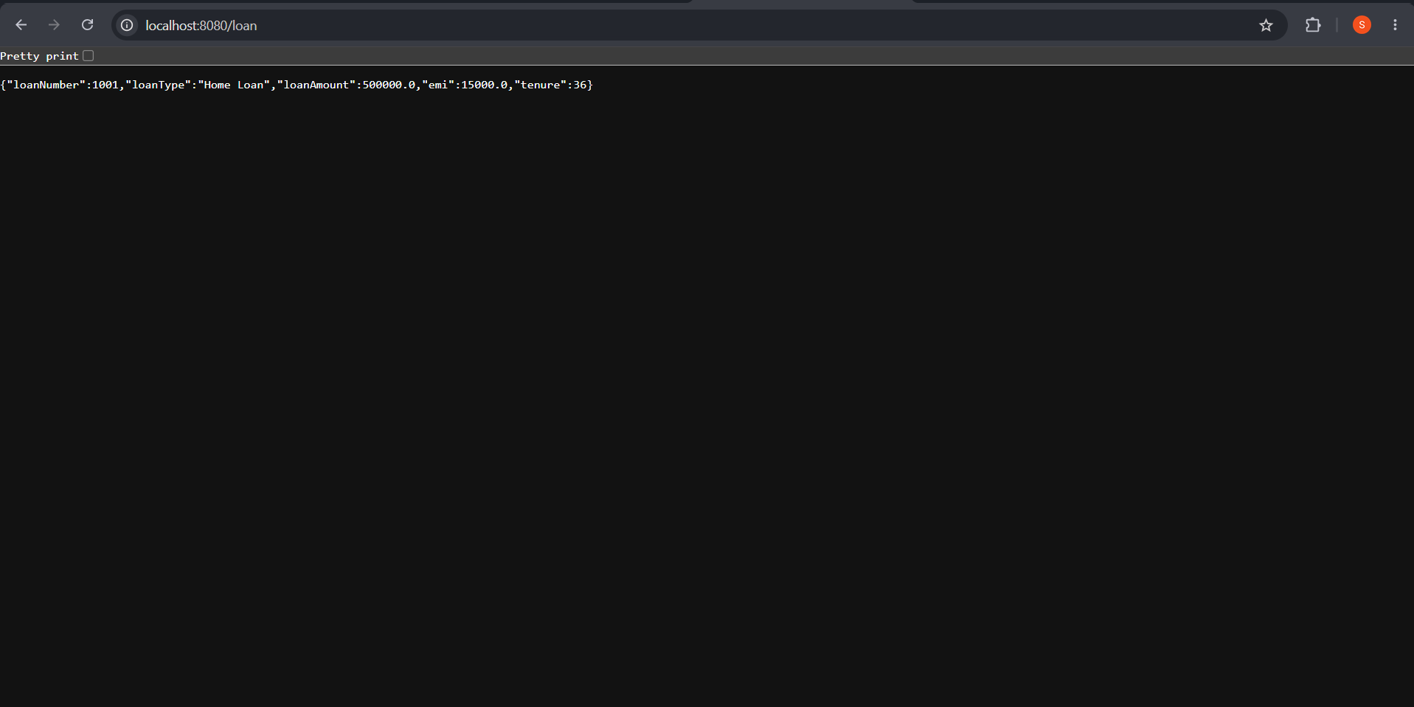
Step 5: Create Greet Service
Created a new Spring Boot microservice named greet-service.
A REST endpoint /greet was created to return the following response:
Hello from Greet Service
The Greet Service was configured to run on port 8083 and register with the Eureka Discovery Server.
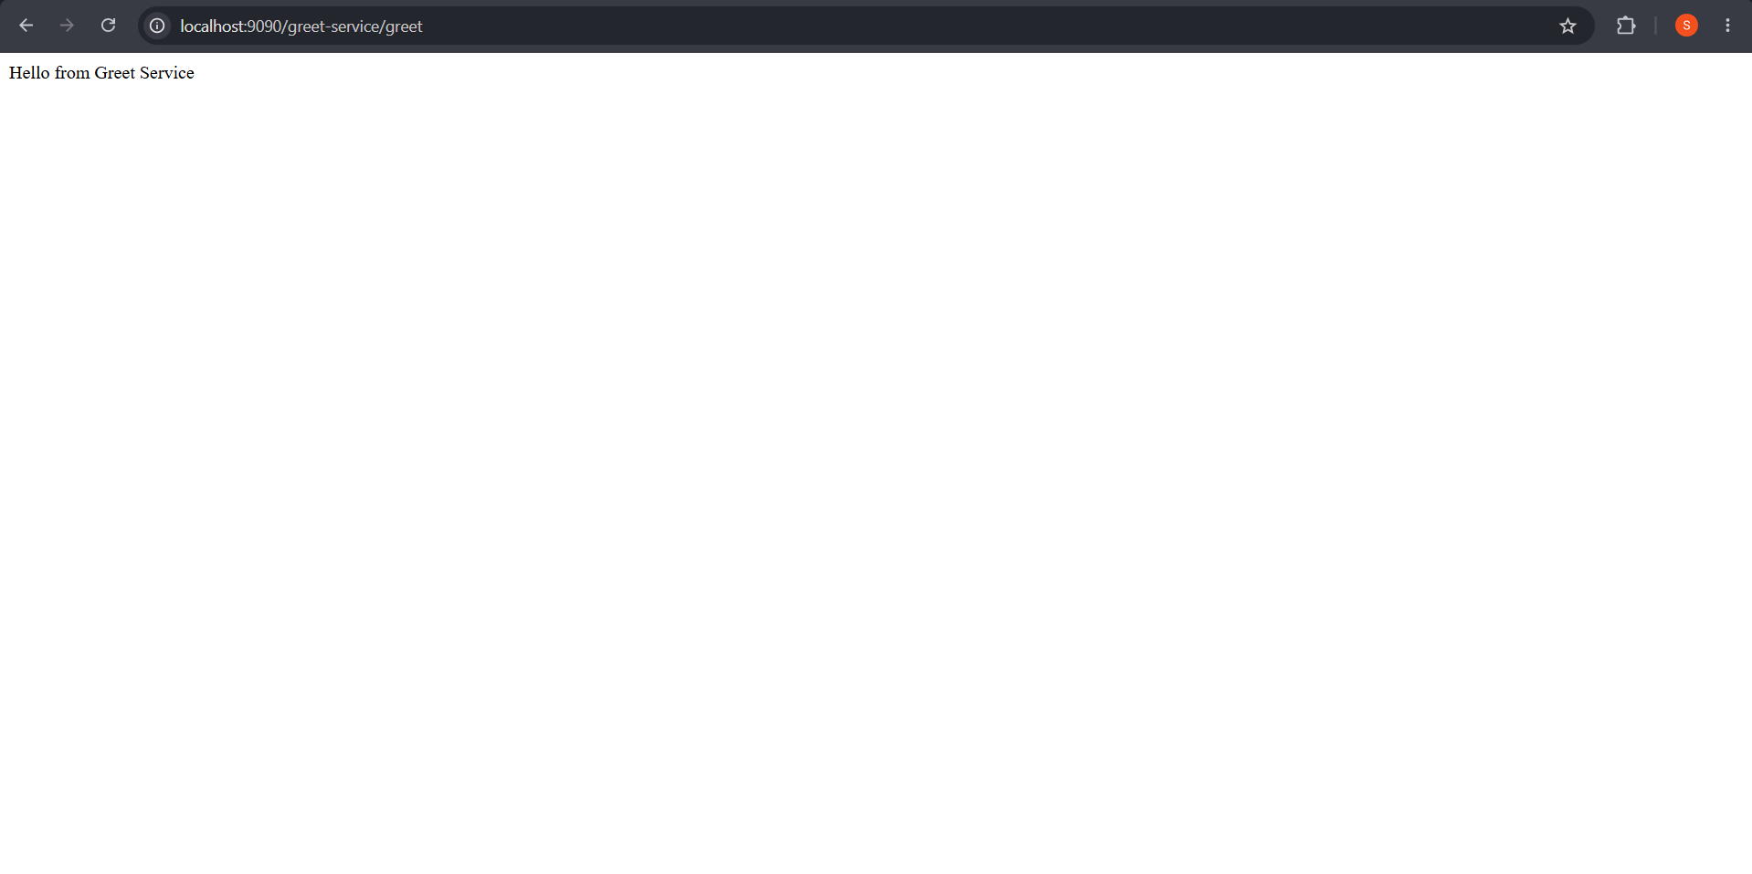
Step 6: Verify Service Registration in Eureka
Opened the Eureka Dashboard and verified that the required microservices were successfully registered with the Eureka Discovery Server with the status UP.

Step 7: Create API Gateway
Created a Spring Boot application named apigateway and added the required Spring Cloud Gateway and Eureka Client dependencies.
The API Gateway was configured to run on port 9090.

Step 8: Register API Gateway with Eureka
Configured the API Gateway as a Eureka Client and successfully registered it with the Eureka Discovery Server.
The Eureka Dashboard was used to verify that both API-GATEWAY and GREET-SERVICE were running with the status UP.

Step 9: Configure API Gateway Routing
Configured the API Gateway to route incoming requests to the Greet Service using Eureka Service Discovery and Load Balancing.
The following Gateway URL was used:
localhost:9090/greet-service/greet
The request was successfully routed to the Greet Service.
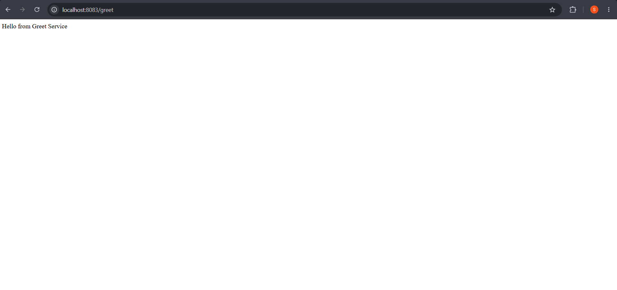
Step 10: Create Log Filter
Created a LogFilter class inside the API Gateway application.
The Log Filter was implemented to intercept incoming HTTP requests and log the request path in the API Gateway console.
The request path was logged as:
Request Path: /greet-service/greet

Step 11: Verify the Final Output
Accessed the Greet Service through the API Gateway using:
localhost:9090/greet-service/greet
The API Gateway successfully routed the request to the Greet Service and returned:
Hello from Greet Service
The Log Filter also successfully logged the incoming request path in the console.



