Git HOL1
Step 1: Initialize Git Repository
Command:
git init
Screenshot:
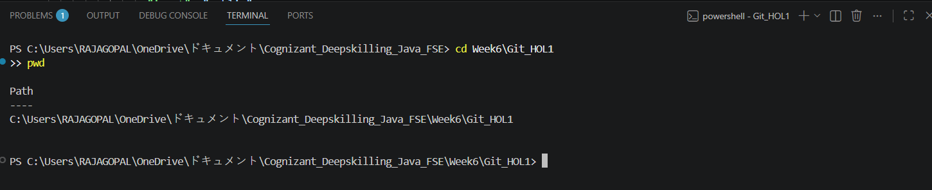
Step 2: Check Git Status
Command:
git status
Screenshot:
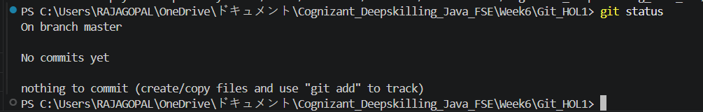
Step 3: Create README File
Command:
echo "# Git HOL1" > README.md
Screenshot:

Step 4: Check Git Status
Command:
git status
Screenshot:
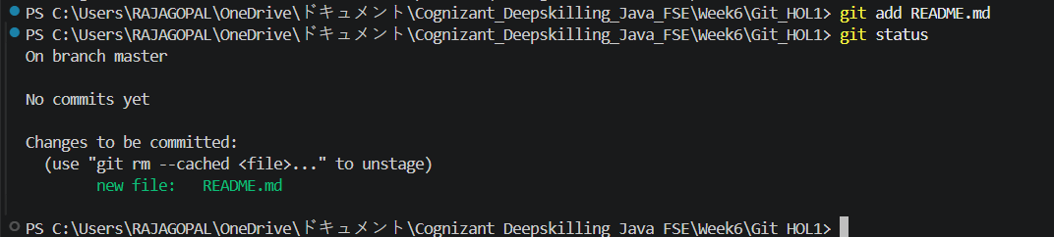
Step 5: Add File to Staging Area
Command:
git add README.md
git status
Screenshot:
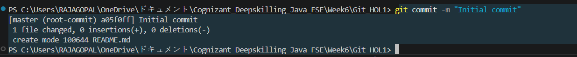
Step 6: Commit Changes
Command:
git commit -m "Initial commit"
Step 7: View Commit History
Command:
git log --oneline

