HOL5 Word Document
Step 1: Initialize the Git Repository
Commands:
git init
echo "# Git HOL5" > README.md
git add README.md
git commit -m "Initial commit"

Step 2: Verify the Repository Status
Command:
git status

Step 3: Verify the Remote Repository
Command:
git remote -v
Result
The Git repository was initialized successfully and verified to be in a clean state.
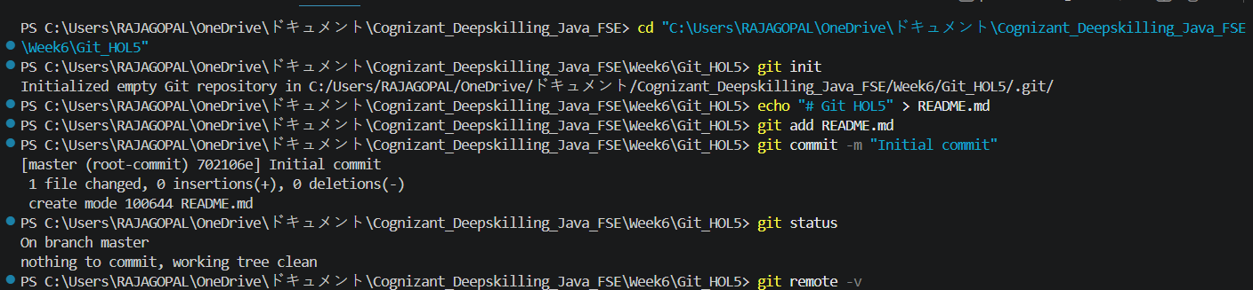

Result
The Git repository was initialized successfully and verified to be in a clean state.

