Exercise 1 – ReactJS HOL
Step 1: Created React application myfirstreact.
Step 2: Modified App.js to display the first React message.
Step 3: Executed the application using npm start.
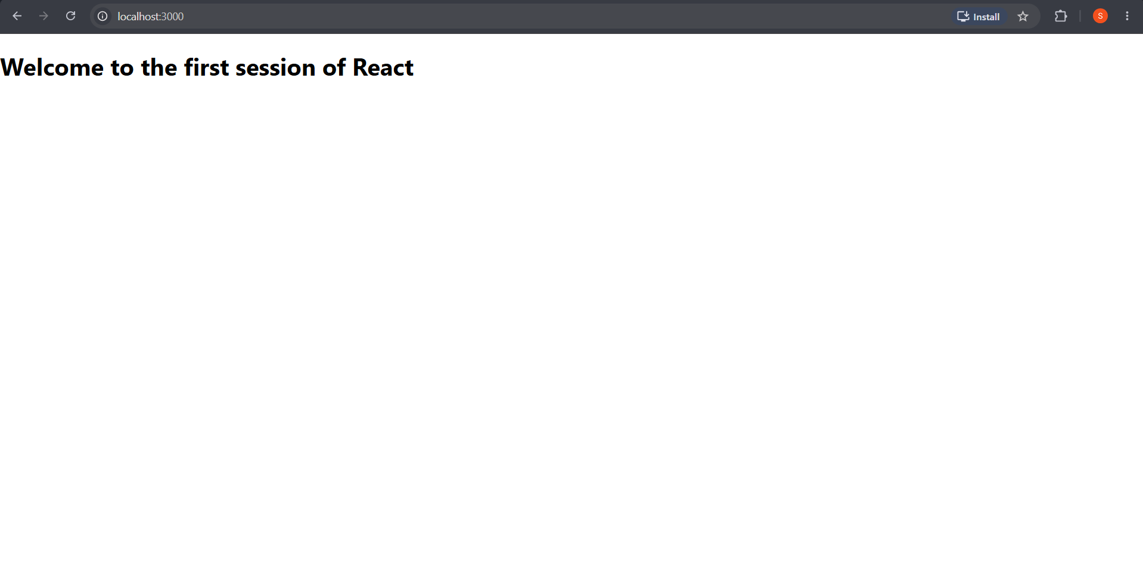

Exercise 2 – ReactJS HOL
Step 1: Created React application studentapp.
Step 2: Implemented Student component.
Step 3: Executed the application.
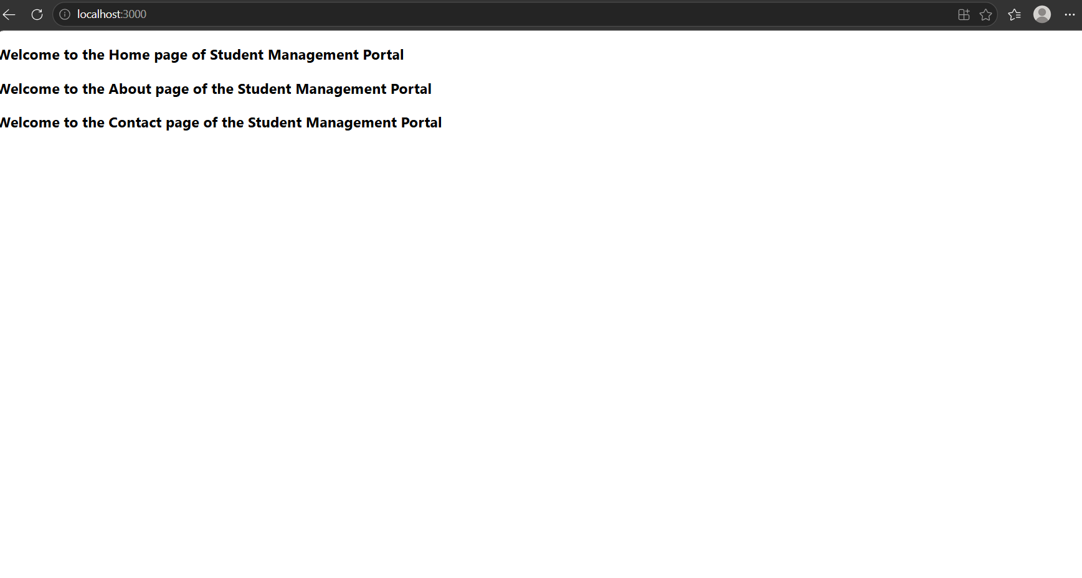
Exercise 3 – ReactJS HOL
Step 1: Created React application.
Step 2: Implemented Score Calculator.
Step 3: Executed the application.
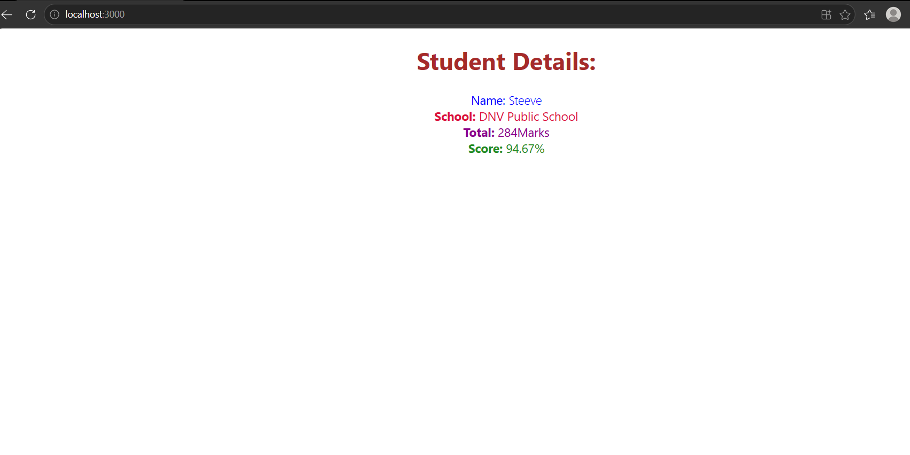

Exercise 4 – ReactJS HOL
Step 1: Created React application.
Step 2: Implemented Cricket Application.
Step 3: Executed the application.
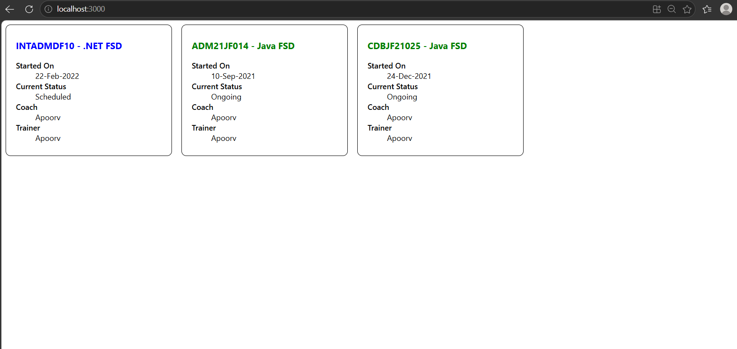
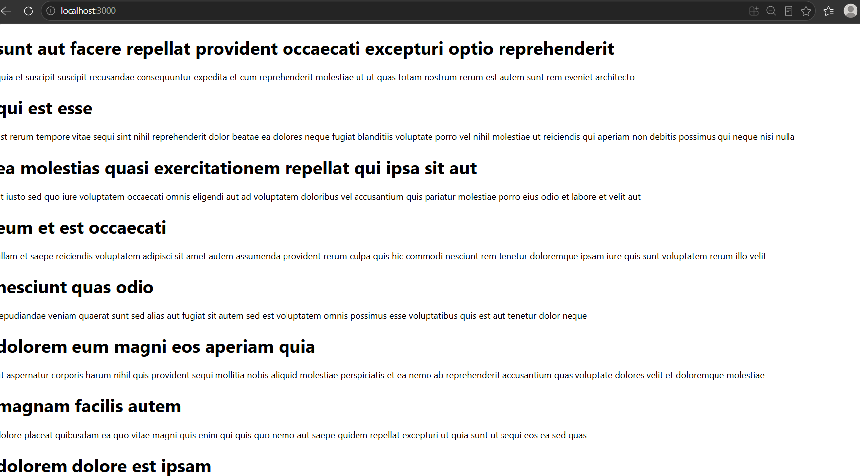

Exercise 5 – ReactJS HOL
Step 1: Created React application.
Step 2: Implemented List of Players.
Step 3: Executed the application.
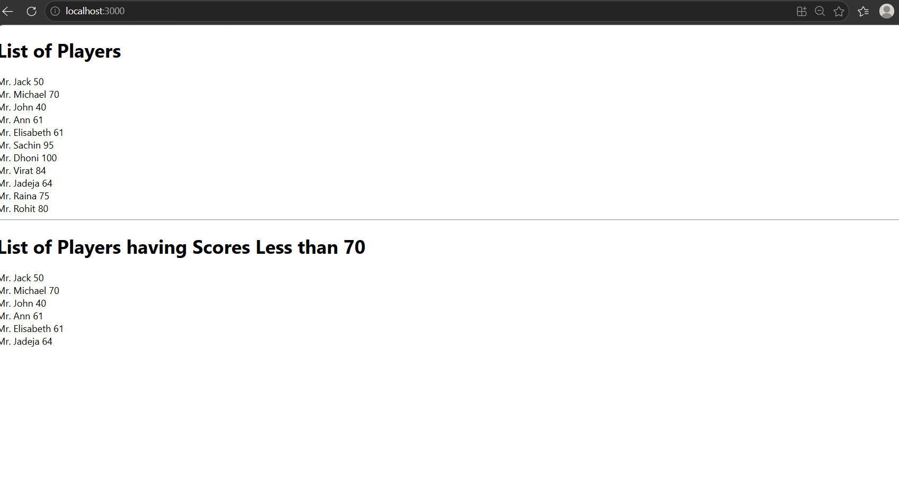
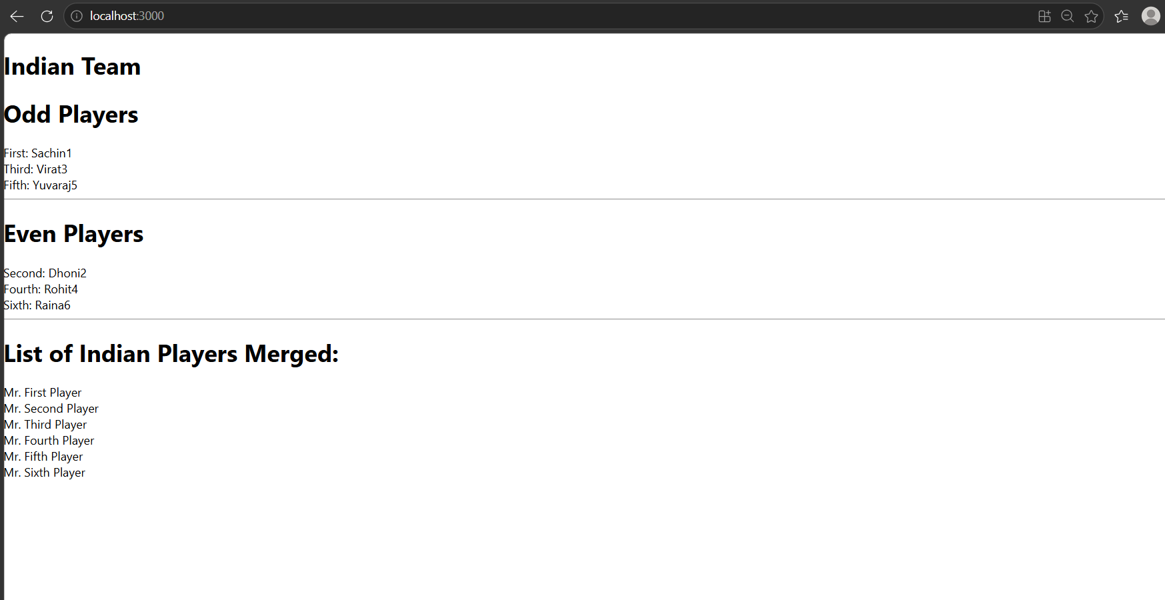

Exercise 9 – ReactJS HOL
Step 1: Created React application.
Step 2: Implemented Blogger Application using Axios.
Step 3: Executed the application.
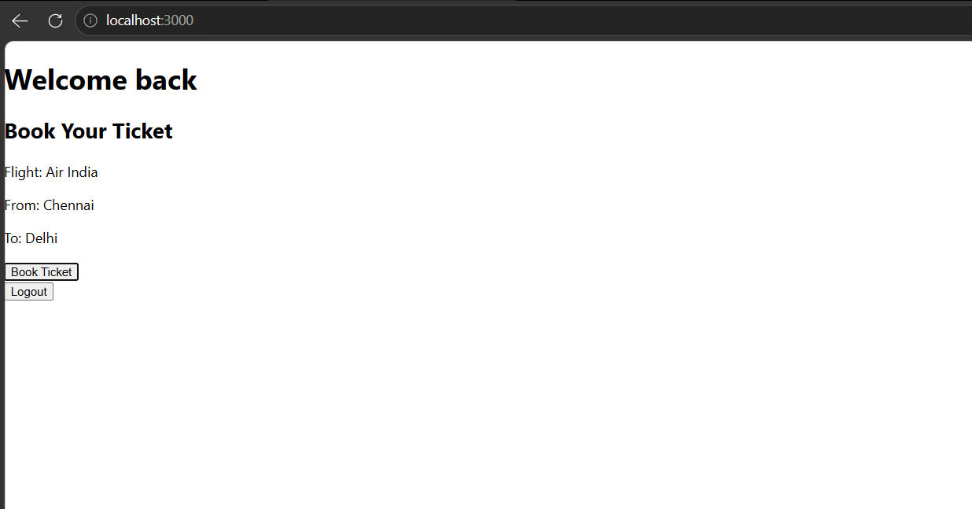

Exercise 10 – ReactJS HOL
Step 1: Created React application.
Step 2: Implemented Office Space Rental Application using JSX and conditional styling.
Step 3: Executed the application.
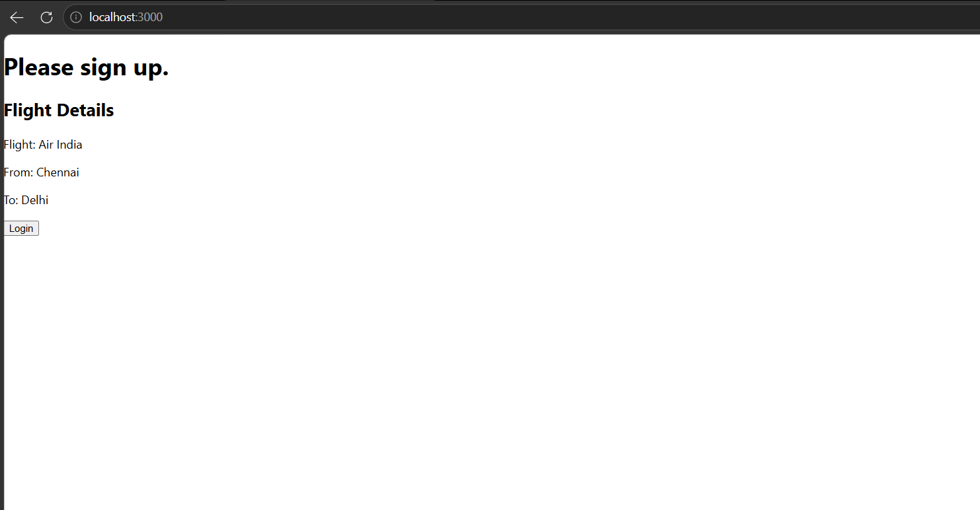

Exercise 11 – ReactJS HOL
Step 1: Created React application.
Step 2: Implemented Event Examples Application with event handling and Currency Converter.
- App.js
- CurrencyConvertor.js
Step 3: Executed the application.
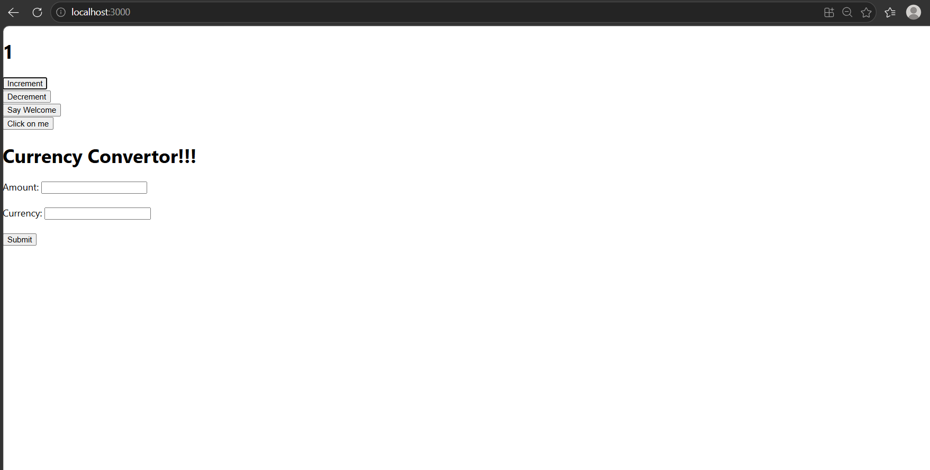

Exercise 12 – ReactJS HOL
Step 1: Created React application.
Step 2: Implemented Ticket Booking Application using Conditional Rendering.
Step 3: Executed the application.

Exercise 13 – ReactJS HOL
Step 1: Created React application.
Step 2: Implemented Blogger Application using Components and map().
- BookDetails.js
- BlogDetails.js
- CourseDetails.js
- App.js
Step 3: Executed the application.
