Exercise 1 – Create Spring Web Project using Maven
Step 1:
Opened Spring Initializr.
Step 2:
Configured Group Id as com.cognizant and Artifact Id as spring-learn.
Step 3:
Added Spring Web and Spring Boot DevTools dependencies.
Step 4:
Generated and imported the Maven project.
Step 5:
Built the project using Maven using the command mvn clean package.
Step 6:
Executed the SpringLearnApplication class successfully.
Output:
Tomcat started on port 8080 (http)
Started SpringLearnApplication
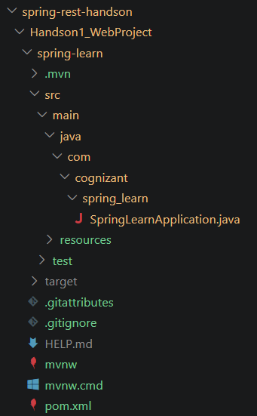
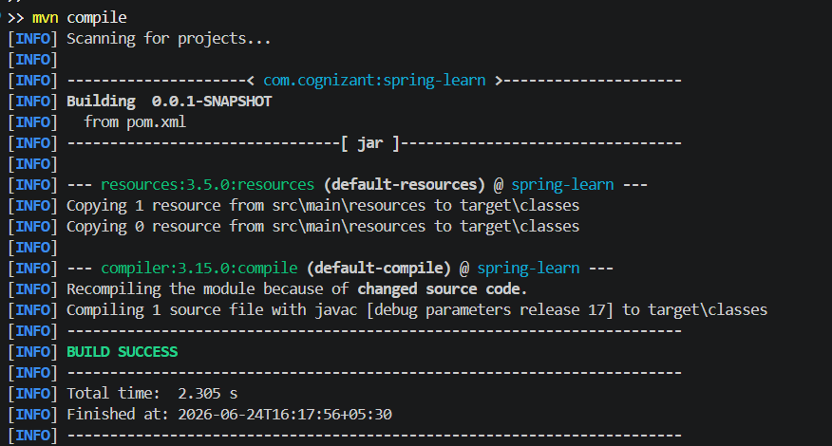
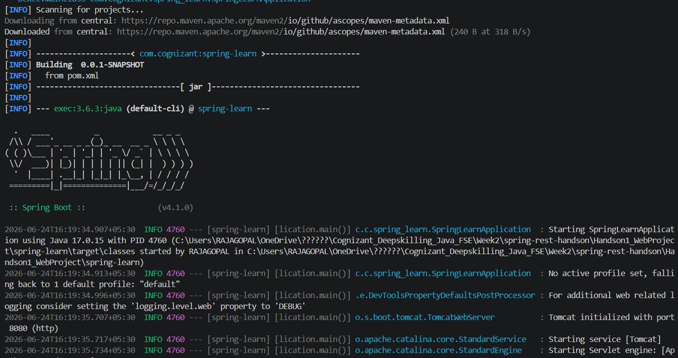
Result:
Spring Web Project was created, built and executed successfully.

Exercise 2 – Spring Core: Load Country from Spring Configuration XML
Step 1:
Created a Spring configuration file named country.xml inside src/main/resources.
Step 2:
Configured a bean named country with code as IN and name as India.
Step 3:
Created Country.java with code and name properties.
Step 4:
Loaded the XML configuration using ClassPathXmlApplicationContext.
Step 5:
Retrieved the bean using getBean().
Step 6:
Displayed the country details in the console.
Output:
Country [code=IN, name=India]
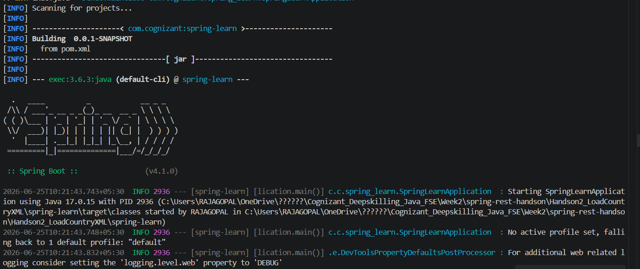
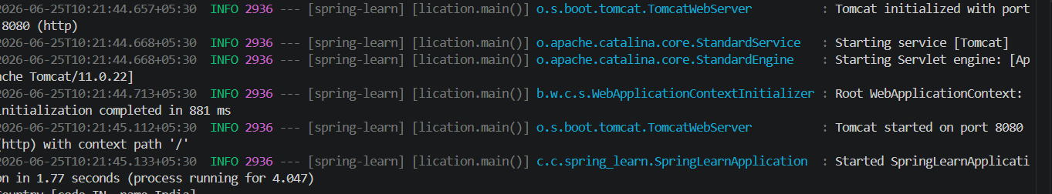

Result:
Successfully loaded the Country bean from Spring XML configuration.

Exercise 3 – Hello World RESTful Web Service
Step 1:
Created the controller package.
Step 2:
Created HelloController.java.
Step 3:
Annotated the class with @RestController.
Step 4:
Created a GET endpoint using @GetMapping("/hello").
Step 5:
Implemented the sayHello() method to return "Hello World!!".
Step 6:
Started the Spring Boot application.
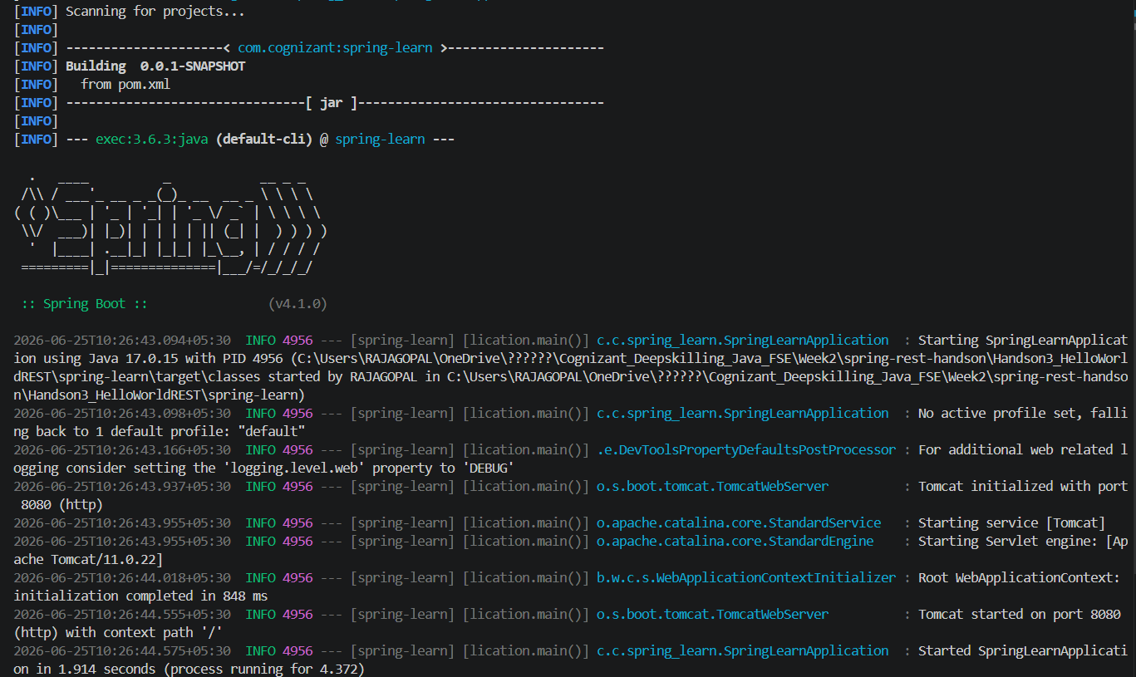

Step 7:
Invoked the URL http://localhost:8080/hello.
Output:
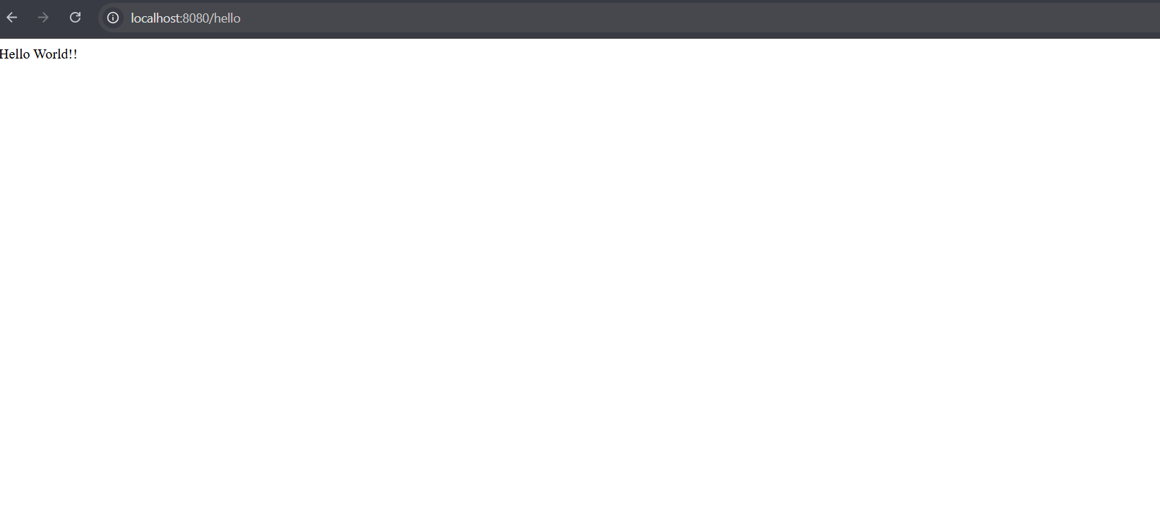
Hello World!!
Result:
Successfully implemented a Hello World RESTful Web Service.

Exercise 4 – REST Country Web Service
Step 1:
Created CountryController.java inside the controller package.
Step 2:
Annotated the class with @RestController.
Step 3:
Created a GET endpoint using @GetMapping("/country").
Step 4:
Implemented the getCountryIndia() method.
Step 5:
Started the Spring Boot application.
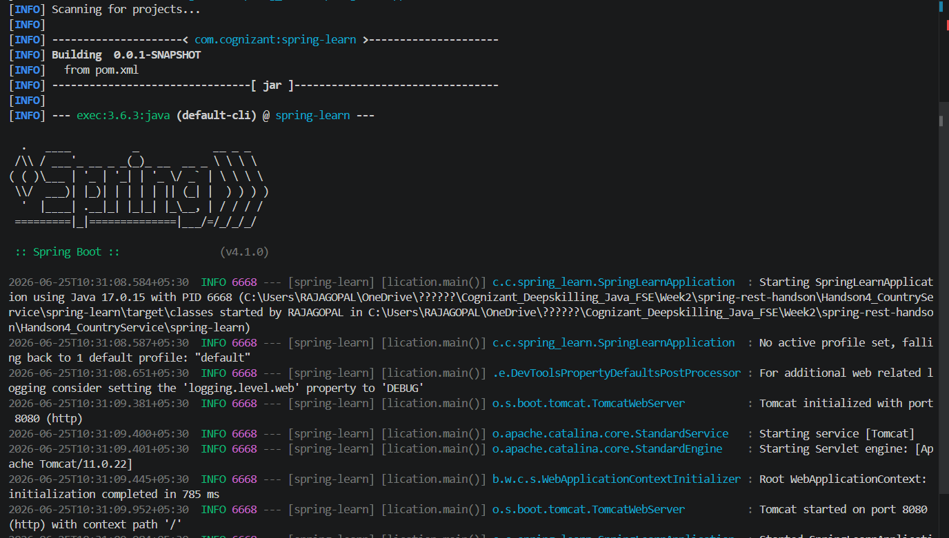
Step 6:
Invoked the URL http://localhost:8080/country.

Output:
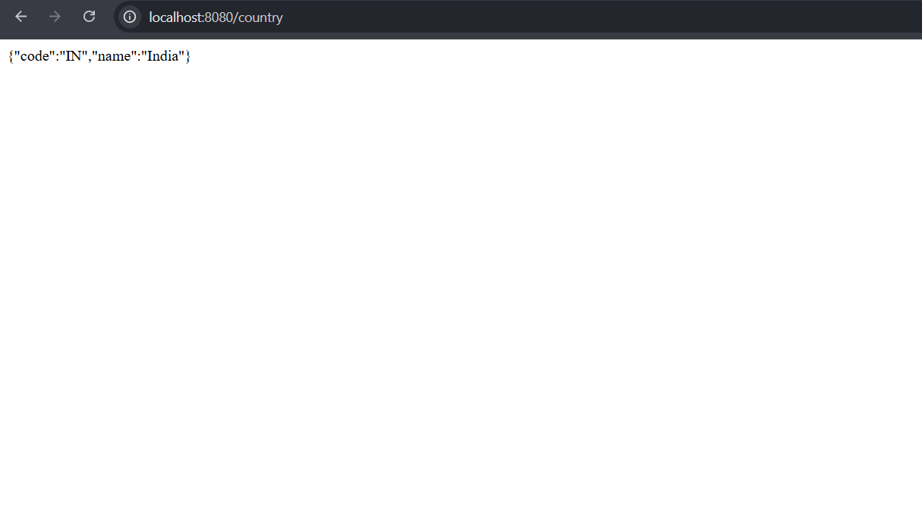
{"code":"IN","name":"India"}
Result:
Successfully implemented a RESTful Country Web Service.

Exercise 5 – REST Get Country Based on Country Code
Step 1:
Modified CountryController.java to accept the country code as a path variable.
Step 2:
Used @PathVariable to receive the country code.
Step 3:
Created a GET endpoint using @GetMapping("/country/{code}").
Step 4:
Returned the country details for the code "IN".
Step 5:
Started the Spring Boot application.
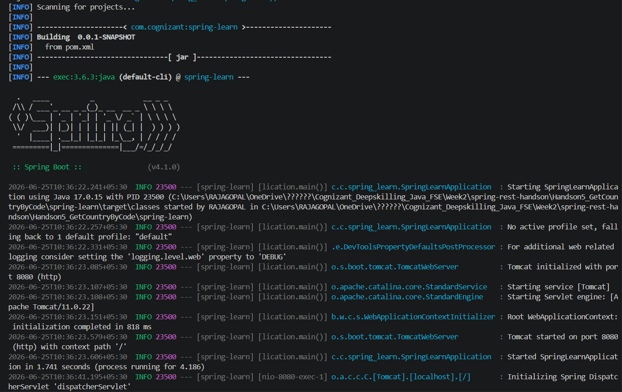
Step 6:
Invoked the URL http://localhost:8080/country/IN.

Output:
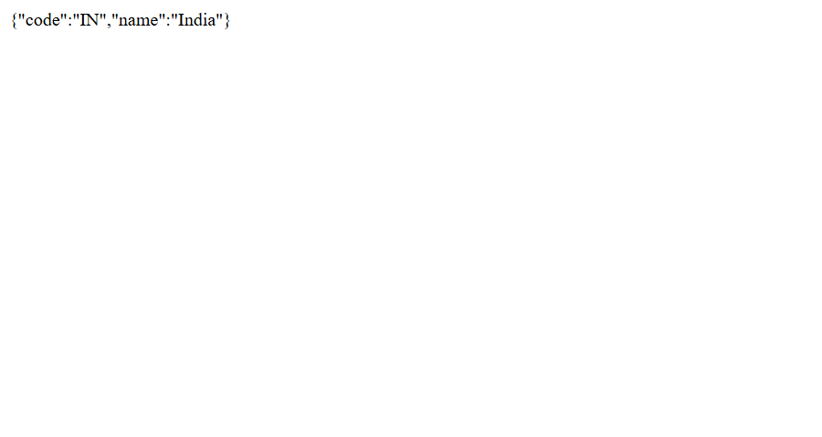
{"code":"IN","name":"India"}
Result:
Successfully implemented a RESTful web service to retrieve country details based on the country code.

Exercise – JWT Authentication using Spring Boot
Step 1
Created a Spring Boot Maven project named spring-learn.
Added the required dependencies:
- Spring Web
- Spring Security
- JWT
- DevTools
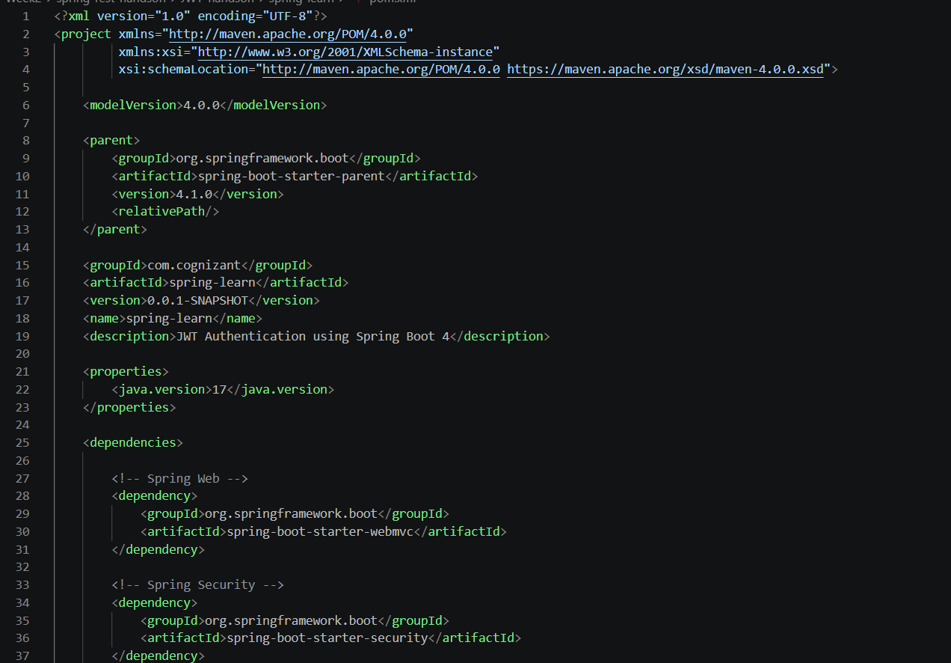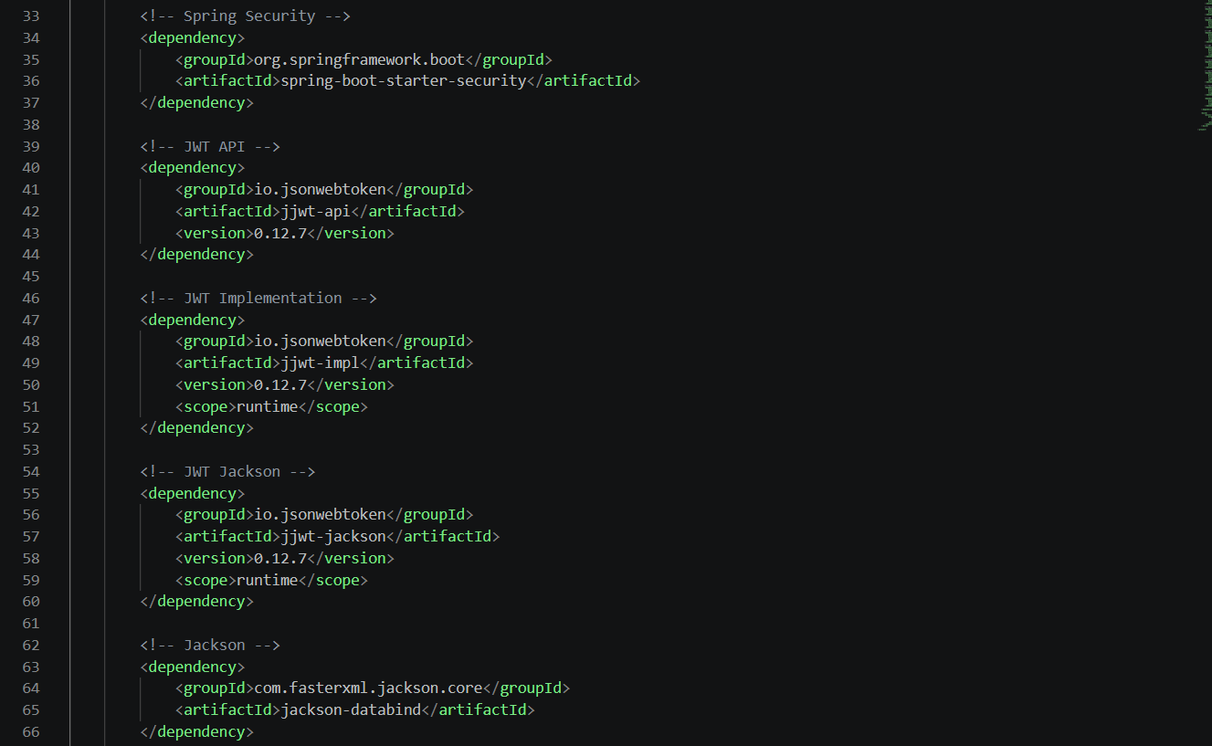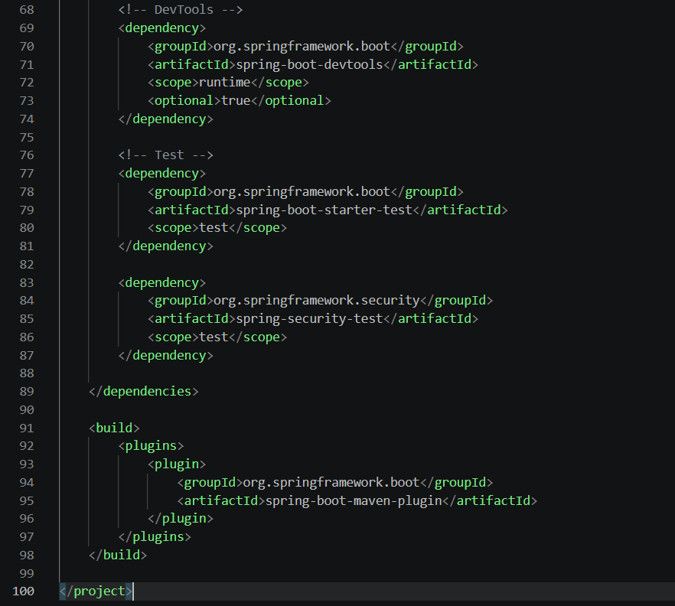
Step 2
Created the required packages:
- config
- controller
- model
- service
- util
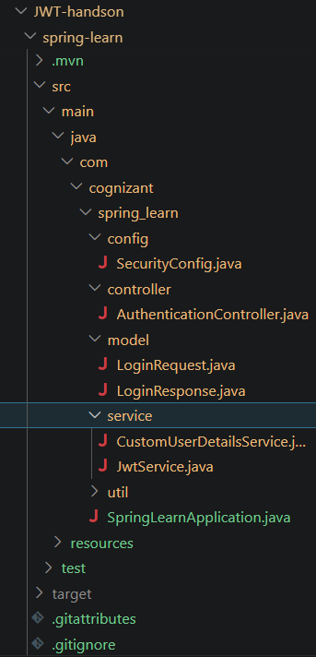
Step 3
Created the following Java classes:
- LoginRequest.java
- LoginResponse.java
- JwtUtil.java
- JwtService.java
- CustomUserDetailsService.java
- SecurityConfig.java
- AuthenticationController.java
Implemented JWT authentication functionality and configured Spring Security.
Step 4
Compiled the project using Maven.
Command:
mvn compile
Output:
BUILD SUCCESS
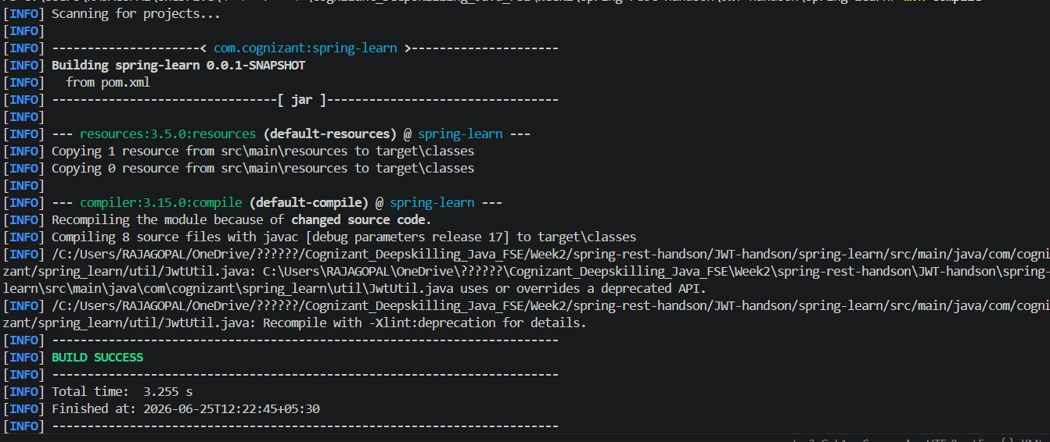
Step 5
Executed the Spring Boot application.
Command:
mvn exec:java "-Dexec.mainClass=com.cognizant.spring_learn.SpringLearnApplication"
Spring Boot application started successfully.
Tomcat started on port 8080.
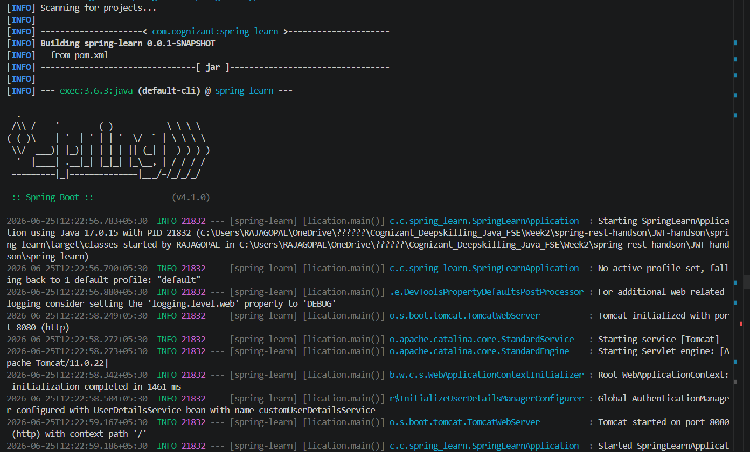
Step 6
Verified the application by accessing the home endpoint.
URL:
http://localhost:8080/
Output:
Welcome to JWT Authentication
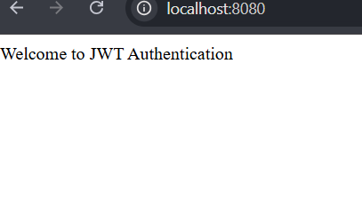
Result
Successfully implemented the JWT Authentication application using Spring Boot and Spring Security. The project was compiled successfully, the application started without errors, and the home endpoint was verified successfully.

