Exercise 1: Control Structures in PL/SQL
STEP 1:Table Created Values Inserted
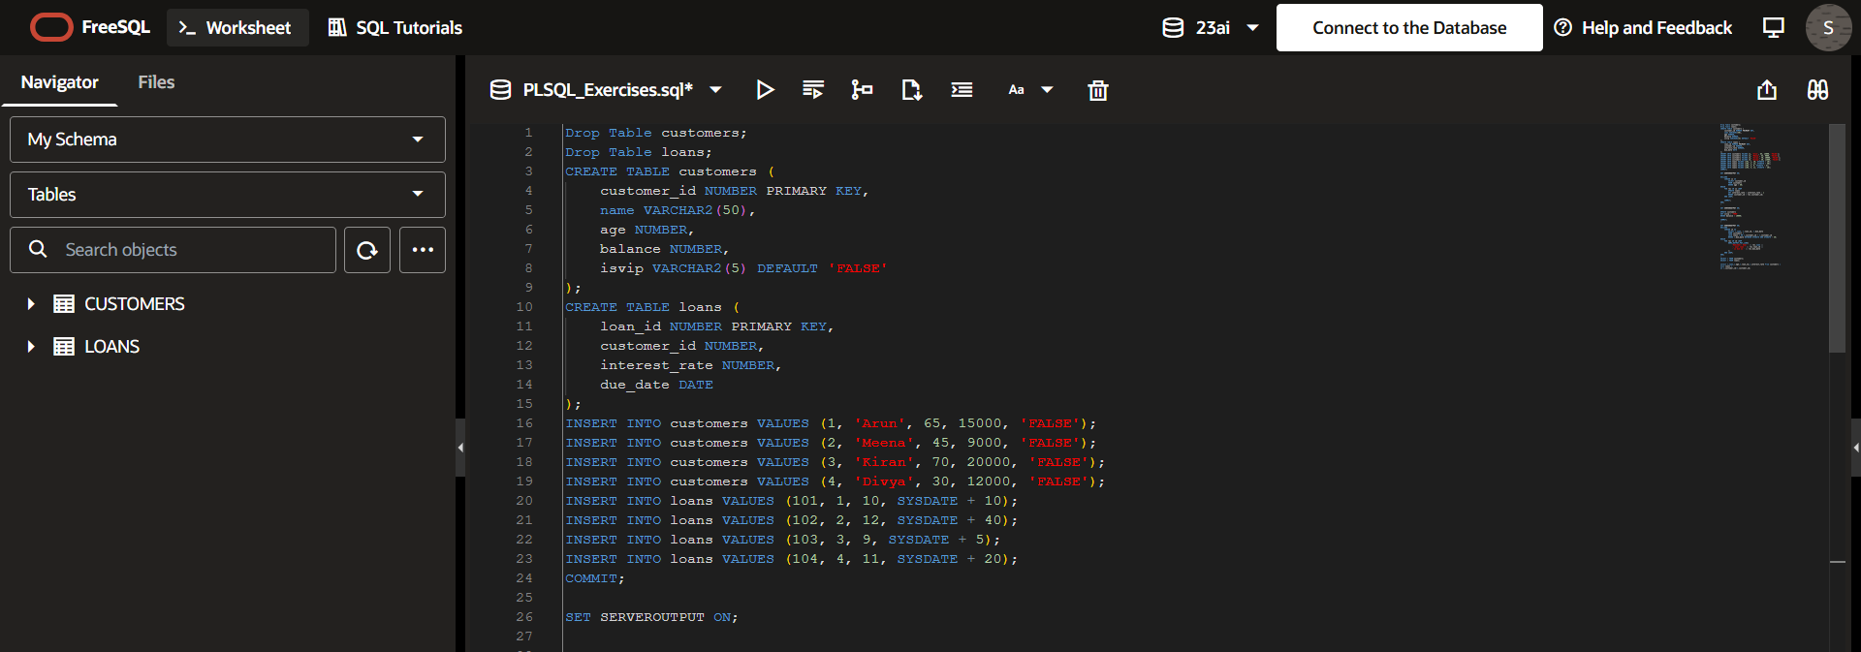
STEP 2:Scenario 1
Scenario 1
Problem Statement:
Apply a 1% discount to loan interest rates for customers above 60 years old.
This PL/SQL block uses a cursor to fetch all customers whose age is greater than 60. It loops through each selected customer one by one. For every such customer, it updates their loan interest rate by reducing it by 1% in the loans table. Finally, the COMMIT statement permanently saves all the changes made in the database.
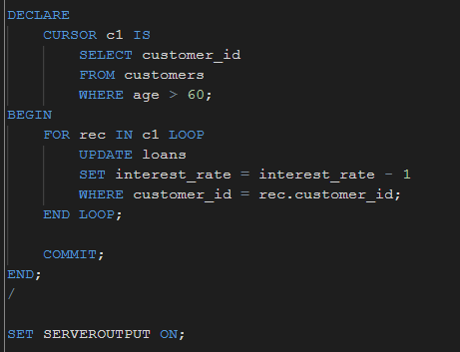

Output:
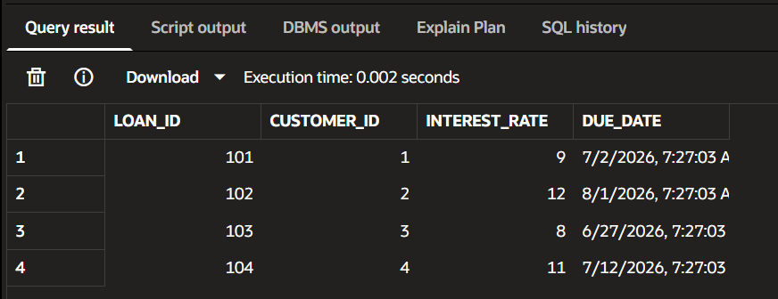

Step 3:Scenario 2
Problem Statement:
Set IsVIP = TRUE for customers with balance > 10000
This PL/SQL block updates the customers table by setting the isvip flag to TRUE for all customers whose balance is greater than 10,000. It uses a simple UPDATE statement with a condition to filter eligible customers. After updating, the COMMIT statement permanently saves the changes in the database. This helps in automatically promoting high-balance customers to VIP status.

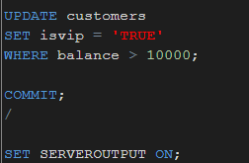

Output:
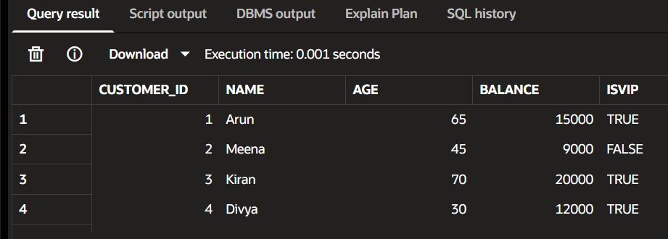
Step 4:
Scenario 3:
Problem Statement:
Send reminder for loans due in next 30 days
This PL/SQL block uses a cursor to retrieve customers whose loan due dates fall within the next 30 days from the current date. It joins the customers and loans tables to get customer details along with their loan information. For each matching record, it prints a reminder message using DBMS_OUTPUT.PUT_LINE. This helps the bank notify customers in advance about upcoming loan due dates.
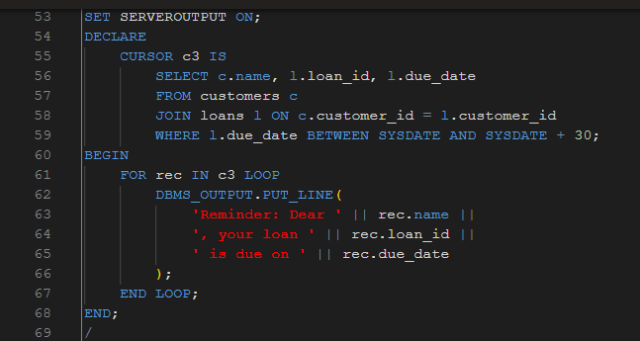
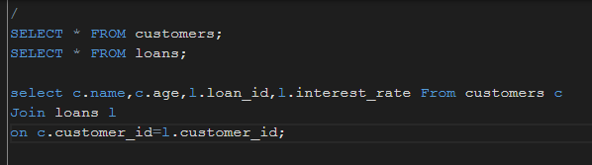
Output:
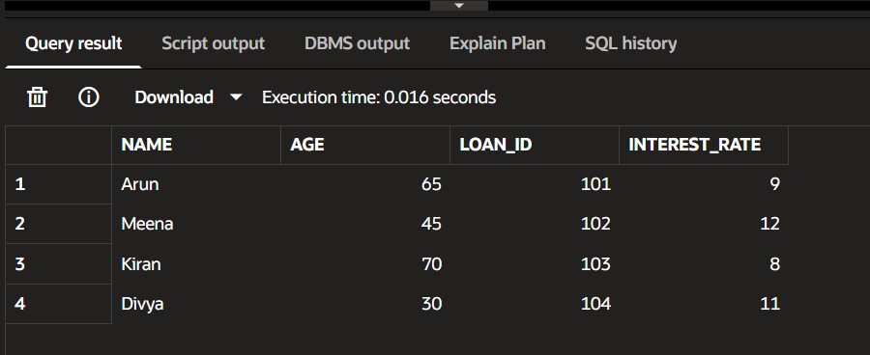

Exercise 3: Stored Procedures

Step 1:Scenario 1

Scenario 1
Problem:
Process monthly interest (1%) for savings accounts

This block applies a 1% monthly interest to all savings accounts in the SavingsAccounts table. It updates each account’s balance by increasing it based on the current amount. The changes are permanently saved using the COMMIT statement after execution.

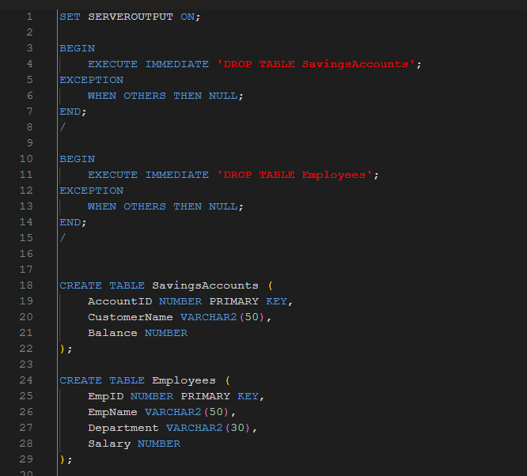

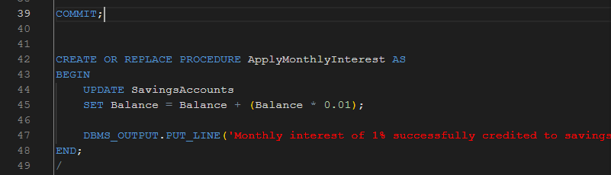
Output:
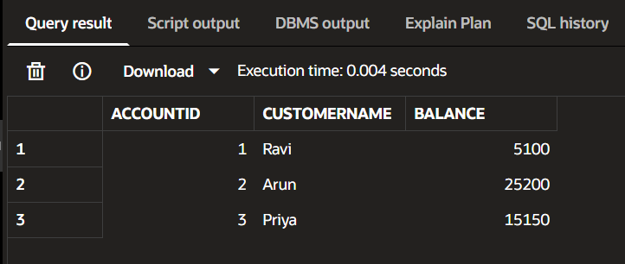
Step 2: Scenario 2
Problem Statement
Update the salary of employees in a specified department by adding a bonus percentage passed as a parameter.
This stored procedure updates employee salaries based on their department. It takes the department name and bonus percentage as input parameters. The salary of all employees in that department is increased accordingly and the changes are saved in the database.
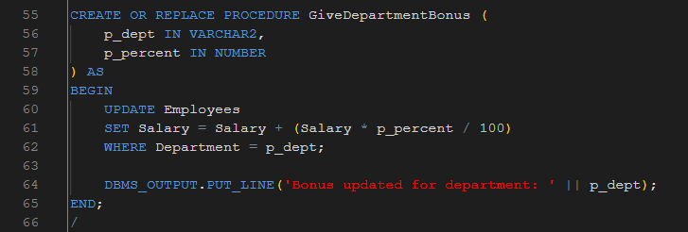
Output:
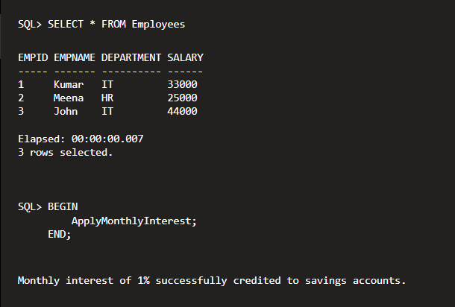

Step 3:
Scenario 3:
Problem Statement
Transfer a specified amount from one account to another after checking whether the source account has sufficient balance.

This stored procedure handles fund transfer between two savings accounts. It first checks the balance of the source account to ensure sufficient funds are available. If enough balance exists, the amount is deducted from the source account and added to the target account; otherwise, the transaction is rejected.

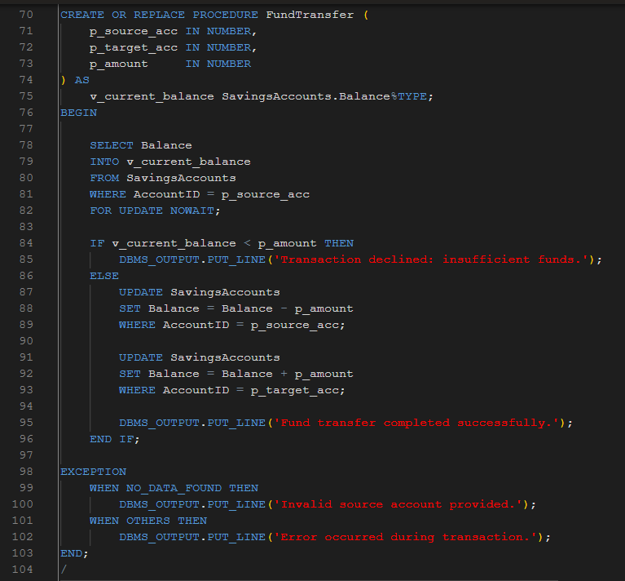

Output:
