EXERCISE 1 – SPRING DATA JPA QUICK EXAMPLE
Step 1:
Created a Maven Project named Handson1_QuickExample.
Step 2:
Added the required dependencies in pom.xml:
- Spring Boot Starter
- Spring Boot Starter Data JPA
- MySQL Connector
- Spring Boot Starter Test
Step 3:
Created the package structure:
- com.cognizant.ormlearn
- com.cognizant.ormlearn.model
- com.cognizant.ormlearn.repository
- com.cognizant.ormlearn.service
Step 4:
Created the following files:
- OrmLearnApplication.java
- Country.java
- CountryRepository.java
- CountryService.java
- application.properties
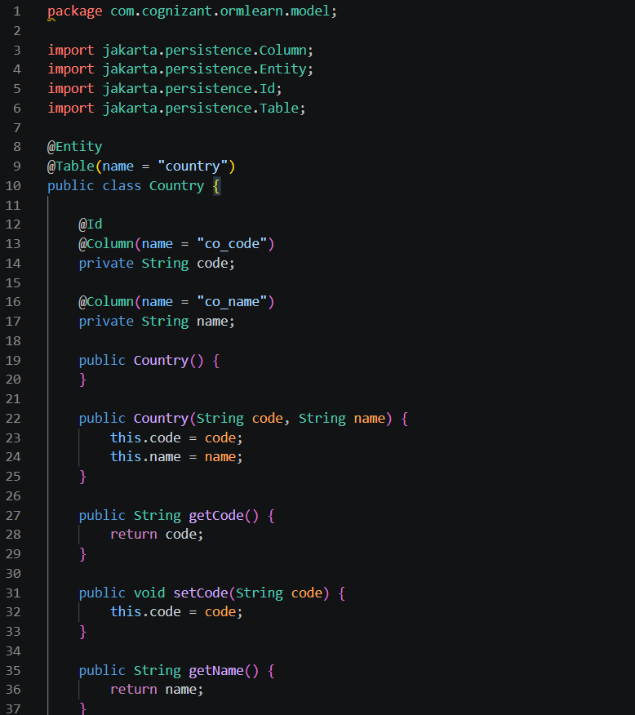
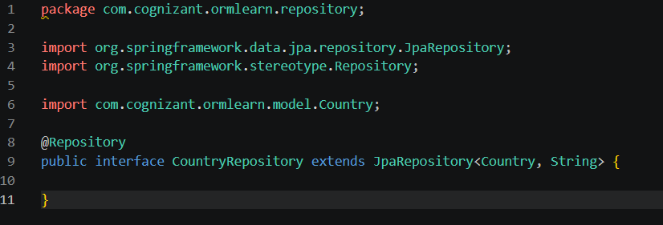
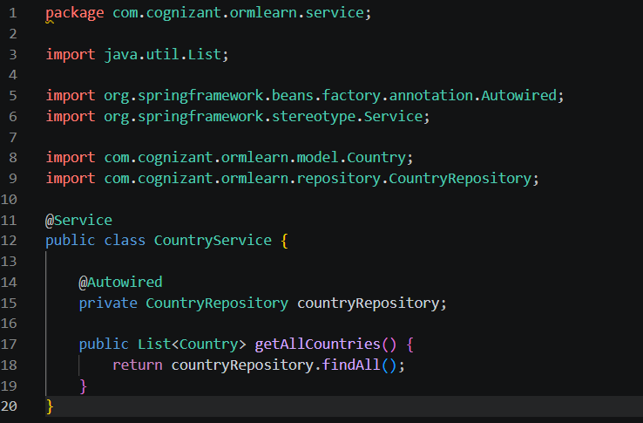
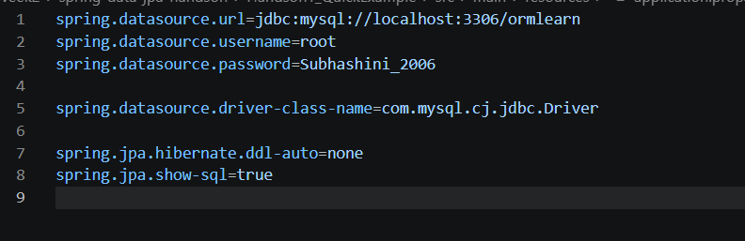
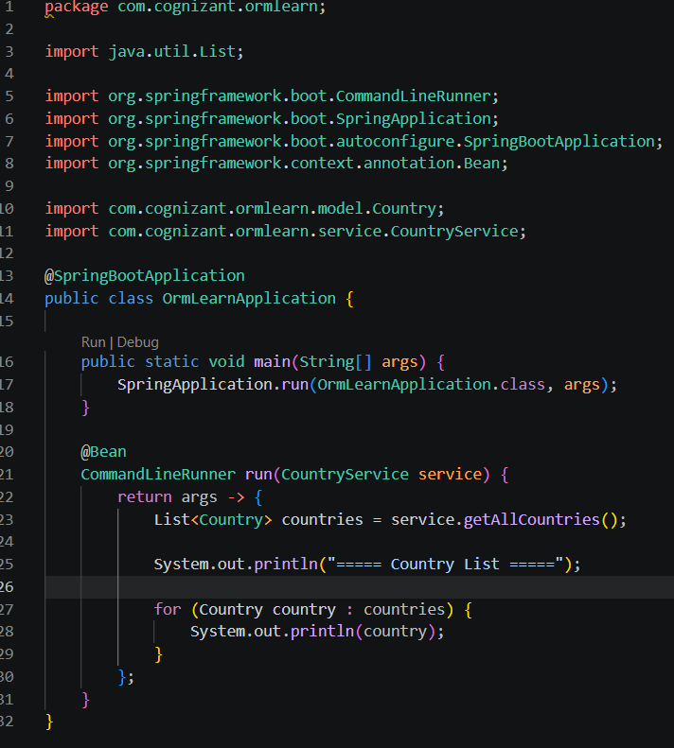
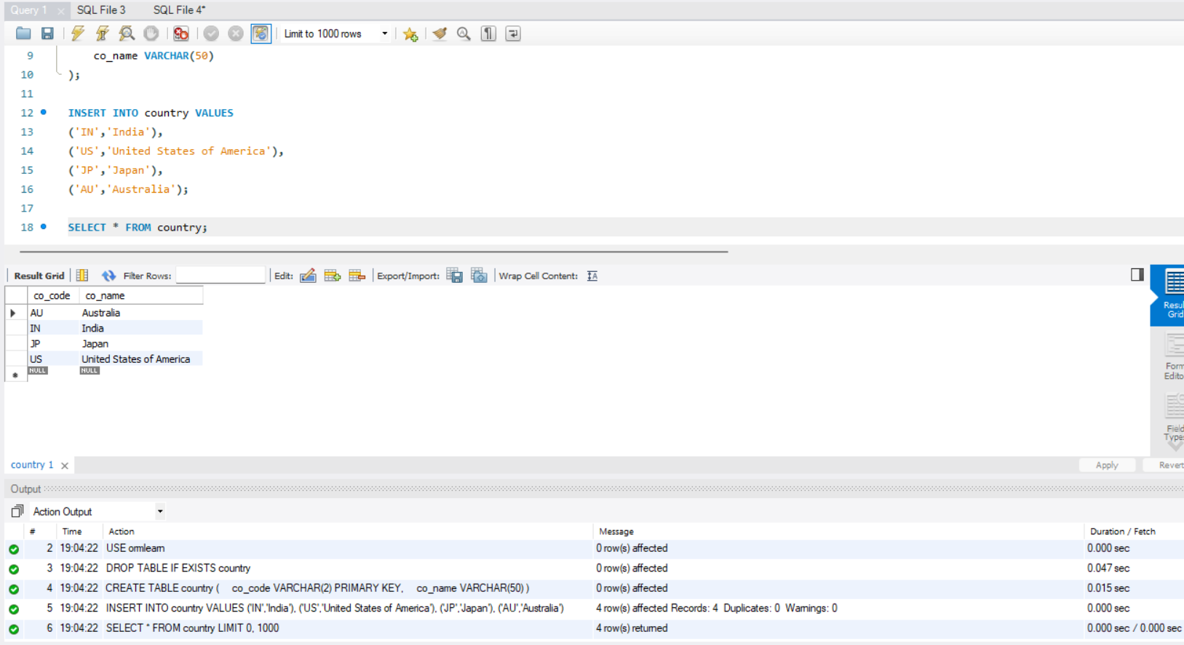
Step 5:
Configured the MySQL Database properties in application.properties:
- Database URL
- Username
- Password
- JDBC Driver
- Hibernate Configuration
- SQL Display
Step 6:
Created the MySQL database ormlearn and created the country table with sample records.
Step 7:
Compiled the project using Maven.
Commands Used:
mvn clean
mvn compile
Step 8:
Packaged the project.
Command Used:
mvn package
Step 9:
Executed the application.
Command Used:
java -jar target\ormlearn-1.0.jar
Output:
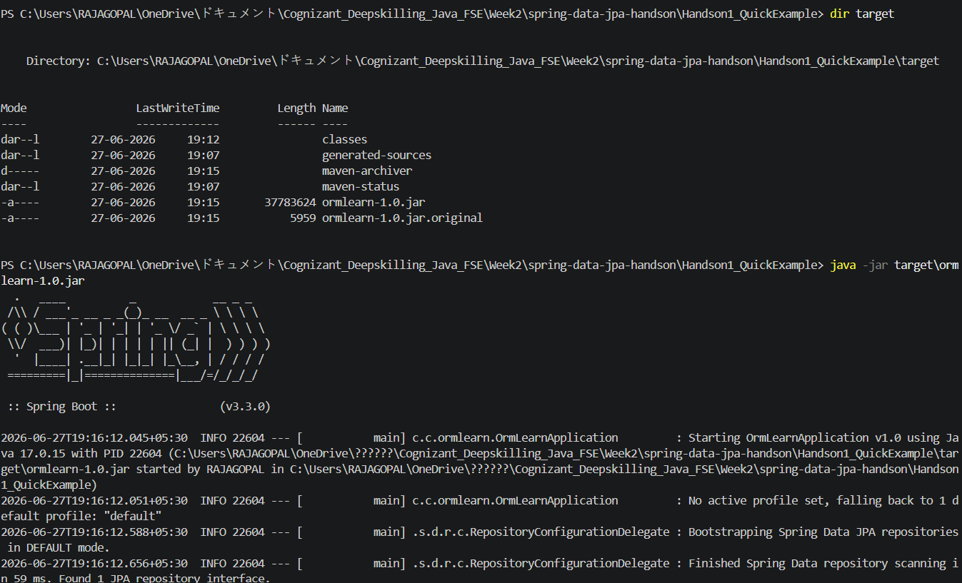
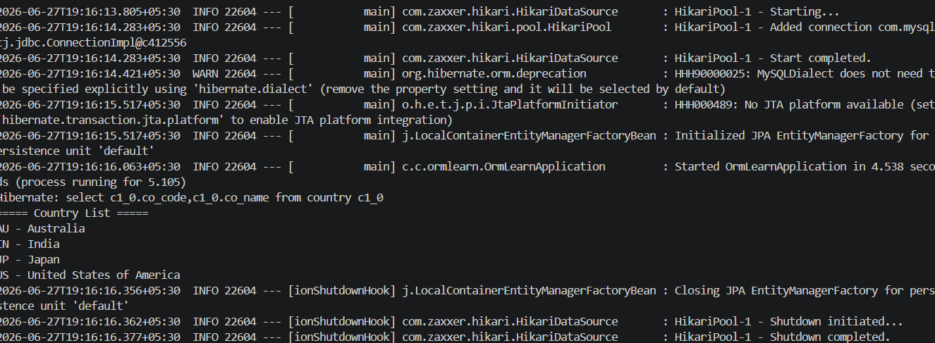
===== Country List =====

AU - Australia
IN - India
JP - Japan
US - United States of America
Result
The Spring Data JPA application was successfully connected to the MySQL database. The country records were retrieved using JpaRepository and displayed successfully in the console. This demonstrates the successful integration of Spring Boot, Spring Data JPA, Hibernate, and MySQL.

EXERCISE 2 – Difference between JPA, Hibernate and Spring Data JPA
Step 1:
Studied Java Persistence API (JPA).
JPA (Java Persistence API)
• JPA is a specification (JSR 338).
• It defines standards for data persistence in Java applications.
• JPA does not provide implementation.
Step 2:
Studied Hibernate Framework.
Hibernate
• Hibernate is an ORM (Object Relational Mapping) framework.
• Hibernate is one of the implementations of JPA.
• Hibernate maps Java objects to database tables.
• It reduces JDBC boilerplate code.
Step 3:
Studied Spring Data JPA.
Spring Data JPA
• Spring Data JPA is built on top of JPA.
• It reduces boilerplate code.
• It provides JpaRepository for CRUD operations.
• It simplifies database access and transaction management.
Step 4:
Compared JPA, Hibernate and Spring Data JPA.
Comparison:
JPA
• Type: Specification
• Implementation: No
• Purpose: Defines persistence standards
Hibernate
• Type: ORM Framework
• Implementation: Yes
• Purpose: Implements JPA and performs ORM
Spring Data JPA
• Type: Abstraction Framework
• Implementation: Uses JPA/Hibernate
• Purpose: Simplifies database operations
Result:
Studied and compared JPA, Hibernate and Spring Data JPA. Understood their roles, features and relationship in Java persistence applications.

