Ex. No. 2 Implementation of fork(), exec() and wait() System Calls

Program:
#include <stdio.h>
#include <stdlib.h>
#include <unistd.h>
#include <sys/wait.h>
int main(){
pid_t pid;
int status;
printf("Parent process: PID = %d\n", getpid());
pid = fork();
if (pid < 0)
perror("fork failed");
exit(1); }
else if (pid == 0) {
printf("Child process: PID = %d, Parent PID = %d\n",
getpid(), getppid());
printf("Child is about to execute 'ls -l' using execlp()\n");
execlp("ls", "ls", "-l", NULL)
perror("execlp failed");
exit(1);
}
else {
printf("Parent waiting for child (PID = %d) to finish...\n", pid);
wait(&status);
if (WIFEXITED(status))
printf("Child terminated normally with exit code %d\n",
WEXITSTATUS(status));
else
printf("Child terminated abnormally\n");

printf("Parent process finished execution.\n");
}

return 0;
}
Output:

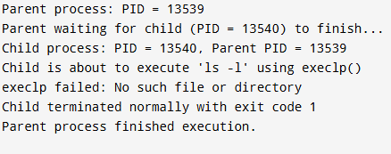

Ex. No. 4 CPU Scheduling - First Come First Serve (FCFS)

Program:
#include <stdio.h>
int main()
{
int n, i;
int bt[20], at[20], wt[20], tat[20];
float total_wt = 0, total_tat = 0;
printf("Enter number of processes: ");
scanf("%d", &n);
printf("Enter Arrival Time and Burst Time for each process:\n");
for (i = 0; i < n; i++) {
printf("P%d - Arrival Time: ", i + 1);
scanf("%d", &at[i]);
printf("P%d - Burst Time: ", i + 1);
scanf("%d", &bt[i]);
}
int completion_time = 0;
printf("\nProcess\tAT\tBT\tWT\tTAT\n");
for (i = 0; i < n; i++) {
if (completion_time < at[i])
completion_time = at[i];
wt[i] = completion_time - at[i];
completion_time += bt[i];
tat[i] = completion_time - at[i];
total_wt += wt[i];
total_tat += tat[i];
printf("P%d\t%d\t%d\t%d\t%d\n", i + 1, at[i], bt[i], wt[i], tat[i]);
}
printf("\nAverage Waiting Time = %.2f\n", total_wt / n);
printf("Average Turnaround Time = %.2f\n", total_tat / n);
return 0;
}

Output:
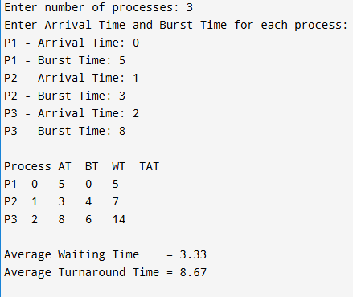

Ex. No. 5 CPU Scheduling - Shortest Job First (SJF), Non-Preemptive

Program:
#include <stdio.h>
int main()
{
int n, i;
int bt[20], at[20], wt[20], tat[20], done[20];
float total_wt = 0, total_tat = 0;
int completed = 0, current_time = 0;

printf("Enter number of processes: ");
scanf("%d", &n);

printf("Enter Arrival Time and Burst Time for each process:\n");
for (i = 0; i < n; i++) {
printf("P%d - Arrival Time: ", i + 1);
scanf("%d", &at[i]);
printf("P%d - Burst Time: ", i + 1);
scanf("%d", &bt[i]);
done[i] = 0;
}

while (completed != n) {
int idx = -1;
int min_bt = 1000000;
for (i = 0; i < n; i++) {
if (!done[i] && at[i] <= current_time) {
if (bt[i] < min_bt) {
min_bt = bt[i];
idx = i;
}
}
}

if (idx == -1) {
current_time++;
continue;
}

wt[idx] = current_time - at[idx];
current_time += bt[idx];
tat[idx] = current_time - at[idx];
done[idx] = 1;
completed++;
}

printf("\nProcess\tAT\tBT\tWT\tTAT\n");
for (i = 0; i < n; i++) {
total_wt += wt[i];
total_tat += tat[i];
printf("P%d\t%d\t%d\t%d\t%d\n", i + 1, at[i], bt[i], wt[i], tat[i]);
}

printf("\nAverage Waiting Time = %.2f\n", total_wt / n);
printf("Average Turnaround Time = %.2f\n", total_tat / n);

return 0;
}

Output:
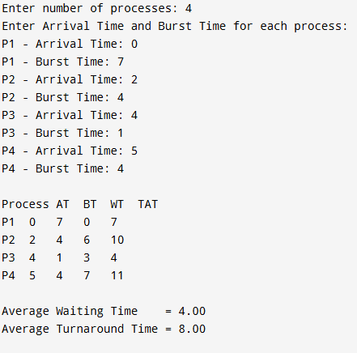

Ex. No. 6 CPU Scheduling - Round Robin

Program:
#include <stdio.h>
int main()
{
int n, i, tq;
int bt[20], at[20], rem_bt[20], wt[20], tat[20];
float total_wt = 0, total_tat = 0;
printf("Enter number of processes: ");
scanf("%d", &n);
printf("Enter Arrival Time and Burst Time for each process:\n");
for (i = 0; i < n; i++) {
printf("P%d - Arrival Time: ", i + 1);
scanf("%d", &at[i]);
printf("P%d - Burst Time: ", i + 1);
scanf("%d", &bt[i]);
rem_bt[i] = bt[i];
}
printf("Enter Time Quantum: ");
scanf("%d", &tq);

int current_time = 0, completed = 0;
int queue[1000], front = 0, rear = 0;
int in_queue[20] = {0};
for (i = 0; i < n; i++) {
if (at[i] <= current_time && !in_queue[i]) {
queue[rear++] = i;
in_queue[i] = 1;
}
}

while (completed != n) {
if (front == rear) {
/* Queue empty - advance time to next arrival */
current_time++;
for (i = 0; i < n; i++)
if (at[i] <= current_time && !in_queue[i] && rem_bt[i] > 0) {
queue[rear++] = i;
in_queue[i] = 1;
}
continue;
}
int idx = queue[front++];
if (rem_bt[idx] > tq) {
current_time += tq;
rem_bt[idx] -= tq;
} else {
current_time += rem_bt[idx];
wt[idx] = current_time - at[idx] - bt[idx];
tat[idx] = current_time - at[idx];
rem_bt[idx] = 0;
completed++;
}
for (i = 0; i < n; i++)
if (at[i] <= current_time && !in_queue[i] && rem_bt[i] > 0) {
queue[rear++] = i;
in_queue[i] = 1;
}
if (rem_bt[idx] > 0)
queue[rear++] = idx;
}

printf("\nProcess\tAT\tBT\tWT\tTAT\n");
for (i = 0; i < n; i++) {
total_wt += wt[i];
total_tat += tat[i];
printf("P%d\t%d\t%d\t%d\t%d\n", i + 1, at[i], bt[i], wt[i], tat[i]);
}

printf("\nAverage Waiting Time = %.2f\n", total_wt / n);
printf("Average Turnaround Time = %.2f\n", total_tat / n);
return 0;
}
Output:
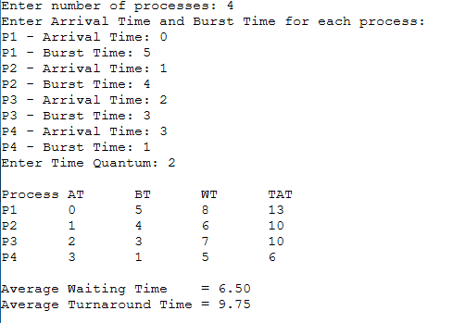

Ex. No. 7 CPU Scheduling - Priority Scheduling (Non-Preemptive)
Program:
#include <stdio.h>
int main()
{
int n, i;
int bt[20], at[20], pr[20], wt[20], tat[20], done[20];
float total_wt = 0, total_tat = 0;
int completed = 0, current_time = 0;

printf("Enter number of processes: ");
scanf("%d", &n);

printf("Enter Arrival Time, Burst Time and Priority (lower value = higher priority):\n");
for (i = 0; i < n; i++) {
printf("P%d - Arrival Time: ", i + 1);
scanf("%d", &at[i]);
printf("P%d - Burst Time: ", i + 1);
scanf("%d", &bt[i]);
printf("P%d - Priority: ", i + 1);
scanf("%d", &pr[i]);
done[i] = 0;
}

while (completed != n) {
int idx = -1;
int best_pr = 1000000;
for (i = 0; i < n; i++) {
if (!done[i] && at[i] <= current_time) {
if (pr[i] < best_pr ||
(pr[i] == best_pr && idx != -1 && at[i] < at[idx])) {
best_pr = pr[i];
idx = i;
}
}
}

if (idx == -1) {
current_time++;
continue;
}

wt[idx] = current_time - at[idx];
current_time += bt[idx];
tat[idx] = current_time - at[idx];
done[idx] = 1;
completed++;
}
printf("\nProcess\tAT\tBT\tPriority\tWT\tTAT\n");
for (i = 0; i < n; i++) {
total_wt += wt[i];
total_tat += tat[i];
printf("P%d\t%d\t%d\t%d\t\t%d\t%d\n", i + 1, at[i], bt[i], pr[i], wt[i], tat[i]);
}

printf("\nAverage Waiting Time = %.2f\n", total_wt / n);
printf("Average Turnaround Time = %.2f\n", total_tat / n);

return 0;
}
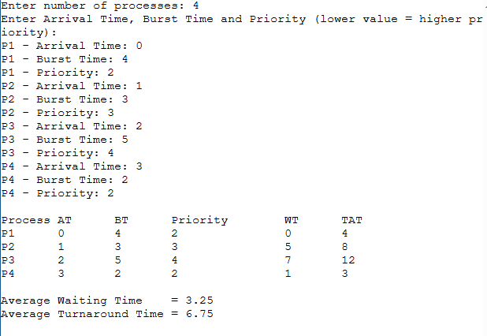
Output:

Ex. No. 8 Process Synchronization - Producer-Consumer Problem using Semaphores
Program:

