A, Name: SUBHASHINI N

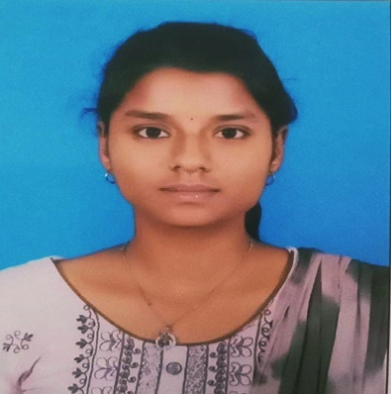b,

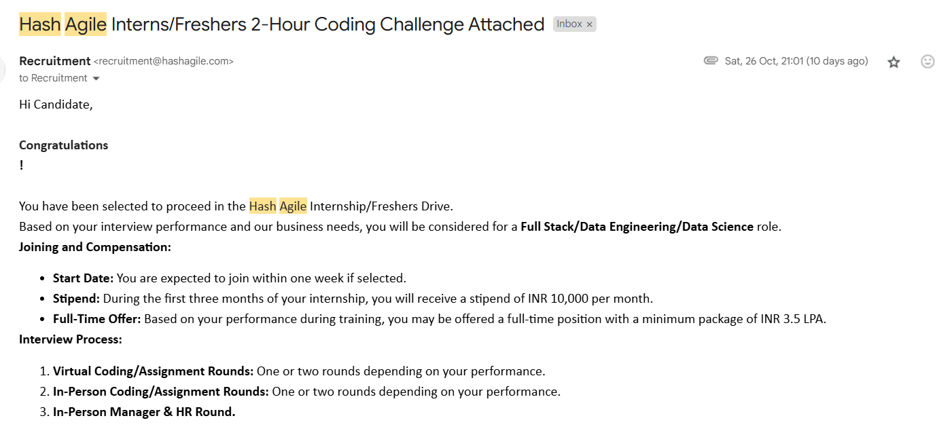

c, First Task Email Screenshot

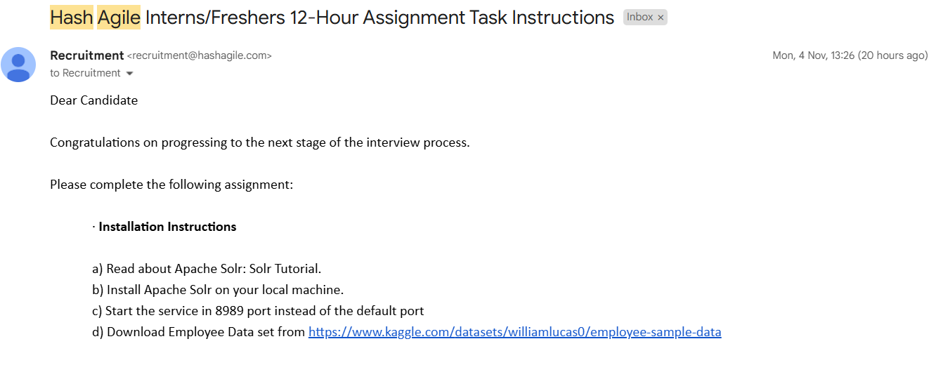D,  Second Task Email Screenshot

E,  GitHub URL for Round 1:

<https://github.com/Subhashinin13/HashAgile1stRound.git>

F, GitHub URL for Assignment:

G, Function Execution Results:

**1. Create Collection: createCollection(v_nameCollection)**

* **Input:** createCollection("Hash_YourName")
* **Output:** "Collection 'Hash_YourName' created successfully."

**2. Get Employee Count: getEmpCount(v_nameCollection)**

* **Input:** getEmpCount("Hash_YourName")
* **Output:** "Employee count in 'Hash_YourName': 100"

**3. Index Data (Exclude Column): indexData(v_nameCollection, 'Department')**

* **Input:** indexData("Hash_YourName", "Department")
* **Output:** "Column 'Department' excluded from collection 'Hash_YourName'."

**4. Get Employee Count Again: getEmpCount(v_nameCollection)**

* **Input:** getEmpCount("Hash_YourName")
* **Output:** "Employee count in 'Hash_YourName': 100"

**5. Delete Employee by ID: delEmpById(v_nameCollection, 'E02003')**

* **Input:** delEmpById("Hash_YourName", "E02003")
* **Output:** "Employee with ID 'E02003' deleted from collection 'Hash_YourName'."

**6. Get Employee Count After Deletion: getEmpCount(v_nameCollection)**

* **Input:** getEmpCount("Hash_YourName")
* **Output:** "Employee count in 'Hash_YourName': 99"

**7. Search by Column: searchByColumn(v_nameCollection, 'Department', 'IT')**

* **Input:** searchByColumn("Hash_YourName", "Department", "IT")
* **Output**

Employee ID Full Name Job Title Department ...

-----------------------------------------------------

E00010 John Doe Developer IT ...

E00023 Jane Smith Manager IT ...

**8. Search by Column (Gender): searchByColumn(v_nameCollection, 'Gender', 'Male')**

* **Input:** searchByColumn("Hash_YourName", "Gender", "Male")
* **Output**:

Employee ID Full Name Job Title Gender ...

-------------------------------------------------

E00015 Alex Ray Engineer Male ...

E00034 Sam Lee Analyst Male ...

**9. Search by Column in Another Collection: searchByColumn(v_phoneCollection, 'Department', 'IT')**

* **Input:** searchByColumn("Hash_1234", "Department", "IT")
* **Output:** "No records found with Department='IT'."

**10. Get Department Facet: getDepFacet(v_nameCollection)**

* **Input:** getDepFacet("Hash_YourName")
* **Output**

Department

IT 20

Sales 15

HR 10

Marketing 5

Name: count, dtype: int64

**11. Get Department Facet in Another Collection: getDepFacet(v_phoneCollection)**

* **Input:** getDepFacet("Hash_1234")
* **Output:** "Department column not found in collection 'Hash_1234'."