**Configuring Telnet on a switch and a router in Packet Tracer**

**Aim:** To configure Telnet on a switch and a router using Packet Tracer

Telnet is an application layer protocol that allows a network administrator to access and manage remote devices. A user on a client machine can use a software (also known as a Telnet client) to access a command-line interface of another, remote machine that is running a Telnet server program. A network administrator can access the device by telnetting to the IP address or hostname of a remote device. The network administrator will then be presented with a virtual terminal that can interact with the remote host.

**(i) Telnet configuration on a switch**

1. Create the network topology below in Packet Tracer.

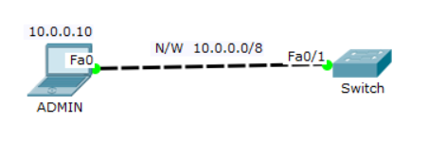

Assign the laptop a static IP address of 10.0.0.10. The topology above consists of an ADMIN laptop and a remote switch. Configure Telnet on the switch so that as the admin, you’ll be able to access and manage the switch remotely.

1. Configure enable password or enable secret password on the switch. If you fail to do this, you won’t get past the executive mode of the switch even after you establish a telnet connection to the switch.

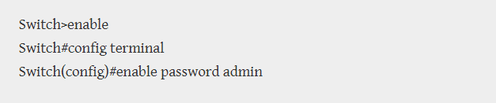

1. Configure a VLAN interface on the switch

Assign an IP address to the VLAN interface of the switch so that we can Telnet the switch from the laptop using this address.

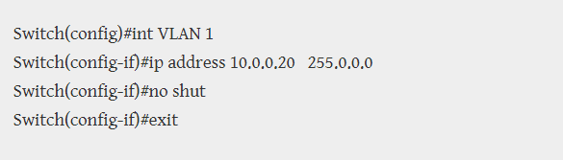

1. Configure a Telnet password for remote access.

This password is configured on VTY lines. VTY means Virtual Terminal. Before you can manage the switch remotely via Telnet, you’ll have to provide this password.

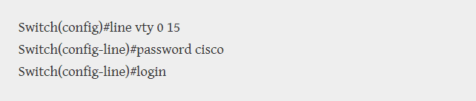

Telnet access to the switch is allowed through VTY lines. We can establish up to 16 telnet connections to the switch at the same time. That’s what ‘0 15’means.

1. Test Telnet connectivity. Go to command prompt of the laptop and type telnet 10.0.0.20. Hope you remember that 10.0.0.20 is the VLAN address of the switch through which we can access it remotely.

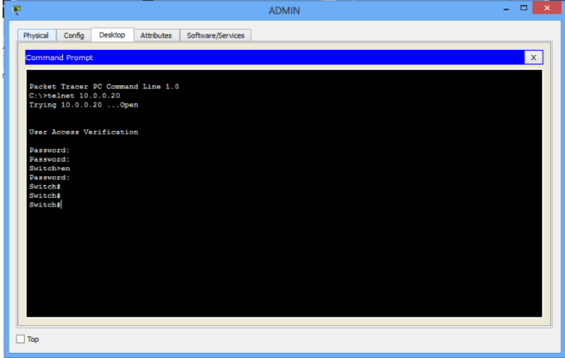

1. Now provide the Telnet password that you set in step 3. Mine is cisco. Notice that password characters won’t show up (no echo) on the screen as you type them, but just type, then hit ENTER. After you’re authenticated, you will see the CLI of the remote switch appear. Now provide the enable password admin (or yours which you set in step 1) to enter the privileged executive mode of the switch.
2. You can then continue to configure your switch the way you desire (but now, remotely). Note that Telnet and enable passwords are different. Enable password authenticates you into privileged executive mode of the terminal device (switch, for example), but you’re using Telnet Password to allow you access the interface of the remote device after connecting to it. You can see that we used telnet password to access the CLI of the remote switch.

That’s all for Telnet configuration on a switch.

**(ii)** **Telnet Configuration on Router**

For a router, Telnet configuration is almost same as that of the switch.

1. Build the network topology below

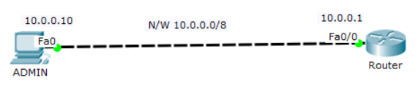

1. Configure enable password or enable secret password on the router

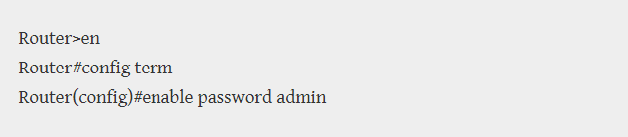

1. Configure IP addresses on the admin PC and interface fa0/0 of the router

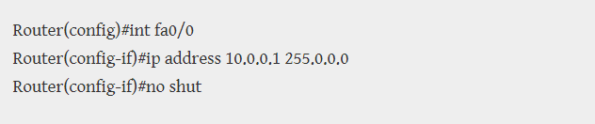

IP address 10.0.0.10 Subnet mask 255.0.0.0 Default gateway 10.0.0.1

1. Configure VLAN interface on the router. This interface allows for remote access on a switch or router via protocols such as Telnet or Secure Shell (SSH)

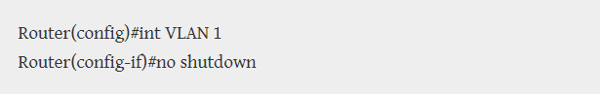

As you can see, we’ve not configured the VLAN interface with an IP address. We could do this but it unnecessary. We already have an interface fa0/0 of the router with an IP address through which we can Telnet the router from the PC.

1. We can now telnet the router using the IP address of fa0/0 interface. So, in the command prompt of the admin PC type telnet 10.0.0.1 then hit enter key.
2. Provide Telnet Password (that you set in step 4), then hit enter. Correct password allows you access the CLI of the router.
3. Now provide the enable password (that you set in step 2) to be allowed into privileged executive mode of the router.

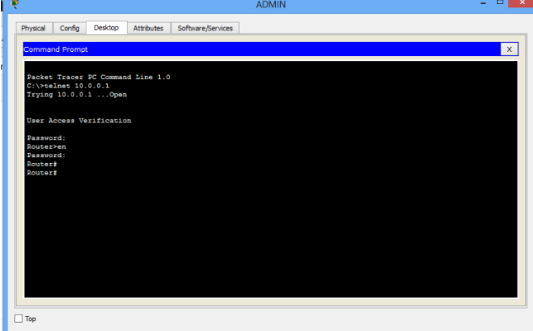

You can now do configurations on the router from the PC remotely.

**Result:** Telnet is configured successfully on a switch and a router using Packet Tracer