1. Create 2 Queues in PBS Cluster.
2. Big Queue

Commands to create Queue:

Qmgr: create queue big queue_type=execution

Qmgr: set queue big enabled=True

Qmgr: set queue big started=True

Qmgr: set queue big resources_default.nodes=1

Qmgr: set queue big resources_default.walltime=3600

Qmgr: p s

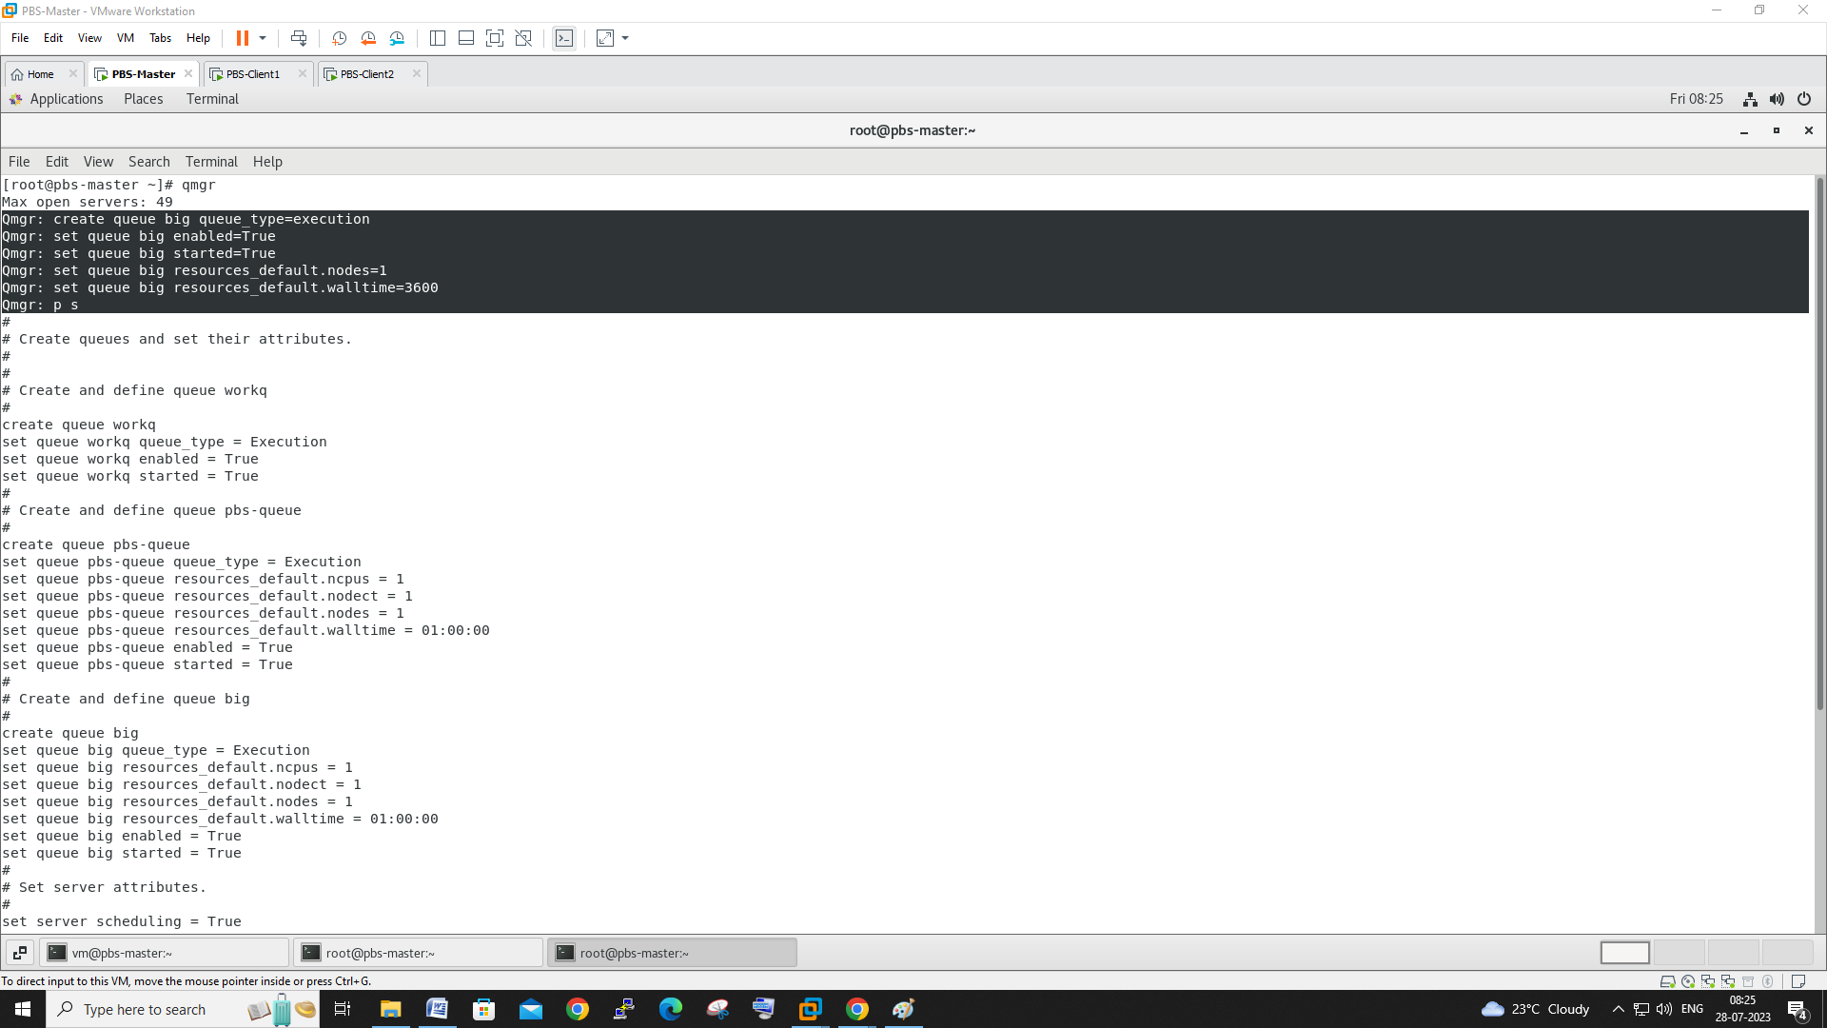

1. Small Queue Creation.

Qmgr: create queue small queue_type=execution

Qmgr: set queue small enabled=True

Qmgr: set queue small started=True

Qmgr: set queue small resources_default.nodes=1

Qmgr: set queue small resources_default.walltime=3600

Qmgr: ps

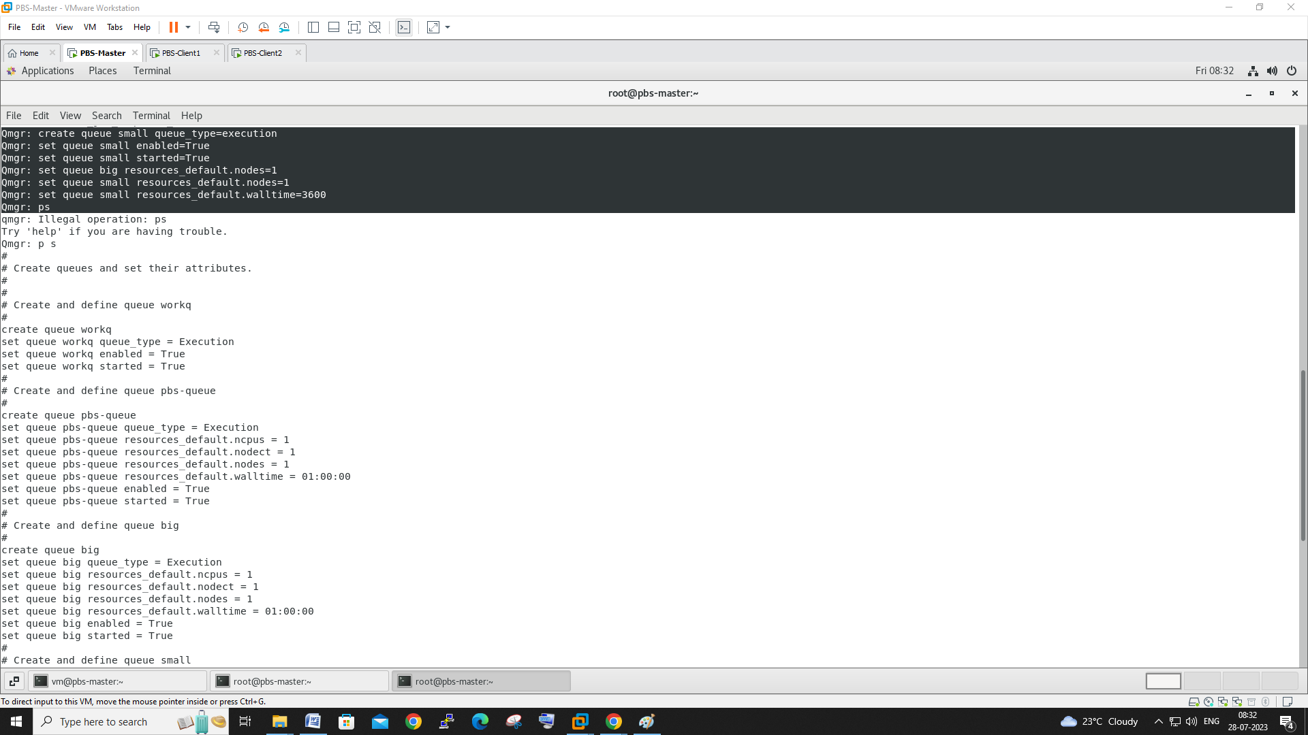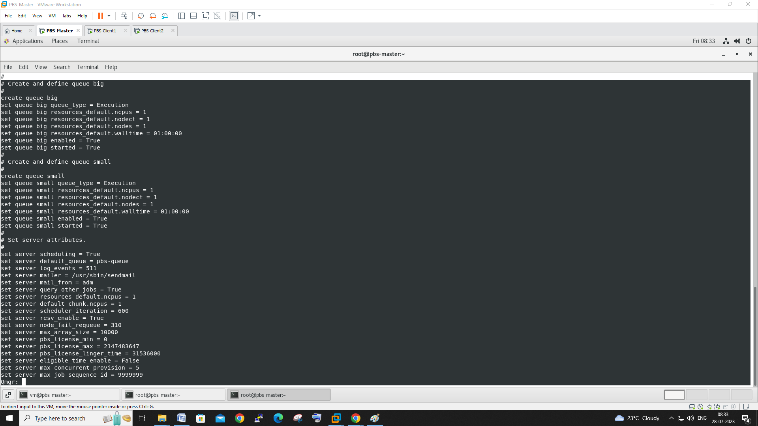

1. Adding each host to each Queue

Qmgr: set node pbs-client1 queue=big

Qmgr: set node pbs-client2 queue=small

