NIKE SALES INSIGHTS REPORT
Dashboard overview, data summary and key findings

1. Dashboard
The dashboard has two pages. Page 1 covers profit, revenue, region, channel, size and unit contribution. Page 2 covers order-level flags (profit, revenue, discount) and discount by product line.

Dashboard Page 1 – Sales Performance
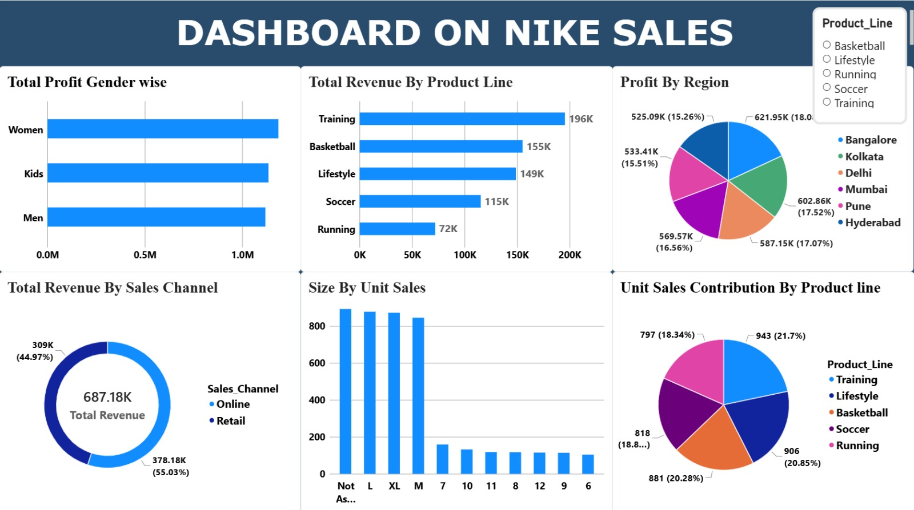

Dashboard Page 2 – Order Flags & Discounts
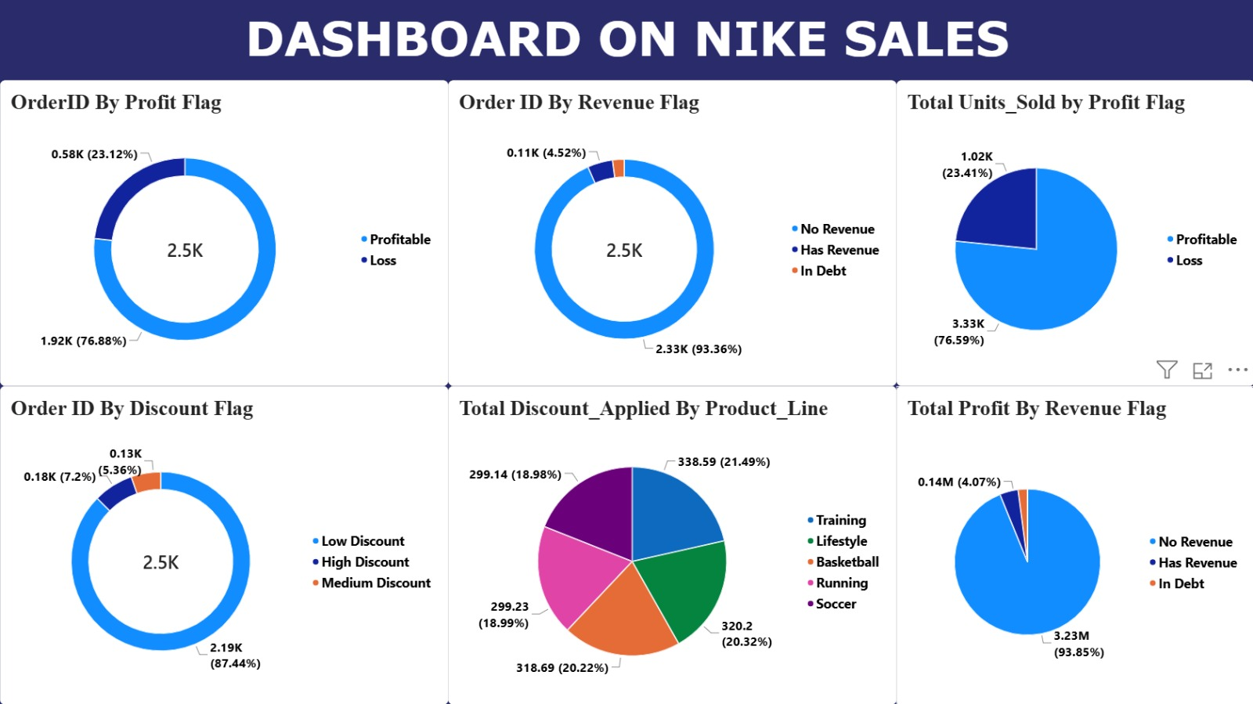

2. Data Summary
Source: Nike_Sales_Cleaned.xlsx (Sheet1) – 100 order records and 16 columns: Order_ID, Gender_Category, Product_Line, Product_Name, Size, Units_Sold, MRP, Discount_Applied, Revenue, Order_Date, Sales_Channel, Region, Profit, Profit Flag, Discount Flag and Revenue Flag. There are no blank cells. Currency values are shown as recorded in the file.

Key figures
Metric | Value
Total orders (rows) | 100
Total units sold | 170 (12 rows have returns / negative units)
Total revenue | 33,666
Total profit | 113,107
Average MRP | 6,255.52
Average discount applied | 0.63
Sales channels | Online (55 orders), Retail (45 orders)
Regions | 6 (Bangalore, Delhi, Hyderabad, Kolkata, Mumbai, Pune)
Product lines / products | 5 lines / 20 products
Order date range | Sep 2023 – Nov 2025 (27 orders have no date)

By gender category
Gender | Orders | Units | Revenue | Profit
Kids | 32 | 54 | 11,841 | 48,327
Men | 39 | 63 | 1,224 | 34,100
Women | 29 | 53 | 20,601 | 30,680

By product line
Product Line | Orders | Units | Revenue | Profit
Training | 28 | 40 | 5,500 | 34,146
Basketball | 21 | 48 | 15,101 | 23,523
Soccer | 16 | 21 | 2,515 | 19,384
Running | 19 | 28 | -2,579 | 18,339
Lifestyle | 16 | 33 | 13,129 | 17,715

By sales channel
Channel | Orders | Units | Revenue | Profit
Online | 55 | 90 | 9,134 | 65,778
Retail | 45 | 80 | 24,532 | 47,329

By region
Region | Orders | Units | Revenue | Profit
Pune | 14 | 33 | 20,031 | 30,953
Bangalore | 21 | 37 | 0 | 24,740
Delhi | 19 | 36 | 2,515 | 23,777
Mumbai | 17 | 28 | 6,619 | 12,731
Kolkata | 13 | 16 | 0 | 12,698
Hyderabad | 16 | 20 | 4,501 | 8,208

Flag distribution
Flag | Category | Orders | Share
Profit Flag | Profitable | 74 | 74%
 | Loss | 26 | 26%
Revenue Flag | No Revenue | 92 | 92%
 | Has Revenue | 6 | 6%
 | In Debt | 2 | 2%
Discount Flag | Low Discount | 89 | 89%
 | High Discount | 6 | 6%
 | Medium Discount | 5 | 5%

Data quality notes
- 27 of 100 orders have no order date (“Not Present”) and 18 have the size “Not Assigned”.
- 12 rows have negative Units_Sold (likely returns), and 4 Order_IDs appear more than once.
- Revenue is 0 for 92 of 100 orders, so revenue-based views depend on very few records.
- Size mixes apparel sizes (M, L, XL) and shoe sizes (6–12) in one column.
- Important: The Excel file has 100 orders and about 34K total revenue, whereas the dashboard shows about 2.5K orders and 687K revenue. The dashboard was therefore built on a larger dataset, and the Excel file appears to be a sample of it. Dashboard figures are quoted from the images; Excel figures come from the file. The two are not directly comparable in absolute terms, but their proportions are very similar.

3. Key Insights

Profit and revenue
- Profit is evenly spread across genders: Women, Kids and Men each bring in roughly 1.1–1.2M in profit on the dashboard, with Women slightly ahead. In the Excel sample, Kids lead on profit (48.3K) and Men are third.
- Training is the top revenue line: It generates 196K, followed by Basketball (155K), Lifestyle (149K), Soccer (115K) and Running (72K). Running earns about 63% less than Training.
- Running is the weakest line: It has the lowest revenue on the dashboard and is the only line with negative revenue (-2.6K) in the Excel sample.
- Training also leads on profit in the sample: Training earns 34.1K, about 30% of total profit, from the largest number of orders (28).
- Online generates more revenue than Retail: Online contributes 378.18K (55.03%) of the 687.18K total revenue and Retail 309K (44.97%).
- Retail is stronger per order in the sample: Retail brings in 24.5K of revenue from 45 orders, against 9.1K from 55 Online orders, but Online earns more profit (65.8K vs 47.3K).

Regions
- Regional profit is balanced: All six regions fall between 15.3% and 18.0% of profit. Bangalore leads (621.95K), then Kolkata (602.86K) and Delhi (587.15K). Hyderabad is lowest (525.09K).
- The narrow gap means no region is a clear weak spot, so growth is likely to come from improving individual product lines or channels rather than from one region.
- Pune is the revenue standout in the sample: It holds 20.0K of the 33.7K total revenue and the highest profit (31.0K).

Units and sizes
- Unit sales are evenly split across product lines: Training sells the most (943 units, 21.7%) and Running the least (797 units, 18.34%).
- Running sells fewer units and earns the least revenue, so improving demand or pricing for Running is the clearest opportunity.
- Apparel-style sizes dominate: “Not Assigned”, L, XL and M each sell roughly 850–890 units, while each individual shoe size (6–12) sells only about 100–160.
- A large “Not Assigned” size group is a data gap: It is among the top sellers, so size-level analysis is incomplete until it is filled in.

Orders, profit and loss
- Most orders are profitable: About 1.92K of 2.5K orders (76.88%) are profitable and 0.58K (23.12%) make a loss. The Excel sample shows the same pattern (74 vs 26).
- Units follow the same pattern: 3.33K units (76.59%) are sold in profitable orders and 1.02K (23.41%) in loss-making ones.
- Loss-making orders carry heavier discounts in the sample: They account for 26% of orders but 27% of total discount applied, and their profit is -16.4K versus 129.5K for profitable orders.
- Profit comes almost entirely from orders flagged “No Revenue”: They hold 3.23M (93.85%) of profit, which suggests the revenue field is incomplete or not recorded for most orders.

Discounts
- Almost all orders carry a low discount: 87.44% are Low Discount, 7.2% are High and 5.36% are Medium.
- Discounting is similar across product lines: Training has the highest total discount applied (338.59, 21.49%), and Soccer and Running the lowest (about 299, 19%).
- Training combines the highest discount and the highest revenue, which makes it the best line to test whether lighter discounting can protect margin.
- High discounts are rare, so their effect is limited: The six High Discount orders in the sample earned about 2.6K profit and negative revenue.

4. Recommendations
- Prioritise Training and Basketball for stock and promotion, as they lead on revenue and units.
- Review Running pricing, range and discounting, as it is the lowest-earning line.
- Investigate loss-making orders (about 23–26% of orders) by checking discount level, product and channel.
- Keep growing Online while looking at what makes Retail orders more valuable.
- Fix data quality: fill in missing dates and sizes, remove duplicate Order_IDs, and confirm how revenue is recorded so that “No Revenue” stops dominating the analysis.

