***Cognizant Java FSE – (Deep Skilling)***

***(WEEK-8)***

# **MODULE: GIT**

*Submitted by*

Name: S Subhashri

Email: [22102152@rmd.ac.in](mailto:22102152@rmd.ac.in)

College: RMD ENGINEERING COLLEGE

Batch: Java FSE – 2026

Superset ID: 6397078

**Exercise 1: Basic Git Setup & Commit**

**EXERCISE 2: Using .gitignore**

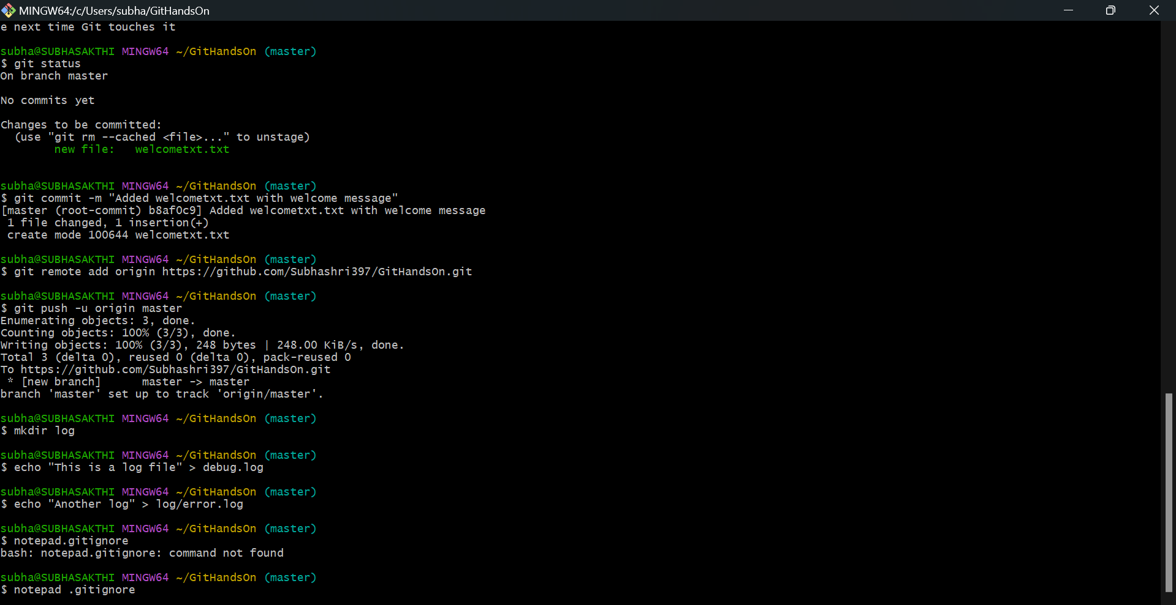

**EXERCISE : 3 Branching & Merging**

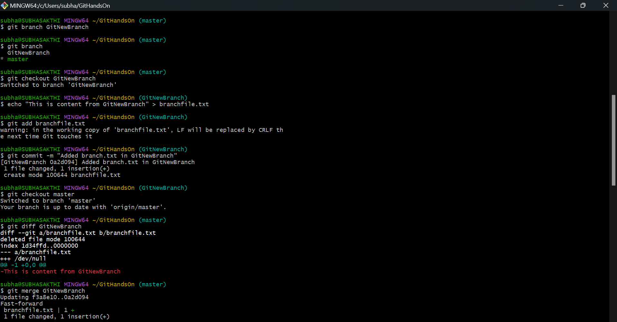

**Exercise : 4 Conflict Resolution**

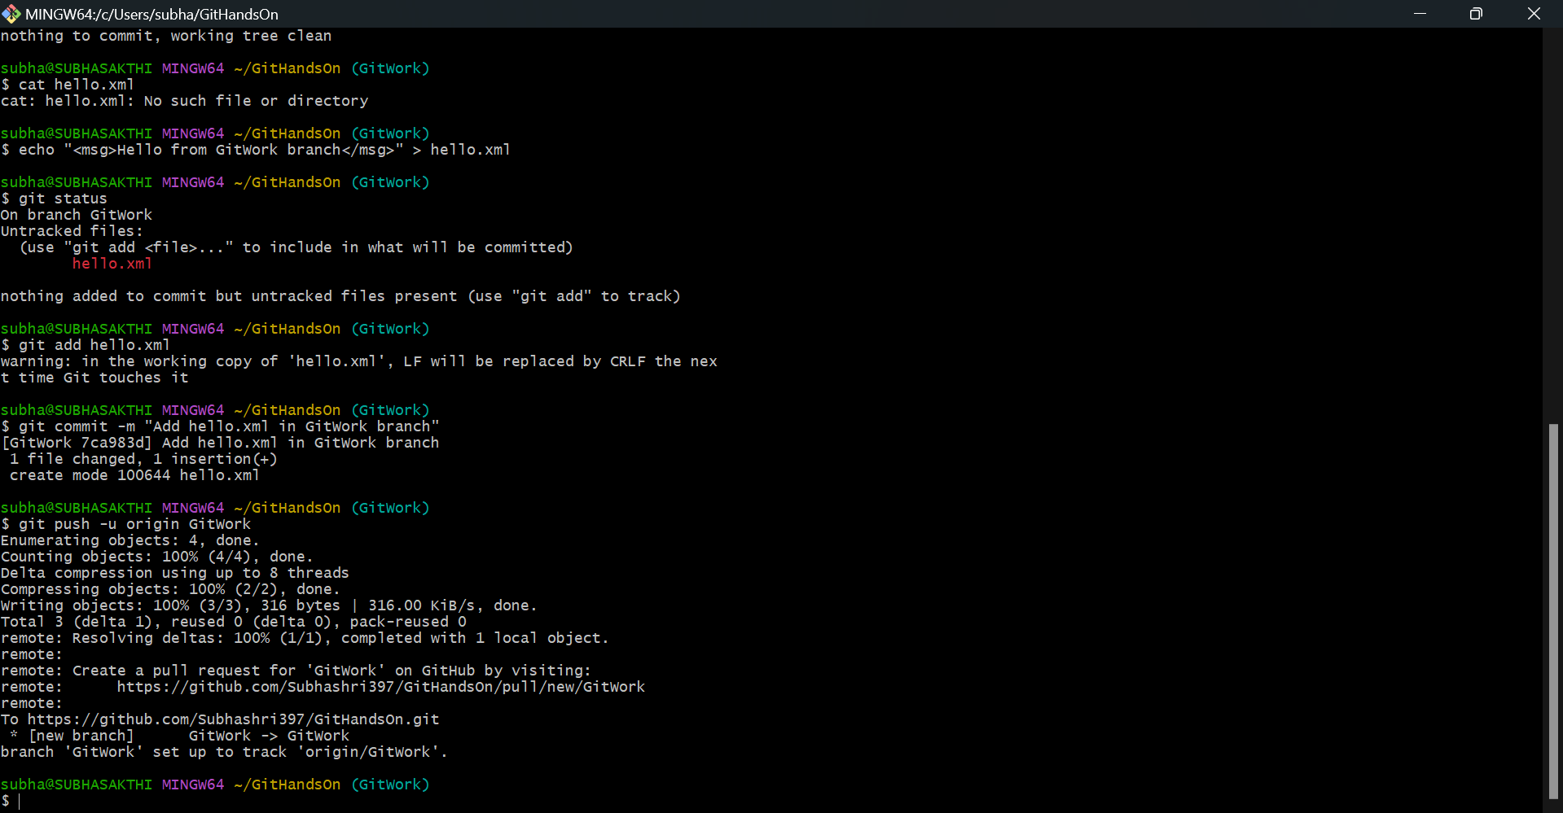

**Exercise 5: CLEANUP AND PUSH**

