Enterprise DevOps Project
From Code to Production — A Step-by-Step Setup Guide
How to build a real-world, production-style microservices platform
using AWS, Terraform, Docker, Kubernetes, Jenkins, and Prometheus/Grafana
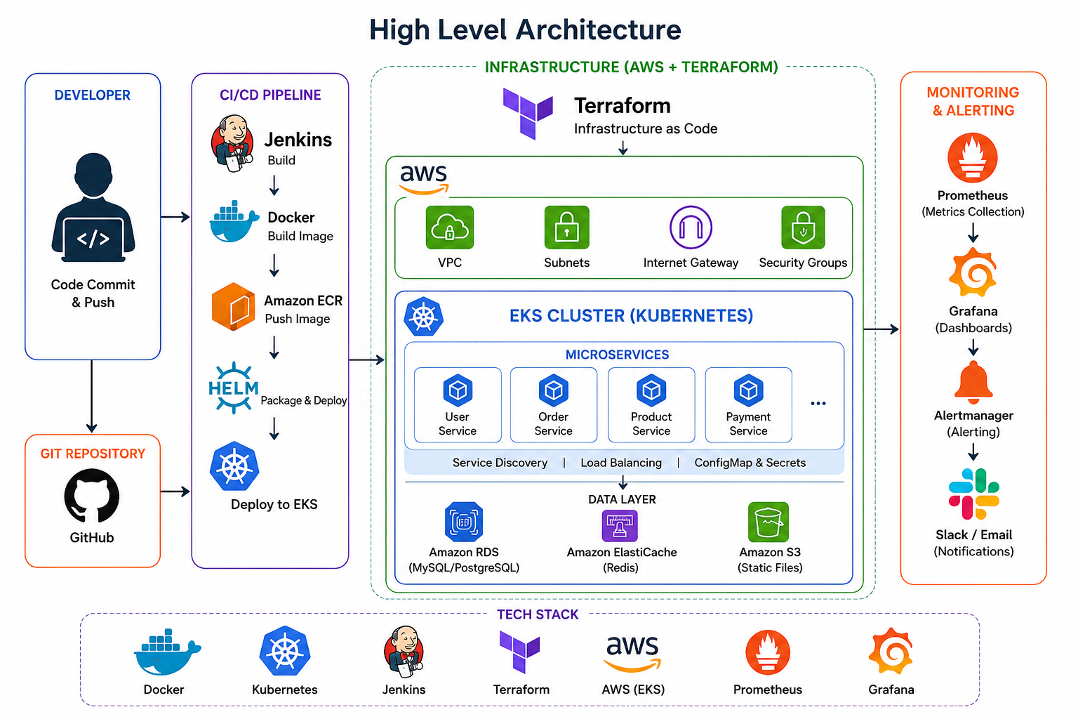

Table of Contents

Why This Document?
This guide explains, in plain language, how a real company sets up a production-ready application platform. We don't just install tools randomly — we follow an engineering lifecycle where every step prepares the foundation for the next.
By the end, you'll understand exactly how code goes from a developer's laptop, through automated testing and deployment, all the way to a live, monitored, secured application running for real users.

1. High-Level Architecture
Before setup, it helps to see the big picture. The diagram below shows how all the pieces connect: the developer commits code, the CI/CD pipeline builds and deploys it, the AWS infrastructure runs it inside Kubernetes, and the monitoring stack keeps watch over everything.

How to Read This Diagram
- Developer: writes code and pushes it to GitHub.
- CI/CD Pipeline: Jenkins automatically builds, containerizes (Docker), and deploys (Helm) the code.
- Infrastructure (AWS + Terraform): the cloud foundation — VPC, subnets, security groups — and the EKS (Kubernetes) cluster running all microservices.
- Data Layer: RDS (database), ElastiCache (Redis), and S3 (file storage) support the microservices.
- Monitoring & Alerting: Prometheus collects metrics, Grafana visualizes them, and Alertmanager sends alerts to Slack/Email.

2. Tech Stack Used
Each tool in this project has one clear job. Here's what each one is for:
Tool | Role in the Project
Docker | Containerize each microservice
Kubernetes (EKS) | Run and orchestrate containers
Jenkins | Automate build and deployment (CI/CD)
Terraform | Create AWS infrastructure as code
AWS | Cloud provider hosting everything
Prometheus | Collect metrics from the cluster
Grafana | Visualize metrics on dashboards

3. The Complete Flow, Step by Step
This is the full journey from an idea to a live, production application. Each numbered step builds on the one before it.
- Gather Requirements
- Design Architecture
- Create GitHub Repositories
- Setup AWS Account & IAM
- Write Terraform Modules
- Deploy Networking (VPC, Subnets, IGW, NAT)
- Deploy EKS Cluster
- Provision RDS, Redis, S3 & ECR
- Dockerize Microservices
- Push Images to ECR
- Create Helm Charts
- Install & Configure Jenkins
- Build CI/CD Pipeline
- Deploy Applications to EKS
- Configure ALB, Ingress & DNS
- Setup Monitoring (Prometheus & Grafana)
- Setup Logging (Fluent Bit & Loki)
- Configure Alerting (Alertmanager)
- Implement Security Best Practices
- Test, Optimize & Release to Production

4. Detailed Setup Guide (18 Phases)
Now let's go through every phase in detail — what it is, what you actually do, and what you should have at the end of it.

Phase 1: Requirement Gathering & Planning
Before touching any tool, understand what you are building.
What you do:
- Understand the business requirements of the application
- Identify all the microservices needed (user, order, payment, etc.)
- Estimate expected traffic and load
- Define environments: Development, QA, Staging, Production
- Decide on the cloud provider (we use AWS)
- Decide the DevOps tool stack (Terraform, Jenkins, Docker, Kubernetes, etc.)
- Estimate infrastructure cost
Deliverable: Architecture diagram, infrastructure design, technology stack, repo strategy, environment plan.

Phase 2: Source Code Preparation
Set up where the application code will live before building any infrastructure.
What you do:
- Create a GitHub Organization for the project
- Create one repository per microservice (user-service, order-service, payment-service, product-service, notification-service)
- Create separate repos for terraform-infra, helm-charts, and jenkins-pipeline
- Define a branching strategy (e.g. main, develop, feature/*)
- Define pull request rules and a code review process
- Set repository permissions for the team
Deliverable: All source code repositories created and ready.

Phase 3: AWS Foundation
Prepare the cloud account and access before creating any resources.
What you do:
- Create the AWS account
- Create IAM Users, IAM Groups, and IAM Roles
- Set up billing alerts so costs don't surprise you
- Install and configure the AWS CLI
- Create a Terraform backend (S3 + DynamoDB) to store infrastructure state
- Plan your network: CIDR block 10.0.0.0/16, 2 public subnets, 2 private subnets
Deliverable: AWS account fully ready for infrastructure creation.

Phase 4: Infrastructure as Code (Terraform)
From this point on, nothing is created manually in the AWS console — everything is written as code.
What you do:
- Write reusable Terraform modules for: VPC, Subnets, Internet Gateway, NAT Gateway, Route Tables, Security Groups, IAM, EKS, RDS, Redis, S3
- Organize the repo as: terraform/modules/{vpc, eks, rds, redis, s3, security-group} and terraform/environments/{dev, stage, prod}
Deliverable: Complete, reusable infrastructure code ready to deploy.

Phase 5: Networking Deployment
Deploy the private network first — everything else lives inside it.
What you do:
- Run Terraform to create the VPC
- Create public and private subnets
- Create the Internet Gateway and an Elastic IP
- Create the NAT Gateway (lets private resources reach the internet)
- Configure Route Tables, Network ACLs, and Security Groups
Deliverable: A private, secure AWS network is ready.

Phase 6: Kubernetes Infrastructure (EKS)
With networking ready, deploy the Kubernetes cluster that will run your microservices.
What you do:
- Use Terraform to create the EKS Cluster
- Create Managed Node Groups (the worker machines)
- Create IAM Roles and the OIDC Provider for the cluster
- Add IAM policies needed for autoscaling
- Configure kubectl and kubeconfig on your machine
- Verify the cluster with: kubectl get nodes
Deliverable: A running, verified Kubernetes cluster.

Phase 7: Supporting AWS Services
Provision the backend services your applications will depend on.
What you do:
- Create Amazon RDS (managed MySQL/PostgreSQL database)
- Create Amazon ElastiCache (Redis) for caching
- Create Amazon S3 buckets for static files
- Create an ECR repository to store Docker images
- Enable CloudWatch Logs
Deliverable: All backend services available for the applications.

Phase 8: Application Containerization
Package each microservice so it can run anywhere, the same way every time.
What you do:
- For every microservice, prepare: application code, a Dockerfile, a .env file, a health check endpoint, requirements, and a build script
- Example flow: User Service → Docker Build → Docker Image → Push to Amazon ECR
Deliverable: Container images for every microservice, ready to deploy.

Phase 9: Kubernetes Manifests / Helm Charts
Define exactly how each service should run on Kubernetes, packaged for repeatable deployment.
What you do:
- For every service create: Deployment, Service, Ingress, ConfigMap, Secret, Horizontal Pod Autoscaler, Service Account
- Package everything into Helm charts
- Organize as: helm/{user-service, order-service, payment-service, shared-library}
Deliverable: Deployment templates ready for every microservice.

Phase 10: CI/CD Infrastructure (Jenkins)
Set up the server that will automate your build-and-deploy process.
What you do:
- Provision a Jenkins server
- Install Docker, AWS CLI, kubectl, Helm, Terraform, Git, and Java on it
- Configure credentials: AWS access, GitHub token, Slack, Email, and build agents
Deliverable: CI/CD server fully operational.

Phase 11: Build the CI/CD Pipeline
Automate the journey from code commit to running application.
What you do:
- Create a Jenkins Pipeline with this flow:
- Developer pushes code → Webhook trigger → Checkout code → Run unit tests → Build application → Docker build → Tag image → Push image to ECR → Helm package → Deploy to EKS → Smoke test → Notify team
Deliverable: Fully automated deployments — push code, and it ships itself.

Phase 12: Deploy Microservices
Deploy services in the correct dependency order so nothing fails on startup.
What you do:
- Deploy in this order: Database → Redis → User Service → Product Service → Order Service → Payment Service → Notification Service
- Verify Pods, Services, Endpoints, and Ingress are all healthy
Deliverable: The full application running inside the cluster.

Phase 13: External Access
Make the application reachable by real users on the internet.
What you do:
- Configure the AWS Load Balancer Controller
- Set up an Application Load Balancer (ALB) and Ingress rules
- Attach an SSL certificate for HTTPS
- Point a Route53 DNS record to the load balancer
- Traffic flow: User → DNS → ALB → Ingress → Service → Pods
Deliverable: Application accessible publicly and securely.

Phase 14: Monitoring
See what's happening inside your cluster at all times.
What you do:
- Install Prometheus, Grafana, Node Exporter, and kube-state-metrics
- Monitor nodes, pods, deployments, CPU, memory, network, and storage
Deliverable: Live dashboards showing the health of the whole platform.

Phase 15: Logging
Centralize logs from everywhere so you can debug issues quickly.
What you do:
- Install Fluent Bit, Loki, and connect to Grafana
- Collect application logs, container logs, node logs, and Kubernetes events
Deliverable: One place to search and view all logs.

Phase 16: Alerting
Get notified the moment something goes wrong, instead of finding out from a user.
What you do:
- Configure Alertmanager for: pod crash, node failure, high CPU, high memory, disk full, application down, ingress failure
- Send notifications to Slack, Email, and Microsoft Teams
Deliverable: Real-time alerts reaching the team automatically.

Phase 17: Security
Harden the platform before it goes anywhere near production traffic.
What you do:
- Use IAM Roles and IRSA (IAM Roles for Service Accounts)
- Store secrets in Secrets Manager and Kubernetes Secrets
- Apply RBAC and Network Policies
- Scan container images for vulnerabilities
- Enable encryption and follow the principle of least privilege
Deliverable: A secured, production-grade platform.

Phase 18: Production Readiness
Final checks to make sure the platform can handle real-world failure and load.
What you do:
- Set up Horizontal Pod Autoscaler and Cluster Autoscaler
- Define a rolling update and rollback strategy
- Implement Blue-Green and Canary deployment options
- Set up a backup strategy and a disaster recovery plan
- Review cost optimization opportunities
- Write infrastructure documentation
- Perform load testing, security testing, DR drills, and end-to-end validation
Deliverable: A fully tested, production-ready platform.

5. Key Takeaway for Students
Notice the pattern: Plan → Code → Infrastructure → Containers → Automation → Deployment → Visibility → Security. This is the exact sequence followed by enterprise DevOps teams, because each phase depends on the one before it. Learning the tools in isolation is not enough — understanding this sequence is what makes you job-ready.

