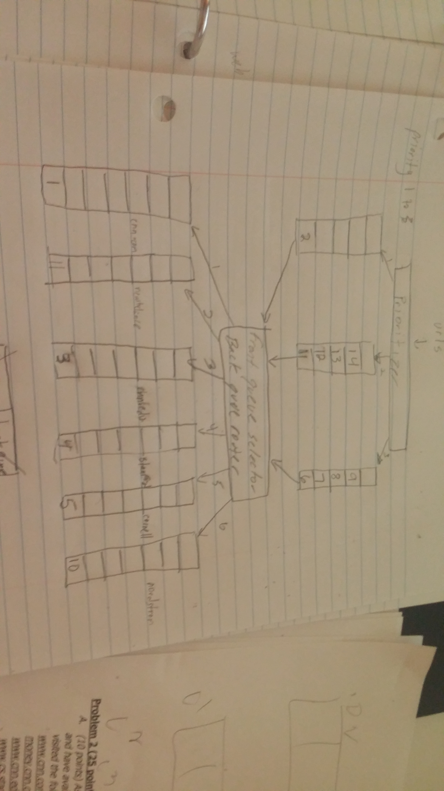

|  |  |
| --- | --- |
| URL | Figure Label |
| www.cnn.com | 1 |
| money.cnn.com | 2 |
| www.cnn.edu/world/ | 3 |
| www.cs.stanford.edu/ | 4 |
| www.cs.cornell.edu/ | 5 |
| www.cs.stanford.edu/~manning | 6 |
| www.cs.stanford.edu/~ng | 7 |
| http://machinelearning.cis.cornell.edu/pages/people.php | 8 |
| http://www.cs.cornell.edu/home/kleinber/ | 9 |
| http://shop.nordstrom.com/ | 10 |
| http://www.newbalance.com/ | 11 |
| http://www.newbalance.com/women/clothing/short-sleeve-shirts-1/ | 12 |
| www.macys.com | 13 |
| http://www.amazon.com | 14 |

|  |  |
| --- | --- |
| Host | Back Queue |
| Cnn.com | 0 |
| Cnn.edu | 0 |
| Stanford.edu | 0 |
| Cornell.edu | 0 |
| Nordstrom.com | 0 |
| Newbalance.com | 0 |
| Macys.com | 0 |
| Amazon.com | 0 |

This is at the beginning of the crawl when the queues are being filled for the first time. No Page has been crawled.