Analysis of ECG / EKG signal using MATLAB

Advaith Girish   
Dept. of Electronics & Communication Engineering  
IIITDM Kancheepuram  
esd18i002@iiitdm.ac.in

Subhasish Pramanik  
Dept. of Electronics & Communication Engineering  
IIITDM Kancheepuram  
esd18i025@iiitdm.ac.in

*Abstract*— This research deals with the study and analysis of ECG / EKG signals processed by the software MATLAB. The paper contains simulation of ECG signal, feature extraction and comparison of the ECG signal with the normal ranges. It also deals with the abnormalities that can be bought up by analysing the ECG signal. This report shows us that ECG signals can be processed and analysed in real time also by the use of MATLAB with great accuracy and convenience.

Keywords—component, formatting, style, styling, insert (key words)

# Introduction (ECG / EKG signal)

Electrocardiography is the process of producing an electrocardiogram (ECG or EKG). [[1]](https://en.wikipedia.org/wiki/Electrocardiography)

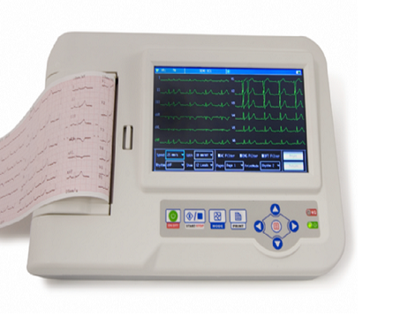

Fig. A typical Electrocardiogram Machine

An electrocardiogram — abbreviated as EKG or ECG — is a test that measures the electrical activity of the heartbeat. With each beat, an electrical impulse (or “wave”) travels through the heart. This wave causes the muscle to squeeze and pump blood from the heart. [[2]](https://www.heart.org/en/health-topics/heart-attack/diagnosing-a-heart-attack/electrocardiogram-ecg-or-ekg)

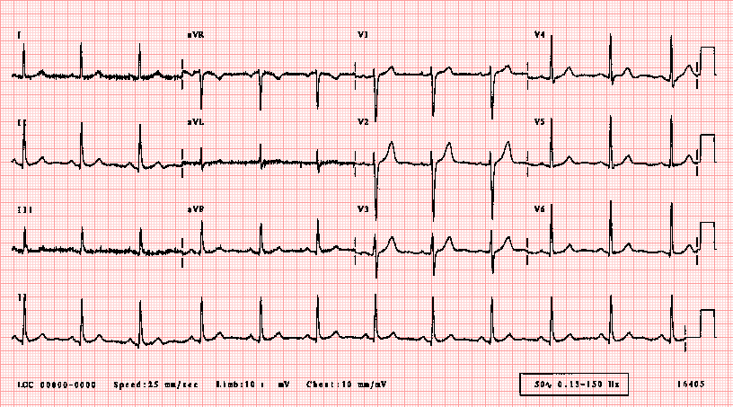

Fig. A typical ECG / EKG graph

 It is a graph of [voltage](https://en.wikipedia.org/wiki/Voltage" \o "Voltage) versus time of the electrical activity of the [heart](https://en.wikipedia.org/wiki/Heart" \o "Heart)[[4]](https://en.wikipedia.org/wiki/Electrocardiography" \l "cite_note-5) using [electrodes](https://en.wikipedia.org/wiki/Electrode" \o "Electrode) placed on the skin. These electrodes detect the small electrical changes that are a consequence of cardiac muscle [depolarization](https://en.wikipedia.org/wiki/Depolarization" \o "Depolarization) followed by [repolarization](https://en.wikipedia.org/wiki/Repolarization" \o "Repolarization) during each cardiac cycle (heartbeat). [[1]](https://en.wikipedia.org/wiki/Electrocardiography)

In a conventional 12-lead ECG, ten electrodes are placed on the patient's limbs and on the surface of the chest. The overall [magnitude](https://en.wikipedia.org/wiki/Magnitude_(mathematics)" \o "Magnitude (mathematics)) of the heart's [electrical potential](https://en.wikipedia.org/wiki/Electrical_potential" \o "Electrical potential) is then measured from twelve different angles ("leads") and is recorded over a period of time (usually ten seconds). In this way, the overall magnitude and direction of the heart's electrical depolarization is captured at each moment throughout the [cardiac cycle](https://en.wikipedia.org/wiki/Cardiac_cycle" \o "Cardiac cycle). [[1]](https://en.wikipedia.org/wiki/Electrocardiography)

There are three main components to an ECG: the [P wave](https://en.wikipedia.org/wiki/P_wave_(electrocardiography)" \o "P wave (electrocardiography)), which represents the depolarization of the atria; the [QRS complex](https://en.wikipedia.org/wiki/QRS_complex" \o "QRS complex), which represents the depolarization of the ventricles; and the [T wave](https://en.wikipedia.org/wiki/T_wave" \o "T wave), which represents the repolarization of the ventricles. [[1]](https://en.wikipedia.org/wiki/Electrocardiography)

In this project, we use ECG samples from the database of PhysioNet ATM [[3]](https://physionet.org/). For the project we used the software MATLAB provided by MATHWORKS. The ECG samples had a lot of noise, so we used Low-pass & High-pass filter respectively to filter out the ECG signal with good QRS complex.

After filtering the ECG signal with the use of MATLAB, we perform the following steps

1. Load the ECG data.
2. Plot the patient’s ECG and add labels.
3. Add the peak markers to the ECG graph.
4. P-Wave analysis.
5. PR interval analysis.
6. QRS interval analysis.
7. QT interval analysis.
8. Information declaration.

# Reading the ECG Signal

## Significant features of ECG signal :

A typical ECG graph, plotted in a graph paper. The ECG paper speed is ordinarily 25mm/sec. As a result, each 1mm box corresponds to 0.04 second (40 millisecond).

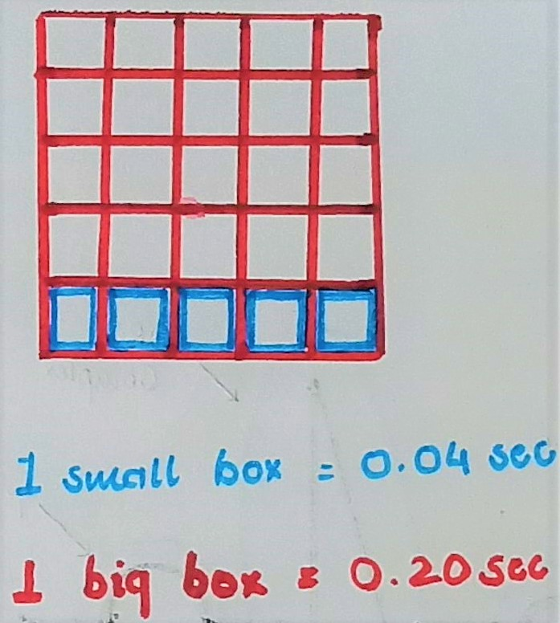

Fig. An ECG graph paper boxes

A typical electrocardiograph lead is shown in the Fig. below.

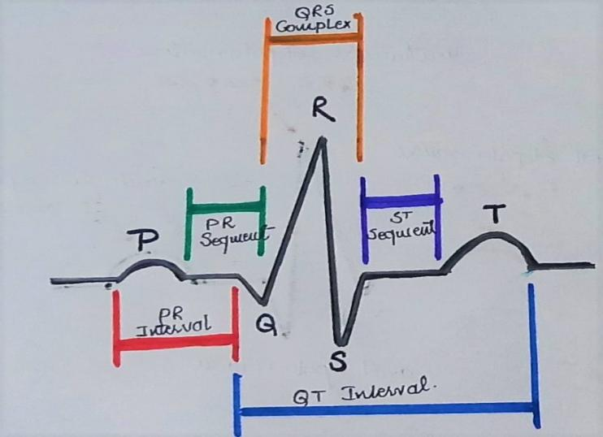

Fig. A typical ECG lead

The significant features of the waveform are

1. P, Q, R, S, and T peaks.
2. P and T wave & duration of them.
3. QRS complex & duration of them.
4. P-R, Q-R-S and Q-T intervals.

When we observe an ECG graph, we notice that it is a mixture of triangular and sinusoidal waveforms. While the QRS complex can be said to be triangular waveforms, P & T are sinusoidal waveforms.

While every amplitude, variations, the point-intervals and the heart rate should be in a specified gap for the diagnosis to be normal. The normal time interval for different intervals are :

1. Heart rate should be in-between 60 and 100 beats per minute.
2. Heart rate variation should be less than 10%.
3. P-R interval should be in-between 0.12 seconds to 0.20 seconds.
4. QRS complex should be less than 0.12 seconds.
5. Q-T interval should be less than 0.48 seconds.

# Analysis of ECG Signal

A typical period of an ECG signal consists of the following [[4]](https://www.youtube.com/watch?v=FThXJUFWUrw):

* P-wave : P-wave represents atrial depolarization. During atrial depolarization, the atrium are contracting.
* QRS complex : QRS complex represents ventricular depolarization. During ventricular depolarization, the ventricles of the heart are contracting.
* T-wave : T-wave represents ventricular repolarization. During ventricular repolarization, the ventricles get relaxed.

Every depolarization is always followed by repolarization. But there is no sign of an atrial repolarization because ventricles tend to contract stronger than the atrium, they tend to mask the atrial repolarization.

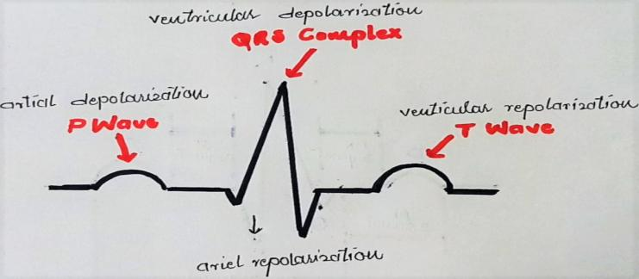

Fig. Depolarizarion & repolarization

* Heart rate in an ECG is basically derived from the R-peaks. The number of R-peaks in a period of time decides the heart rate of the person.

# ECG Signal Acquisition

All the ECG signals were acquired from the PysioNet ATM [[3]](https://physionet.org/). After acquiring the ECG signals, they were processed with the help of MATLAB software. They were passed on from the low-pass & high-pass filters to reduce the noise & the high-peak disturbances respectively. They were then loaded into another MATLAB file for processing, analysis & diagnosis.

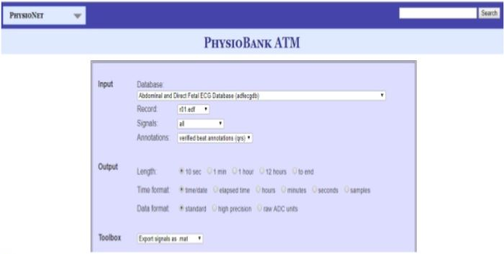

Fig. PhysioNet ATM for sample ECG signal

# ECG Signal processing & Analysis

After loading the ECG signals, the following some analysis and diagnosis on the ECG were performed:

## Peak identification

At first an array is created with the indices of each peak. After the peaks are identified, markers were added to each peak to segregate them into different peaks (P, Q, R, S, T peaks). After this the graph is plotted with the markers marking the peaks and a legend showing the peak types.

## Function that returns interval between peaks

After identifying the peaks and plotting them into the ECG graph, we made a function to identify the interval between the peaks. The following steps were done to create the function :

1. Declare the function.
2. Check if the second peak comes before the first peak at the start.
3. Check if the first peak appears at the end of the data without the second peak after.
4. Return the array with interval between eah set of pairs.

## P-wave analysis

1. Calculating the period of heart beat and then finding the heart rate. The equation to calculate the average heart rate is given below :

**Average Heart Rate = 60 \* Average R-R interval(sec)**

1. Comparing the heart rate with normal heart rate and diagnosing problems (if any).
2. Calculating the maximum variation in heart rate. The equation to calculate the variation in heart rate is given below :

**Variation in Heart Rate = {{RR interval(i-1) - RR interval(i)} / RR interval(i-1)}**

1. Comparing the maximum variation in heart rate with normal variation in heart rate and diagnosing problems (if any).

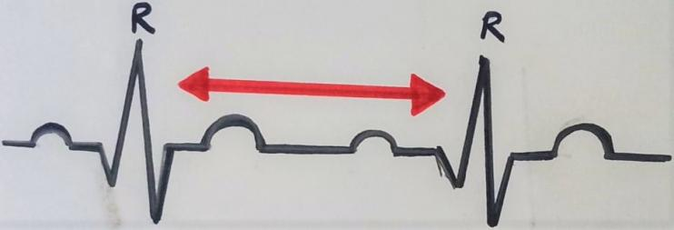

Fig. R-R interval in an ECG lead

## PR interval analysis

1. Finding each PR interval.
2. Calculating the average PR interval. The equation to calculate the average PR interval is given below :

**Average PR Interval = Sum of all PR interval / No. of PR interval**

1. Comparing the PR interval duration with normal PR interval and diagnosing problems (if any).

## QRS interval analysis

1. Finding each QRS interval.
2. Calculating the average QRS interval. The equation to calculate the average QRS interval given below :

**Average QRS interval = Sum of all QRS interval / No. of QRS interval**

1. Comparing the QRS interval duration with normal QRS interval and diagnosing problems (if any).

## QT interval analysis

1. Finding the QT interval (here it is calculated from Q peak to T peak).

NOTE : although QT interval should be from start of Q wave and till T wave, by approximation we took it from the peaks.

1. Calculating the average QT interval. The equation to calculate the average QT interval is given below :

**Average QT interval = Sum of all QT interval / No. of QT interval**

1. Comparing the QT interval duration with normal QT interval and diagnosing problems (if any).

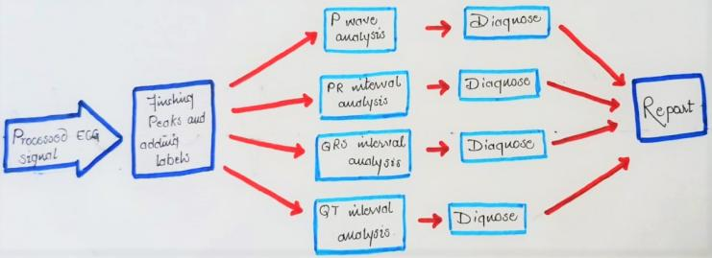

Fig. Block Diagram of ECG signal processing

# Problem Diagnosis

The different problems diagnosed from the software are :

* Heart Rate :
  + If 60 < Heart Rate < 100, Heart Rate is normal.
  + If Heart Rate < 60, problem - Sinus Bradycardia.
  + If Heart Rate > 100, problem - Sinus Tachycardia.

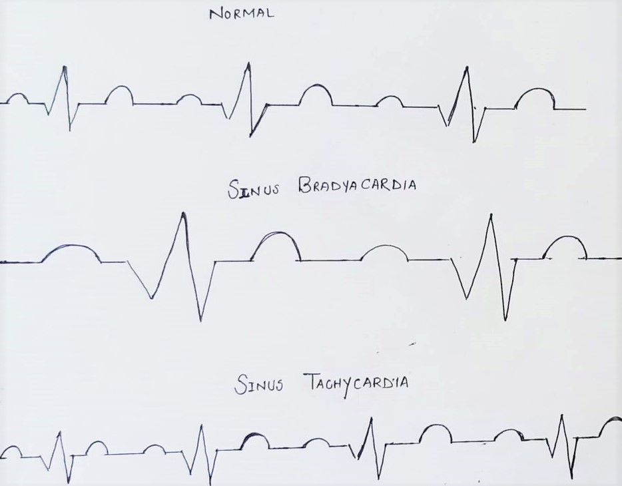

Fig. Problem associated with Heart Rate Variation

* Maximum Variation in Heart Rate :
  + If Maximum Variation in Heart Rate < 10%, Maximum Variation in Heart Rate is normal.
  + If Maximum Variation in Heart Rate > 10%, problem - Sinus Arrhythmia.

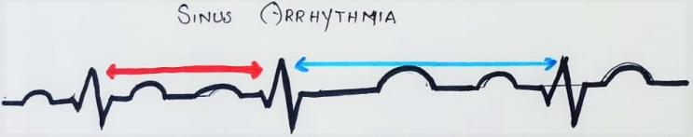

Fig. Problem associated with Heart Rate Variation

* Average PR Interval :
  + If 0.12s < Average PR Interval < 0.20s, PR Interval is normal.
  + If Average PR Interval < 0.12s, problem - short, can be Wolff Parkinson White Syndrome or Lown Ganone Levine Syndrome.
  + If Average PR Interval > 0.20s, problem - long, can be 1st degree heart block & trifascular block.
* Average QRS Interval :
  + If Average QRS Interval < 0.12s, QRS interval is normal.
  + If Average QRS Interval > 0.20s, problem - long, can be right or left bundle block, Hyperkalaemia.
* Average QT Interval :
  + If Average QT Interval < 0.48s, QT Interval is normal.
  + If Average QT Interval > 0.48s, problem - high, can be Myocardial Infarction or Subarachnoid Haemorrhage (SAH).

# Problems Associated with ECG Diagnosis

* Sinus Bradycardia : Sinus Bradycardia is a slow, regular heartbeat. It happens when the heart’s pacemaker, the sinus node, generates heart beats less than 60 times in a minute.
* Sinus Tachycardia : Sinus tachycardia (also colloquially known as sinus tach or sinus tachy) is an elevated sinus rhythm characterized by an increase in the rate of electrical impulses arising from the sinoatrial node. In adults, sinus tachycardia is defined as a heart rate greater than 100 beats/min (bpm).
* Sinus arrhythmia is a variation of normal sinus rhythm that characteristically presents with an irregular rate in which the change in the R-R interval is greater than 0.12 seconds.
* Wolff Parkinson White Syndrome : In Wolff-Parkinson-White (WPW) syndrome, an extra electrical pathway between your heart's upper and lower chambers causes a rapid heartbeat. The episodes of fast heartbeats usually aren't life-threatening, but serious heart problems can occur.
* Lown Ganone Levine Syndrome : Lown–Ganong–Levine syndrome (LGL) is a pre-excitation syndrome of the heart. Those with LGL syndrome have episodes of abnormal heart racing with a short PR interval and normal QRS complexes seen on their electrocardiogram when in a normal sinus rhythm.
* Trifascular Block : Trifascicular block is a problem with the electrical conduction of the heart, specifically the three fascicles that carry electrical signals from the atrioventricular node to the ventricles. The three fascicles include the right bundle branch, the left anterior fascicle and the left posterior fascicle.
* Hyperkalaemia : Hyperkalemia is an elevated level of [potassium](https://en.wikipedia.org/wiki/Potassium" \o "Potassium) (K+) in the [blood](https://en.wikipedia.org/wiki/Serum_(blood)" \o "Serum (blood)).[[1]](https://en.wikipedia.org/wiki/Hyperkalemia" \l "cite_note-Leh2011-1) Normal potassium levels are between 3.5 and 5.0 [mmol/L](https://en.wikipedia.org/wiki/Molar_concentration" \o "Molar concentration) (3.5 and 5.0 [mEq/L](https://en.wikipedia.org/wiki/Equivalent_(chemistry)" \o "Equivalent (chemistry))) with levels above 5.5 mmol/L defined as hyperkalemia.
* Myocardial Infarction : A myocardial infarction (MI), commonly known as a heart attack, occurs when blood flow decreases or stops to a part of the heart, causing damage to the heart muscle. The most common symptom is chest pain or discomfort which may travel into the shoulder, arm, back, neck or jaw.
* Subarachnoid Haemorrhage (SAH) : Subarachnoid hemorrhage (SAH) is bleeding into the subarachnoid space—the area between the arachnoid membrane and the pia mater surrounding the brain. Symptoms may include a severe headache of rapid onset, vomiting, decreased level of consciousness, fever, and sometimes seizures.

# Problems Associated with ECG Diagnosis

* Patient 1 (ecg1.mat) :
  + Heart rate: 137bpm - Sinus Tachycardia.
  + Variation in Heart Rate: Less than 10% - Normal
  + PR Interval: 0.11seconds - Short, can be Wolff Parkinson White Syndrome or Lown Ganong Levine Syndrome.
  + QRS Interval: 0.06seconds - Normal QRS Duration.
  + QT Interval: 0.38seconds - Normal QTC Interval.

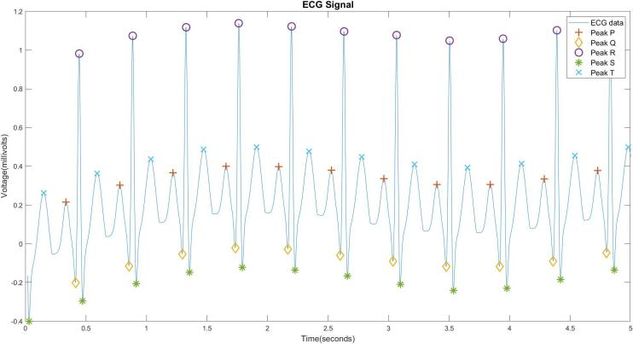

* Patient 2 (ecg1.mat) :
  + Heart rate: 67bpm - Normal Rate.
  + Variation in Heart Rate: Less than 10% - Normal.
  + PR Interval: 0.18seconds - PR Interval Normal.
  + QRS Interval: 0.09seconds - Normal QRS.
  + QT Interval: 0.46seconds - Normal QTC Interval.

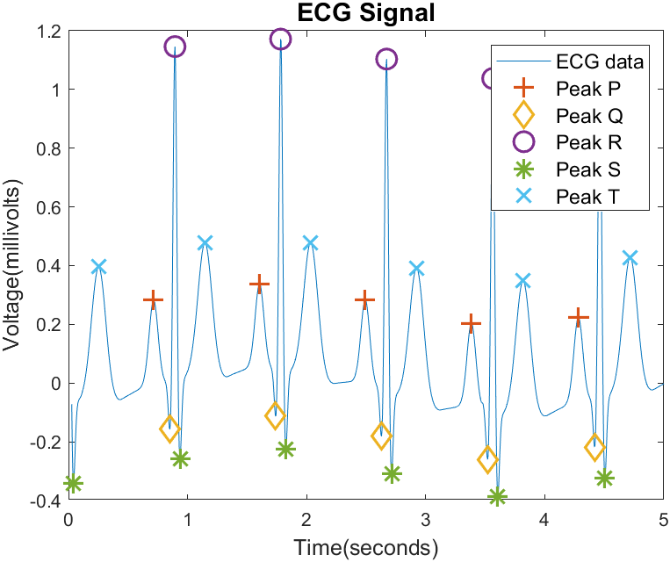

* Patient 3 (ecg3.mat) :
  + Heart rate: 43bpm - Sinus Bradycardia.
  + Variation in Heart Rate: Less than 10% - Normal.
  + PR Interval: 0.25seconds - Long, can be first degree heart block and trifascular block.
  + QRS Interval: 0.11seconds - Normal QRS Duration.
  + QT Interval: 0.51seconds - High, can be Myocardial Infarction or Subarachnoid Haemorrhage (SAH).

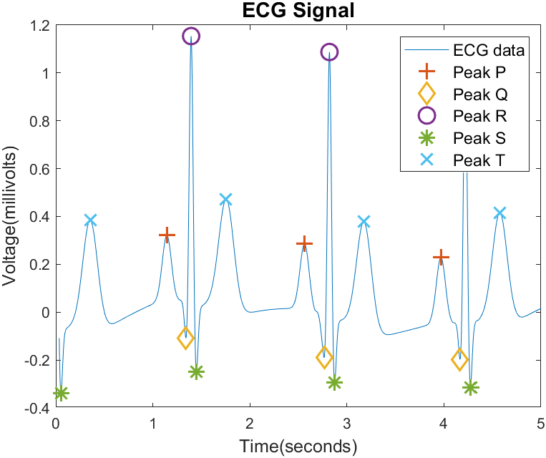

##### References

<https://en.wikipedia.org/wiki/Electrocardiography> [1].

<https://www.heart.org/en/health-topics/heart-attack/diagnosing-a-heart-attack/electrocardiogram-ecg-or-ekg> [2]

<https://physionet.org/> [3].

<https://www.youtube.com/watch?v=FThXJUFWUrw> [4].