#### Working Principle

##### Fabric Pressure Sensor

The fabric pressure sensor used in this project idea works on the principle of a pressure sensor using piezoelectric conductive fabrics. A pressure sensor is basically an instrument which converts the applied pressure into an analog electrical signal.

A conductive fabric is usually made with conductive materials woven into the strands of the fabric. Applying a mechanical stress (pressure) on the fabric material, an electric potential appears across the materials which is directly proportional to the amount of stress applied. This is known as the Piezoelectric effect on which these fabric-based pressure sensors work on.

This effect works because of the electrical dipoles created within these fabrics. Normally there is a charge imbalance between the different atoms in a molecule of the fabric and this will create a dipole moment between these atoms.

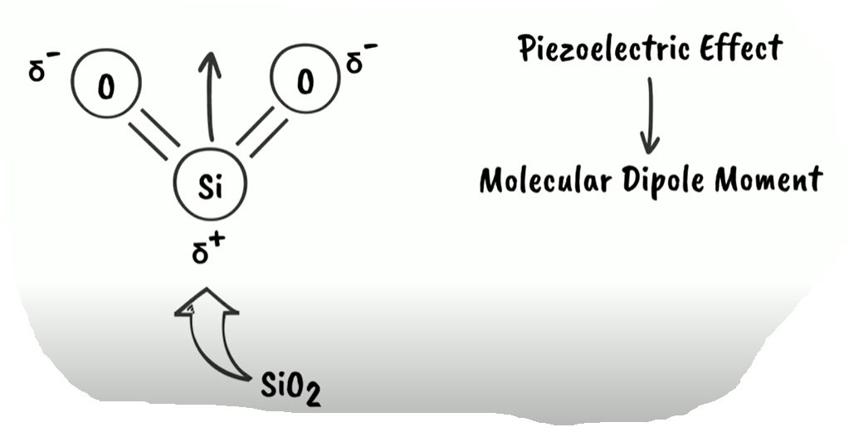

Now these dipole moments tend to have the same direction when are next to each other forming domains. Now all these domains have a resultant dipole moment towards a particular direction. There are numerous such domains present inside a conductive fabric, and although all these domains all have a dipole moment, the fabric is non-conductive in its rest state (when no pressure is applied) as all these domains are randomly oriented inside the fabric.

When a mechanical stress (pressure) is applied on the fabric, these domains re-orient themselves into a single direction, thus getting polarised. This re-orientation of the dipole moments (domains) will create an uneven charge distribution between two ends of the fabric, and as a result a potential difference will be created. This potential difference will be used to drive the RGB LED.

##### RGB LED

An RGB LED is a combination of three coloured (Red, Green, Blue) LEDs combined in a single package. It has 4 leads - the longest one being either common anode or common cathode lead depending on the type of the LED and the rest of the leads correspond to each of the three colours. We then connect the common anode/cathode lead to the positive/negative lead of a battery which powers the LED, and then each of the other colour leads to different power inputs to switch on and off each colour. Combining these primary colours (R, G and B) will result in different colours depending on the intensity which is applied to each lead.

##### Idea Application

In this idea, three fabric - based pressure sensors will be created which will be connected to the three leads of the RGB LED to control each colour. Pressing any of the three pressure sensors individually will trigger the LED to emit either red, green or blue colours. On pressing two of these three sensors together, the RGB LED will get triggered to emit either yellow, cyan or magenta and on pressing all three, the LED will emit white light. The pressure with which the user presses the sensors will regulate the amount of brightness of the emitted light. For further details, you can follow the 'sketches on functioning' in the Idea Exploration section.

The 'detailed sketches' in the Idea Exploration section gives an exploded view on how the fabric pressure sensor will be created.