Lesson 03 Demo 01

Executing Ad Hoc Commands

Objective: To demonstrate ad hoc commands for quickly executing tasks on remote servers without writing full playbooks

Tools required: Ansible, Ubuntu OS

Prerequisites: None

Steps to be followed:
- Generate SSH key pair on the main node
- Copy the SSH key on the other two nodes
- Update the host file with the host IP address
- Establish connectivity between specified hosts and the Ansible server
- Gather System Information Using Ad-Hoc Commands

Step 1: Generate SSH key pair on the main node

- Use the following command to generate the SSH key on the main Ansible server:
ssh-keygen
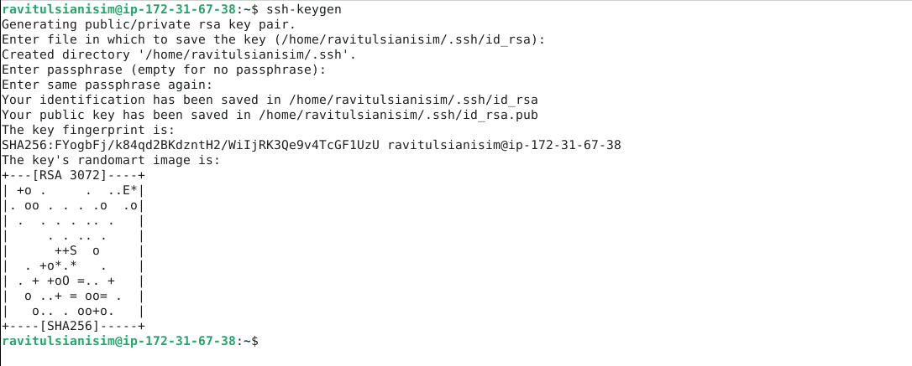

Step 2: Copy the SSH key on the other two nodes

  - Use the following command to copy the public key in a file named authorized_keys
in localhost:
cat .ssh/id_rsa.pub >> .ssh/authorized_keys


Step 3: Update the host file with the host IP address

  - Use the following command to open the Ansible inventory file and add the host localhost to it:
sudo vi /etc/ansible/hosts

  - When the file opens, add the below two lines of the code at the end of the file:
[webservers]
localhost:42006
40.86.1.9:42006

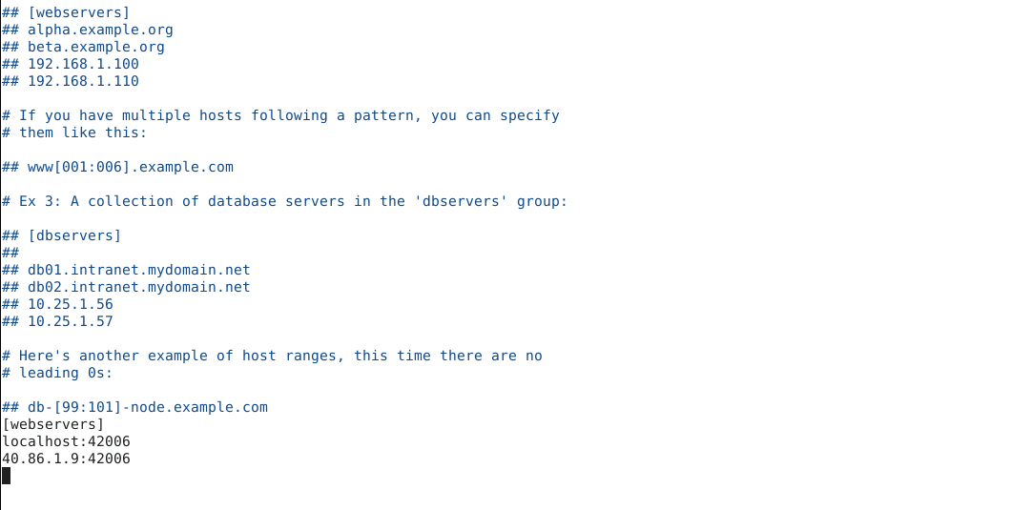
Note: Press esc, then write :wq and press enter to save the file.

Step 4: Establish connectivity between specified hosts and the Ansible server

  - Run the following command to verify connectivity to all servers listed under the webservers group in your Ansible hosts file:
ansible -m ping webservers

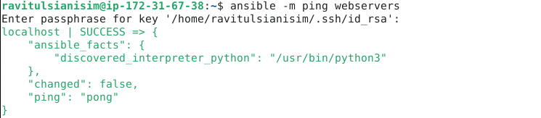

  - Use the following command to check the number of hosts in the host file:
ansible all --list-hosts

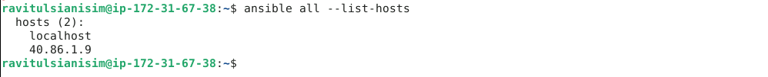

Step 5: Gather System Information Using Ad Hoc Commands

  - Run the following command to obtain the uptime from all managed hosts using an ad hoc command:
ansible all -m shell -a uptime

  - Similarly, execute the below command to obtain detailed information about memory usage on all hosts:
ansible all -m shell -a "free -m"

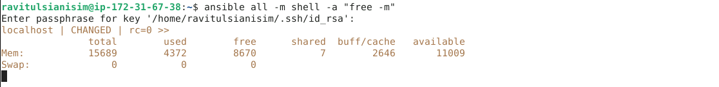

You will see that Ansible logs in to each machine in turn and runs the uptime command, returning the current uptime output.

By following these steps, you have successfully demonstrated how to use ad hoc commands for quickly executing tasks on remote servers without the need for full playbooks.

