Lesson 03 Demo 03

Working with Ansible Facts

Objective: To demonstrate ansible facts for efficiently gathering system information to optimize playbook tasks

Tools required: Ansible, Ubuntu OS

Prerequisites: Refer demo 01 to establish connectivity between the hosts

Steps to be followed:
- Gather all facts
- Filter specific facts

Step 1: Gather all facts

- Execute the following command to collect a comprehensive set of data from each host :
ansible all -m setup
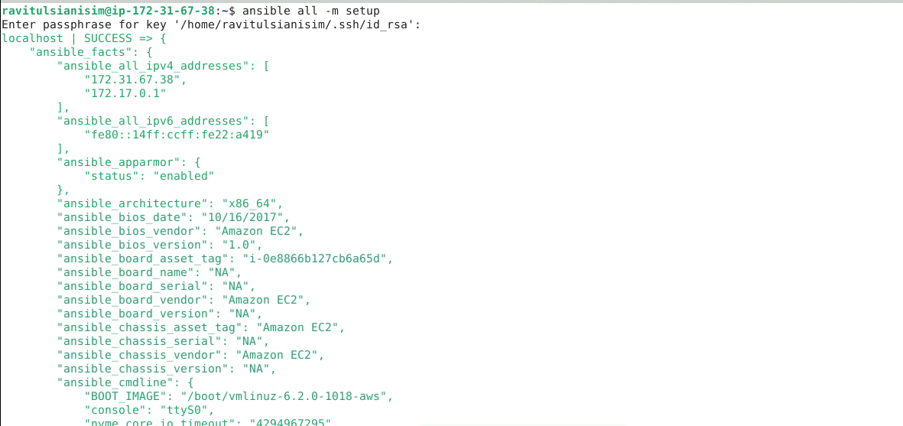

Step 2: Filter specific facts

  - Execute the following command to find out the operating system type of each host:
ansible all -m setup -a 'filter=ansible_os_family'
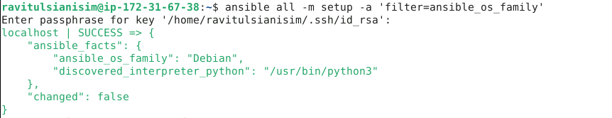

You can see that the command successfully retrieved the operating system family Debian for the localhost, using Python 3 as the interpreter, without making any changes to the system.

  - Execute the following command to gather detailed information about the storage devices on all hosts:
ansible all -m setup -a 'filter=ansible_devices'
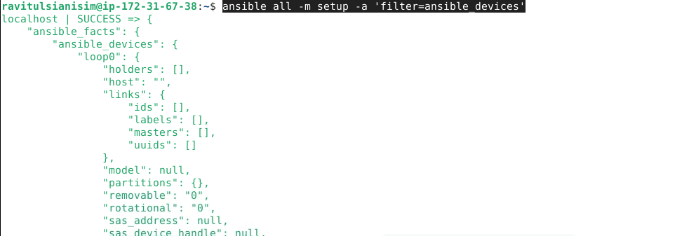

You can see that the command successfully retrieved detailed information about the devices on localhost.

By following these steps, you have successfully demonstrated the use Ansible facts for efficiently gathering system information to optimize playbook tasks.

