Lesson 03 Demo 07

Deploying a Voting Application
Objective: To deploy a voting application using Kubernetes pods
Tools required: kubeadm, kubectl, kubelet, and containerd

Prerequisites: A Kubernetes cluster (refer to Demo 01 from Lesson 01 for setting up a cluster)

Steps to be followed:
- Create a namespace
- Create an application for deployment
- Verify the deployment of the application

Step 1: Create a namespace

- Create a namespace named vote in the master node using the following command:
kubectl create namespace vote

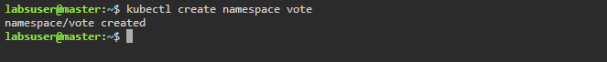
to facilitate

- Execute the following command to set the vote namespace as the current context:
kubectl config set-context --current --namespace=vote

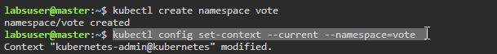

Step 2: Create an application for deployment

- Execute the following command to clone the repository that contains the voting application:
git clone https://github.com/dockersamples/example-voting-app.git

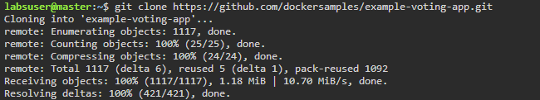

- Navigate to the cloned directory using the following command:
cd example-voting-app/

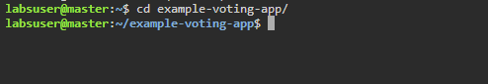

- Execute the following command to deploy the resources defined in the configuration files located in the k8s-specifications directory:
kubectl create -f k8s-specifications/

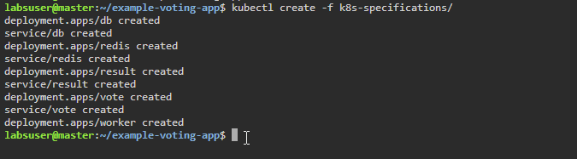

Step 3: Verify the deployment of the application
- Verify the created Kubernetes pod state using the following command:
kubectl get pod -n vote -o wide

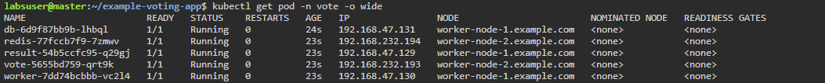

- Execute the following command to retrieve information about deployments in the vote namespace:
kubectl get deployment -n vote

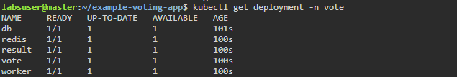

- To get detailed information about the pods within the vote namespace, run the following commands:
kubectl get pod --namespace vote -o wide
kubectl get svc --namespace vote -o wide

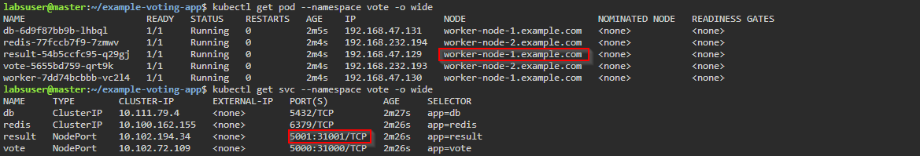

Remember to note the NODE and PORT(S) where the pod is running.

- Execute the following command to get the INTERNAL-IP address of worker-node-1.example.com:
kubectl get nodes -o wide

- Open the Firefox browser on the master node's desktop and paste the INTERNAL-IP address and port number

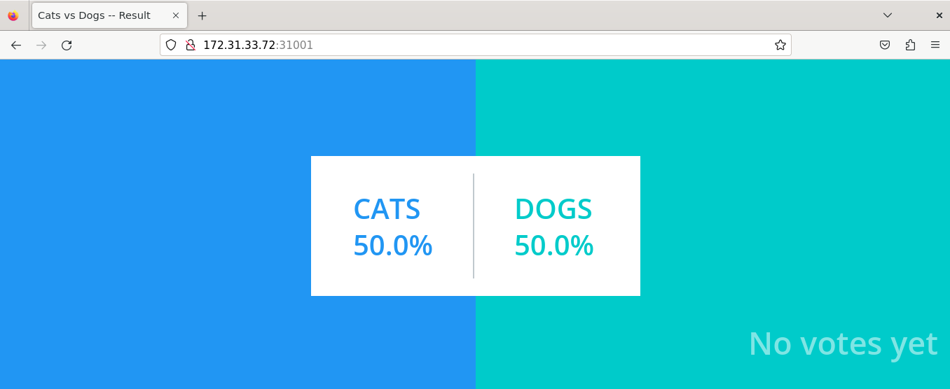

Note: Use the current IP address of worker-node-1.example.com and the port number where the resulting pod is deployed

By following these steps, you have successfully deployed a voting application using Kubernetes pods.

