Lesson 03 Demo 03

Configuring a Pod Using an Init Container

Objective: To create and configure a pod using an init container to design more complex and flexible workflows for Kubernetes applications

Tools required: kubeadm, kubectl, kubelet, and containerd

Prerequisites: A Kubernetes cluster (refer to Demo 01 from Lesson 01 for setting up a cluster)

Steps to be followed:
- Create a pod
- Create services
- Verify the pod’s state

Step 1: Create a pod

- On the master node, enter the command nano init2-container.yaml to create a YAML file

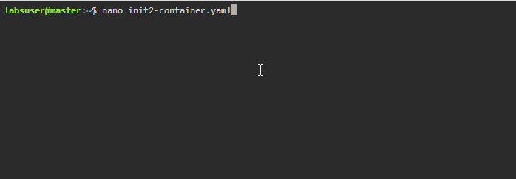

- Add the following code in the YAML file:

apiVersion: v1
kind: Pod
metadata:
name: myapp-pod
labels:
app: myapp
spec:
containers:
- name: myapp-container
image: registry.access.redhat.com/ubi8/ubi:latest
command: ['sh', '-c', 'echo The app is running! && sleep 3600']
initContainers:
- name: init-myservice
image: registry.access.redhat.com/ubi8/ubi:latest
command: ['sh', '-c', 'until getent hosts myservice; do echo waiting for myservice; sleep 2; done;']
- name: init-mydb
image: registry.access.redhat.com/ubi8/ubi:latest
command: ['sh', '-c', 'until getent hosts mydb; do echo waiting for mydb; sleep 2; done;']

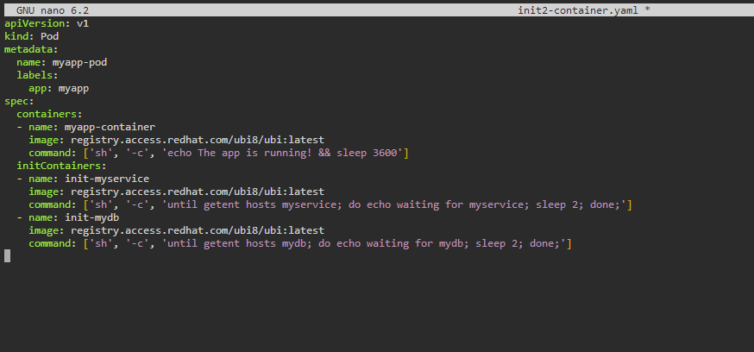

- Create a pod using the following command:
kubectl create -f init2-container.yaml

- Verify the pod’s state using the following command:
kubectl get pods

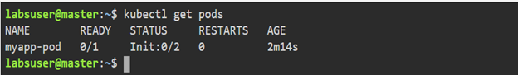

Step 2: Create services

- For the first service, create the init2-myservice.yaml file using the following command:
nano init2-myservice.yaml

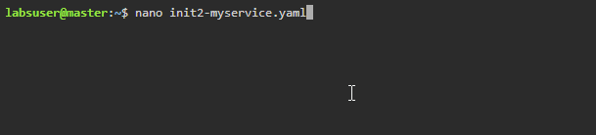

- Add the following code in the YAML file:

kind: Service
apiVersion: v1
metadata:
name: myservice
spec:
ports:
- protocol: TCP
port: 80
targetPort: 9376

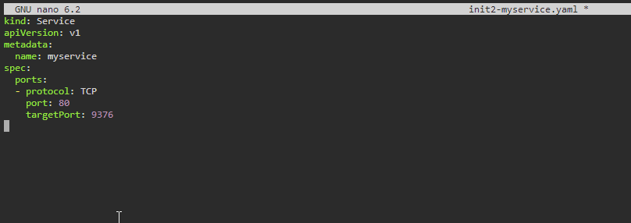

- Run the following command to create the first service named myservice:
kubectl create -f init2-myservice.yaml

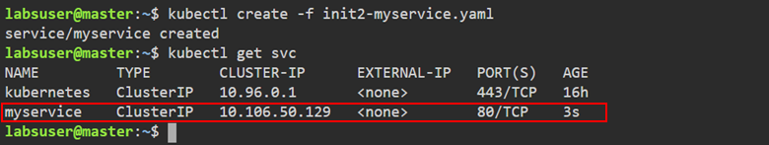

The first service is created successfully.

- For the second service, create the init2-mydb.yaml file using the following command:
nano init2-mydb.yaml

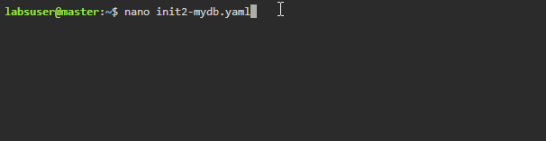

- Enter the following code in the YAML file:

kind: Service
apiVersion: v1
metadata:
name: mydb
spec:
ports:
- protocol: TCP
port: 80
targetPort: 9377

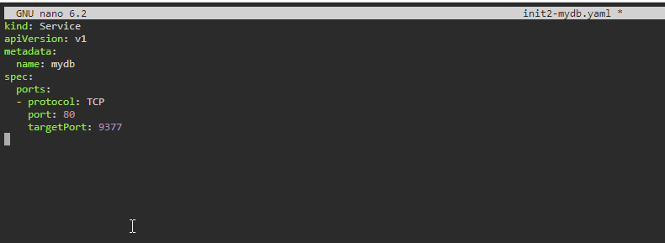

- Run the following command to create the second service named mydb:
kubectl create -f init2-mydb.yaml

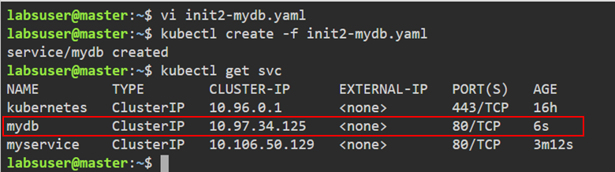
The second service is created successfully.

Step 3: Verify the pod’s state

- Run the following command to verify the state of the pod:
kubectl get pods

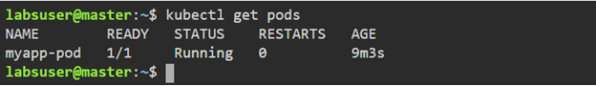

You can see that the pod is running.

By following these steps, you have successfully configured a pod using an init container.

