Lesson 03 Demo 06

Deploying Multitier Applications Using Kubernetes

Objective: To deploy and verify a multitier WordPress and MySQL application on Kubernetes for managing, scaling, and maintaining them

Tools required: kubeadm, kubectl, kubelet, and containerd

Prerequisites: A Kubernetes cluster (refer to Demo 01 from Lesson 01 for setting up a cluster)

Steps to be followed:
- Create a deployment for MySQL
- Create a deployment for WordPress
- Expose the service for WordPress and MySQL deployment
- Verify the deployment of the application

Step 1: Create a deployment for MySQL

- To create a MySQL database deployment, draft the following YAML code and save it in the mysql.yaml file:

apiVersion: apps/v1
kind: Deployment
metadata:
name: mysql-deployment
labels:
app: mysql
spec:
replicas: 1
selector:
matchLabels:
app: mysql
template:
metadata:
labels:
app: mysql
spec:
containers:
- name: mysql
image: mysql:5.6
env:
- name: MYSQL_ROOT_PASSWORD
value: simplilearn
- name: MYSQL_DATABASE
value: database1

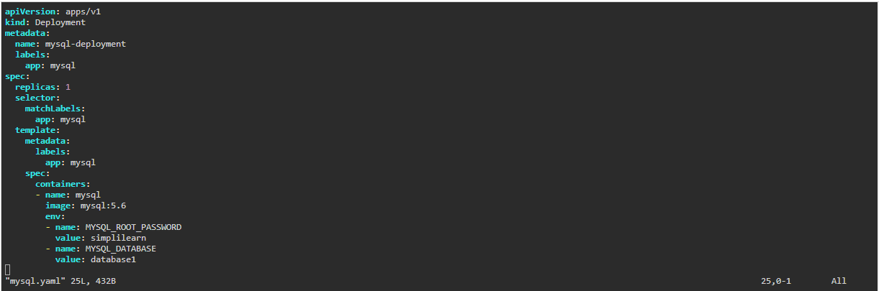

- To create a deployment for MySQL, use the following command:
kubectl create -f mysql.yaml

- To verify pods and deployments, run the following commands:
kubectl get pods
kubectl get deployments

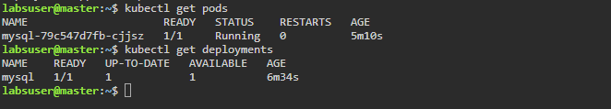
Upon execution, a deployment for MySQL is created.

Step 2: Create a deployment for WordPress

- To create a WordPress deployment, draft the following YAML code and save it in the wordpress.yaml file:

apiVersion: apps/v1
kind: Deployment
metadata:
name: wordpress
labels:
app: wordpress
spec:
replicas: 1
selector:
matchLabels:
app: wordpress
template:
metadata:
labels:
app: wordpress
spec:
containers:
- image: wordpress
name: wordpress
env:
- name: WORDPRESS_DB_HOST
value: mysql
- name: WORDPRESS_DB_PASSWORD
value: simplilearn
- name: WORDPRESS_DB_USER
value: root
- name: WORDPRESS_DB_NAME
value: database1
resources: {}

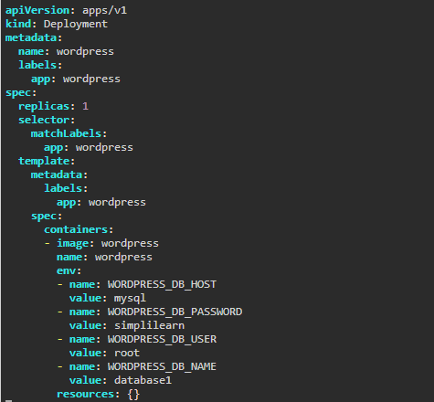
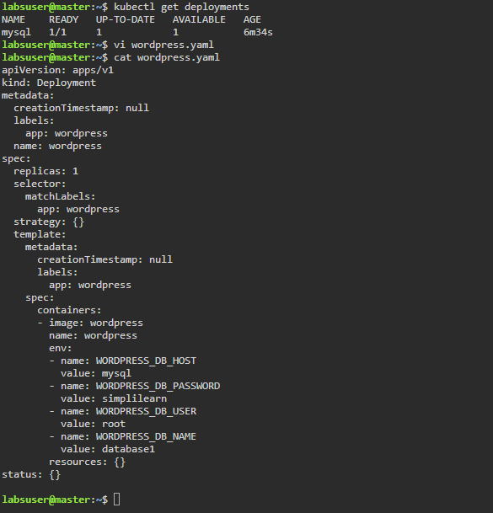

- To create a deployment for WordPress, use the following command:
kubectl create -f wordpress.yaml

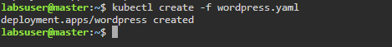

- To verify pods and deployments, run the following commands:
kubectl get pods
kubectl get deployments

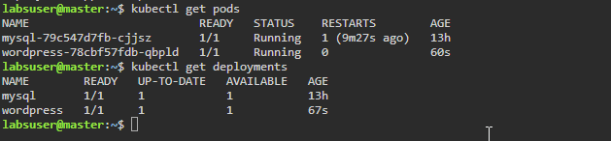

Upon execution, a deployment for WordPress is created.

Step 3: Expose the service for WordPress and MySQL deployment

- To expose the service for WordPress and MySQL deployment, run the following commands:
kubectl expose deployment mysql-deployment --port=3306
kubectl expose deployment wordpress --port=80

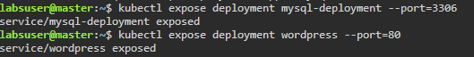

Note: Use the kubectl get svc command to list the services in the cluster

- Change the service type for both MySQL and WordPress from ClusterIP to NodePort using the following commands:
kubectl edit svc mysql-deployment
kubectl edit svc wordpress

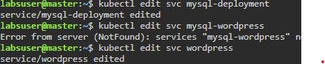

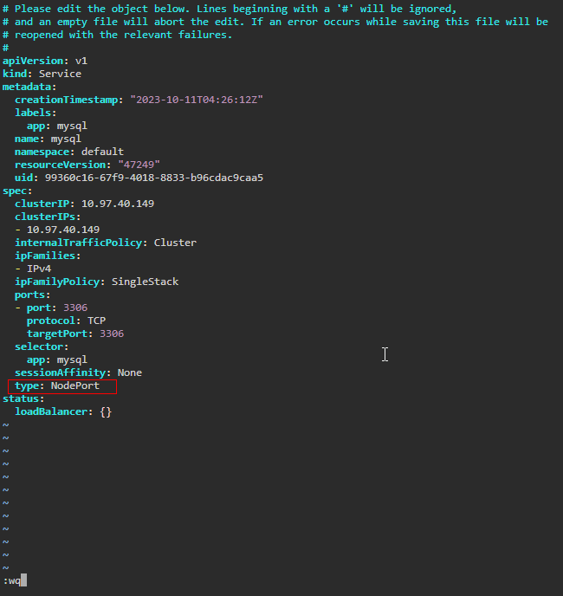

Note: Change the service type from ClusterIP to NodePort

- To verify the service type of MySQL and WordPress, run the following command:
kubectl get svc

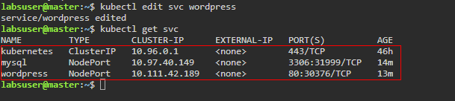

- To get detailed information on the pods, use the following commands:
kubectl get pods -o wide
kubectl get nodes -o wide

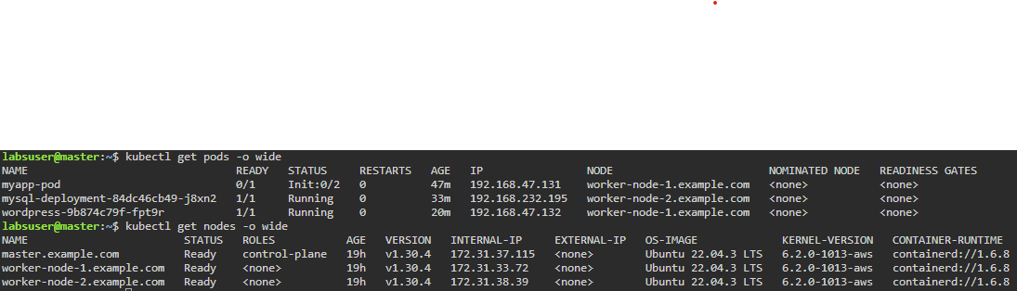

Note: Copy the following things to your Notepad for the next step:
      - WordPress pod IP address or the respective nodes' Internal-IP (for example, 192.168.47.132)
      - Service NodePort of WordPress (for example, 172.31.33.72)

Step 4: Verify the deployment of the application

- In the master node, go to desktop mode

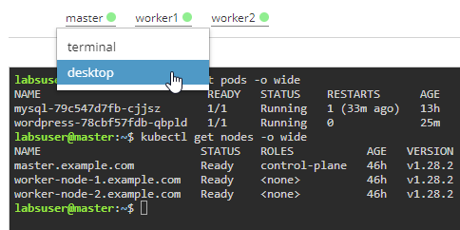

- Open the Firefox web browser

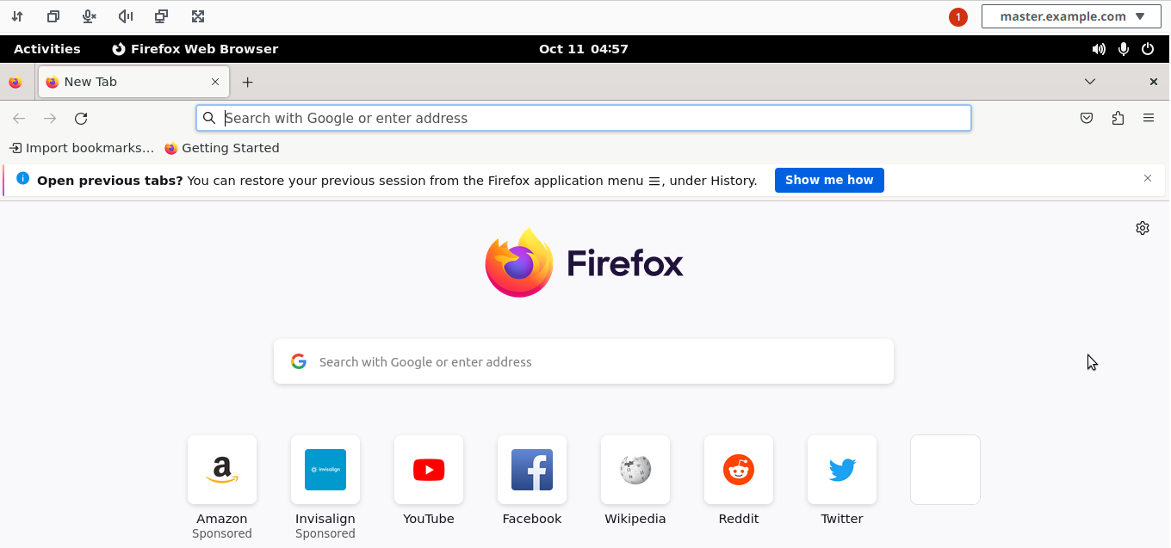

- In the browser, enter the IP address and service NodePort (refer to step 3.4)
Example: 172.31.24.170:30376 or 192.168.47.135:80

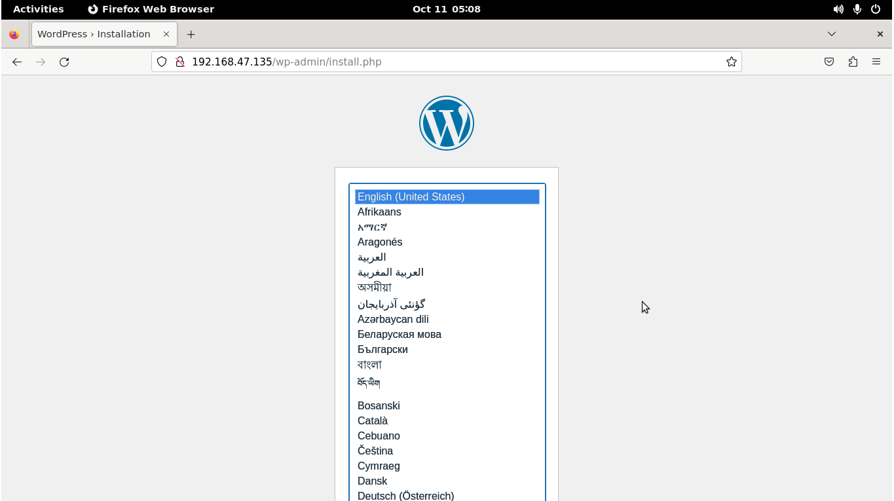

- The WordPress default page will appear. Finish the installation process and provide the necessary account information. Click on Install Wordpress

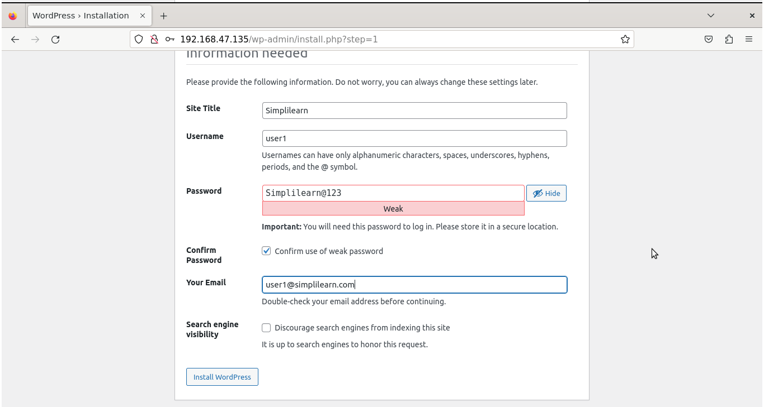

- On the login page, enter the username and password provided during the installation process

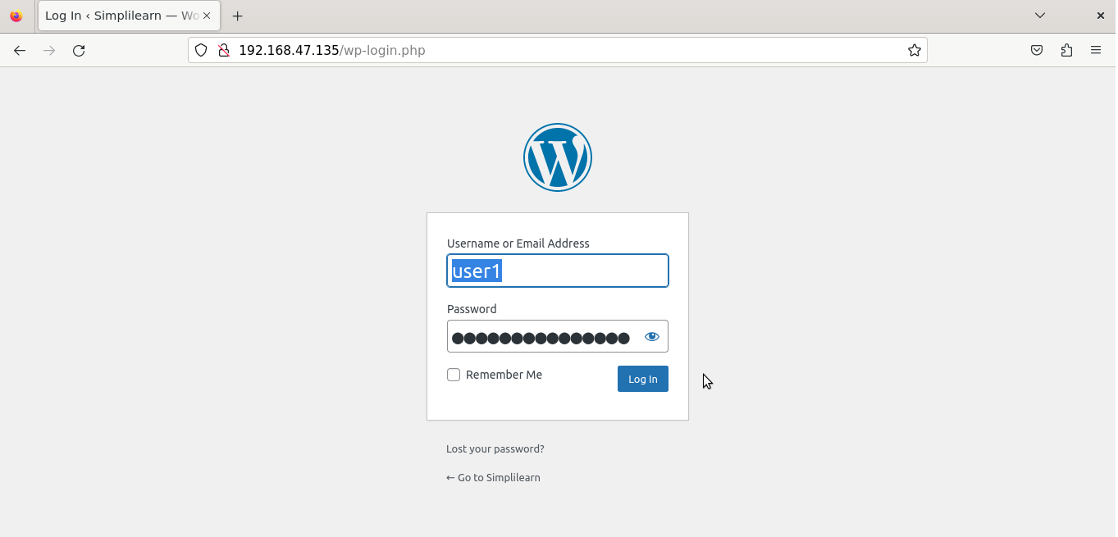

The WordPress application is successfully deployed as seen in the screenshot above.

By following these steps, you have successfully deployed a multitier application using Kubernetes.

