Lesson 07 Lesson-End Project

Deploying WordPress and MySQL Using PersistentVolume

Project Agenda: To deploy WordPress and MySQL on Kubernetes with PersistentVolume using NFS and hostPath for web-based access

Description: This project involves deployment of WordPress and MySQL on a Kubernetes cluster, leveraging PersistentVolume with NFS and hostPath configurations to host a web-based WordPress application with data persistence and accessibility.

Tools required: kubeadm, kubectl, kubelet, and containerd

Prerequisites: A Kubernetes cluster should already be set up (refer to the steps provided in Lesson 02, Demo 01 for guidance).

Expected Deliverables: A fully deployed Kubernetes cluster, MySQL, and WordPress applications with PersistentVolume, allowing web-based access to the WordPress site

Steps to be followed:
- Configure the NFS kernel server
- Set the permissions
- Configure the NFS common on client machines
- Create a MySQL manifest file and deploy it using NFS-based PersistentVolume
- Create a WordPress manifest file and deploy it using hostPath-based PersistentVolume

Step 1: Configure the NFS kernel server

- Switch to superuser, create a directory /data with the -p option to create parent directories on the worker-node-1, and then list the contents of /data using the following commands:
sudo su
mkdir -p /data
ls -alrt /data/
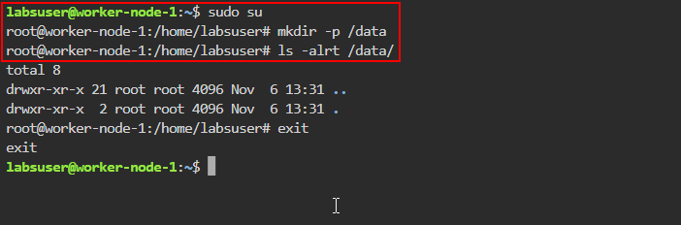
Note: Type exit and press the enter key

- Install the NFS kernel server on the machine:
sudo apt install nfs-kernel-server
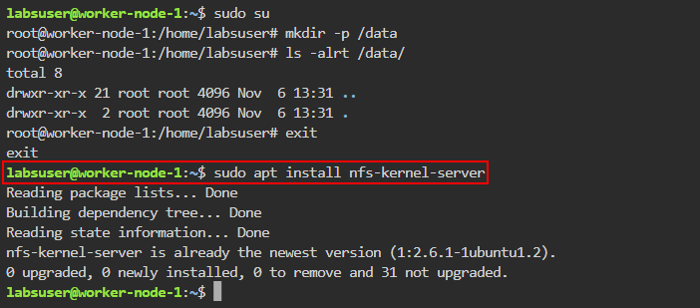

Step 2: Set the permissions

- On the worker-node-1, open the exports file in the /etc directory using the following command:
sudo nano /etc/exports

- Inside the file, append the following code:
/data *(rw,sync,no_root_squash)

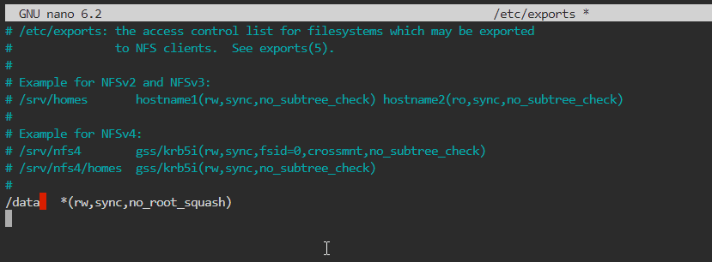

- Use the cat command to view the file

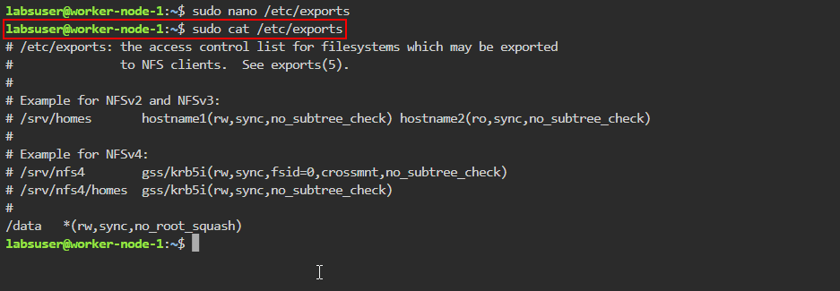

- Export all shared directories defined in the /etc/exports file using the following command:
sudo exportfs -rv

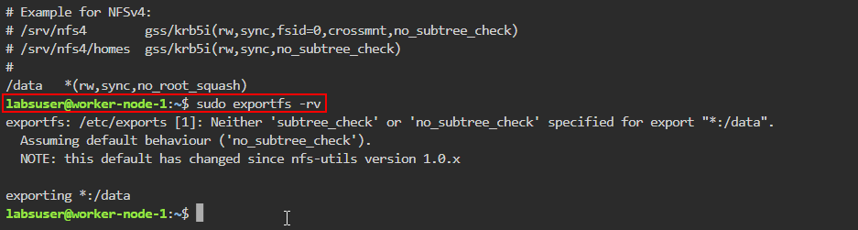

- Make the folder publicly accessible by changing its owner user and group using the following command:
sudo chown nobody:nogroup /data/

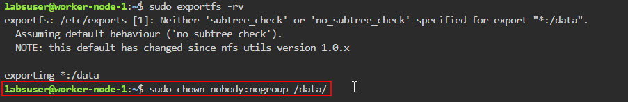

- Assign full permissions to read, write, and execute files in this directory using the following command:
sudo chmod 777 /data/

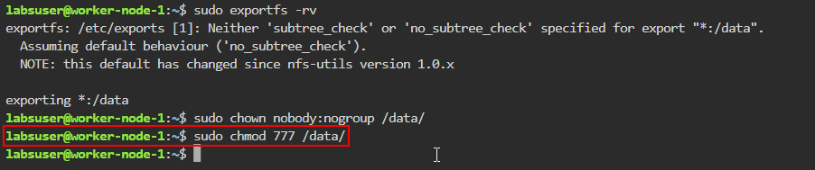

- Restart the NFS kernel server to apply the changes using the following command:
sudo systemctl restart nfs-kernel-server
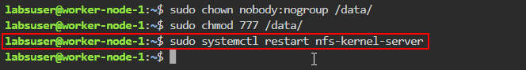
- Retrieve the internal IP of the node where NFS server is installed using the following command:
ip a
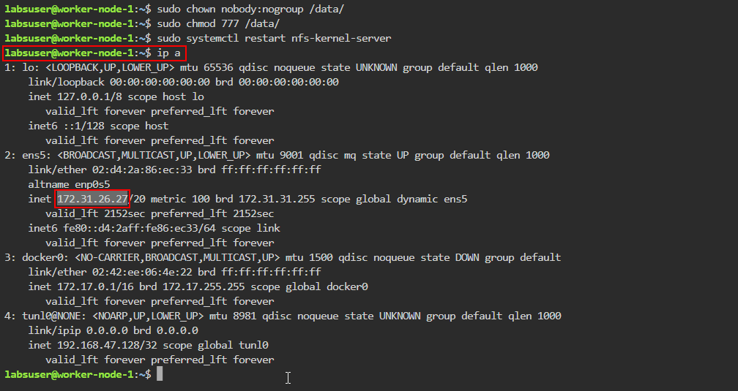
After running this command, look for the relevant IP address in the output. This IP will be used to associate the PV with the NFS server.
Note: Save the IP address to use in the next steps

Step 3: Configure the NFS common on client machines

Note: Perform the below steps on each worker node intended for sharing

- Run the following command to install the NFS common package:
sudo apt install nfs-common

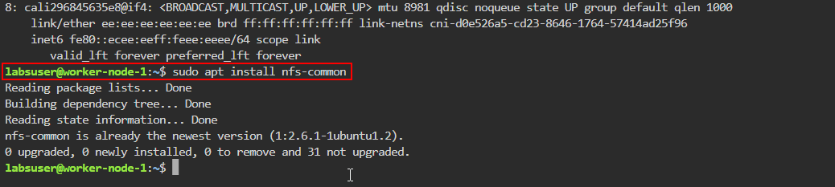

- Execute the following commands to refresh the NFS common service and verify its status:
sudo rm /lib/systemd/system/nfs-common.service
sudo systemctl daemon-reload
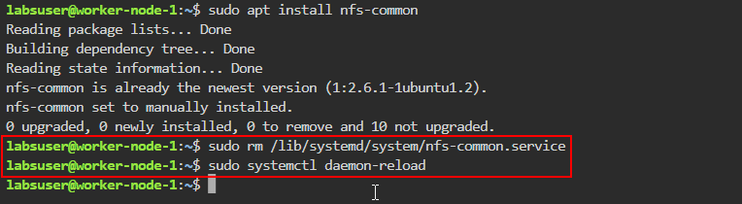

- Restart the NFS client service and check its status using the following commands:
sudo systemctl restart nfs-common
sudo systemctl status nfs-common

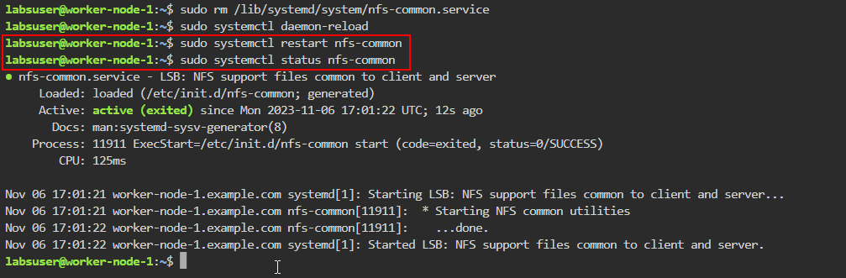

Note: The these steps are to be performed in both the worker nodes as shown in the screenshots above.

Step 4: Create a MySQL manifest file and deploy it using NFS-based
PersistentVolume

- On the master node, retrieve information about the nodes in the Kubernetes cluster using the following command:
kubectl get node
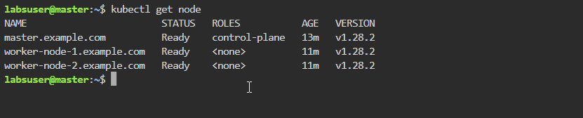

- Create the YAML file using the following command:
nano nfs-mysql.yaml
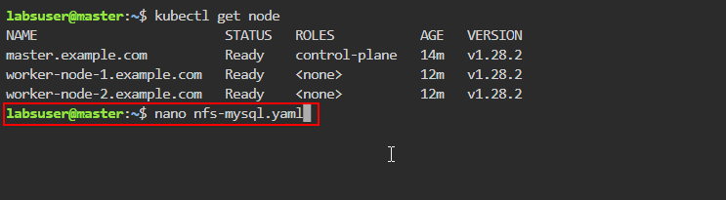

- Add the following code to the nfs-mysql.yaml file:
apiVersion: v1
kind: PersistentVolume
metadata:
name: mysql-nfs
spec:
capacity:
storage: 1Gi
accessModes:
- ReadWriteMany
persistentVolumeReclaimPolicy: Recycle
mountOptions:
- hard
- nfsvers=4.1
nfs:

path: /data
server: 172.31.3.94
---
kind: PersistentVolumeClaim
apiVersion: v1
metadata:
name: mysql-nfs
spec:
accessModes:
- ReadWriteMany
resources:
requests:
storage: 500Mi
---

apiVersion: v1
kind: Service
metadata:
name: mysql
labels:
app: mysql-wordpress
spec:
ports:
- port: 3306
selector:
app: mysql-wordpress
product: mysql
---
apiVersion: apps/v1
kind: Deployment
metadata:
name: mysql
labels:
app: mysql-wordpress
spec:
selector:
matchLabels:
app: mysql-wordpress
product: mysql
strategy:
type: Recreate
template:
metadata:
labels:
app: mysql-wordpress
product: mysql
spec:
containers:
- image: mysql
name: mysql-container
env:
- name: MYSQL_DATABASE
value: wordpress
- name: MYSQL_ROOT_PASSWORD
value: rootroot
ports:
- containerPort: 3306
name: mysql

volumeMounts:
- name: mysql-storage
mountPath: /var/lib/mysql
volumes:
- name: mysql-storage
persistentVolumeClaim:
claimName: mysql-nfs
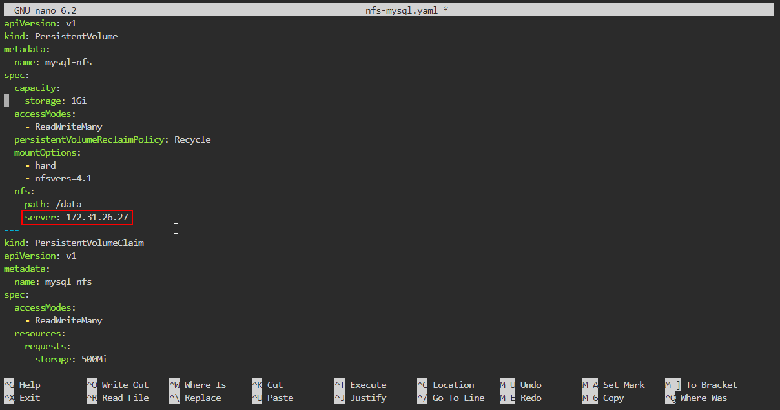
Note: Replace server: IP with the internal IP of the NFS server from step 2.8 as shown in the screenshot above

- Use the cat command to view the content of nfs-mysql.yaml file
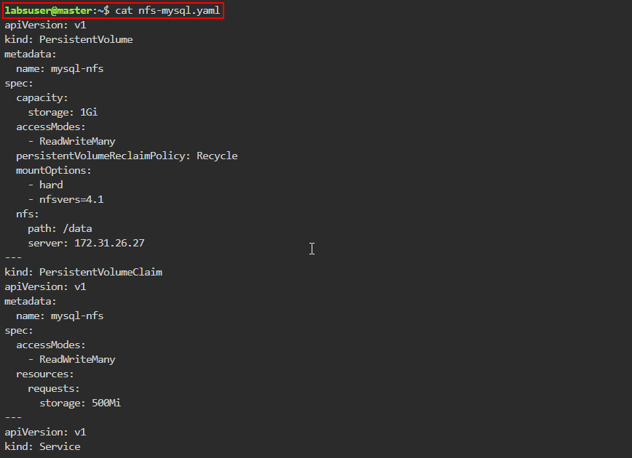
- Apply the configuration defined in nfs-mysql.yaml using the following command:
kubectl apply -f nfs-mysql.yaml
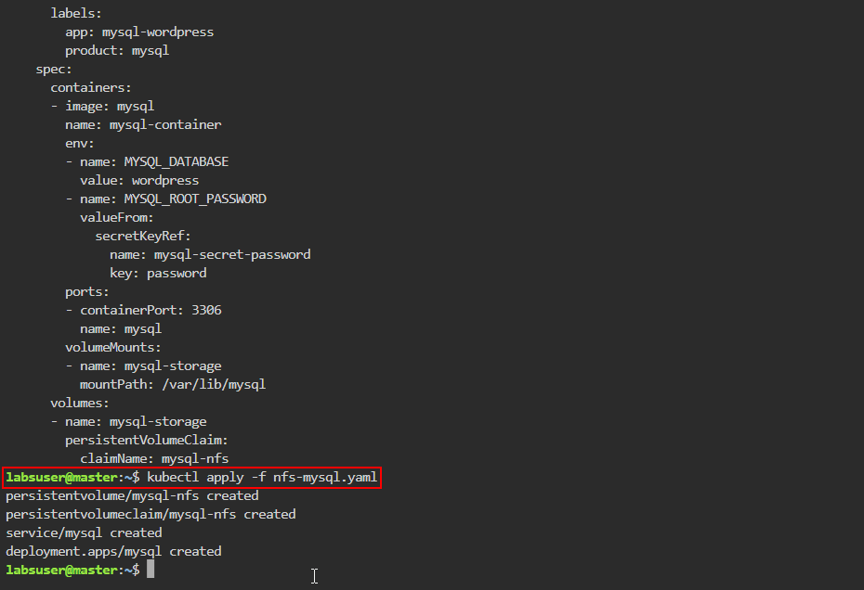
- List all the PVs in the cluster using the following command:
kubectl get pv
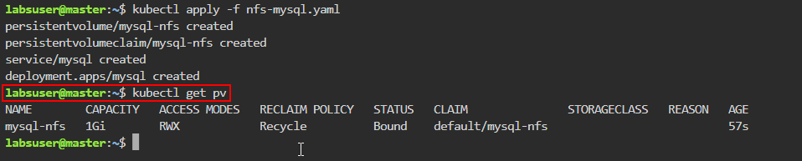

- List all the PVCs in the cluster using the following command:
kubectl get pvc
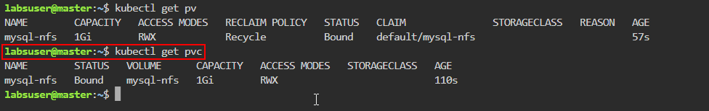
- List deployments in the Kubernetes cluster, and display additional wide output details using the following command:
kubectl get deployments -o wide
- Retrieve a list of services in the Kubernetes cluster, and display additional wide output details using the following command:
kubectl get services -o wide
- Obtain a list of pods in the Kubernetes cluster and display additional wide output details using the following command:
kubectl get pods -o wide
Note: Save the pod name for the next step

- View the last 10 lines of logs for a specific pod using the following command:
kubectl logs <pod_name> | tail -n 10
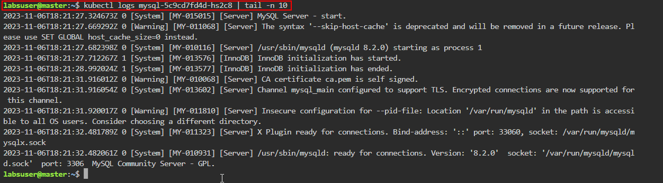
Note: Replace <pod_name> with the name of the pod from step 4.10 as shown in the screenshot above

Step 5: Create a WordPress manifest file and deploy it using hostPath-based
PersistentVolume

- Create the YAML file using the following command:
nano wordpress-volume.yaml
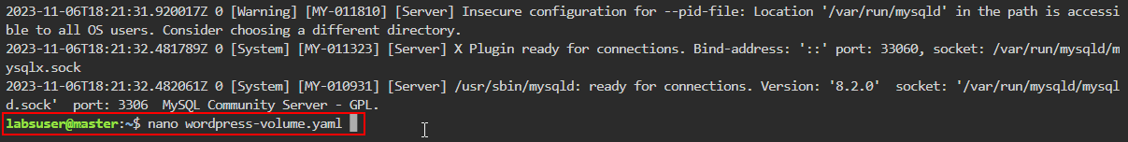
- Add the following code to the wordpress-volume.yaml file:
apiVersion: v1
kind: PersistentVolume
metadata:
name: hostpath-pv
labels:
type: hostpath
spec:
capacity:
storage: 2Gi
accessModes:
- ReadWriteMany
storageClassName: ""

persistentVolumeReclaimPolicy: Delete
hostPath:
type: DirectoryOrCreate
path: "/opt/ "
---
kind: PersistentVolumeClaim
apiVersion: v1
metadata:
name: wordpress-hostpath
spec:
accessModes:
- ReadWriteMany
storageClassName: ""
resources:
requests:
storage: 500Mi
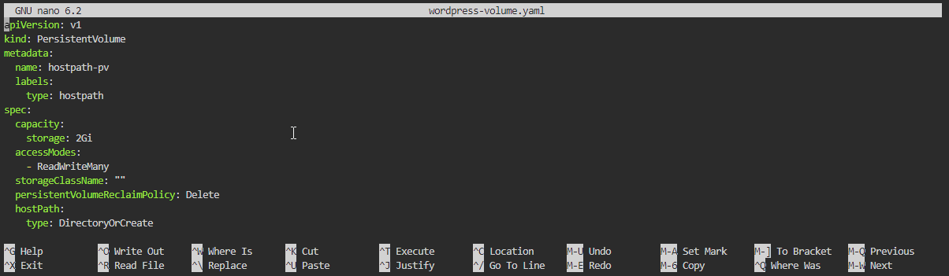
- Use the cat command to view the content of the wordpress-volume.yaml file
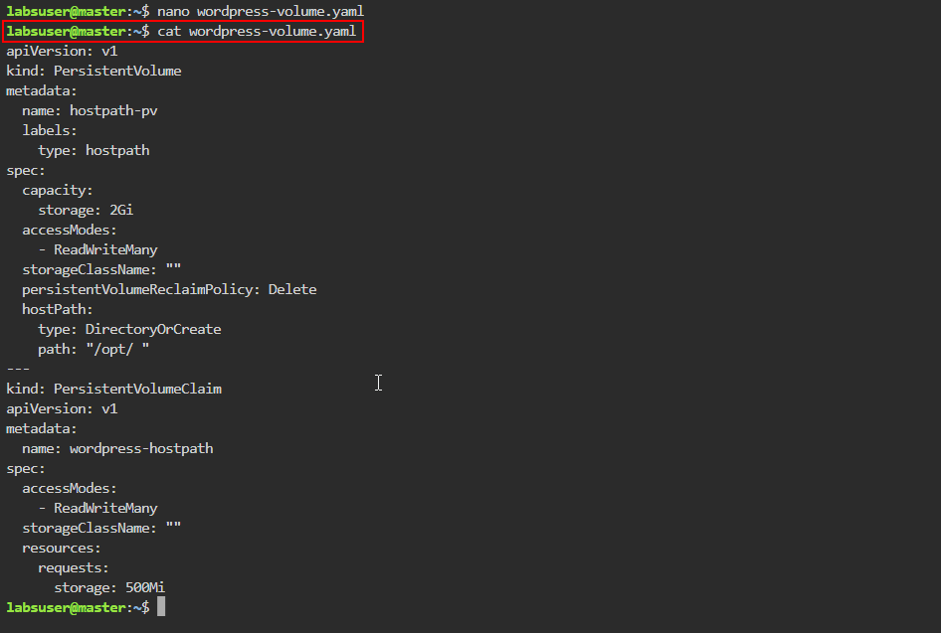

- Apply the configuration defined in wordpress-volume.yaml using the following command:
kubectl apply -f wordpress-volume.yaml
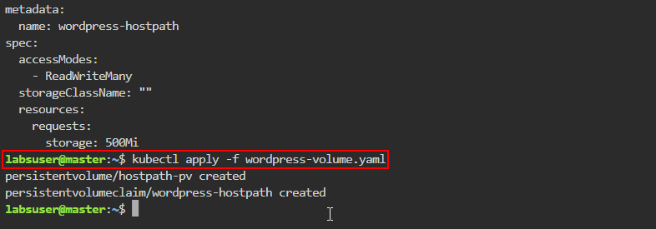
- List all the PVs and PVCs in the cluster using the following command:
kubectl get pv
kubectl get pvc
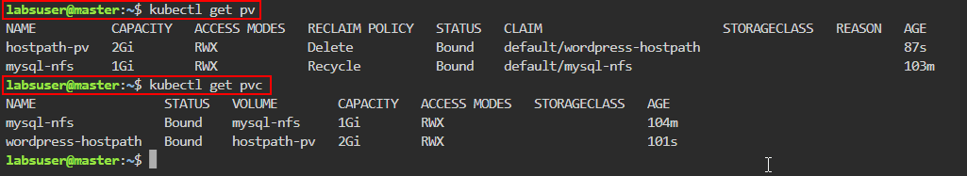
- Create the YAML file using the following command:
nano wordpress-deployment.yaml
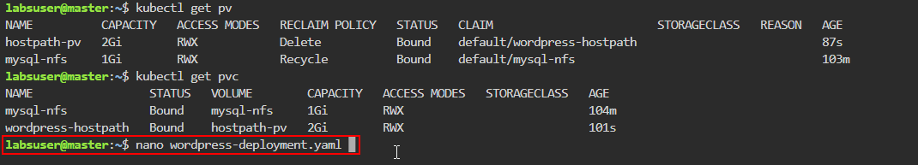

- Add the following code to the wordpress-deployment.yaml file:
apiVersion: v1
kind: Service
metadata:
name: wordpress
labels:
app: mysql-wordpress
spec:
ports:
- port: 80
selector:
app: mysql-wordpress
tier: frontend
type: NodePort
---
apiVersion: apps/v1
kind: Deployment
metadata:
name: wordpress
labels:
app: mysql-wordpress
spec:
selector:
matchLabels:
app: mysql-wordpress
tier: frontend
strategy:
type: Recreate
template:
metadata:
labels:
app: mysql-wordpress
tier: frontend
spec:
containers:
- image: wordpress
name: wordpress

env:
- name: WORDPRESS_DB_HOST
value: mysql
- name: WORDPRESS_DB_USER
value: root
- name: WORDPRESS_DB_PASSWORD
value: rootroot
ports:
- containerPort: 80
name: wordpress
volumeMounts:
- name: wordpress-storage
mountPath: /var/www/html
volumes:
- name: wordpress-storage
persistentVolumeClaim:
claimName: wordpress-hostpath
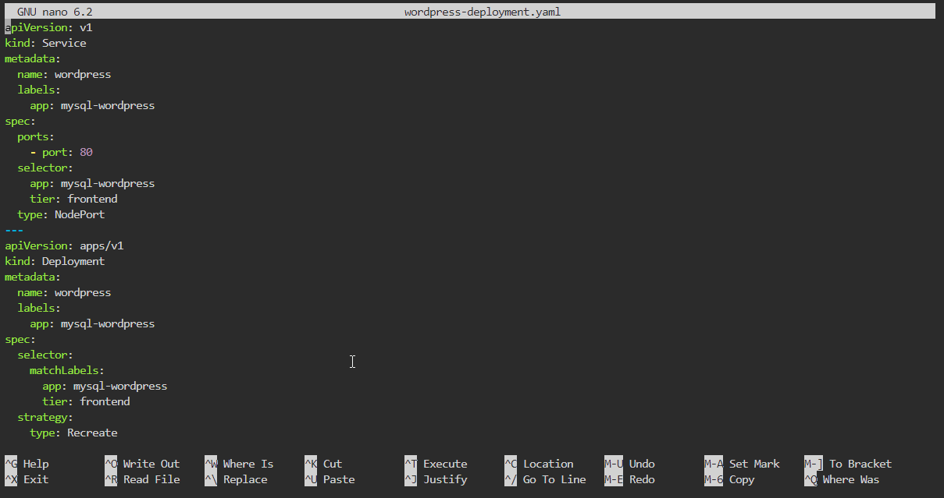

- Apply the configuration defined in wordpress-deployment.yaml using the following command:
kubectl apply -f wordpress-deployment.yaml
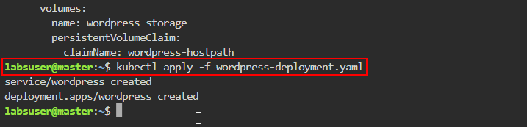
- List deployments in the Kubernetes cluster, and display additional wide output details using the following command:
kubectl get deployments -o wide
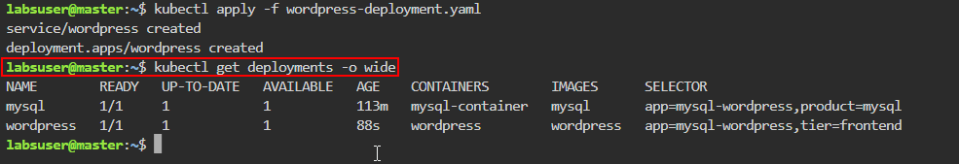
- Retrieve a list of services in the Kubernetes cluster, and display additional wide output details using the following command:
kubectl get services -o wide
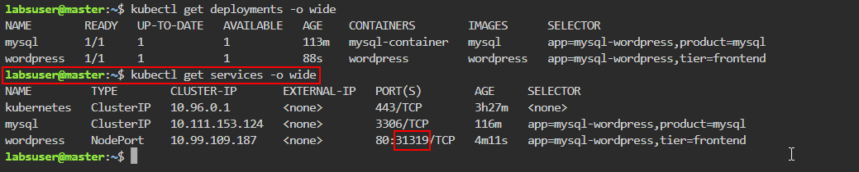
Note: Save the port number for the next steps

- Obtain a list of pods in the Kubernetes cluster and display additional wide output details using the following command:
kubectl get pods -o wide
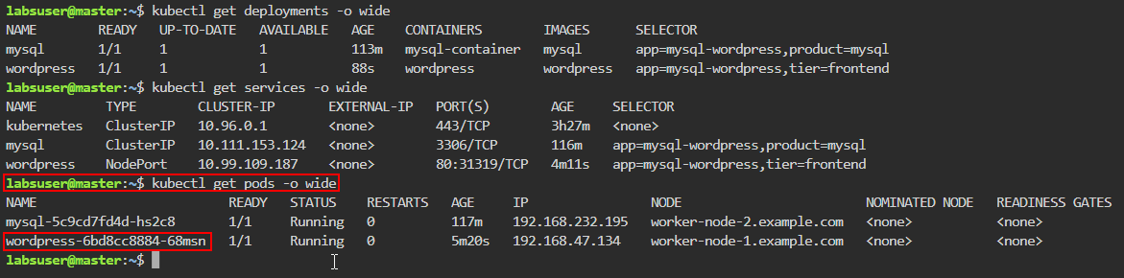
Note: Save the name of the pod for the next step

- Stream and monitor WordPress pod logs by executing the following command:
kubectl logs <pod-name> -f
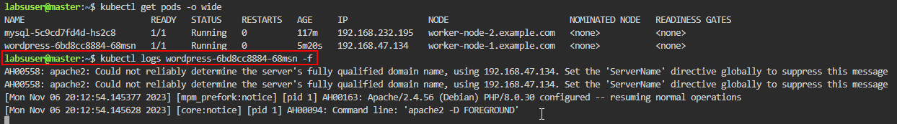
Note: Replace the <pod-name> with the name of your pod from step 5.11

- Click on the master button and then click on the desktop option
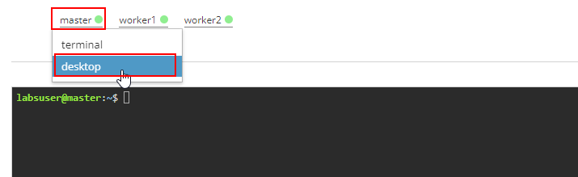

- Click on the Activities button
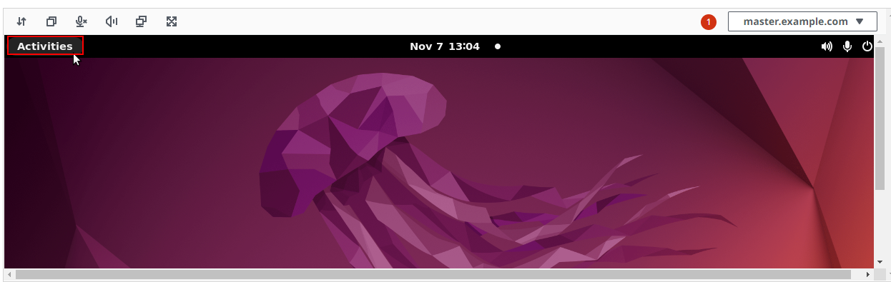
- Search for and click on Firefox Web Browser
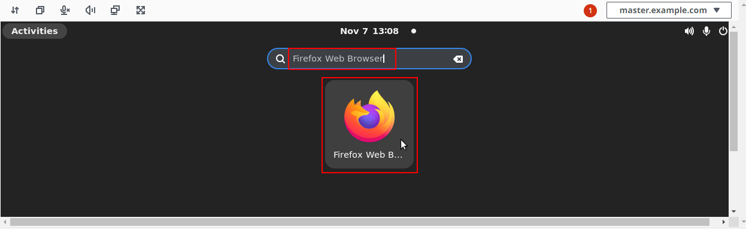

- In the Firefox browser add the below URL to access the WordPress application
http://localhost:<node-port>
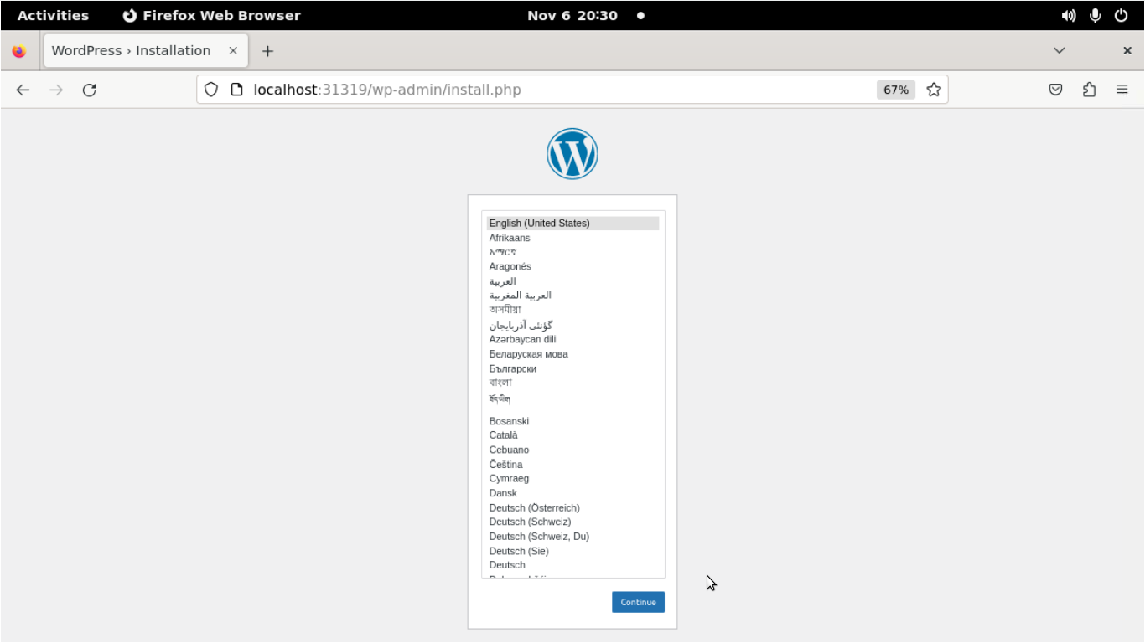
Note: Replace the <node-port> with the port number saved earlier from step 5.10

By following these steps, you have successfully configured a Kubernetes cluster to deploy WordPress and MySQL with PersistentVolume, ensuring data persistence and enabling web access to your WordPress application.

