Lesson 06 Demo 01

Sharing Data Between Containers in the Same Pod

Objective: To demonstrate data-sharing between containers in the same pod through hostPath volumes for mounting pod files onto the file system of the host node

Tools required: kubeadm, kubectl, kubelet, and containerd

Prerequisites: A Kubernetes cluster should already be set up (refer to the steps provided in Lesson 01, Demo 01 for guidance).

Steps to be followed:
- Configure and launch the pod with the shared volume
- Interact with the shared volume from both containers
- Test data persistence and sharing capability

Step 1: Configure and launch the pod with the shared volume

- Open the YAML configuration file with the following command:
nano emptydir.yaml
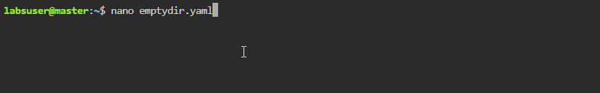

- Enter the following code into the emptydir.yaml file to define the pod with two containers sharing a volume:
apiVersion: v1
kind: Pod
metadata:
name: container-share-volume
spec:
containers:
- name: container1
image: centos:7
command:
- "bin/bash"
- "-c"
- "sleep 10000"
volumeMounts:
- name: container-volume
mountPath: "/tmp/xchange"
- name: container2
image: centos:7
command:
- "bin/bash"
- "-c"
- "sleep 10000"
volumeMounts:
- name: container-volume
mountPath: "/tmp/data"
volumes:
- name: container-volume
emptyDir: {}
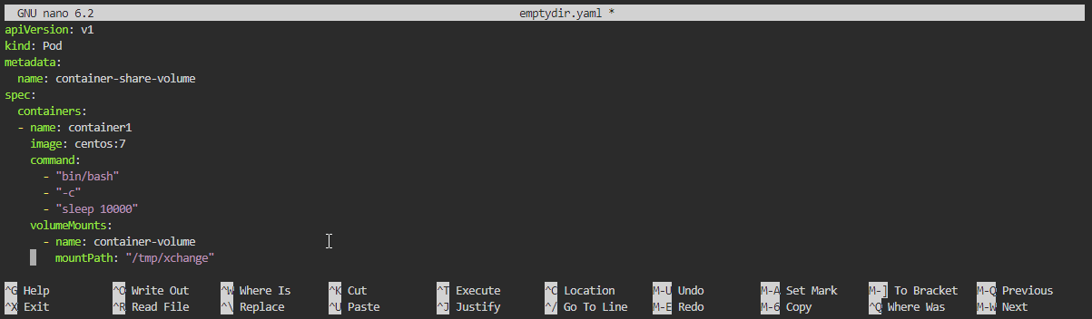
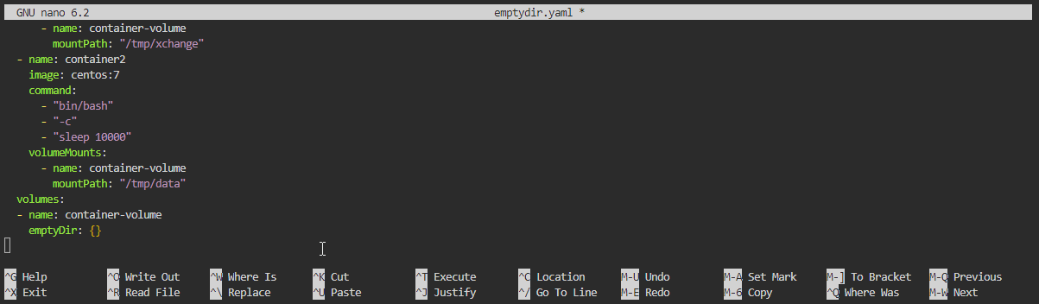
- Launch the web service by applying the configuration with the following command:
kubectl apply -f emptydir.yaml
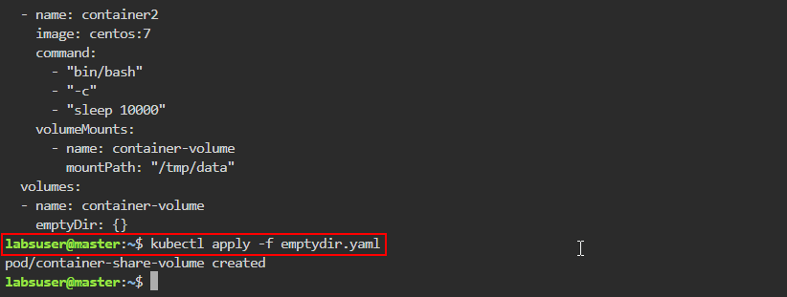
- Confirm that the pod is running and the volume is correctly shared by using the following command:
kubectl describe pod container-share-volume
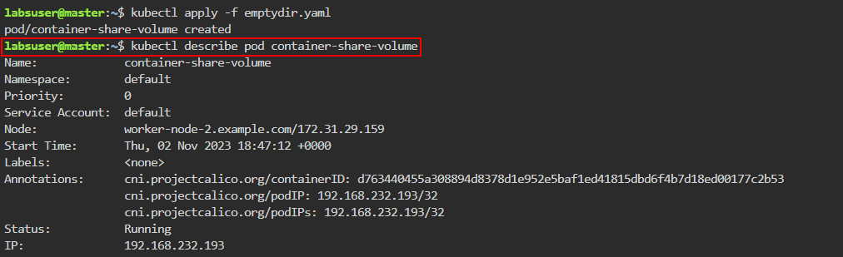
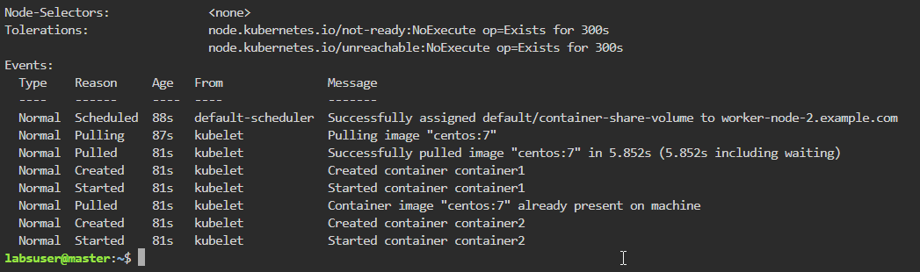

Step 2: Interact with the shared volume from both containers

- Open a shell session in container1 with the following command:
kubectl exec -it container-share-volume -c container1 -- bash
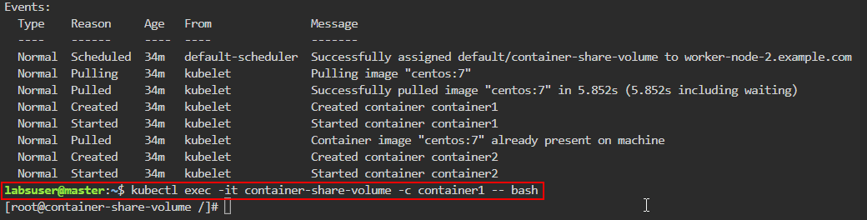
- Within the shell session, use the following commands to navigate to the shared volume and create files:
cd /tmp/xchange
touch container1-file{1..10}.txt
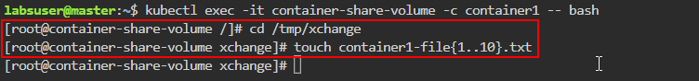

- List the files to confirm their creation using the following command:
ls
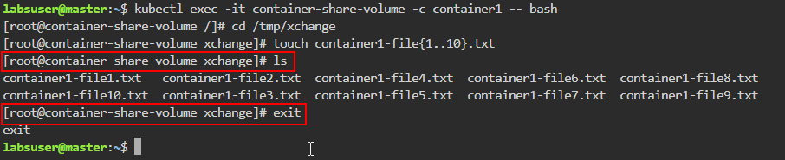
Note: Exit the shell session with the exit command

- Open a shell session in container2 using the following command:
kubectl exec -it container-share-volume -c container2 -- bash
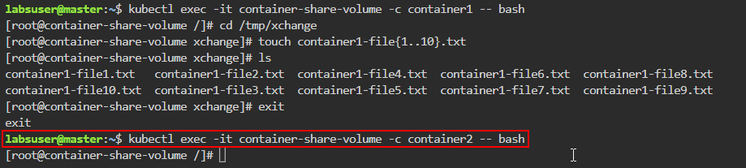

- Verify using the following commands that container2 can see the files created by container1:
cd /tmp/data
ls
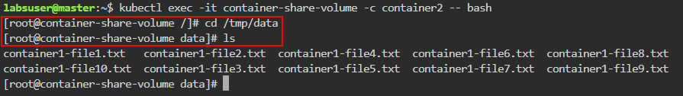
Note: Remain in the shell session without exiting

Step 3: Test data persistence and sharing capability

- Use the following command to create additional files in container2:
touch container2-file{1..10}.txt
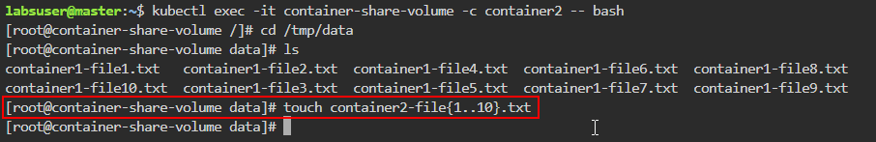
- List the files to confirm their creation with the help of the following command:
ls
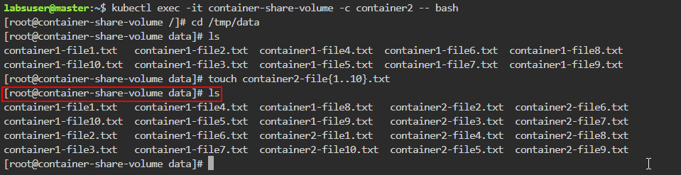
- Write to a file from container2 with the help of the following command:
echo “testing from container2” >> container1-file.txt
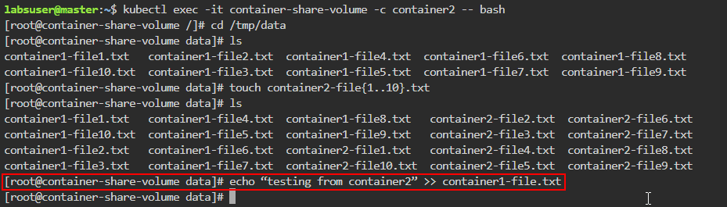

- Read the content of the file to verify the write operation with the help of the following command:
cat container1-file.txt
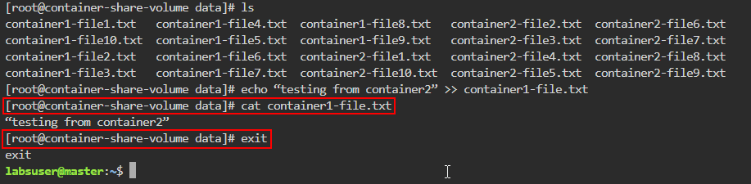
Note: Exit the shell session with the exit command

- Use the following command to return to container1:
kubectl exec -it container-share-volume -c container1 – bash
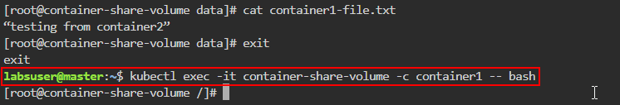
- Validate that container1 can see the changes using the following commands:
cd /tmp/xchange
ls
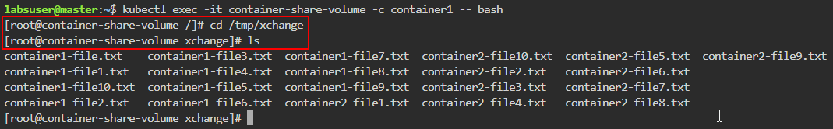
- Use the following command to count the number of files:
ls | wc -l
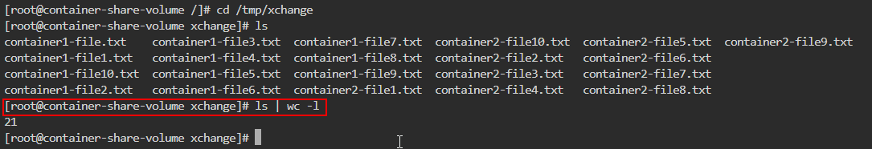

- Read the contents of the file written by container2 using the following command:
cat container1-file.txt
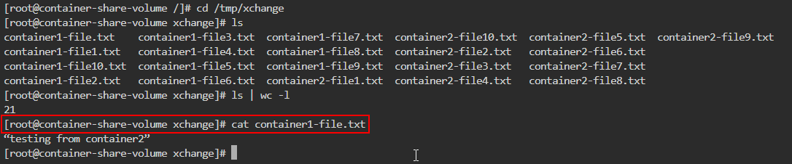
By following these steps, you have successfully implemented data sharing between containers within the same pod using hostPath volumes in Kubernetes.

