**WOMEN SAFETY DEVICES USING INTERNET OF THINGS(IOT)**

*Submitted To*

**FACULTY NAME: - Dr. Kayalvizhi Jayavel**

*Submitted by*

**NAME: - SUBHASMITA SAHU**

**DEPT: - IT**

**REG NO: - RA1711008010380**

**BATCH NO: -2**

|  |  |  |
| --- | --- | --- |
| **Sno.** | **Topic** | **Page No.** |
| **1.** | Abstract | 3 |
| **2.** | Introduction | 4 |
| **3.** | Components Requirements | 5-7 |
| **4.** | Circuit Diagram using Fritzing | 7 |
| **5.** | Methodology | 8-10 |
| **6.** | Implementation | 10-12 |
| **7.** | Coding | 12-13 |
| **8.** | Conclusion | 14 |
| **9.** | References | 15 |

**INDEX**

**ABSTRACT**

This Project presents a women safety detection system using GPS and GSM modems. The system can be interconnected with the alarm system and alert the neighbours. This detection and messaging system is composed of a GPS receiver, Microcontroller and a GSM Modem. GPS Receiver gets the location information from satellites in the form of latitude and longitude. The Microcontroller processes this information and this processed information is sent to the user using GSM modem A GSM modem is interfaced to the MCU. The GSM modem sends an SMS to the predefined mobile number. When a woman is in danger and in need of self-defence then she can press the switch which is allotted to her. By pressing the switch, the entire system will be activated then immediately a sms will be sent to concern person with location using GSM and GPS.I.

**INTRODUCTION**

Security is the condition of being protected against danger or loss. In the general sense, security is a concept similar to safety. The nuance between the two is an added emphasis on being protected from dangers that originate from outside. Individuals or actions that encroach upon the condition of protection are responsible for the breach of security. The word "security" in general usage is synonymous with "safety," but as a technical term "security" means that something not only is secure but that it has been secured. This project is designed with ATmega328.

This Project presents a women safety detection system using GPS and GSM modems. The system can be interconnected with the alarm system and alert the neighbours. This detection and messaging system is composed of a GPS receiver, Microcontroller and a GSM Modem. GPS Receiver gets the location information from satellites in the form of latitude and longitude.

The Microcontroller processes this information and this processed information is sent to the user using GSM modem A GSM modem is interfaced to the MCU. The GSM modem sends an SMS to the predefined mobile number. When a woman is in danger and in need of self-defence then she can press the switch which is allotted to her. By pressing the switch, the entire system will be activated then immediately a sms will be sent to concern person with location using GSM and GPS.

This project uses regulated 5V, 750mA power supply. 7805 three terminal voltage regulator is used for voltage regulation. Bridge type full wave rectifier is used to rectify the ac output of secondary of 230/12V step down transformer.

**REQUIREMENTS (HARDWARE AND SOFTWARE)**

* GSM TECHNOLOGY :-Global system for mobile communication (GSM) is a globally accepted standard for digital cellular communication. GSM is the name of a standardization group established in 1982 to create a common European mobile telephone standard that would formulate specifications for a pan-European mobile cellular radio system operating at 900 MHz.
* ATMEGA328 Microcontroller :-The Atmel AVR® core combines a rich instruction set with 32 general purpose working registers. All the 32 registers are directly connected to the Arithmetic Logic Unit (ALU), allowing two independent registers to be accessed in a single instruction executed in one clock cycle. The resulting architecture is more code efficient while achieving throughputs up to ten times faster than conventional CISC microcontrollers.
* Arduino Uno Board :- It is the best board to get started with electronics and coding.

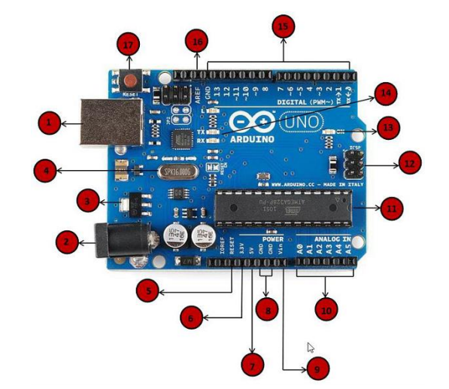

1.Power USB Arduino board can be powered by using the USB cable from computer. All we need to do is connect the USB cable to the USB connection.

2. Power (Barrel Jack) Arduino boards can be powered directly from the AC mains power supply by connecting it to the Barrel Jack.

3. Voltage Regulator The function of the voltage regulator is to control the voltage given to the Arduino board and stabilize the DC voltages used by the processor and other elements.

4. Crystal Oscillator The crystal oscillator helps Arduino in dealing with time issues. How does Arduino calculate time? The answer is, by using the crystal oscillator. The number printed on top of the Arduino crystal is 16.000H9H. It tells us that the frequency is 16,000,000 Hertz or 16 MHz.

5. Arduino Reset We can reset wer Arduino board, i.e., start wer program from the beginning. We can reset the UNO board in two ways. First, by using the reset button (17) on the board. Second, we can connect an external reset button to the Arduino pin labelled RESET (5).

6. Pins (3.3, 5, GND, Vin)

• 3.3V (6) − Supply 3.3 output volt

• 5V (7) − Supply 5 output volt

• Most of the components used with Arduino board works fine with 3.3 volt and 5 volt.

• GND (8)(Ground) − There are several GND pins on the Arduino, any of which can be used to ground wer circuit.

• Vin (9) − This pin also can be used to power the Arduino board from an external power source, like AC mains power supply.

7. Analog pins :-The Arduino UNO board has five analog input pins A0 through A5. These pins can read the signal from an analog sensor like the humidity sensor or temperature sensor and convert it into a digital value that can be read by the microprocessor.

* LIQUID CRYSTAL DISPLAY (16 X 2 ) LCD stands for Liquid Crystal Display. LCD is finding wide spread use replacing LEDs (seven segment LEDs or other multi segment LEDs) because of the following reasons: 1. The declining prices of LCDs. 2. The ability to display numbers, characters and graphics. This is in contrast to LEDs, which are limited to numbers and a few characters. 3. Incorporation of a refreshing controller into the LCD, thereby relieving the CPU of the task of refreshing the LCD. In contrast, the LED must be refreshed by the CPU to keep displaying the data. 4. Ease of programming for characters and graphics.
* POWER SUPPLY In this project we have power supplies with +5V & -5V option normally +5V is enough for total circuit.
* TRANSFORMER Transformers are used to convert electricity from one voltage to another with minimal loss of power. They only work with AC (alternating current) because they require a changing magnetic field to be created in their core. Transformers can increase voltage (step-up) as well as reduce voltage (step-down).
* RECTIFIERS The purpose of a rectifier is to convert an AC waveform into a DC waveform (OR) Rectifier converts AC current or voltages into DC current or voltage. There are two different rectification circuits, known as 'half-wave' and 'full-wave' rectifiers. Both use components called diodes to convert AC into DC.
* FILTERS A filter circuit is a device which removes the ac component of rectifier output but allows the dc component to the load. The most commonly used filter circuits are capacitor filter, choke input filter and capacitor input filter or pi-filter. We used capacitor filter here.

**Circuit Diagram Using Fritzing**

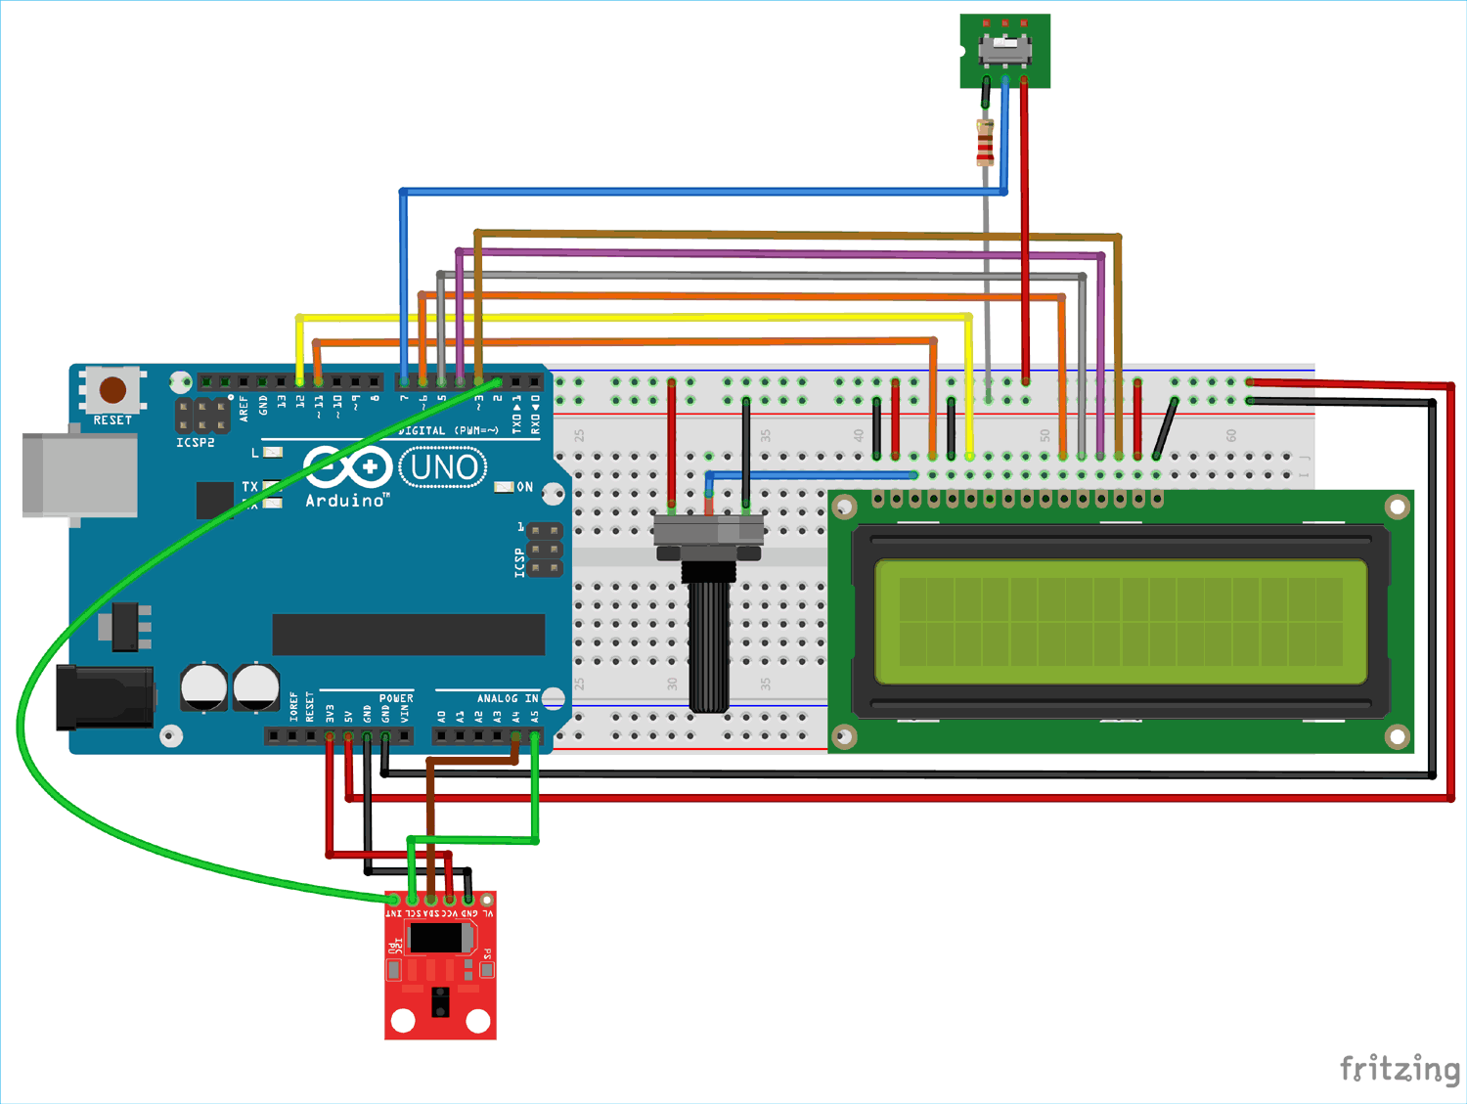

**METHODOLOGY**

**(Flow Chart/Algorithm, Block Diagram)**

WORKING PROCEDURE This project clearly uses two main modules of GSM and a microcontroller. The user when sends the messages through his phones those reaches the GSM , through the AT commands all those messages reaches the microcontroller. That microcontroller takes the data in terms of bits through the Max232. Those information will be transmitted to the LCD display.

**Flow Chart :-**

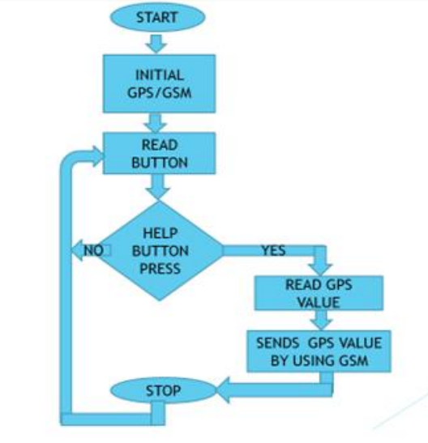

**ALGORITHM**

1.Initialize GPS sensor with 9600 baud rate.

2.connect GPS TX Pin connected to aurdino RX pin 0.

3.once power is on it takes 3 min to 5 min to activate gps sensor.

4.GPS sensor is giving different data like GPGGA, GPGSV ,GPGSA.

5.in that we require GPGMC.

6.from that we have to extract the required data.

7.finally display the data on the LCD display

**BLOCK DIAGRAM OF THE PROJECT**

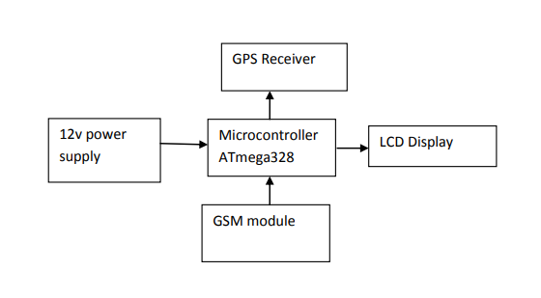

**FUNCTIONS OF EACH BLOCK**

POWER SUPPLY: The primary function of a power supply is to convert one form of electrical energy into another and, as a result power supplies.

MICROCONTROLLER: The microcontroller is used to manipulate the serial operation based the program present in the output is taken from one of the four ports.

LCD DISPLAY: LCDs are available to display arbitrary images which can be displayed or hidden, such as preset words, digits and 7 segment displays as in a digital clock.

CRYSTAL OSCILLATOR: Crystal oscillator is used to produce oscillated pulses which is given to the microcontroller.

GSM MODEM: Global system for mobile communication (GSM) is a globally accepted standard for digital cellular communication. GSM is the name of a standardization group established in 1982 to create a common European mobile telephone standard that would formulate specifications for a pan-European mobile cellular radio system operating at 900 MHz.

GPS RECEIVER: GPS, in full Global Positioning System, space-based radio-navigation system that broadcasts highly accurate navigation pulses to users on or near the Earth. In the United States’ Navstar GPS, 24 main satellites in 6 orbits circle the Earth every 12 hours. In addition, Russia maintains a constellation called GLONASS (Global Navigation Satellite System).

**IMPLEMENTATION/TARGET AUDIENCE**

Software Implementation

**Arduino uno Installation**

**Step 1:-** First we must have our Arduino board (we can choose our favourite board) and a USB cable. In case we use Arduino UNO, Nano, Arduino Mega 2560, or Diecimila, we will need a standard USB cable (A plug to B plug). In case we use Arduino Nano, we will need an A to Mini-B cable.

**Step 2:-** Download Arduino IDE Software. We can get different versions of Arduino IDE from the Download page on the Arduino Official website. We must select wer software, which is compatible with wer operating system (Windows, IOS, or Linux). After wer file download is complete, unzip the file.

**Step 3:-**Power up our board. The Arduino Uno, Mega, Duemilanove and Arduino Nano automatically draw power from either, the USB connection to the computer or an external power supply. If we are using an Arduino Diecimila, we have to make sure that the board is configured to draw power from the USB connection. The power source is selected with a jumper, a small piece of plastic that fits onto two of the three pins between the USB and power jacks. Check that it is on the two pins closest to the USB port. Connect the Arduino board to computer using the USB cable. The green power LED (labelled PWR) should glow.

**Step 4:-** Launch Arduino IDE.

After our Arduino IDE software is downloaded, we need to unzip the folder. Inside the folder, we can find the application icon with an infinity label (application.exe). Double click the icon to start the IDE.

**Step 5:-** Open our first project. Once the software starts, we have two options

* Create a new project

* Open an existing project example.

To create a new project, select File → New. To open an existing project example, select File → Example → Basics → Blink. Here, we are selecting just one of the examples with the name Blink. It turns the LED on and off with some time delay.

To avoid any error while uploading wer program to the board, we must select the correct Arduino board name, which matches with the board connected to wer computer. Go to Tools → Board and select wer board. Here, we have selected Arduino Uno board according to our tutorial, but we must select the name matching the board that we are using.

**Step 7:-**Select wer serial port.

Select the serial device of the Arduino board. Go to Tools → Serial Port menu. This is likely to be COM3 or higher (COM1 and COM2 are usually reserved for hardware serial ports). To find out, we can disconnect wer Arduino board and re-open the menu, the entry that disappears should be of the Arduino board. Reconnect the board and select that serial port.

**Step 8:-** Upload the program to wer board.

ADVANTAGES:

• Sophisticated security.

• Alert message to mobile phone for remote information.

• Mobile number can be changed at any time.

• Can be used to prevent incidents.

• Reduced Cost and Portable Can be easily carried any where.

• Comfortable and Easy to Use

• Monitors all hazards and threats.

APPLICATIONS:

• Security appliances.

• Safety of women and Children.

• Used as a legal evidence of crime with exact location information for prosecution.

**CODE**

#include <LiquidCrystal.h>

LiquidCrystal lcd(12, 11, 7, 6, 5, 4);

String inputString3="";

String Logitude="";

String Latitude="";

int SMSPIN=8;

void setup() {

lcd.begin(16, 2); // put your setup code here, to run once:

Serial.begin(9600);

Serial.println("GPS Ready");

inputString3.reserve(200);

Logitude.reserve(20);

Latitude.reserve(20);

pinMode(SMSPIN,INPUT);

lcd.print("System Ready");

}

void loop()

{

ReadSerialData();

//delay(100);

}

void ReadSerialData()

{

char inChar;

inputString3=""; do{if(Serial.available()){inChar=(char)Serial.read();}}while(inChar!='$'); do{if(Serial.available()){inChar=(char)Serial.read();inputString3=inputString3+inChar;}

}while(inChar!='\n');

if(inputString3[2]=='R' &&inputString3[3]=='M' && inputString3[4]=='C'){CheckForLatitude();}

} void CheckForLatitude()

{ int i=0;

char DataType;

Logitude="";

Latitude="";

do{i++;}while(inputString3[i]!=',');

do{i++;}while(inputString3[i]!=',');

i++; DataType=inputString3[i];i++; do{i++;Latitude=Latitude+inputString3[i];}while(inputString3[i]!=',');

i++; Latitude=Latitude+inputString3[i];i++; do{i++;Logitude=Logitude+inputString3[i];}while(inputString3[i]!=',');

i++; Logitude=Logitude+inputString3[i];i++;

Serial.print("Data Type:");Serial.println(DataType); Serial.print("Latitude:");Serial.println(Latitude); Serial.print("Longitude:");Serial.println(Logitude); lcd.setCursor(0, 0); lcd.print("Lat :");lcd.print(Latitude);

lcd.setCursor(0, 1);

lcd.print("Long:");

lcd.print(Logitude);

int GSMValue=digitalRead(SMSPIN); if(GSMValue==HIGH){SendSMS("7995953860");}

}

void SendSMS(String Number)

{

lcd.setCursor(0,1);

lcd.print("SMS Sending");

Serial.println("AT"); delay(1000);

Serial.println("AT+CSMP=17,167,0,0"); delay(1000); Serial.print("AT+CMGS=");Serial.print('"');Serial.print(Number);Serial.println('"');

delay(3000);

Serial.println("Urgent Help:");

Serial.print("Latitude:");

Serial.println(Latitude);

Serial.print("Longitude:");

Serial.println(Logitude);

Serial.print((char)0x1a);

delay(10000); }

**CONCLUSION**

Effort behind this project is to design and fabricate a gadget which is so compact in itself that provide advantage of personal security system the emergency response system which is helpful for women in the incidents of crime. It is low cost system which can store the data of the members in the particular locality and provide immediate alert in case of crime against women. This provides women security. Being safe and secure is the demand of the day.

**REFERENCES**

A Car Test for the Estimation of GPS/INS Alignment Errors Sinpyo Hong, Man Hyung Lee, Senior Member , IEEE, Sun Hong Kwon, and Ho Hwan Chun IEEETRANSACTIONS ON INTELLIGENTTRANSPORTATION SYSTEMS, VOL. 5, NO. 03,SEPTEMBER 2004.

A.H.Ansari, BalsarfPratiksha P, MaghadeTejal R, YelmameSnehal M, “Women Security System using GSM & GPS”, International Journal of Innovative Research in Science, Engineering and Technology”, Vol.6, Issue 3, March 2017.

Azhaguramyaa V R, Sangamithra D, Sindhja B, “RFID Based Security System for Women”, International Journal of Scientific & Engineering Research Volume 8 Issue 5, May-2017.