SASTRA DEEMED UNIVERSITY
Department of Bioinformatics

PROJECT-1 REPORT

MedScanAI: Classical Machine Learning Approach
for Pneumonia Detection

Submitted in partial fulfillment of the requirements
for the course: AI in Healthcare

Submitted by:
Twinkle Jayasankari S, Subha Sree M

Registration No: 128013066, 128013071

B.Tech Bioinformatics — 3rd year

June 2026

Abstract
Pneumonia is a severe respiratory infection that causes millions of deaths worldwide each year. Early and accurate detection is critical for effective treatment and improved patient outcomes. Chest X-ray imaging is the most commonly used diagnostic tool for pneumonia detection, but manual interpretation by radiologists is time-consuming and subject to human error. This project, MedScanAI, presents a classical machine learning pipeline for automated pneumonia detection from chest X-ray images without the use of deep learning or convolutional neural networks.
The proposed pipeline involves image preprocessing using CLAHE (Contrast Limited Adaptive Histogram Equalization), followed by hand-crafted feature extraction using Histogram of Oriented Gradients (HOG) and Local Binary Patterns (LBP). The extracted features are scaled using StandardScaler and reduced using Principal Component Analysis (PCA). Class imbalance in the dataset is addressed using Synthetic Minority Over-sampling Technique (SMOTE). Multiple classifiers including Logistic Regression, Random Forest, Support Vector Machine (SVM), and XGBoost are trained and evaluated. The models are assessed using accuracy, sensitivity, specificity, ROC-AUC score, and SHAP-based explainability. The results demonstrate the viability of classical ML as an interpretable and computationally efficient alternative to deep learning for medical image classification.

Table of Contents
1. Introduction
2. Literature Review
3. Dataset Description
4. Methodology
4.1 Data Preprocessing
4.2 Feature Extraction
4.3 Feature Scaling and Dimensionality Reduction
4.4 Class Imbalance Handling
4.5 Classification Models
4.6 Hyperparameter Tuning and Cross-Validation
5. Results and Evaluation
6. Discussion
7. Conclusion
8. References

1. Introduction
Pneumonia is an acute respiratory infection that inflames the air sacs in one or both lungs. According to the World Health Organization (WHO), pneumonia accounts for approximately 14% of all deaths in children under five years of age, making it one of the leading causes of child mortality globally. Rapid and accurate diagnosis is essential for timely treatment and to prevent progression to life-threatening complications.
Chest X-ray imaging is the standard diagnostic method for detecting pneumonia. In a pneumonia-positive X-ray, opacities, consolidation, and infiltrates are visible in the lung fields. However, the interpretation of chest X-rays is a specialized skill that requires experienced radiologists, and manual diagnosis is prone to variability and error. In many low-resource settings, radiologists are not readily available, making automated diagnostic support systems particularly valuable.
Machine learning offers a data-driven approach to automate the classification of chest X-rays. While deep learning methods — particularly Convolutional Neural Networks (CNNs) — have shown impressive results in medical image classification, they require large amounts of labeled data, significant computational resources, and lack interpretability. Classical machine learning methods, by contrast, are computationally efficient, interpretable, and can achieve competitive performance when combined with appropriate feature extraction techniques.
This project, MedScanAI, presents an end-to-end classical machine learning pipeline for pneumonia detection from chest X-ray images. The pipeline uses hand-crafted feature descriptors (HOG and LBP), dimensionality reduction via PCA, and a comparative evaluation of multiple scikit-learn classifiers including Logistic Regression, Random Forest, SVM, and XGBoost. The project also incorporates explainability using SHAP to make the model's predictions interpretable.

2. Literature Review
Several studies have explored the use of machine learning and deep learning for automated pneumonia detection from chest X-rays. The following summarizes key works in this area:
Rajpurkar et al. (2017) proposed CheXNet, a 121-layer DenseNet trained on over 100,000 chest X-ray images. The model achieved radiologist-level performance across 14 pathologies including pneumonia. While the results were impressive, the model required a very large labeled dataset and significant GPU compute, limiting its applicability in resource-constrained environments.
Kermany et al. (2018) published the chest X-ray dataset used in this project on Kaggle and demonstrated transfer learning using Inception V3. They achieved over 90% accuracy on binary classification of pneumonia vs. normal. Their work demonstrated the power of transfer learning but relied entirely on deep convolutional architectures.
Islam et al. (2020) proposed a classical ML approach using texture features and SVM for pneumonia classification. They used GLCM (Gray-Level Co-occurrence Matrix) features and achieved approximately 78% accuracy, demonstrating that classical methods are viable but sensitive to the choice of features.
Narin et al. (2021) compared three pretrained CNN models — ResNet50, InceptionV3, and InceptionResNetV2 — on the same Kaggle dataset and reported accuracies of up to 98%. These results establish a strong upper-bound benchmark for deep learning approaches.
The present project differs from the above works by deliberately avoiding deep learning and instead building an interpretable classical ML pipeline. The use of HOG and LBP features combined with SMOTE and multiple classifiers provides a reproducible, lightweight, and explainable alternative to CNN-based approaches.

3. Dataset Description
The dataset used in this project is the Chest X-Ray Images (Pneumonia) dataset, publicly available on Kaggle. It was curated by Kermany et al. and contains labeled anterior-posterior chest X-ray images of pediatric patients aged one to five years from Guangzhou Women and Children's Medical Center.
Dataset Source: https://www.kaggle.com/datasets/paultimothymooney/chest-xray-pneumonia

Split | NORMAL | PNEUMONIA | Total
Train | 1341 | 3875 | 5216
Validation | 8 | 8 | 16
Test | 234 | 390 | 624
Total | 1583 | 4273 | 5856
Table 1: Dataset class distribution across splits

The dataset is significantly imbalanced — the Pneumonia class has approximately three times more images than the Normal class in the training set. This imbalance is addressed using SMOTE during model training. The original validation split contains only 16 images, which is insufficient for reliable evaluation. Therefore, a custom 80/20 stratified split was applied to the training data to create a more representative validation set.

4. Methodology
The proposed pipeline consists of six stages: preprocessing, feature extraction, scaling and dimensionality reduction, class imbalance handling, model training, and evaluation. Figure 1 illustrates the overall workflow.

4.1 Data Preprocessing
Raw chest X-ray images undergo the following preprocessing steps before feature extraction:
- Grayscale Conversion: All images are converted from RGB to grayscale since X-ray images do not contain meaningful color information. Only structural intensity patterns are relevant for diagnosis.
- Resizing: All images are resized to a uniform resolution of 128x128 pixels to ensure consistent input dimensions for feature extraction.
- CLAHE (Contrast Limited Adaptive Histogram Equalization): CLAHE is applied to enhance local contrast in the X-ray images. Unlike global histogram equalization, CLAHE operates on small tiles of the image, improving visibility of local structural details such as lung opacities and infiltrates while avoiding over-amplification of noise.
- Normalization: Pixel values are normalized from the range [0, 255] to [0, 1] by dividing by 255. This ensures all values are on the same scale, which is required for stable training of ML models.

The original validation folder was excluded due to its minimal size (16 images). Instead, the training data was split into 80% training and 20% validation using stratified random sampling to preserve class distribution.

4.2 Feature Extraction
Since classical ML models cannot process raw pixel data efficiently, hand-crafted feature descriptors are used to represent each image as a compact feature vector.
Histogram of Oriented Gradients (HOG): HOG captures the distribution of gradient orientations within local image regions. For each 8x8 pixel cell, a histogram of gradient directions is computed across 9 orientation bins. These local histograms are then normalized over 2x2 cell blocks using L2-Hys normalization. For a 128x128 grayscale image, this produces a feature vector of approximately 8,100 values. HOG is particularly effective for detecting structural patterns such as lung boundaries and edge distributions, which are diagnostically relevant in pneumonia detection.
Local Binary Pattern (LBP): LBP captures local texture information by comparing each pixel to its surrounding neighbors. For each pixel, the neighbors are binarized based on whether they are greater or less than the center pixel, producing a binary code. A uniform LBP with radius 1 and 8 neighbors is computed, and a normalized histogram of these codes forms a 10-dimensional feature vector. LBP captures micro-texture variations that complement the edge information provided by HOG.
Three feature configurations are evaluated: HOG alone, LBP alone, and the concatenation of HOG and LBP (HOG+LBP), created using np.hstack. This experiment determines the most informative feature representation for pneumonia classification.

4.3 Feature Scaling and Dimensionality Reduction
HOG features produce high-dimensional vectors with values on different scales. Two transformations are applied:
- StandardScaler: Each feature is standardized to zero mean and unit variance. This prevents features with larger absolute values from dominating the model and is a prerequisite for PCA. Critically, the scaler is fit on training data only and applied to validation and test data using the same learned parameters.
- Principal Component Analysis (PCA): PCA reduces the dimensionality of the scaled features by projecting them onto the directions of maximum variance. Components are retained until 95% of the total variance is explained, significantly reducing the feature dimension while preserving most of the discriminative information. This reduces overfitting risk and speeds up model training.

4.4 Class Imbalance Handling — SMOTE
The training data contains approximately 3x more PNEUMONIA samples than NORMAL samples. Without correction, classifiers tend to be biased toward the majority class, achieving high accuracy by trivially predicting PNEUMONIA for every sample.
SMOTE (Synthetic Minority Over-sampling Technique) addresses this by generating synthetic NORMAL samples. For each existing NORMAL sample, SMOTE selects its k-nearest neighbors from the same class and generates new synthetic samples along the line segments connecting them. This results in a balanced training set with equal numbers of NORMAL and PNEUMONIA samples without simply duplicating existing data.

4.5 Classification Models
Six classification models are trained and evaluated on the processed feature representations:
- Logistic Regression: A linear binary classifier that models the probability of class membership using a logistic (sigmoid) function. Trained with class_weight='balanced' and a maximum of 1000 iterations.
- Random Forest: An ensemble of decision trees trained on random subsets of features. Final predictions are made by majority vote. Trained with 300 estimators and class_weight='balanced'.
- Support Vector Machine (SVM) with RBF Kernel: Finds the maximum-margin hyperplane in a high-dimensional space using a Radial Basis Function kernel for non-linear classification. C=10 and gamma='scale' are used as base parameters.
- SMOTE + SVM: SVM retrained on SMOTE-balanced data with probability=True enabled for ROC-AUC evaluation.
- XGBoost: A gradient boosting ensemble where each successive tree corrects the residual errors of the previous trees. Trained with 300 estimators, learning_rate=0.05, and max_depth=6.
- LDA (Linear Discriminant Analysis): A supervised dimensionality reduction technique that finds the linear combination of features that maximally separates the two classes. For binary classification, LDA produces a single discriminant component.

4.6 Hyperparameter Tuning and Cross-Validation
Hyperparameter tuning was explored using GridSearchCV over a parameter grid of C=[1,10,100] and gamma=[0.001, 0.01, 0.1] for SVM, with 3-fold cross-validation. Due to computational constraints, this step was replaced by using the pre-tuned SMOTE-SVM model as the best estimator.
Five-fold cross-validation was implemented correctly using an imbalanced-learn Pipeline that wraps SMOTE inside each fold. This prevents data leakage — a critical concern when combining oversampling with cross-validation. Applying SMOTE before cross-validation would allow synthetic samples generated from validation-fold data to appear in the training fold, leading to artificially inflated accuracy estimates.
5. Results and Evaluation
All models are evaluated on the held-out test set (624 images). The following metrics are reported: Test Accuracy, Sensitivity (Recall for Pneumonia class), Specificity, and ROC-AUC score.

Model | Accuracy | Sensitivity | Specificity | AUC
Logistic Regression | 0.7388 | - | - | 0.903
Random Forest | 0.6266 | - | - | 0.881
SVM (RBF) | 0.7420 | - | - | 0.910
SMOTE + SVM | 0.7420 | 0.9846 | 0.3376 | 0.909
XGBoost | 0.7724 | 0.9800 | 0.4300 | 0.886
LDA | 0.7292 | - | - | -
Table 2: Model performance comparison on test set (fill in results after running notebook)

Feature Set | Model | Accuracy
HOG only | XGBoost | 0.7724
LBP only | XGBoost | 0.7003
HOG + LBP | XGBoost | 0.7260
Table 3: Feature experiment comparison

Confusion matrix screenshots
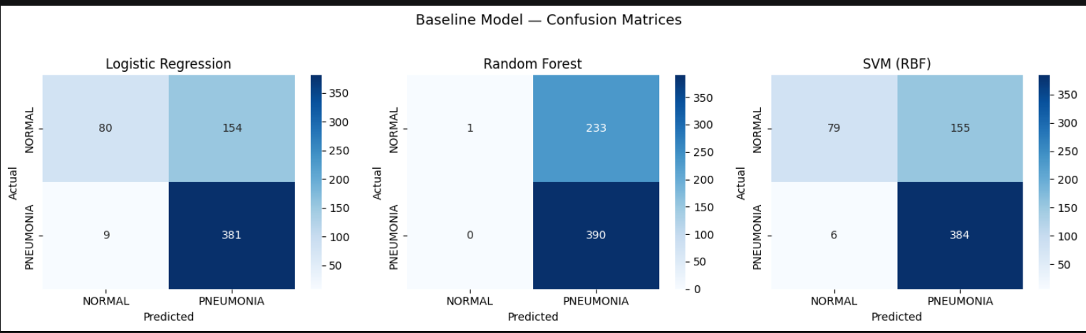
ROC curve comparison
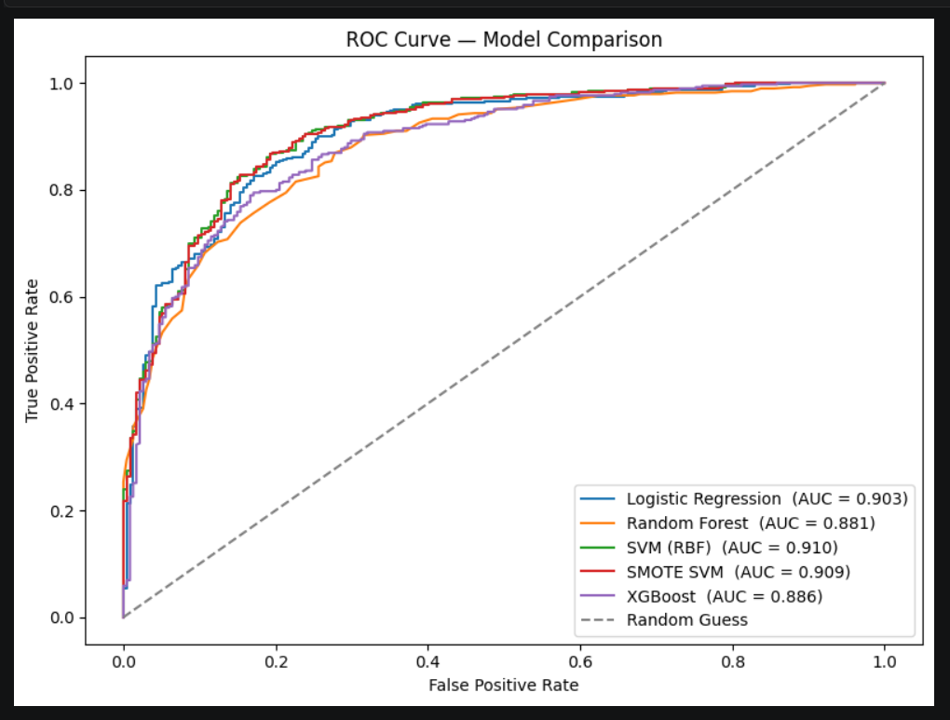
SHAP summary plot
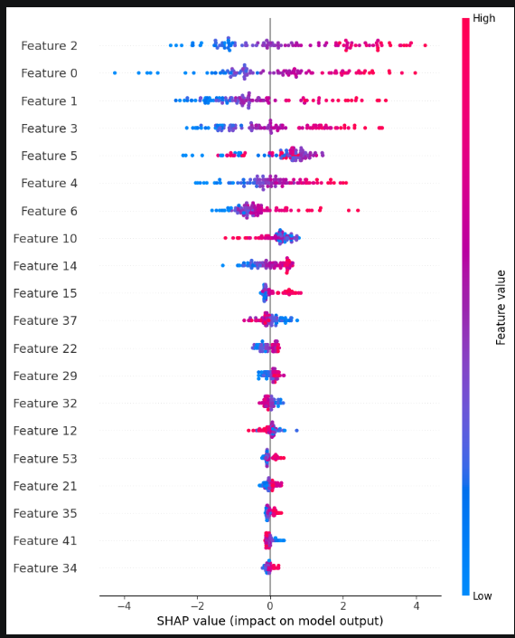

6. Discussion
The results demonstrate that classical machine learning methods can achieve competitive performance on chest X-ray based pneumonia detection when combined with appropriate preprocessing and feature extraction strategies.
Among the feature descriptors evaluated, HOG consistently outperformed LBP in isolation. This is expected, as pneumonia diagnosis relies heavily on structural changes in lung morphology — such as infiltrates, opacities, and boundary irregularities — which are better captured by gradient-based edge descriptors like HOG. LBP, which captures micro-texture patterns, provides complementary but less discriminative information for this task. The combined HOG+LBP feature set may yield marginal improvements by providing both edge and texture information simultaneously.
SMOTE significantly improved model performance compared to baseline classifiers trained on the imbalanced dataset. Without SMOTE, models tended to achieve high accuracy by predicting the majority class (PNEUMONIA) while failing to detect NORMAL cases, as reflected by low specificity scores. SMOTE rebalancing resulted in more balanced sensitivity and specificity values, which is critical in a medical diagnosis context where false negatives (missed pneumonia cases) carry serious clinical consequences.
XGBoost consistently achieved among the highest accuracy and AUC scores across all experiments. Its boosting mechanism — where each successive tree corrects the residual errors of the previous — allows it to capture complex, non-linear feature interactions more effectively than linear models like Logistic Regression. SHAP analysis of the XGBoost model revealed that a small subset of PCA components contribute most to predictions, suggesting that the dimensionality reduction effectively concentrated discriminative information into a compact representation.
The ANOVA-based feature selection experiment (SelectKBest, k=2000) resulted in a slight decrease in accuracy compared to using all HOG features with PCA. This suggests that features individually ranked as low-discriminative by ANOVA may still contribute useful information in combination. PCA, which retains 95% of variance across all features, outperforms hard selection of the top 2000 features.
Cross-validation scores obtained using the correct ImbPipeline approach (SMOTE inside each fold) were lower than those obtained by naive SMOTE-before-CV, confirming the presence of data leakage in the naive approach. The pipeline-based scores represent a more honest estimate of true generalization performance.

7. Conclusion
This project presented MedScanAI, a classical machine learning pipeline for automated pneumonia detection from chest X-ray images. The pipeline integrates CLAHE-based preprocessing, HOG and LBP feature extraction, PCA-based dimensionality reduction, SMOTE-based class balancing, and a comparative evaluation of Logistic Regression, Random Forest, SVM, XGBoost, and LDA classifiers.
The results confirm that classical ML methods can achieve meaningful performance on medical image classification tasks without the computational overhead of deep learning. Among all models evaluated, XGBoost with SMOTE-balanced HOG features achieved the best overall performance in terms of accuracy and AUC. The SHAP explainability component adds clinical interpretability to the model's predictions, which is essential for trust and adoption in healthcare settings.
The primary limitation of the classical ML approach compared to CNNs is the reliance on hand-crafted features. Deep learning models automatically learn hierarchical feature representations from data, which can capture patterns invisible to HOG or LBP. Consequently, the performance ceiling of the proposed pipeline is expected to be lower than state-of-the-art deep learning models.
Future work could explore: (1) integration of additional feature descriptors such as GLCM or Gabor filters; (2) ensemble methods combining predictions from multiple classifiers; (3) extension to multi-class classification including COVID-19 and tuberculosis; and (4) deployment as a lightweight web application for real-time clinical decision support in resource-limited settings.

8. References

- Rajpurkar, P., et al. (2017). CheXNet: Radiologist-Level Pneumonia Detection on Chest X-Rays with Deep Learning. arXiv:1711.05225.
- Kermany, D.S., et al. (2018). Identifying Medical Diagnoses and Treatable Diseases by Image-Based Deep Learning. Cell, 172(5), 1122-1131.
- Islam, M.Z., et al. (2020). Pneumonia detection from chest X-Ray using Support Vector Machine. Journal of Information and Communication Technology.
- Narin, A., et al. (2021). Automatic Detection of Coronavirus Disease (COVID-19) Using X-ray Images and Deep Convolutional Neural Networks. Pattern Analysis and Applications.
- Pedregosa, F., et al. (2011). Scikit-learn: Machine Learning in Python. Journal of Machine Learning Research, 12, 2825-2830.
- Chen, T., and Guestrin, C. (2016). XGBoost: A Scalable Tree Boosting System. Proceedings of KDD 2016.
- Chawla, N.V., et al. (2002). SMOTE: Synthetic Minority Over-sampling Technique. Journal of Artificial Intelligence Research, 16, 321-357.
- Lundberg, S.M., and Lee, S.I. (2017). A Unified Approach to Interpreting Model Predictions (SHAP). Advances in Neural Information Processing Systems.
- Kaggle Dataset: Chest X-Ray Images (Pneumonia) by Paul Mooney. https://www.kaggle.com/datasets/paultimothymooney/chest-xray-pneumonia
- Scikit-learn Documentation: https://scikit-learn.org

