**Lab Assignment 3**

1. Write a function called check-season, it takes a month parameter and returns the season:

Autumn, Winter, Spring or Summer.

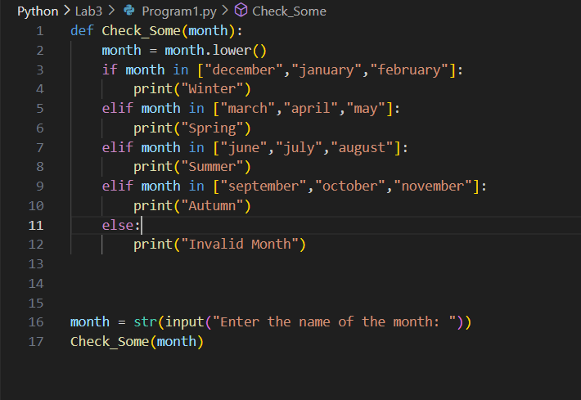

Output :

1.o

1. Write a function called calculate_slope which return the slope of a linear equation .

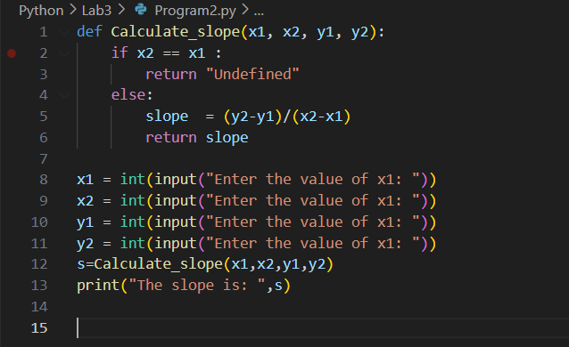

Output:

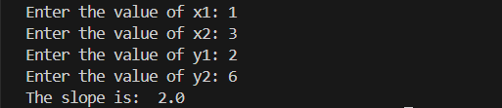

1. Quadratic equation is calculated as follows: ax² + bx + c = 0. Write a function which calculates

solution set of a quadratic equation, _solve_quadratic_eqn_.

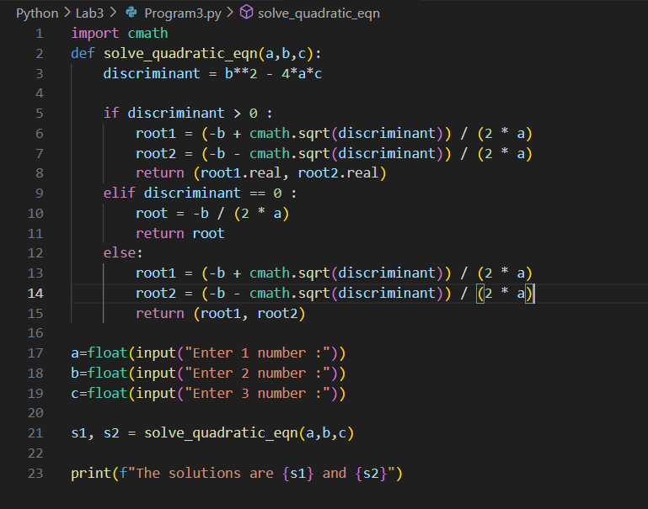

Output:

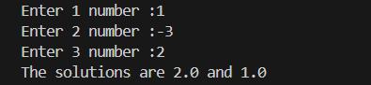

1. Declare a function named print_list. It takes a list as a parameter and it prints out each

element of the list.

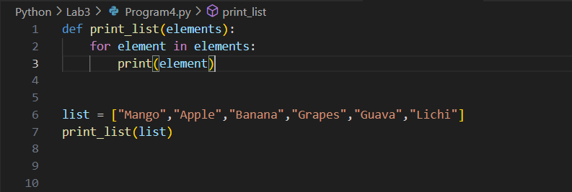

Output:

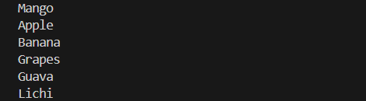

1. Declare a function named reverse_list. It takes an array as a parameter and it returns the

reverse of the array (use loops).

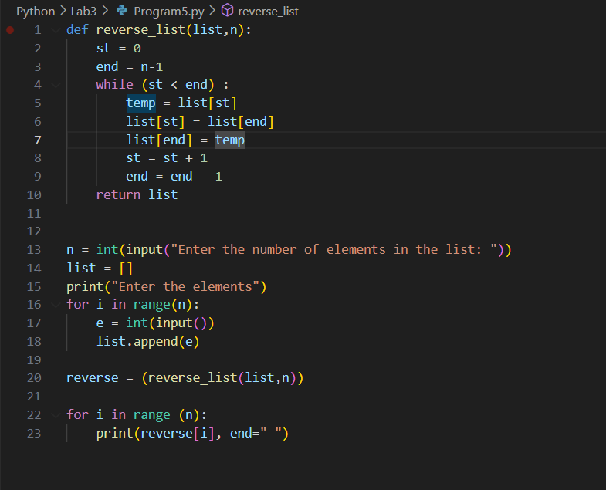

Output:

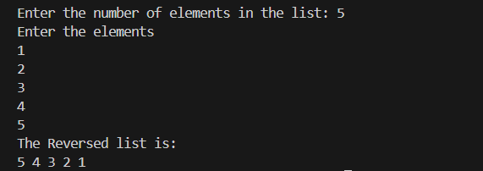

1. Compute the sum up to n terms in the series

1 - 1/2 + 1/3 - 1/4 + 1/5 -... 1/n where n is a positive integer and input by user.

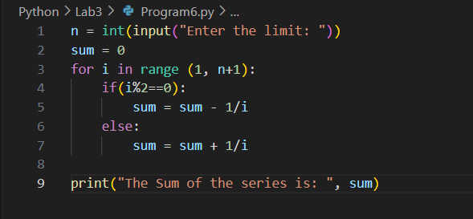

Output:

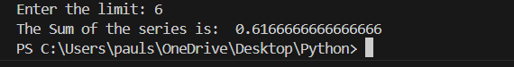

1. Write a program to compute sin x for given x. The user should supply x and a positive integer

n. We compute the sine of x using the series and the computation should use all terms in the

series up through the term involving xn

sin x = x - x3/3! + x5/5! - x7/7! + x9/9! ........

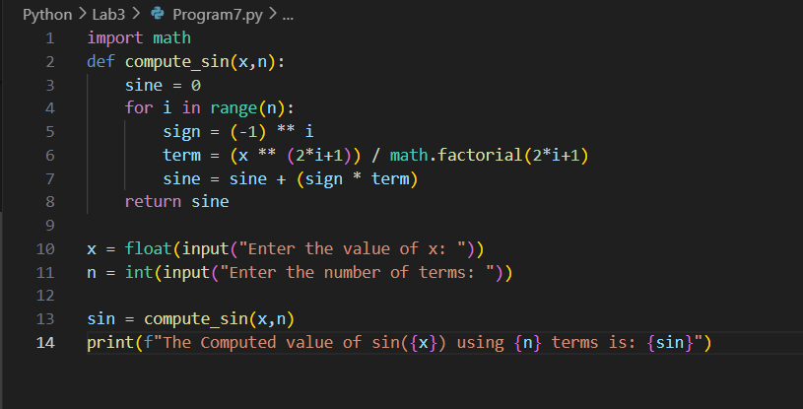

Output:

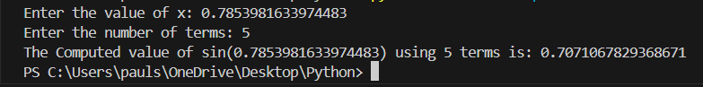

1. Write a program to compute cosine of x. The user should supply x and a positive integer n.

We compute the cosine of x using the series and the computation should use all terms in the

series up through the term involving xn

cos x = 1 - x2/2! + x4/4! - x6/6! ....

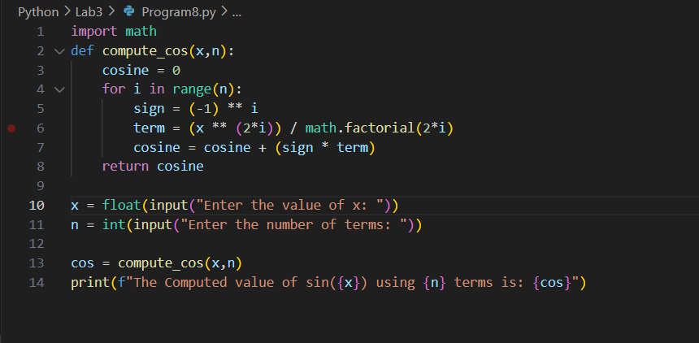

Output:

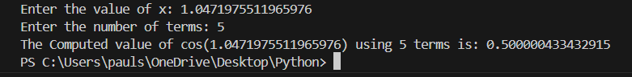

1. Print the pattern upto N Lines:

.

/_\

N=2

.

/ \

/___\

N=3

.

/ \

/ \

/_____\

N=4

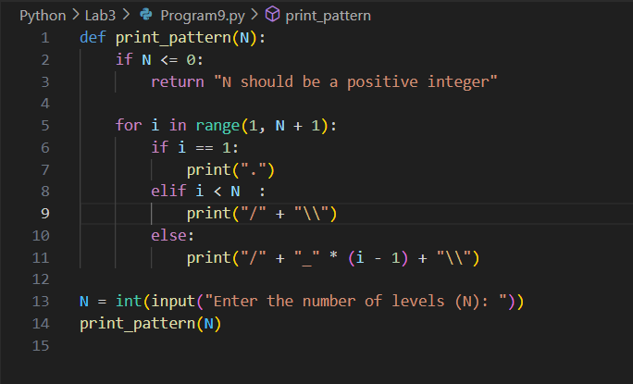

Output:

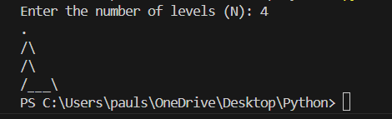

1. Print a number as a 8 segment display N Lines:

_

_|

|_

N=2

_

_|

_|

N=3

|_|

|

N=4

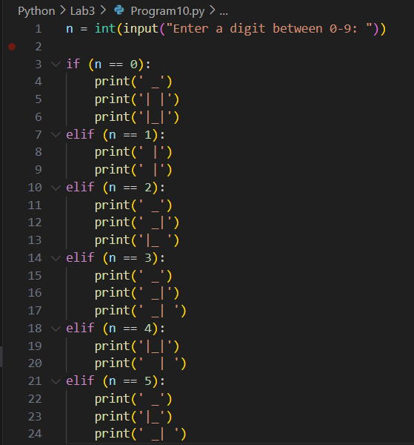

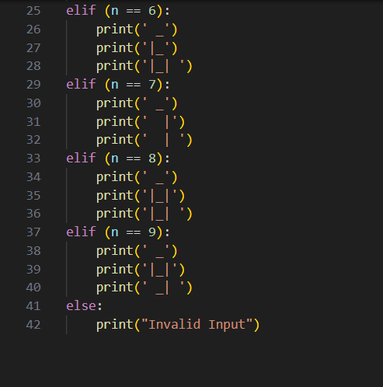

Output:

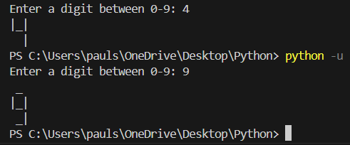

1. Print the pattern upto N lines:

1 2

4 3

N=2

1 2 3

8 9 4

7 6 5

N=3

1 2 3 4

12 13 14 5

11 16 15 610 9 8 7

N=4

1. Write a python script that displays the following table

1 1 1 1 1

2 1 2 4 8

3 1 3 9 27

4 1 4 16 64

5 1 5 25 125

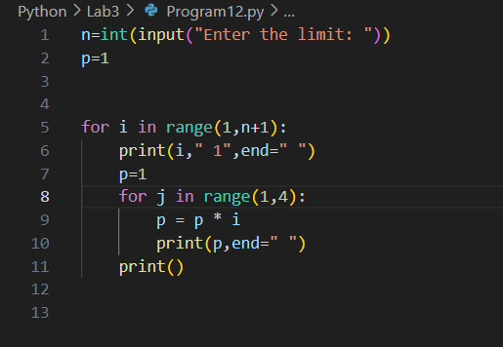

Output:

