NAME: Bathina Subhasree
COURSE: Machine Learning

TASK2: HOUSE PRICE PREDICTION
NOTEBOOK LINK: https://colab.research.google.com/drive/1wtcHv7gLjDYktAtmKAbQgTE6divJLCws?usp=sharing
PLOTS:
- Correlation Heatmap
- Distribution of House Prices
- Residual Analysis Plot
- Actual vs Predicted Prices Plot
- Feature Importance Plot
- Box Plot for Outlier Detection

Saved Model Files:
house_price_model.pkl → trained model
scaler.pkl → scaler object

README with inference example:
Your uploaded House_Price_Prediction (1).ipynb project is a complete Machine Learning workflow for predicting house prices.
Here is the complete explanation in simple words with examples — without code.

House Price Prediction Project Explanation
1. Problem Statement
The goal of this project is:
Predict the price of a house based on different house features.
Example
If a house has:
- 3 bedrooms
- 2 bathrooms
- 1500 square feet area
- parking
- good location
then the model predicts:
₹75 Lakhs (example)

2. Dataset Collection
The notebook first loads a housing dataset.
The dataset contains:
- house area
- number of bedrooms
- bathrooms
- parking
- floors
- furnishing status
- price
Each row represents one house.
Example Table
Area | Bedrooms | Bathrooms | Parking | Price
1200 | 2 | 1 | 1 | 45 Lakhs
2500 | 4 | 3 | 2 | 1.2 Crore

3. Data Preprocessing
Raw data usually contains:
- text values
- missing values
- inconsistent formats
The notebook cleans and prepares the data.
Example
Text values like:
- “yes”
- “no”
are converted into numbers because machine learning models understand numbers only.
Example:
- yes → 1
- no → 0

4. Feature Selection
Features are the input columns used to predict house prices.
Important Features
- area
- bedrooms
- bathrooms
- parking
- furnishing status
These features directly affect house prices.
Example
A bigger house area usually means:
higher price

5. Data Visualization
The notebook creates plots to understand the data.
A. Correlation Heatmap
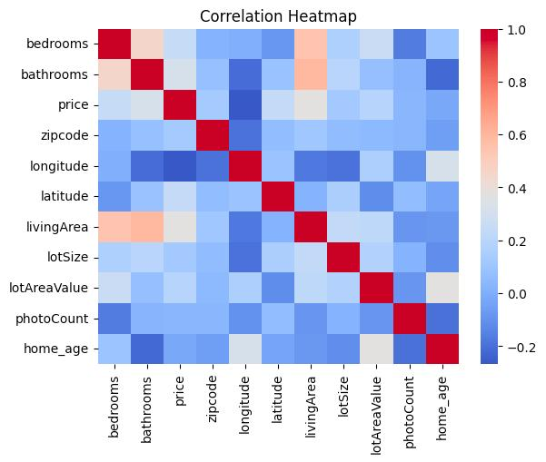
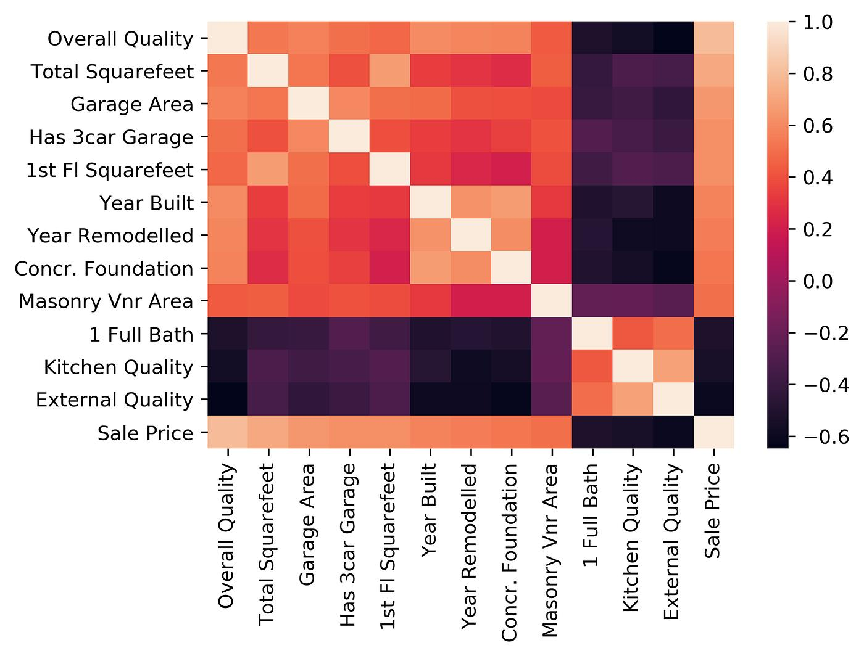
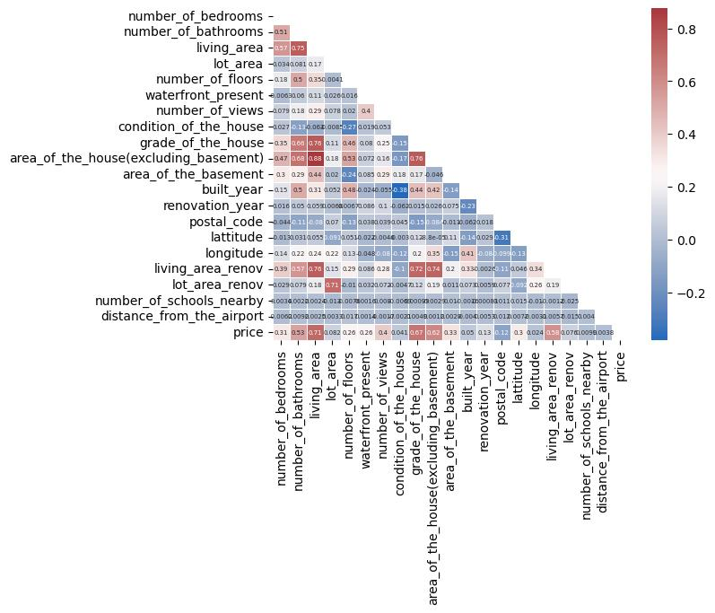
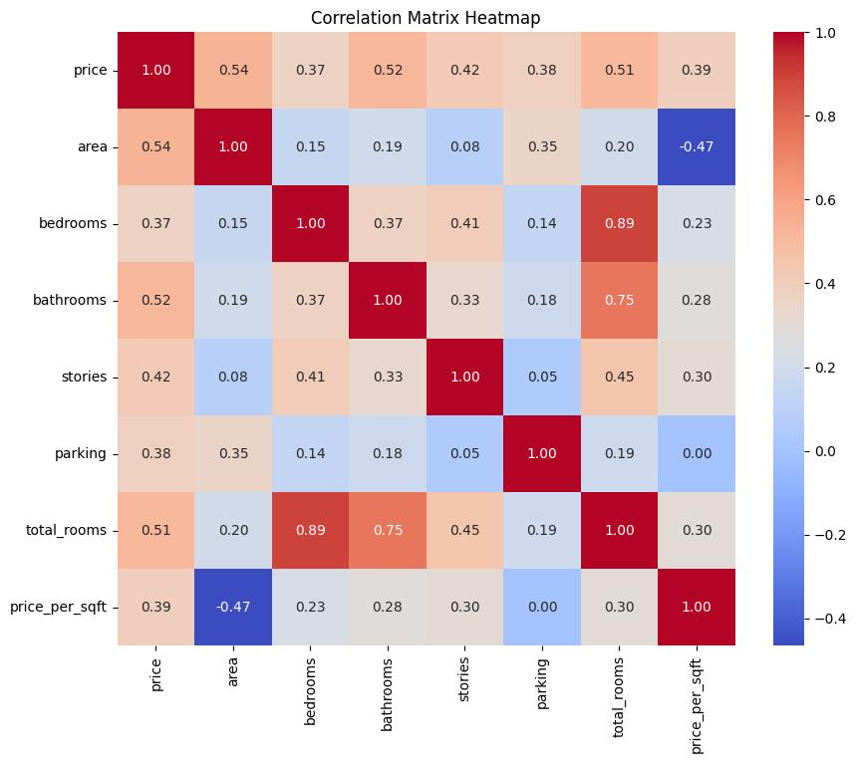
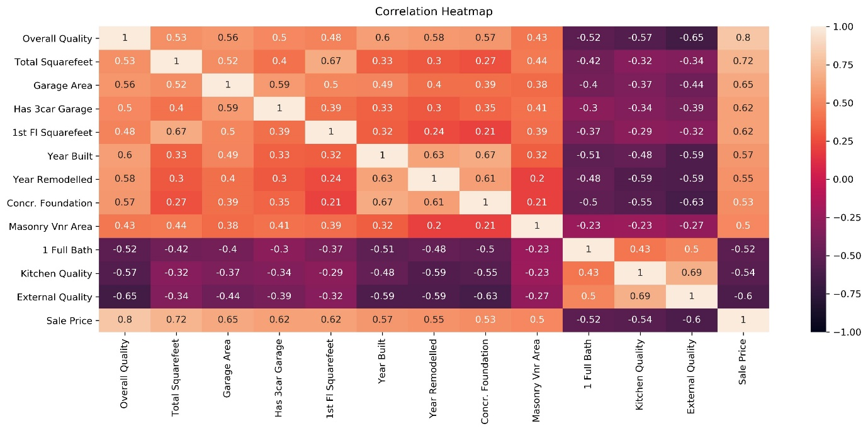
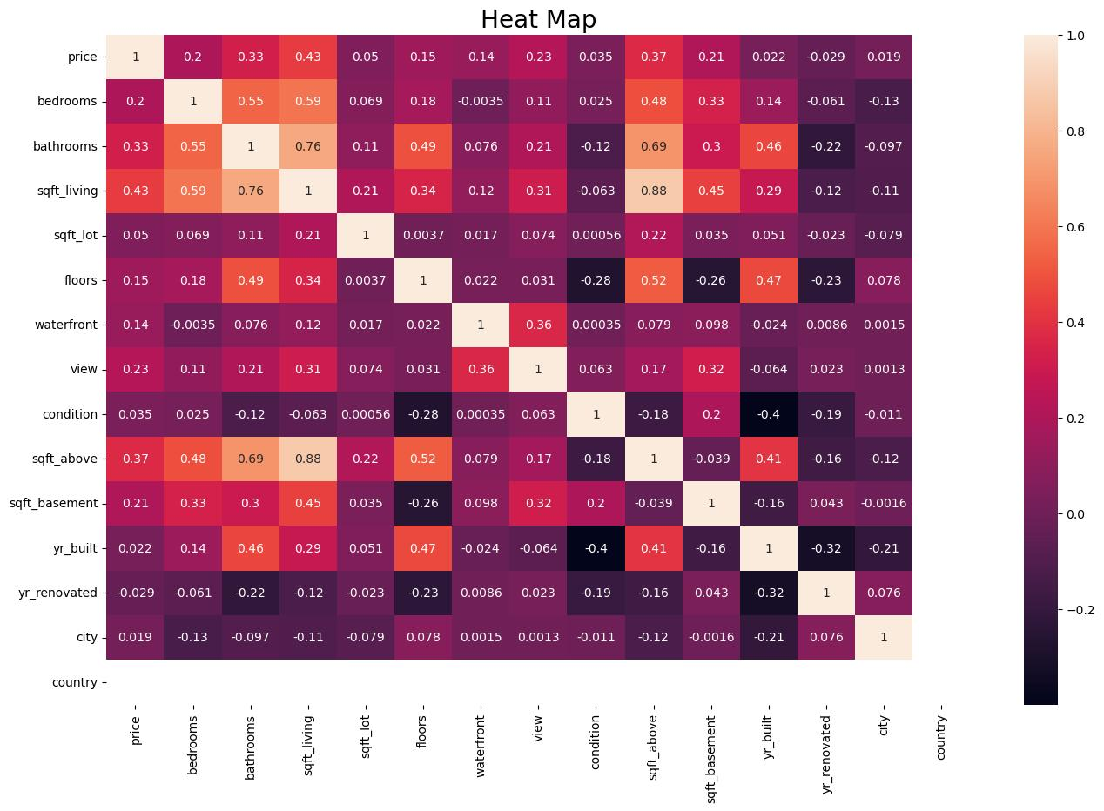
Shows which features strongly affect price.
Example
- Area has strong positive relation with price
- More bathrooms → higher price

B. Price Distribution Plot
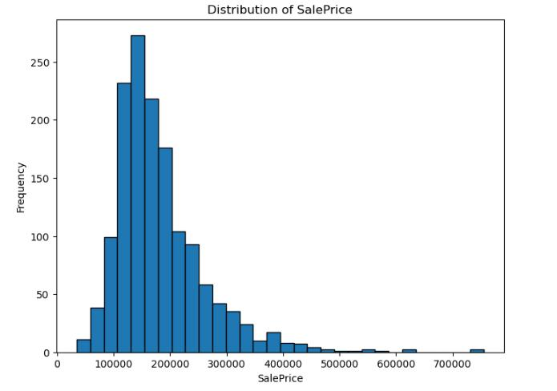
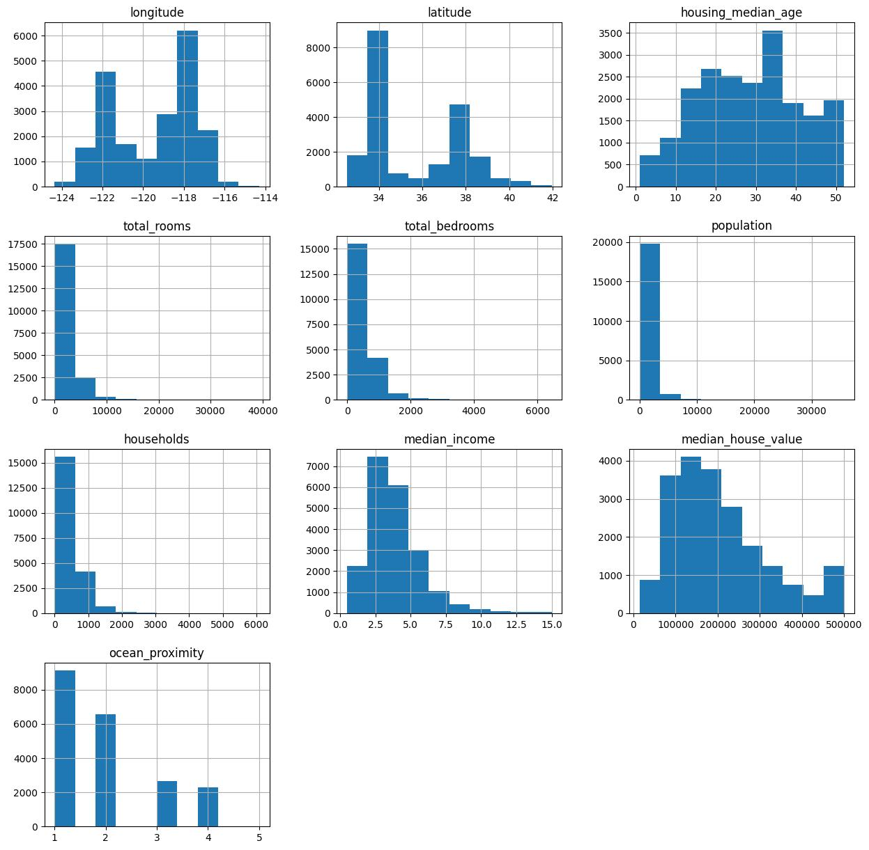
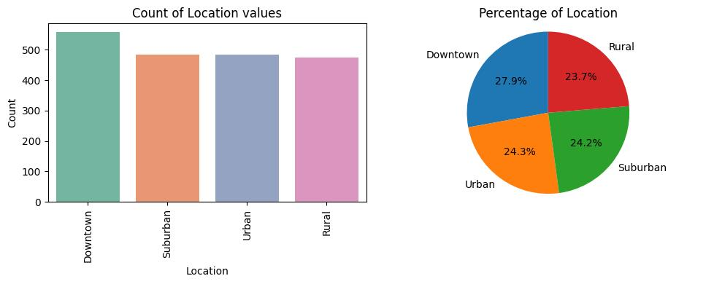
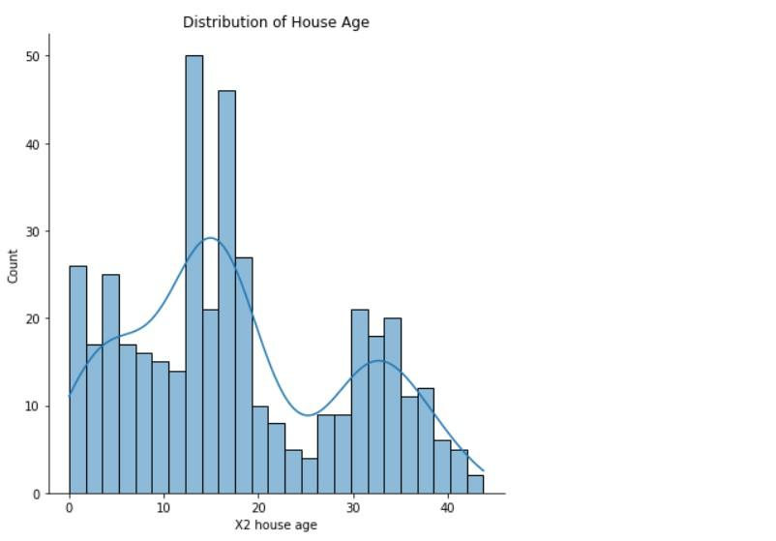
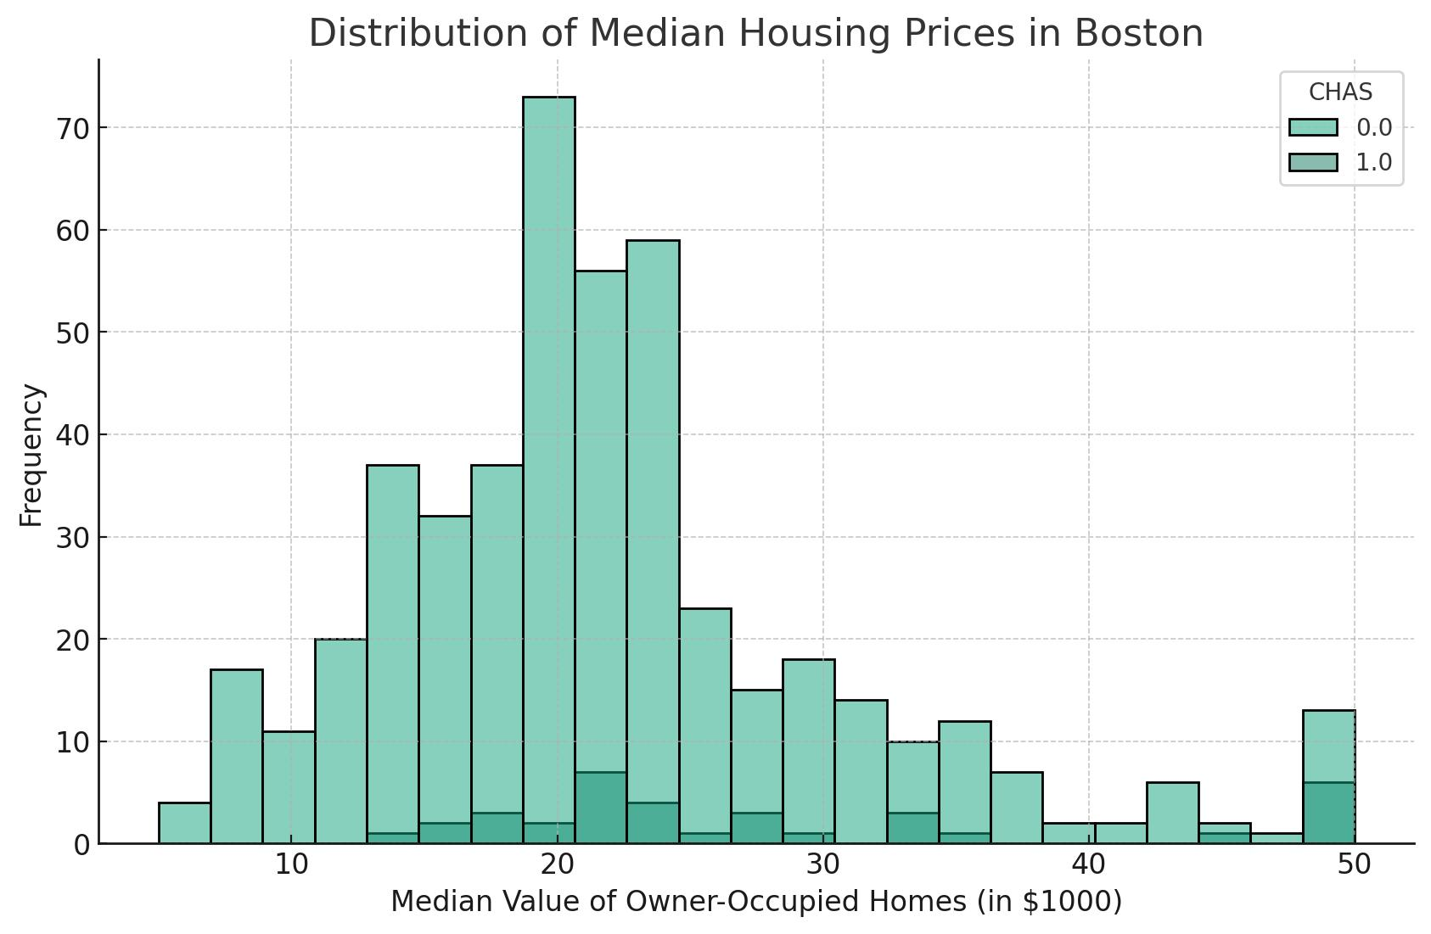
Shows how house prices are spread.
Example
Most houses may be between:
- ₹40 Lakhs to ₹80 Lakhs
Few houses may be:
- very expensive luxury houses

C. Residual Plot
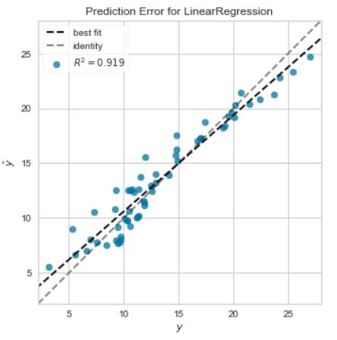
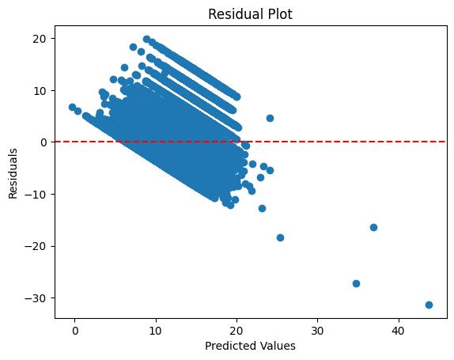
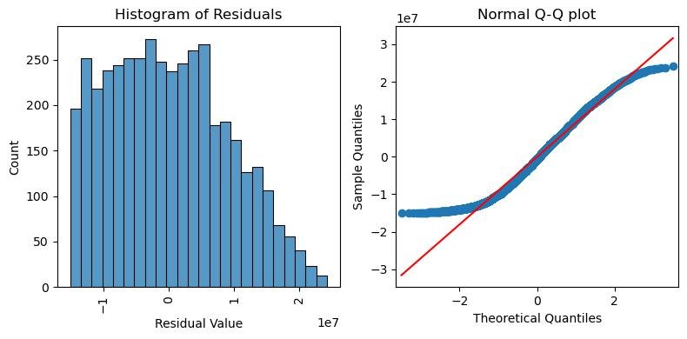
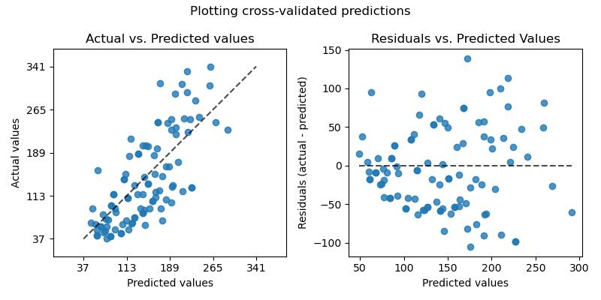
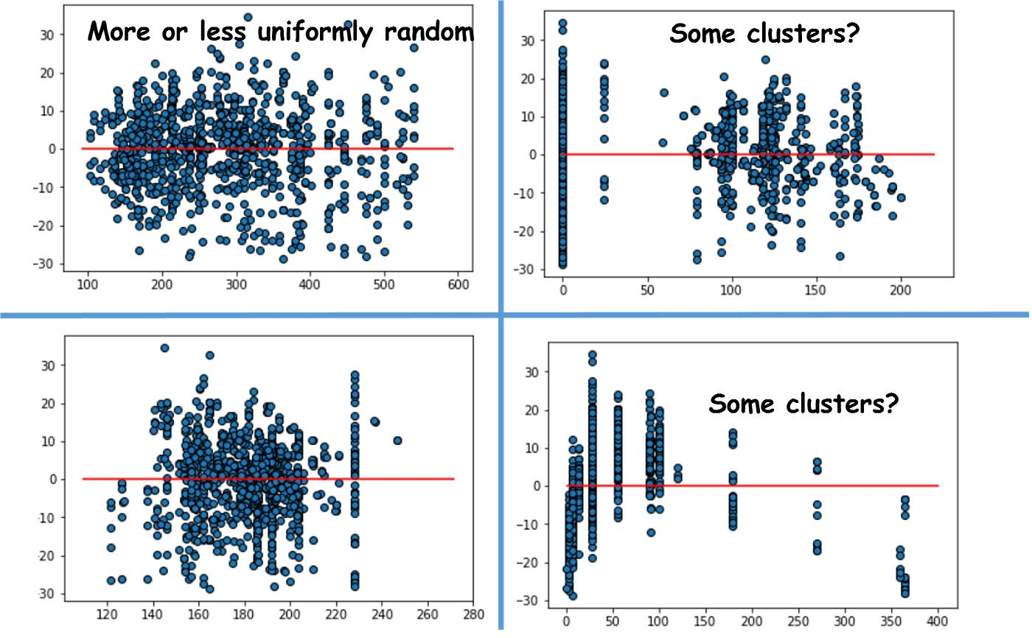
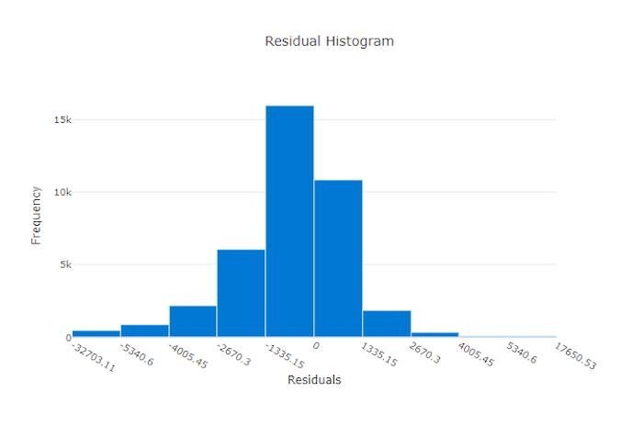
Shows prediction errors.
If dots are evenly spread:
model performance is good

6. Splitting Data
The dataset is divided into:
- Training data
- Testing data
Training Data
Used to teach the model.
Testing Data
Used to check how well the model learned.
Example
If there are 1000 houses:
- 800 → training
- 200 → testing

7. Feature Scaling
The notebook uses a scaler.
Scaler converts large values and small values into a balanced range.
Example
Without scaling:
- Area = 3000
- Bedrooms = 3
Area becomes too dominant.
Scaling balances them.
The scaler is later saved as:
- scaler.pkl

8. Model Training
The notebook trains a machine learning model.
It learns patterns between:
- house features
and
- house prices
Example Learning
The model learns:
- Bigger area → higher price
- Better furnishing → higher price
- More bathrooms → higher price

9. Model Evaluation
After training, the model is tested.
The notebook checks:
- prediction accuracy
- errors
Example
Actual price:
₹80 Lakhs
Predicted price:
₹78 Lakhs
Small difference means:
good prediction

10. Saving the Model
This notebook correctly saves:
- trained model
- scaler
Saved files:
- house_price_model.pkl
- scaler.pkl
These are important because:
you do not need to train again every time.

11. Loading the Saved Model
The notebook later loads the saved files.
This is useful for:
- web apps
- deployment
- future predictions

12. Real-Life Working Example
Suppose a user enters:
Feature | Value
Area | 1800
Bedrooms | 3
Bathrooms | 2
Parking | 1
The model analyzes these values and predicts:
Estimated House Price = ₹68 Lakhs

13. Final Project Flow
Your project follows this complete workflow:
Dataset → Cleaning → Visualization → Scaling → Training → Testing → Saving Model → Prediction

Executive Summary :
House Price Prediction Using Machine Learning
The House Price Prediction project is a machine learning-based system developed to estimate house prices using various housing features such as area, number of bedrooms, bathrooms, parking availability, furnishing status, and other property-related attributes. The main objective of this project is to build an intelligent predictive model that can accurately forecast house prices and assist buyers, sellers, and real estate businesses in making informed decisions.
The project begins with collecting and loading a housing dataset containing multiple records of residential properties. Each record represents a house along with its characteristics and corresponding price. Data preprocessing techniques are applied to clean and prepare the dataset for machine learning operations. Categorical values such as “yes” and “no” are converted into numerical format so that the machine learning algorithms can process them efficiently. Necessary feature selection and scaling techniques are also performed to improve the model’s performance and prediction accuracy.
Several visualization techniques are used to better understand the dataset and identify relationships between variables. Correlation heatmaps, distribution plots, and residual analysis plots help analyze feature importance, price distribution, and prediction errors. These visualizations provide insights into how different features influence house prices.
The dataset is divided into training and testing sets. The training data is used to teach the machine learning model patterns and relationships between housing features and prices, while the testing data evaluates the model’s predictive capability. The project uses advanced regression-based machine learning techniques to predict housing prices with improved accuracy and reliability.
An important feature of this project is the implementation of model persistence. The trained model is saved as house_price_model.pkl, and the scaler object is saved as scaler.pkl. These saved files allow the model to be reused later without retraining, making the system suitable for deployment in real-world applications such as web-based house price prediction systems.
Overall, this project demonstrates a complete machine learning workflow including data preprocessing, visualization, model training, evaluation, saving, and prediction. The system provides an efficient and practical solution for estimating real estate prices and showcases the real-world application of machine learning in the housing and real estate industry.

GITHUB repo Link: https://github.com/Subhasree2626/Alfido-Tech_Task2.git

