**Streamlining Ticket Assignment for Efficient Support Operations**

**Team Members:**

* Subhasree M (Team Leader)
* Abinaya M
* Akhilashree B
* Madhumitha A

**Department:** Infromation Technology

**Course:** ServiceNow Administrator

**Institution:** A.V.C. College of Engineering

**Mentor :** Mr. N.P.K Ganesh Kumar A/S prof IT

**Academic Year:** 2025-2026

**Abstract**

Efficient ticket management plays a crucial role in maintaining smooth IT support operations. In most organizations, tickets are manually assigned to respective departments, which often leads to delays and inefficiencies.  
This project, **“Streamlining Ticket Assignment for Efficient Support Operations,”** aims to automate the ticket assignment process using **ServiceNow**, a cloud-based IT Service Management (ITSM) platform.

By creating users, groups, roles, and automation flows, the system intelligently routes incoming tickets to the appropriate team (e.g., Certificate Issues or Platform Issues) based on the type of problem. This reduces manual intervention, improves response time, and ensures faster issue resolution.

The project demonstrates how automation in service management enhances overall operational efficiency and user satisfaction.

**Tasks Done with Explanation:**

**1. User Creation**

In ServiceNow, users represent individuals who raise or handle tickets.  
We created multiple users such as **admin, certificate_team_user,** and **platform_team_user** using the *User Administration* module.  
Each user has attributes like name, email, department, and assigned roles.

**2. Group Creation**

Groups were created to categorize users based on their function.  
We made two groups:

* **Certificate Group:** Handles certificate-related issues.
* **Platform Group:** Handles platform-related issues.  
  These groups help in routing tickets to the correct team.

**3. Role Creation**

Roles define access permissions for each group or user.  
We created roles such as:

* **cert_role** → Access to certificate issues.
* **plat_role** → Access to platform issues.  
  Roles were assigned to the respective groups to manage visibility and actions.

**4. Table Creation**

A custom table named **Operations_Related** was created to store ticket data.  
The table includes fields such as:

* Ticket ID
* Issue Type
* Description
* Assigned Group
* Status

This table acts as the database for ticket operations.

**5. Adding Choices**

In the *Issue Type* field of the table, choice options were added:

* Login Issue
* 404 Error
* Certificate Issue
* Platform Issue  
  These predefined choices help in categorizing the ticket correctly.

**6. Assigning Roles and Users to Groups**

Each user was assigned to their corresponding group:

* Certificate user → Certificate Group
* Platform user → Platform Group  
  The admin user retains full access for monitoring.

**7. Assigning Roles to Tables**

Roles were linked to the **Operations_Related** table to restrict access:

* Certificate Group → Can view certificate tickets
* Platform Group → Can view platform tickets  
  This ensures security and proper segregation of work.

**8. Creating ACL (Access Control List)**

Access Control Lists were configured to:

* Allow users to read/write data related only to their group.
* Prevent unauthorized access to other group tickets.  
  This improves data security and operational control.

**9. Creating Flows (Automation)**

Two automation flows were created using **Flow Designer**:

* **Flow 1:** Automatically assigns tickets with “Certificate Issue” to the Certificate Group.
* **Flow 2:** Automatically assigns tickets with “Platform Issue” to the Platform Group.  
  The flow triggers when a new record is inserted into the Operations_Related table.

**10. Testing the Automation**

After saving the flow, test tickets were raised with different issue types.  
Results confirmed that the flows worked correctly — each ticket was automatically assigned to the right group without manual intervention.

**Screenshots**

**Step 1: Create Users**

1. Open **ServiceNow**.
2. In the left navigation panel, click **All** → Search **Users**.
3. Select **Users** under **System Security**.

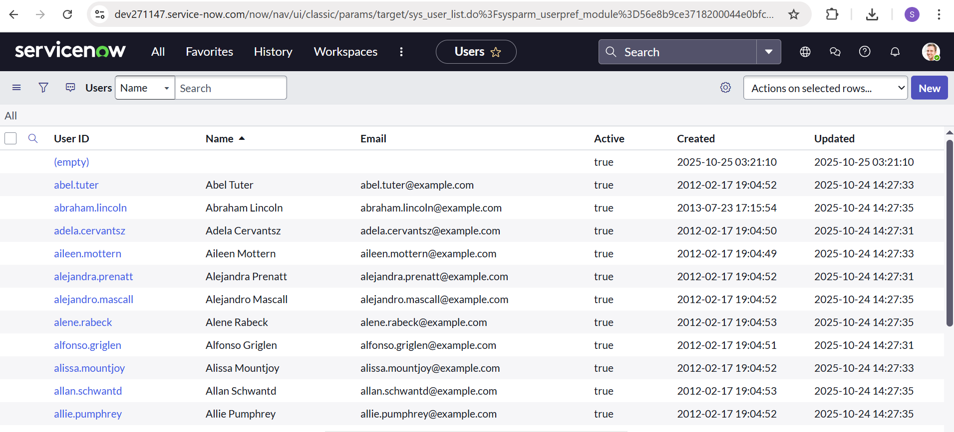

1. Click **New**.
2. Fill the required user details such as:
   * User ID
   * First Name
   * Last Name
   * Email
   * Department

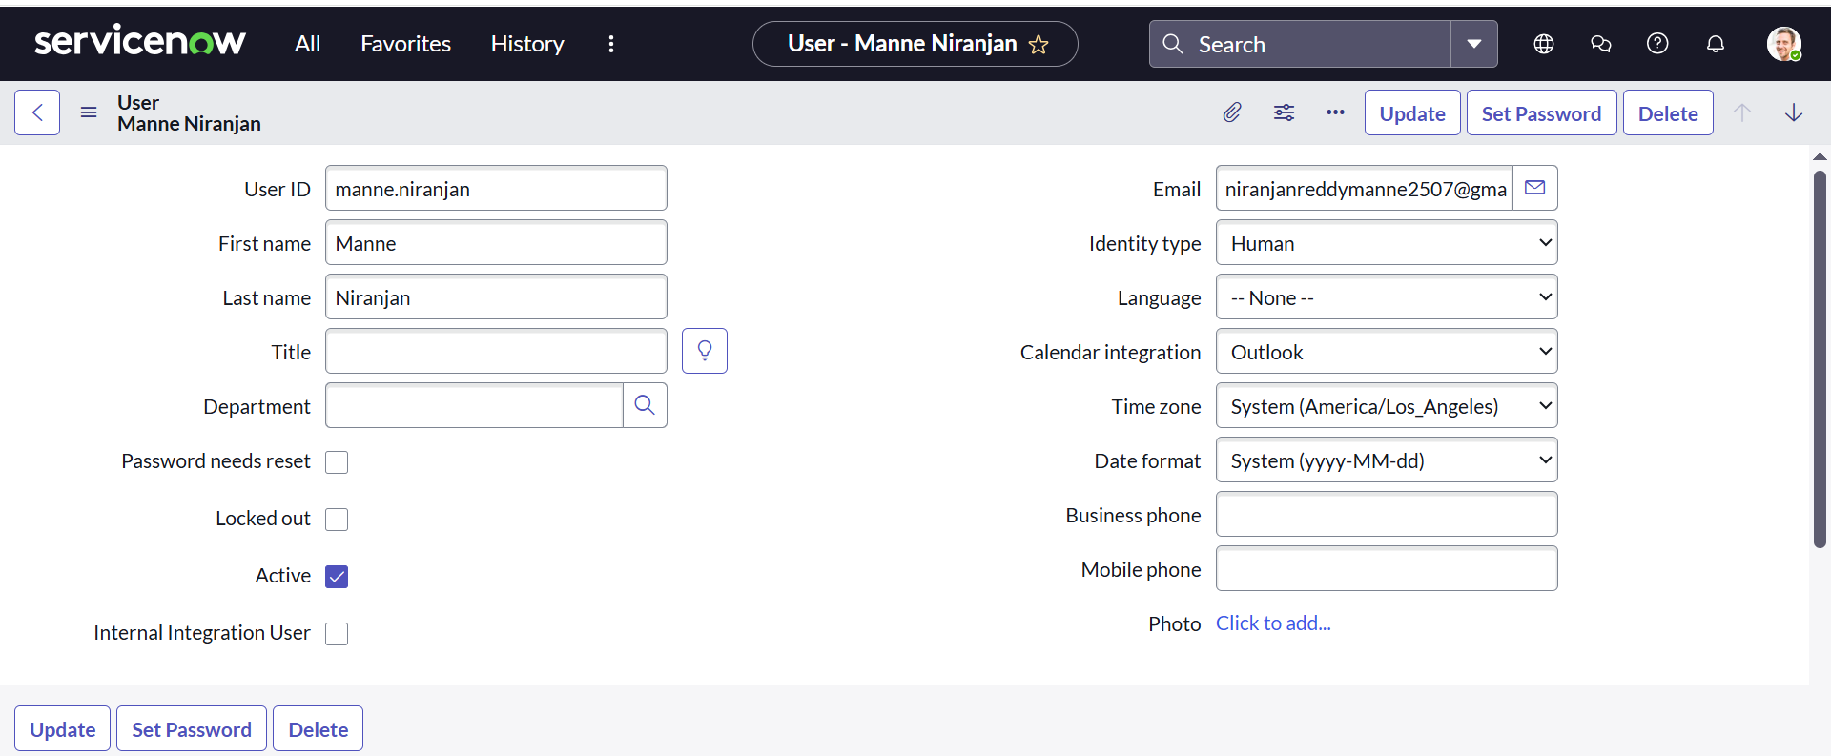

1. Click **Submit**.
2. Repeat the same to create another user.
   * Example:
     + **User 1:** Katherine Pierce
     + **User 2:** Manne Niranjan

**Step 2: Create Groups**

1. In the left navigation panel, click **All** → Search **Groups**.
2. Select **Groups** under **System Security**.

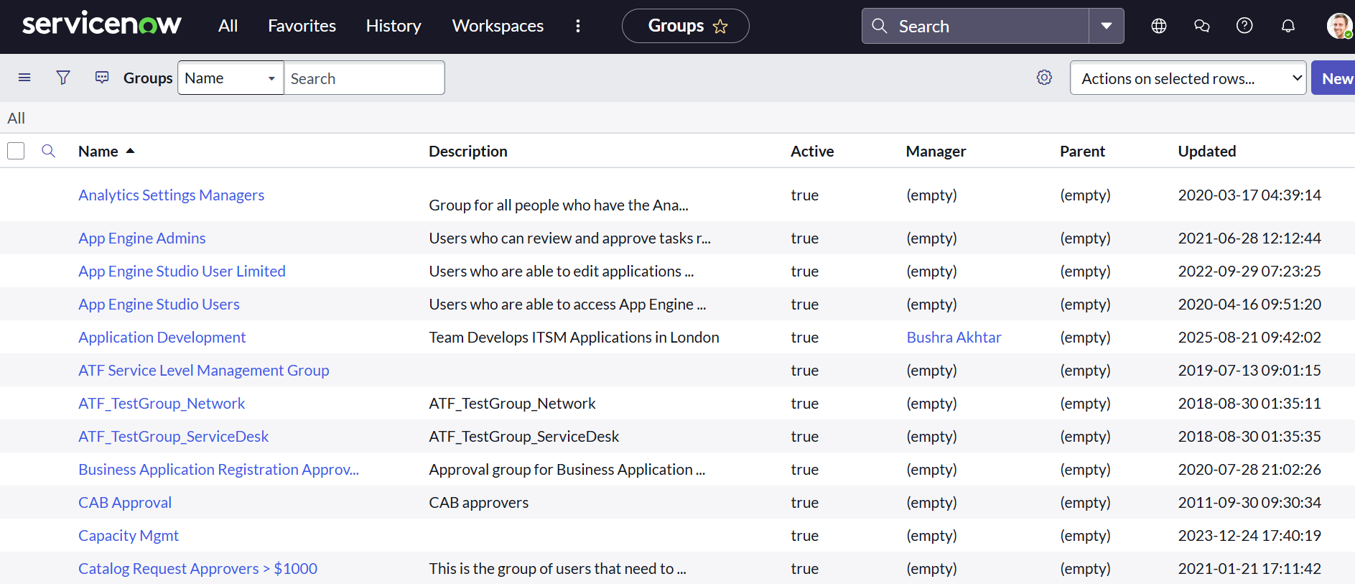

1. Click **New**.
2. Fill the group details such as:
   * Name: *Certificates*
   * Description: Handles certificate-related issues

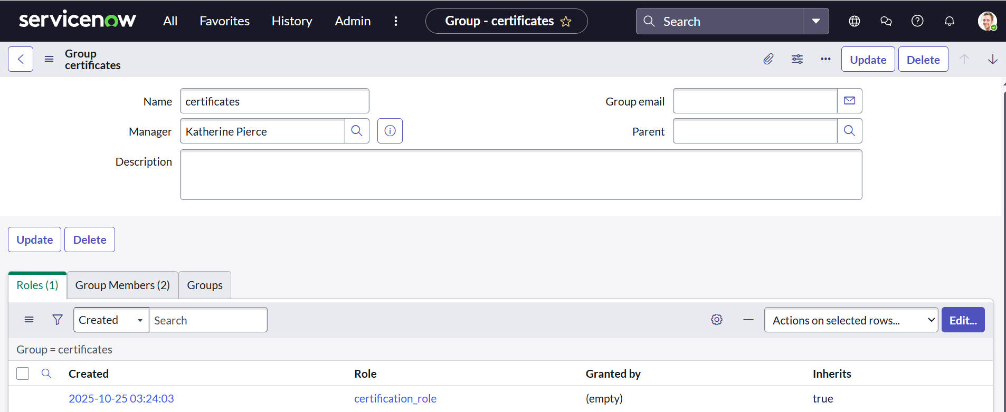

1. Click **Submit**.
2. Create one more group:
   * Name: *Platform*
   * Description: Handles platform-related issues

**Step 3: Create Roles**

1. Navigate to **All** → Search **Roles**.
2. Select **Roles** under **System Security**.

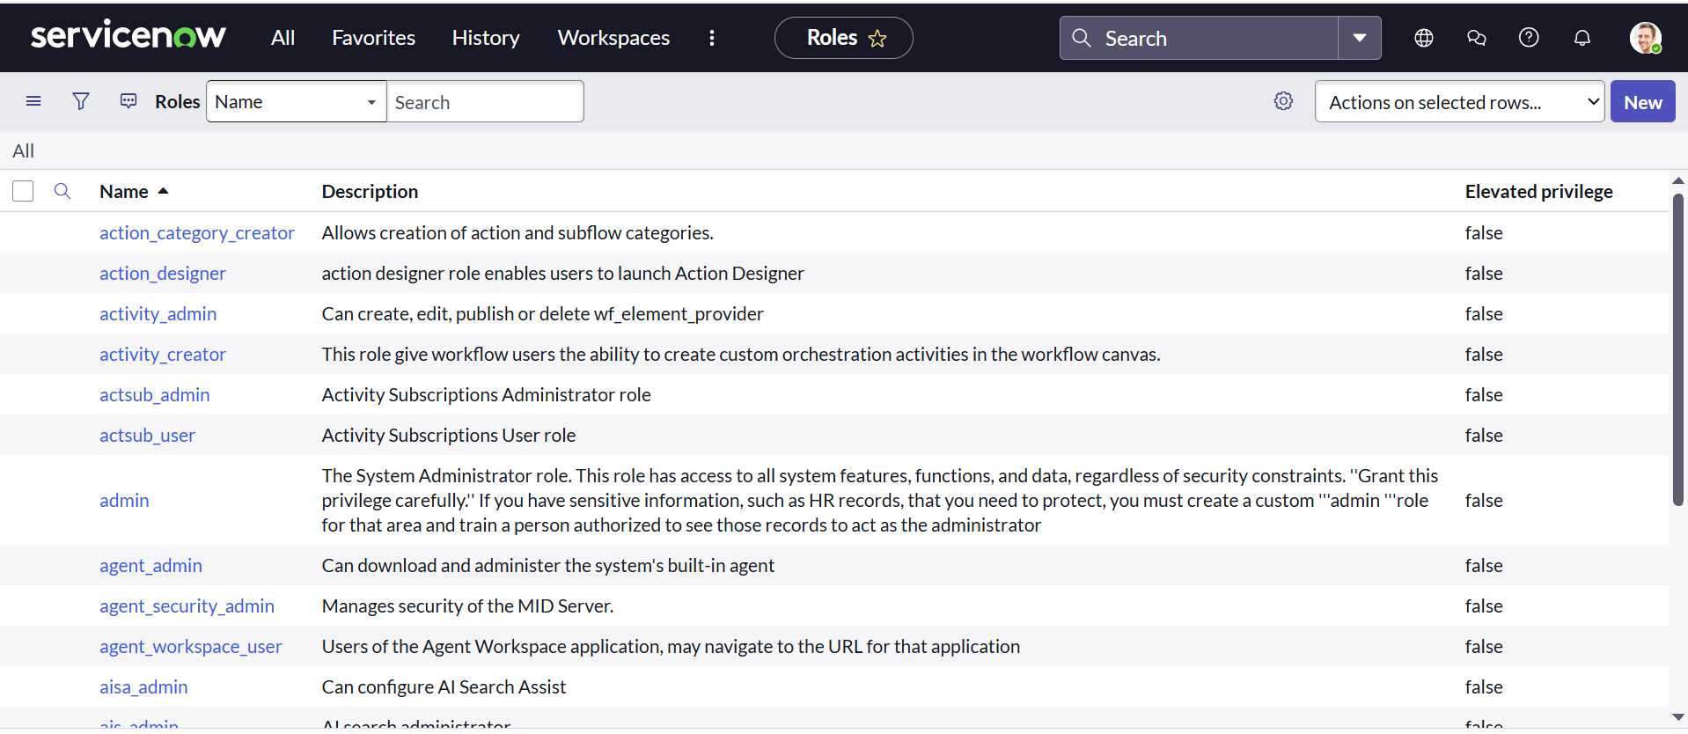

1. Click **New**.
2. Fill the details:
   * Role Name: *Certification_Role*
   * Description: Role for certificate-related support team

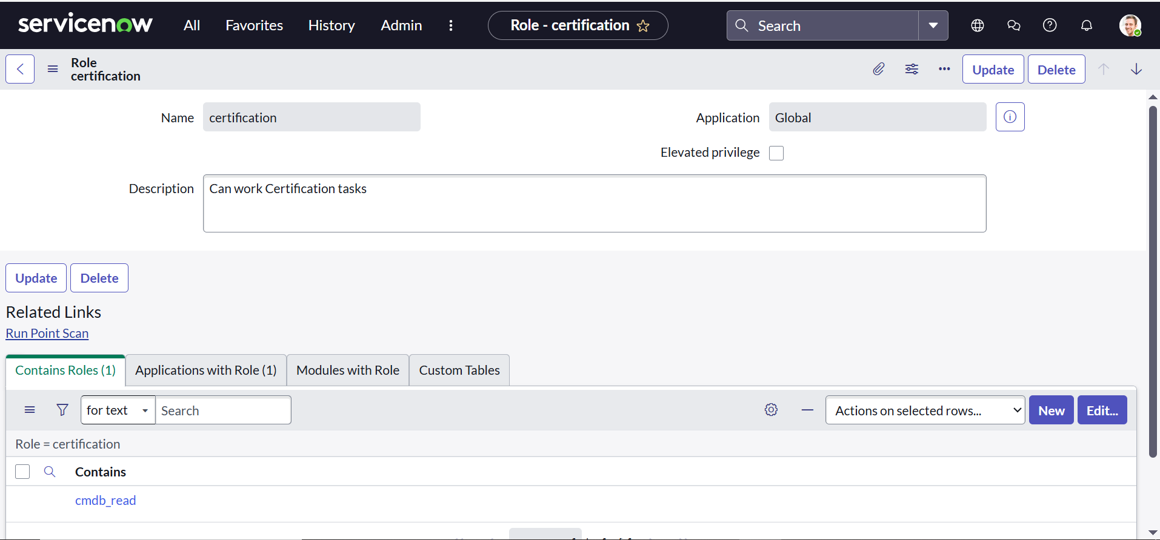

1. Click **Submit**.
2. Create another role:
   * Role Name: *Platform_Role*
   * Description: Role for platform support team

**Step 4: Create a Table**

1. Navigate to **All** → Search **Tables**.
2. Select **Tables** under **System Definition**.
3. Click **New**.

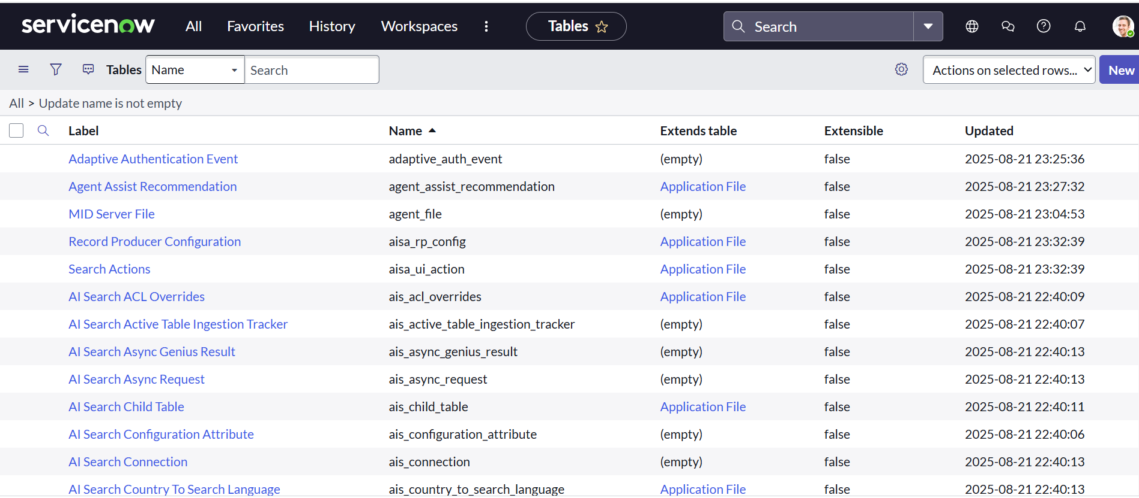

1. Fill the details:
   * Label: *Operations Related*
   * Check **Create Module** and **Create Mobile Module**.
   * Under “New Menu Name”: *Operations Related*.

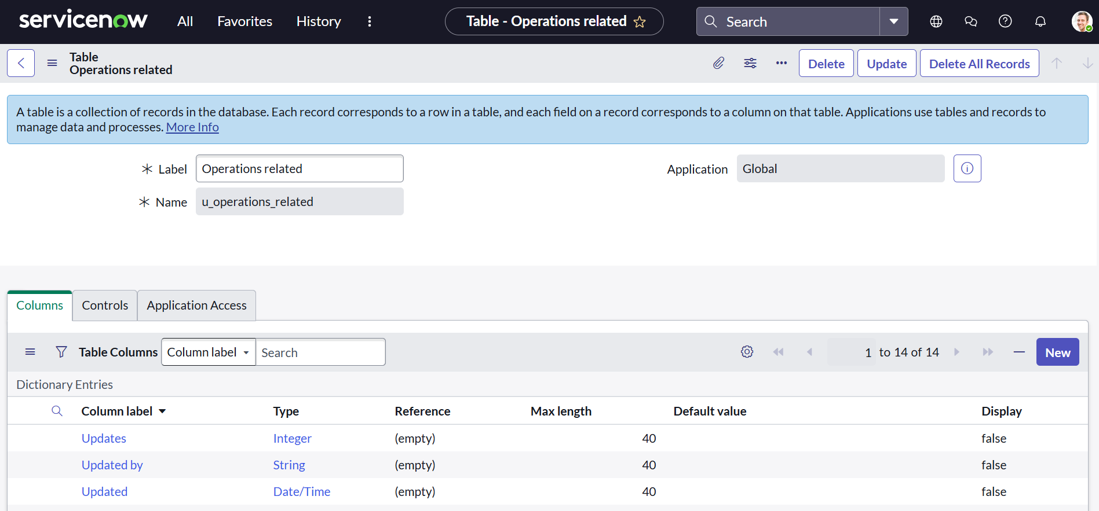

1. Add columns:
   * Issue
   * Assigned to Group
   * Description
2. Click **Submit**.

**Step 5: Create Choices for the “Issue” Field**

1. Open the **Operations Related** table.
2. Click on **Form Design**.
3. Locate the field **Issue** → Click on **Edit Choices**.

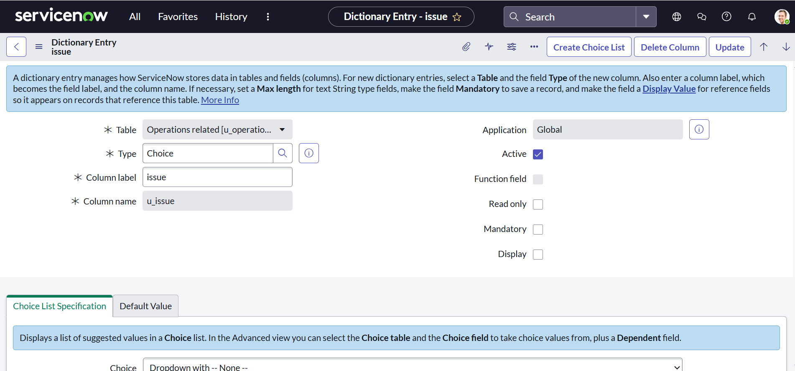

1. Add the following values:
   * Unable to login to platform
   * 404 Error
   * Regarding Certificates
   * User Expired

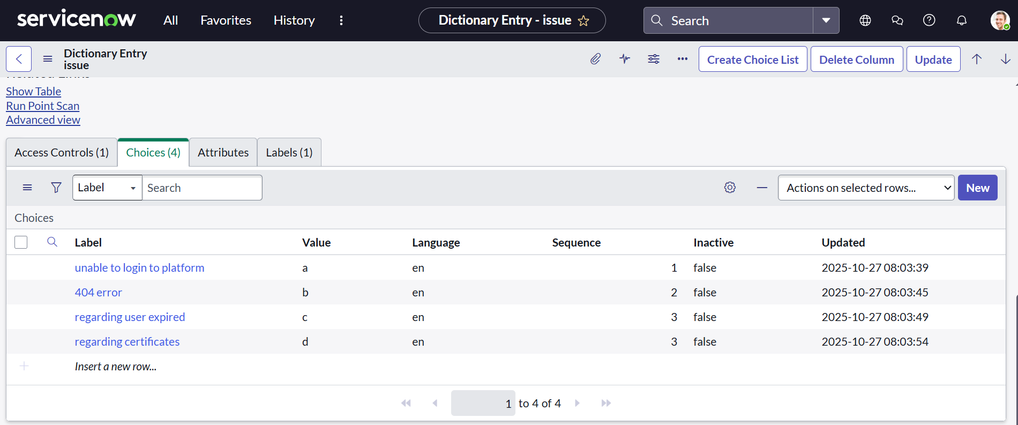

1. Click **Update** to save.

**Step 6: Assign Roles & Users to Certificate Group**

1. Go to **All** → Search **Groups** → Open *Certificates* group.
2. Under **Group Members**, click **Edit**.
3. Select **Katherine Pierce** and click **Save**.

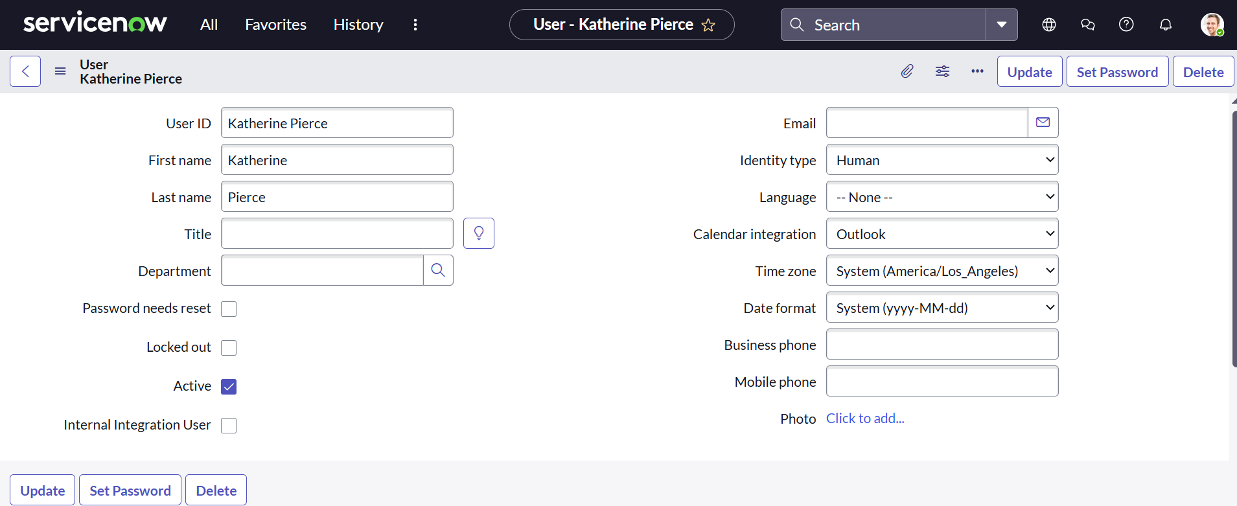

1. Under **Roles**, click **Edit**.
2. Add **Certification_Role** and click **Sa**

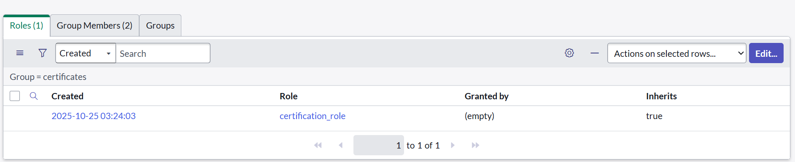

**Step 7: Assign Roles & Users to Platform Group**

1. Go to **All** → Search **Groups** → Open *Platform* group.
2. Under **Group Members**, click **Edit**.

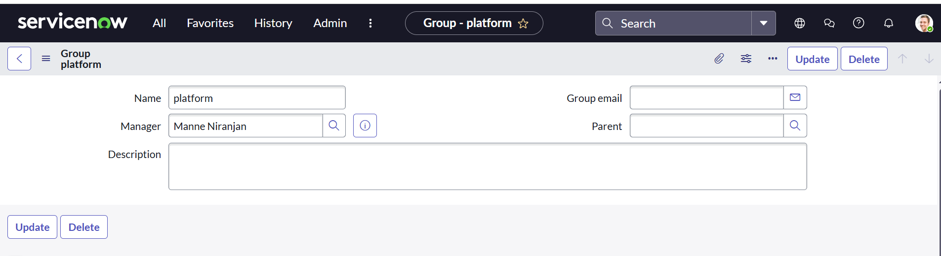

1. Select **Manne Niranjan** and click **Save**.
2. Under **Roles**, click **Edit**.

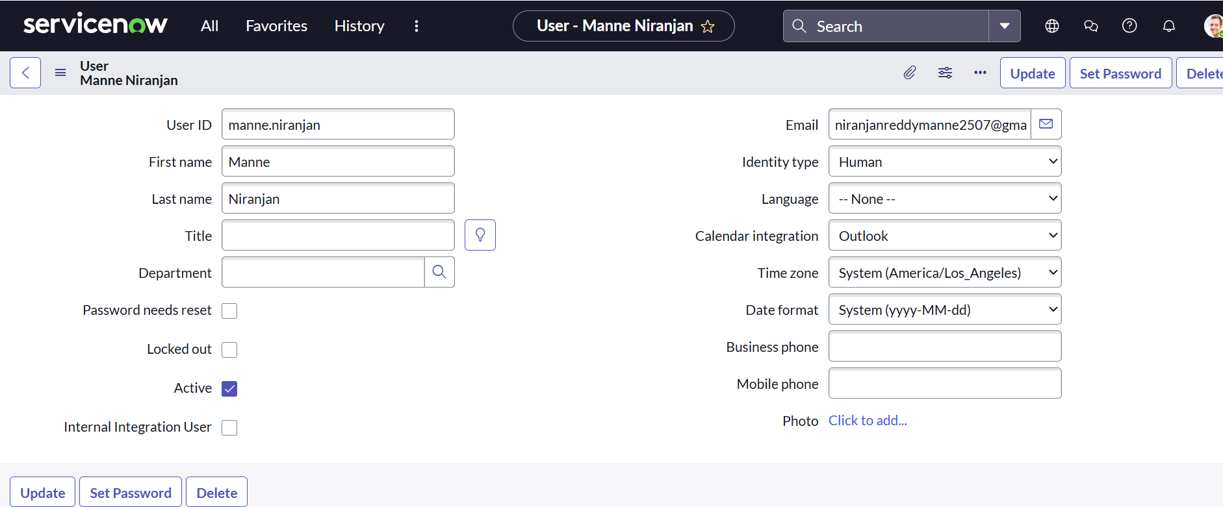

1. Add **Platform_Role** and click **Save**.

**Step 8: Assign Role to Table**

1. Go to **All** → Search **Tables** → Open *Operations Related* table.
2. Click **Application Access** tab.
3. Click on **u_operations_related (Read)** operation.
4. Click on your profile icon (top right) → **Elevate Role** → select **Security Admin** → Click **Update**.

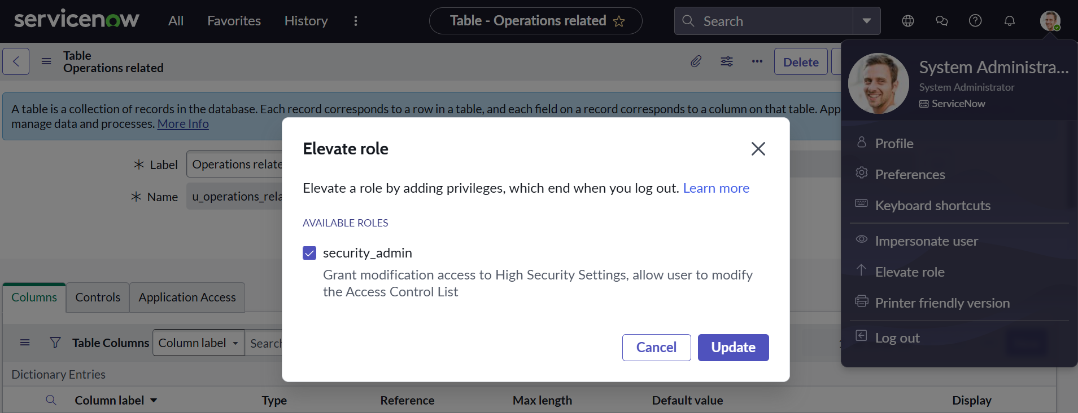

1. Under **Requires Role**, click **Insert a new row** → Add:
   * *Platform_Role*
   * *Certification_Role*
2. Click **Update**.
3. Repeat the same for **Write Operation**.

**Step 9: Create ACL (Access Control List)**

1. Go to **All** → Search **ACL**.
2. Select **Access Control (ACL)** under **System Security**.
3. Click **New**.
4. Fill the details for field-level or table-level access.
5. Under **Requires Role**, click **Insert a new row** and add **admin** role.

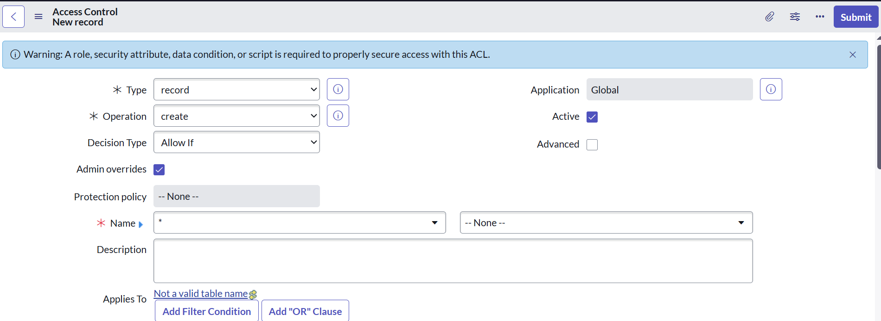

1. Click **Submit**.
2. Repeat and create 4 ACLs for the required fields in your table.

**Step 10: Create Flow to Assign Certificate Tickets Automatically**

1. Go to **All** → Search **Flow Designer**.
2. Click **Flow Designer** → **New Flow**.

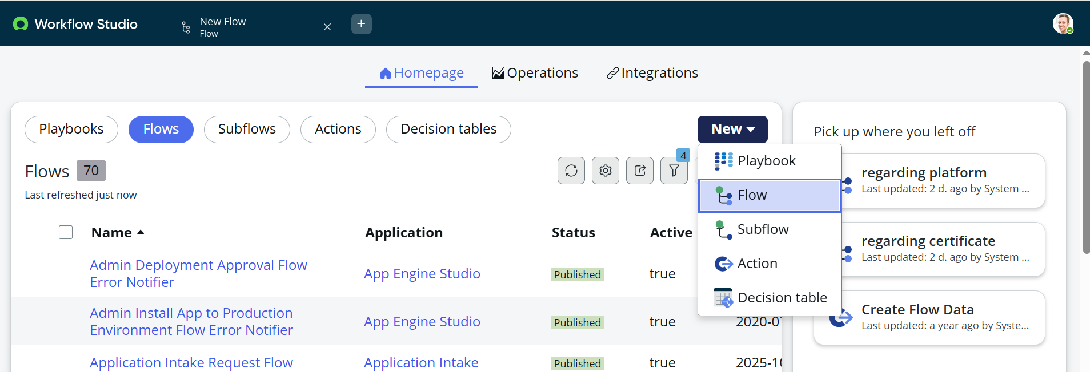

1. In Flow Properties:
   * Name: *Regarding Certificates*
   * Application: *Global*
   * Run User: *System User*
2. Click **Submit**.

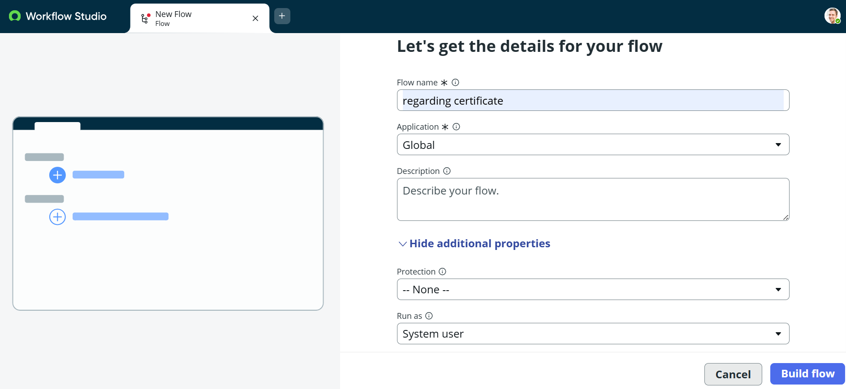

1. Click **Add a Trigger** → Select **Create or Update a Record**.
2. Table: *Operations Related*
3. Condition:
   * Field: *Issue*
   * Operator: *is*
   * Value: *Regarding Certificates*
4. Click **Done**.
5. Click **Add Action** → Search **Update Record**.

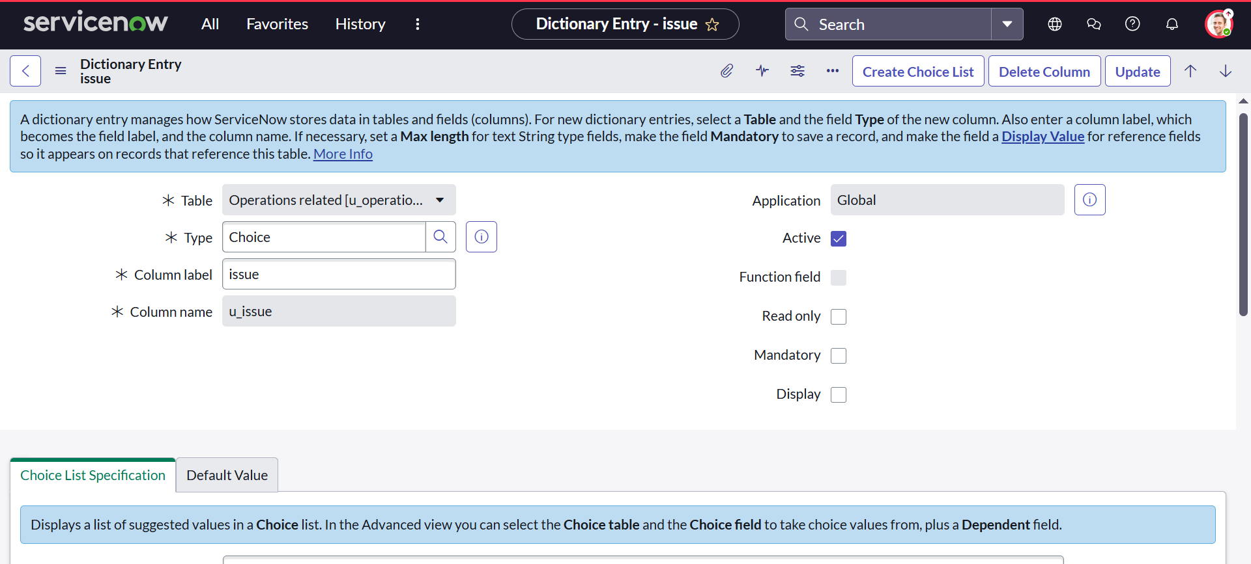

1. In the record field, select:
   * Table: *Operations Related*
   * Field: *Assigned to Group*
   * Value: *Certificates*
2. Click **Done** → **Save** → **Activate**.

**Step 11: Create Flow to Assign Platform Tickets Automatically**

1. Go to **All** → **Flow Designer** → **New Flow**.
2. Flow Name: *Regarding Platform*
3. Application: *Global*
4. Run User: *System User*
5. Click **Add a Trigger** → **Create or Update a Record**.
6. Table: *Operations Related*
7. Conditions:
   * Issue **is** “Unable to login to platform”
   * Issue **is** “404 Error”
   * Issue **is** “User Expired”
8. Click **Done**.
9. Add Action → **Update Record**:
   * Field: *Assigned to Group*
   * Value: *Platform*
10. Click **Done** → **Save** → **Activate**.

**Step 12: Test the Flow**

1. Open **Operations Related** → Click **New Record**.
2. Enter:
   * Issue: *404 Error*
   * Description: *User unable to access portal*

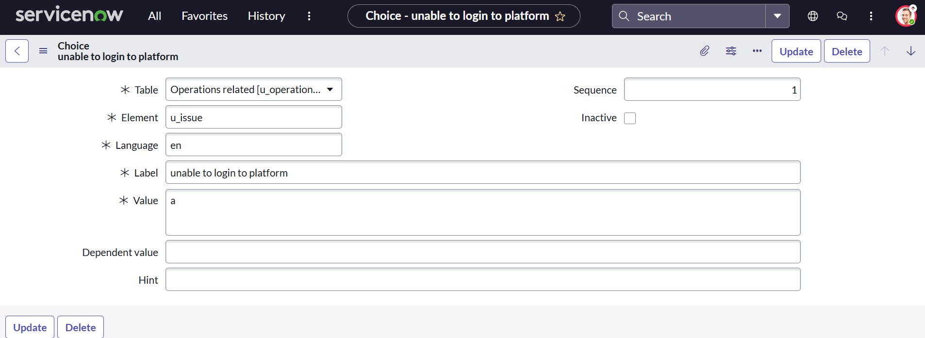

1. Click **Submit**.
2. The record should automatically be assigned to the **Platform Group**.
3. Similarly, test with issue “Regarding Certificates” → Assigned to **Certificates Group**.

**✅ Step 13: Verify the Automation**

* Check that each issue type routes correctly.
* Confirm group assignment in ticket details.
* Ensure no manual routing is required.

**Conclusion**

* The implementation of the automated ticket routing system in ServiceNow has streamlined support operations at ABC Corporation. The automation of ticket assignment has significantly reduced manual errors, optimized team workload, and improved customer satisfaction. This system ensures tickets are routed efficiently and resolved promptly, resulting in enhanced operational productivity.

**Future Enhancement**

* Implement AI/ML-based ticket routing to automatically analyze and assign tickets based on keywords, issue history, and workload.
* Introduce priority-based assignment to ensure high-priority issues are resolved faster.
* Add a real-time analytics dashboard to monitor ticket trends, resolution times, and team performance.
* Integrate email and chatbot support so users can raise or check tickets through multiple communication channels.
* Develop a mobile-friendly version or app to allow support teams to handle tickets anytime, anywhere.