1. **Web Api using .Net core with Swagger**

**Create a .Net core web application with API template. (Use existing application if created). Install Swashbuckle.AspNetCore Nuget package. Post this do the following steps in Startup.cs**

* **In ConfigureServices method, add the code provided below.**

**services.AddSwaggerGen(c =>**

**{**

**c.SwaggerDoc("v1", new Info**

**{**

**Title = "Swagger Demo",**

**Version = "v1",**

**Description = "TBD",**

**TermsOfService = "None",**

**Contact = new Contact() { Name = "John Doe", Email = "john@xyzmail.com", Url = "www.example.com" },**

**License = new License() { Name = "License Terms", Url = "www.example.com" }**

**});**

**});**

* **In Configure method, add the code provided below.**

**app.UseSwagger();**

**app.UseSwaggerUI(c =>**

**{**

**// specifying the Swagger JSON endpoint.**

**c.SwaggerEndpoint("/swagger/v1/swagger.json", "Swagger Demo");**

**});**

**Execute the application which will load the default ‘Values’ controller(Settings as per launchSettings.json) GET action method. Change the url to <https://localhost:[port> number]/swagger**

**Notice the Title, Version, Contact detail provided shown on the top of the page**

**Notice the Values controller HttpVerb action methods getting listed.**

**Click the ‘GET’ action verb method(Without the parameter).**

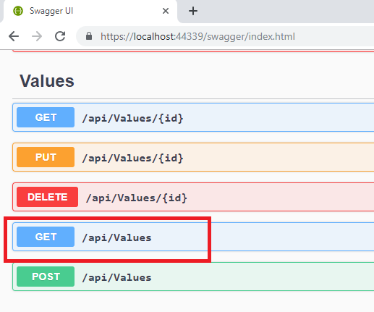

**It opens a panel which has ‘Try it out’ button. Click that and Click ‘Execute’ button.**

1. **Use POSTMAN tool, to point to the local Web API that was created with Employee controller. Test the GET action method using POSTMAN.**

**Verify the output if the List of employees are listed in the ‘Body’ part of the GET window on POSTMAN tool.**

**Verify the Status on the right side of the output pane on POSTMAN tool.**

1. **Modify the Controller name in the Route attribute of the Employee controller to ‘Emp’ and check its access thru POSTMAN**

**Ans:**

**CODE:**

**Program.cs**

var builder = WebApplication.CreateBuilder(args);

// Add services to the container.

builder.Services.AddControllers();

builder.Services.AddEndpointsApiExplorer();

builder.Services.AddSwaggerGen(c =>

{

c.SwaggerDoc("v1", new Microsoft.OpenApi.Models.OpenApiInfo

{

Title = "Swagger Demo",

Version = "v1",

Description = "TBD",

TermsOfService = new Uri("https://example.com/terms"),

Contact = new Microsoft.OpenApi.Models.OpenApiContact

{

Name = "John Doe",

Email = "john@xyzmail.com",

Url = new Uri("https://www.example.com")

},

License = new Microsoft.OpenApi.Models.OpenApiLicense

{

Name = "License Terms",

Url = new Uri("https://www.example.com")

}

});

});

var app = builder.Build();

// Configure the HTTP request pipeline.

app.UseSwagger();

app.UseSwaggerUI(c =>

{

c.SwaggerEndpoint("/swagger/v1/swagger.json", "Swagger Demo");

});

app.UseHttpsRedirection();

app.UseAuthorization();

app.MapControllers();

app.Run();

**EmployeeController.cs**

using Microsoft.AspNetCore.Mvc;

namespace SwaggerDemo.Controllers

{

[ApiController]

[Route("api/[controller]")]

public class EmployeeController : ControllerBase

{

[HttpGet]

public IActionResult Get()

{

var employees = new[]

{

new { Id = 1, Name = "Alice", Department = "HR" },

new { Id = 2, Name = "Bob", Department = "IT" },

new { Id = 3, Name = "Charlie", Department = "Finance" }

};

return Ok(employees);

}

}

}

**OUTPUT**

