DayZ -7 Task

A)Get all the countries from the Asia continent /region using the Filter function

CODE

var xhr = new XMLHttpRequest();

xhr.open("GET","https://restcountries.com/v3.1/all");

xhr.send();

xhr.onload=function(){

var result= JSON.parse(xhr.responseText);

result.filter((countries) => {

return countries.region ==="Asia";

})

console.log(result);}

OUTPUT

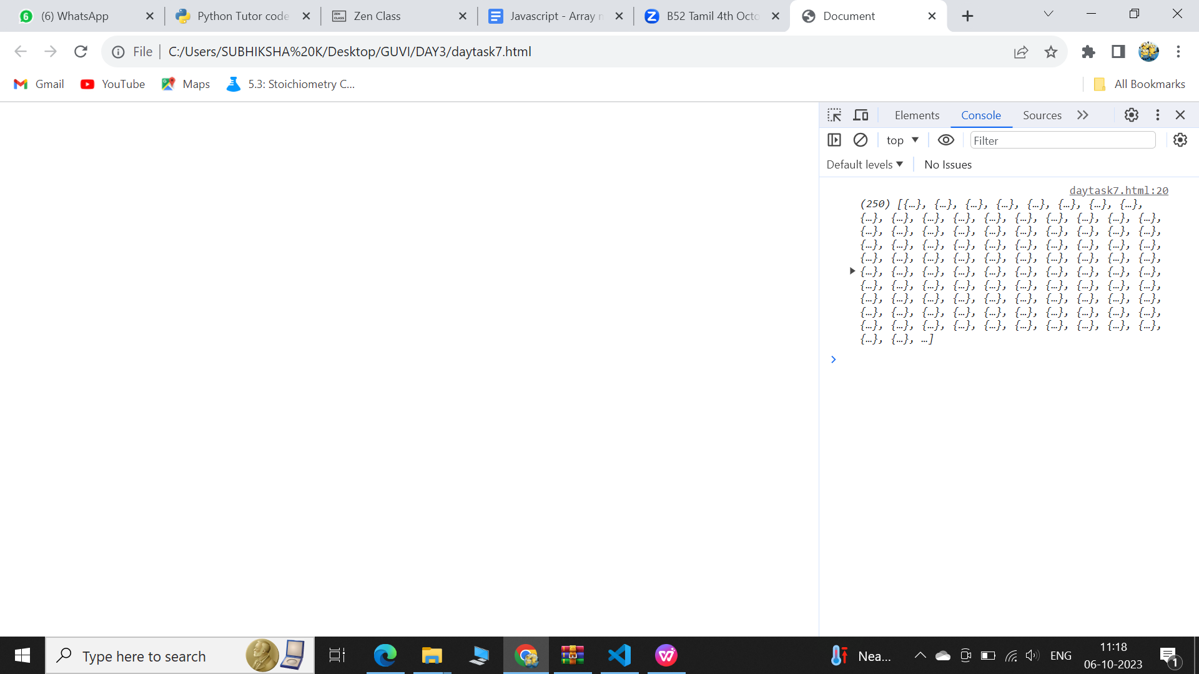

\

1. Get all the countries with a population of less than 2 lakhs using Filter function

CODE

var xhr = new XMLHttpRequest();

xhr.open("GET","https://restcountries.com/v3.1/all");

xhr.send();

xhr.onload=function(){

var result=JSON.parse(xhr.responseText);

const pop = result.filter((element)=>{

return element.population<200000;

})

OUTPUT

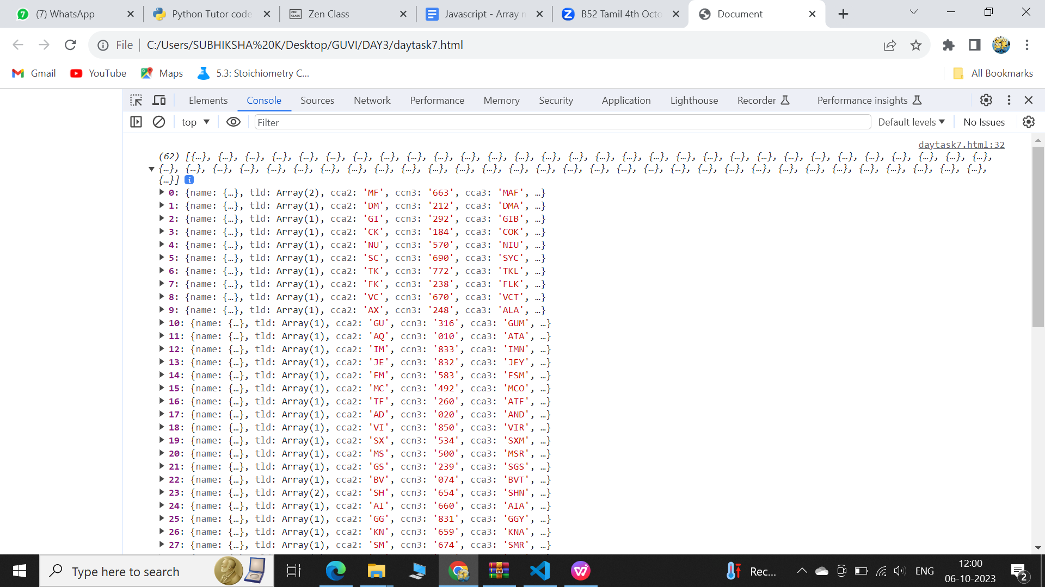

c.Print the following details name, capital, flag using forEach function

CODE

console.log(pop); var xhr = new XMLHttpRequest();

xhr.open("GET","https://restcountries.com/v3.1/all");

xhr.send();

xhr.onload=function() {

var result=JSON.parse(xhr.responseText);

result.forEach(element => {

console.log(element.name);

console.log(element.capital);

console.log(element.flag);

})

};

OUTPUT

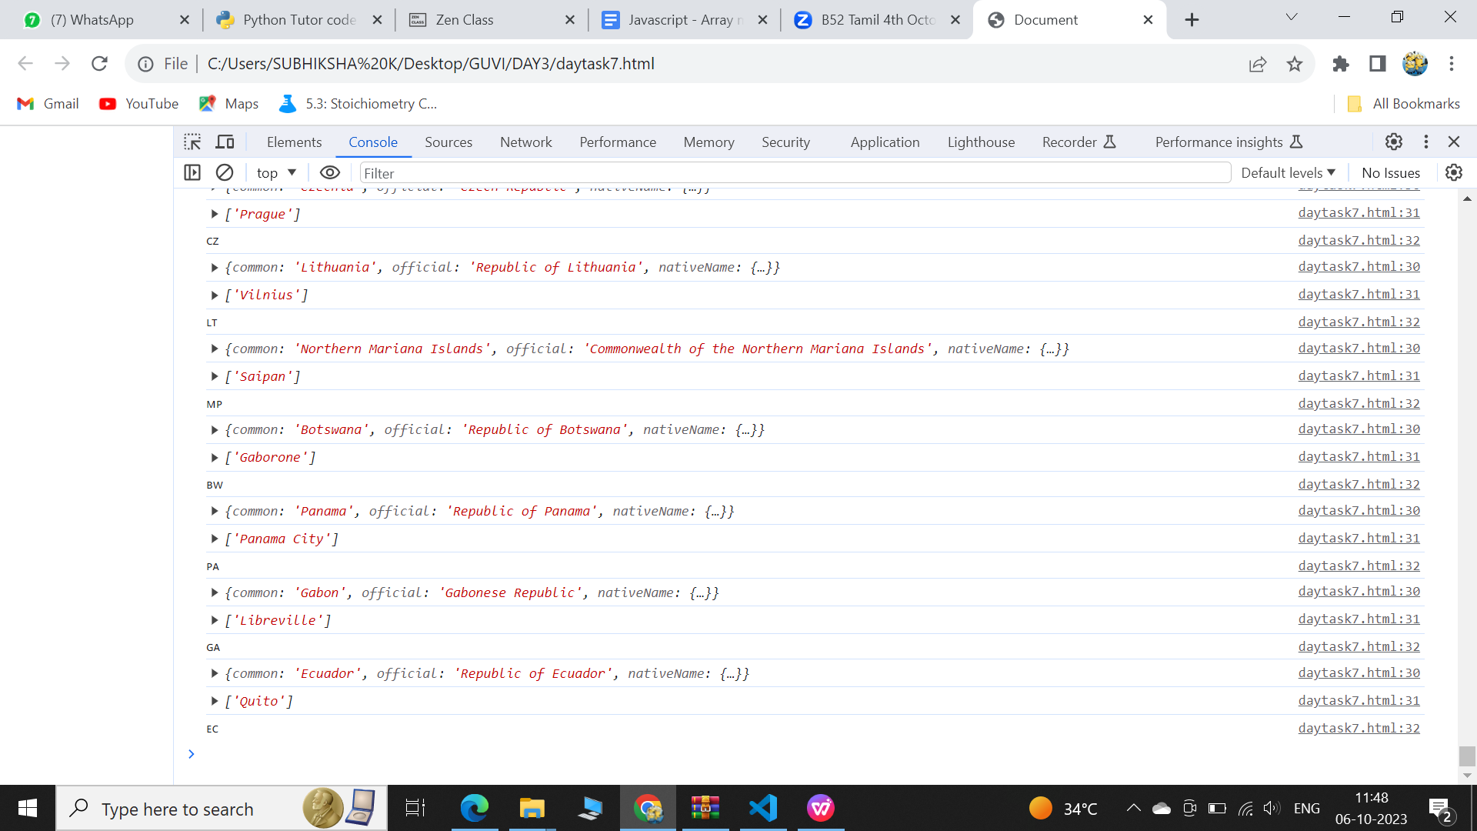

C)Print the total population of countries using reduce function

CODE

var xhr = new XMLHttpRequest();

xhr.open("GET","https://restcountries.com/v3.1/all");

xhr.send();

xhr.onload=function() {

var result=JSON.parse(xhr.responseText);

var total = result.reduce((acc,curr) =>{

return acc+curr.population;

} ,0);

console.log(total);

}

OUTPUT

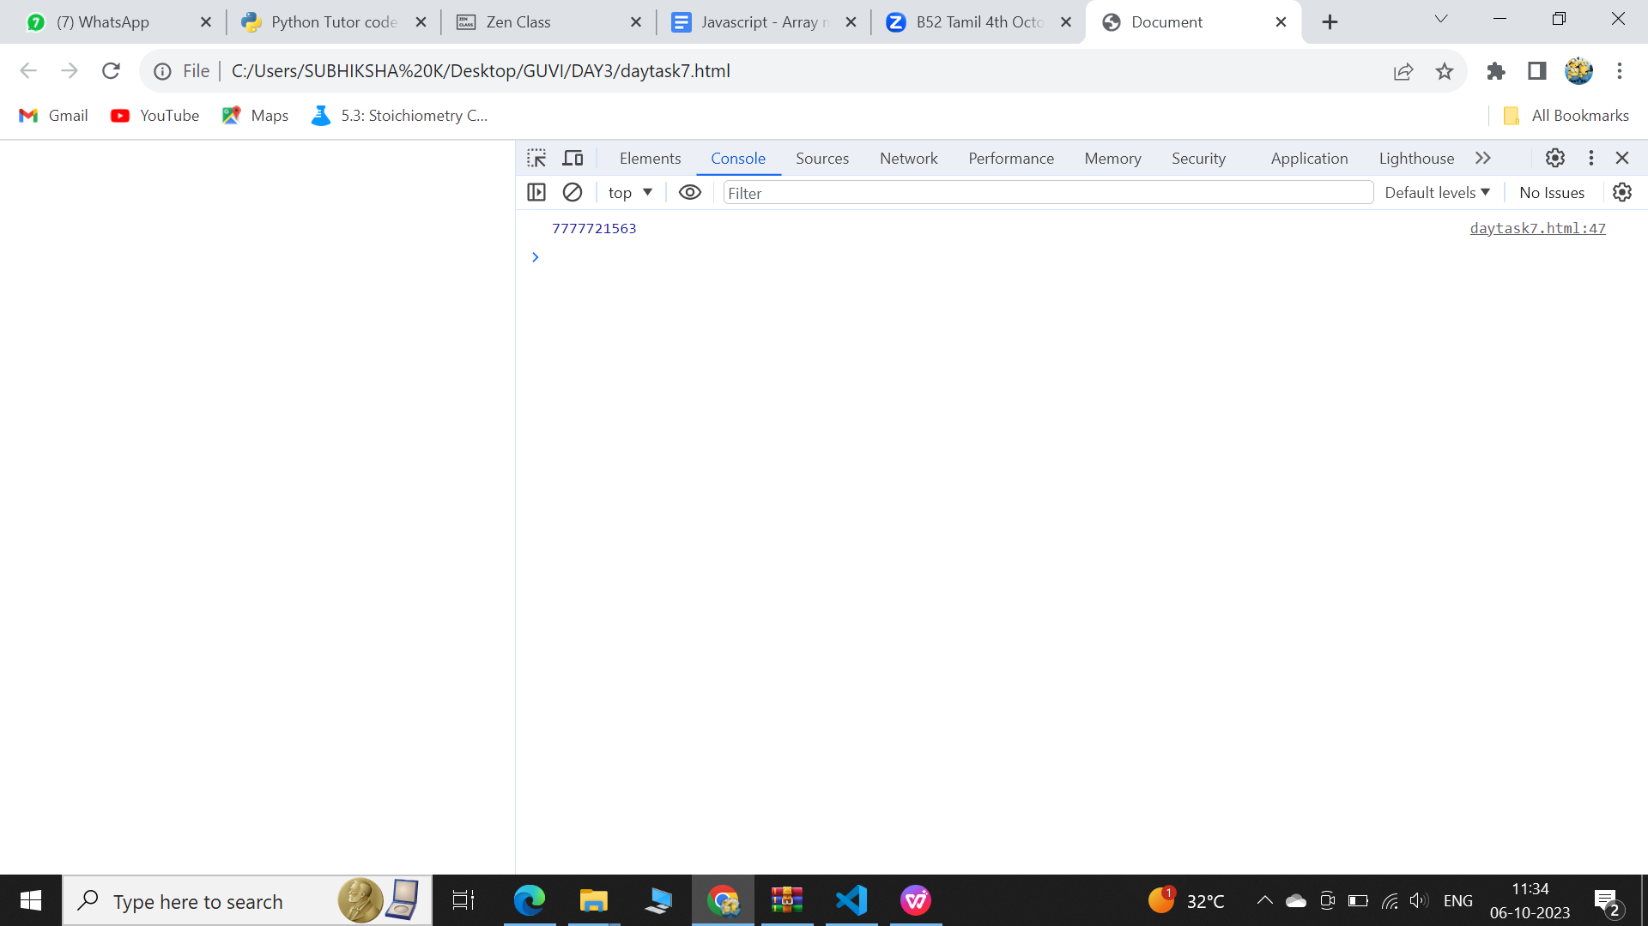

d.Print the total population of countries using reduce function

CODE

var xhr = new XMLHttpRequest();

xhr.open("GET","https://restcountries.com/v3.1/all");

xhr.send();

xhr.onload=function() {

var result=JSON.parse(xhr.responseText);

var total = result.reduce((acc,curr) =>{

return acc+curr.population;

} ,0);

console.log(total);

}

OUTPUT

