**TASK 5**

**For the given JSON iterate over all for loops (for, for in, for of, forEach**

**1)FOR**

**<!DOCTYPE html>**

**<head>**

**<meta charset="UTF-8">**

**<meta name="viewport" content="width=device-width, initial-scale=1.0">**

**<title>Document</title>**

**</head>**

**<body>**

**<script>**

**var frnd= [{**

**"name" : "subhiksha",**

**"clg" : "psg",**

**"class" : "msc physics",**

**"mail": "subhikshaphy@gmail.com"**

**},**

**{**

**"name" : "vinothkumar",**

**"clg" : "psg",**

**"class" : "msc physics",**

**"mail": "vinojillu@gmail.com"**

**}];**

**for(var i = 0; i < frnd.length; i++) {**

**var obj = frnd[i];**

**console.log(obj.name);**

**console.log(obj.clg);**

**console.log(obj.class);**

**console.log(obj.mail);**

**}**

**</script>**

**</body>**

**</html>**

**OUTPUT**

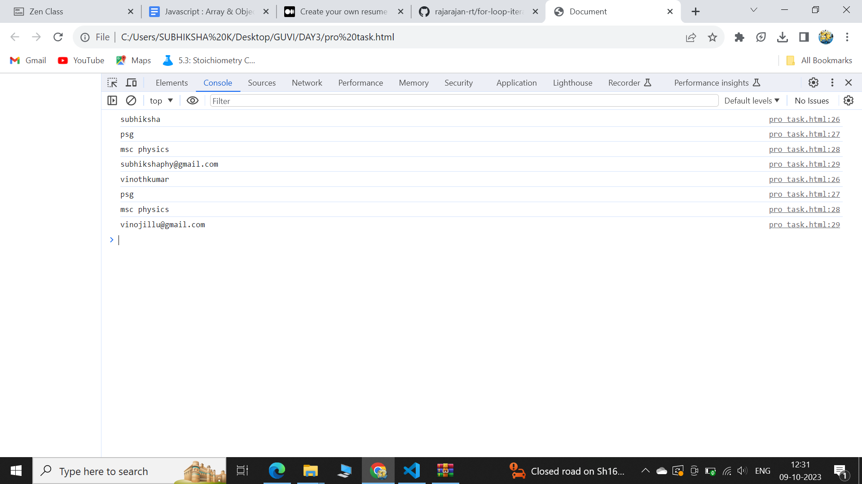

1. **FOR EACH**

**<!DOCTYPE html>**

**<html lang="en">**

**<head>**

**<meta charset="UTF-8">**

**<meta name="viewport" content="width=device-width, initial-scale=1.0">**

**<title>Document</title>**

**</head>**

**<body>**

**<script>**

**var frnd= [{**

**"name" : "subhiksha",**

**"clg" : "psg",**

**"class" : "msc physics",**

**"mail": "subhikshaphy@gmail.com"**

**},**

**{**

**"name" : "vinothkumar",**

**"clg" : "psg",**

**"class" : "msc physics",**

**"mail": "vinojillu@gmail.com"**

**}];**

**frnd.forEach(function(obj) { console.log(obj.clg),console.log(obj.name); });**

**</script>**

**</body>**

**</html>**

**OUTPUT**

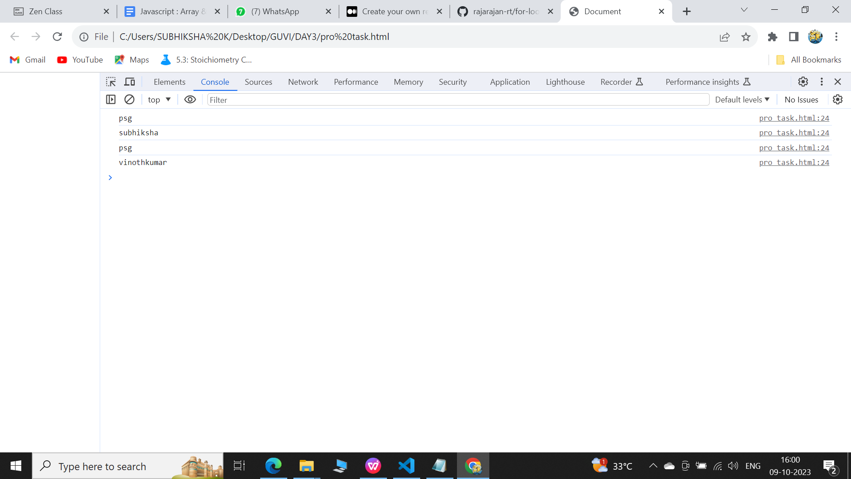

1. **FOR IN**

**<!DOCTYPE html>**

**<html lang="en">**

**<head>**

**<meta charset="UTF-8">**

**<meta name="viewport" content="width=device-width, initial-scale=1.0">**

**<title>Document</title>**

**</head>**

**<body>**

**<script>**

**var frnd= [{**

**"name" : "subhiksha",**

**"clg" : "psg",**

**"class" : "msc physics",**

**"mail": "subhikshaphy@gmail.com"**

**},**

**{**

**"name" : "vinothkumar",**

**"clg" : "psg",**

**"class" : "msc physics",**

**"mail": "vinojillu@gmail.com"**

**}];**

**for (var key in frnd) {**

**if (frnd.hasOwnProperty(key)) {**

**console.log(frnd[key].mail);**

**}**

**}**

**</script>**

**</body>**

**</html>**

**OUTPUT**

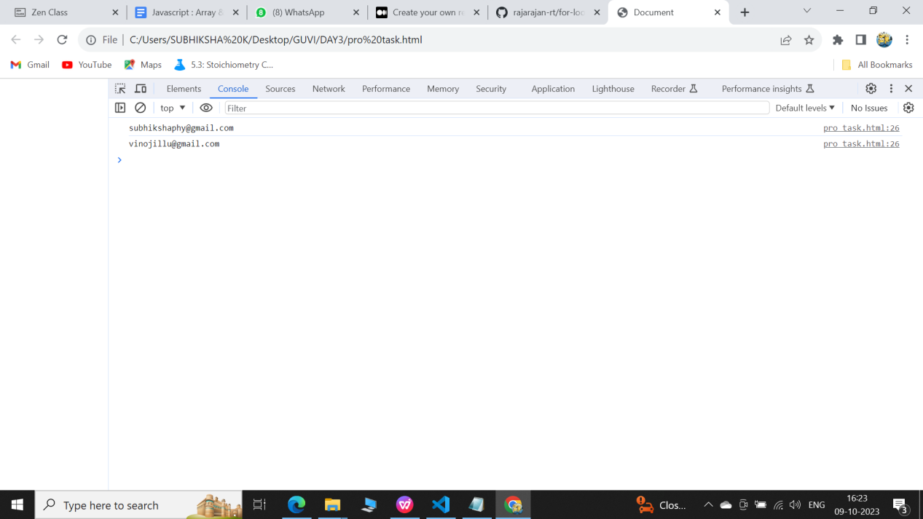

**4)FOR OF**

**<!DOCTYPE html>**

**<html lang="en">**

**<head>**

**<meta charset="UTF-8">**

**<meta name="viewport" content="width=device-width, initial-scale=1.0">**

**<title>Document</title>**

**</head>**

**<body>**

**<script>**

**var frnd= [{**

**"name" : "subhiksha",**

**"clg" : "psg",**

**"class" : "msc physics",**

**"mail": "subhikshaphy@gmail.com"**

**},**

**{**

**"name" : "vinothkumar",**

**"clg" : "psg",**

**"class" : "msc physics",**

**"mail": "vinojillu@gmail.com"**

**}];**

**let text = "";**

**for (let x of frnd[key].class){**

**text += x;**

**}**

**console.log(text);**

**</script>**

**</body>**

**</html>**