VELOOP Rewards - Dashboard Wireframes
Work Package M | Companion to Deliverable 14 (Dashboard Blueprint) | Version 0.2 (revised 10 October 2026; first issued 28 September 2026)
These are low-fidelity wireframes - they show panel layout, chart type, and what each panel will contain, not final visual design. Every number placeholder (0000) is a stand-in; no dashboard shown here has been built or populated with real data. Full per-visual specifications (exact calculation, filters, dimensions, refresh frequency, and the business question each panel answers) are in the Analytics Design Workbook, sheet Dashboard_Blueprint - this document is the visual companion to that sheet, not a replacement for it.

How to read these wireframes
- Each panel's small icon shows the intended chart type: a zig-zag line for trend charts, bars for comparisons, a ring for part-of-whole breakdowns, a funnel shape for multi-stage conversion, a grid for tables, an arc for a gauge-style KPI, and a large placeholder number for a single-metric KPI tile.
- The bold text under each icon is the metric or question the panel answers; the small grey text above it names the chart type and cross-references the KPI ID from the KPI Catalogue where one exists.
- The header bar on each wireframe lists the filters, date range, and refresh frequency that apply to every panel on that dashboard, matching the Dashboard_Blueprint sheet.

Dashboard 1 - Executive Overview
High-level cross-functional view for leadership: registrations, active users, stickiness, task completion, reward and wallet activity, withdrawal and referral health, and a data-trust panel showing control metrics (duplicates, orphans, freshness) so viewers can judge whether the numbers above are currently trustworthy.
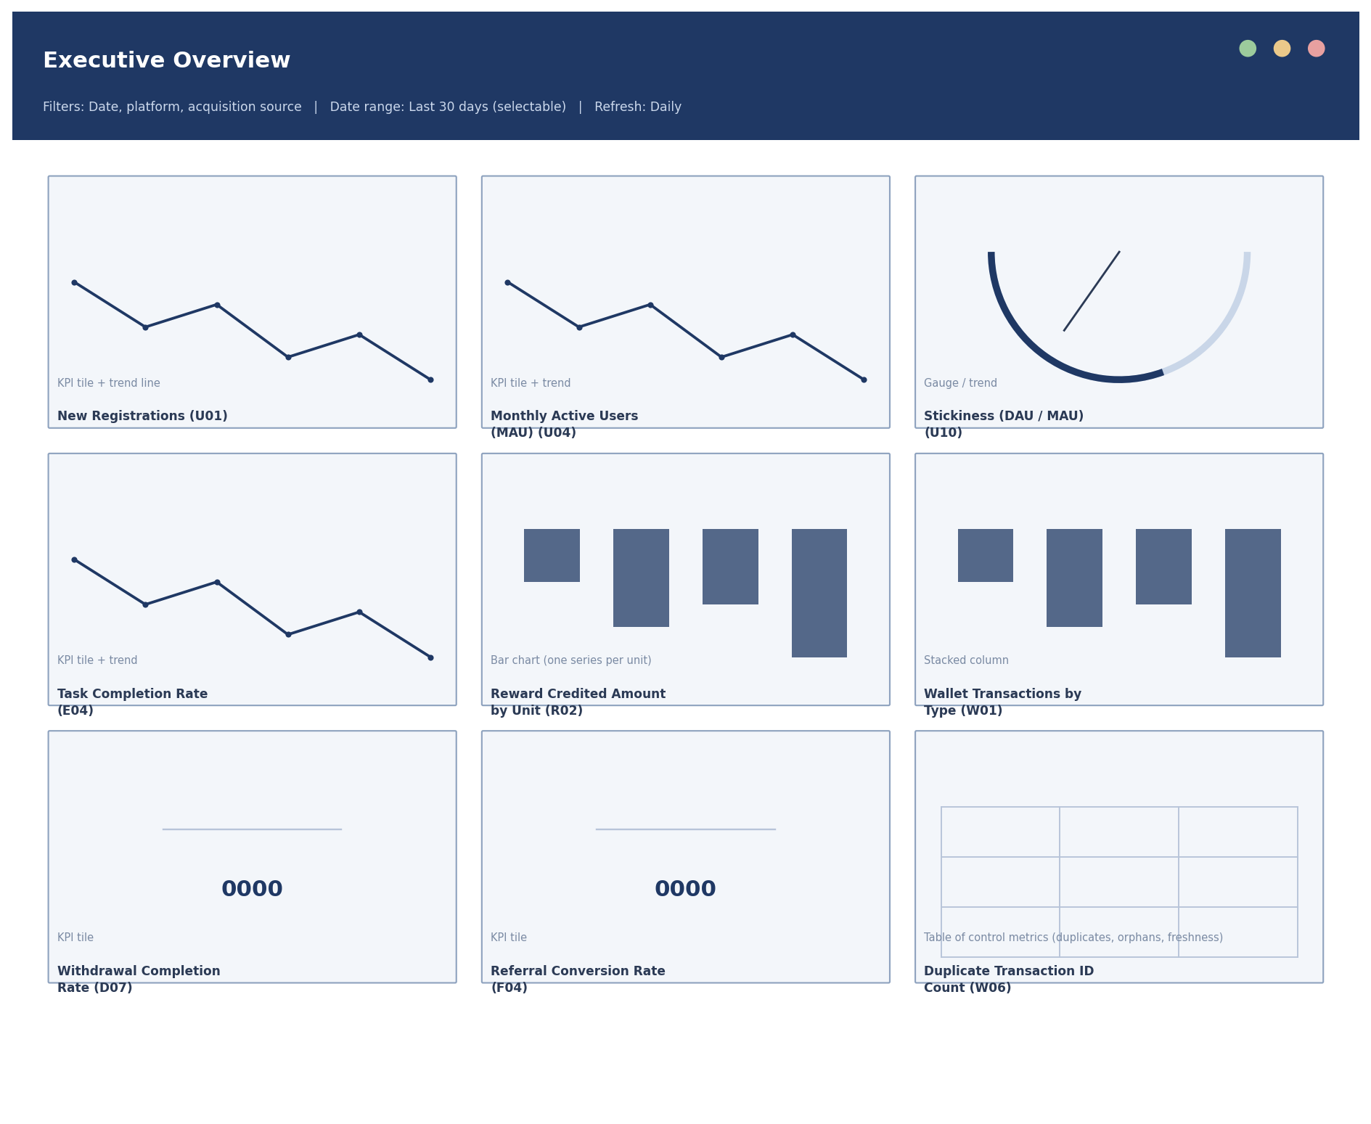
Figure 2 - Dashboard 1 - Executive Overview wireframe. Full specification for each panel is in the Dashboard_Blueprint sheet of the Analytics Design Workbook.

Dashboard 2 - User Analytics
Registrations over time, acquisition source mix, device/platform split, verification and onboarding funnel, and active/returning/inactive segmentation.
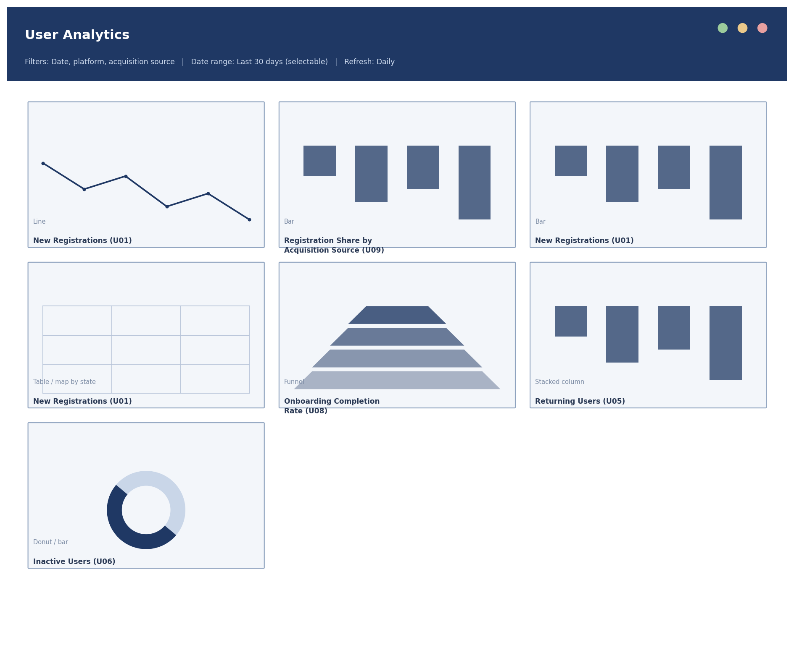
Figure 3 - Dashboard 2 - User Analytics wireframe. Full specification for each panel is in the Dashboard_Blueprint sheet of the Analytics Design Workbook.

Dashboard 3 - Engagement
Feature usage, task funnel (starts to completions), failure breakdown by category, repeat usage, and daily activity trend.
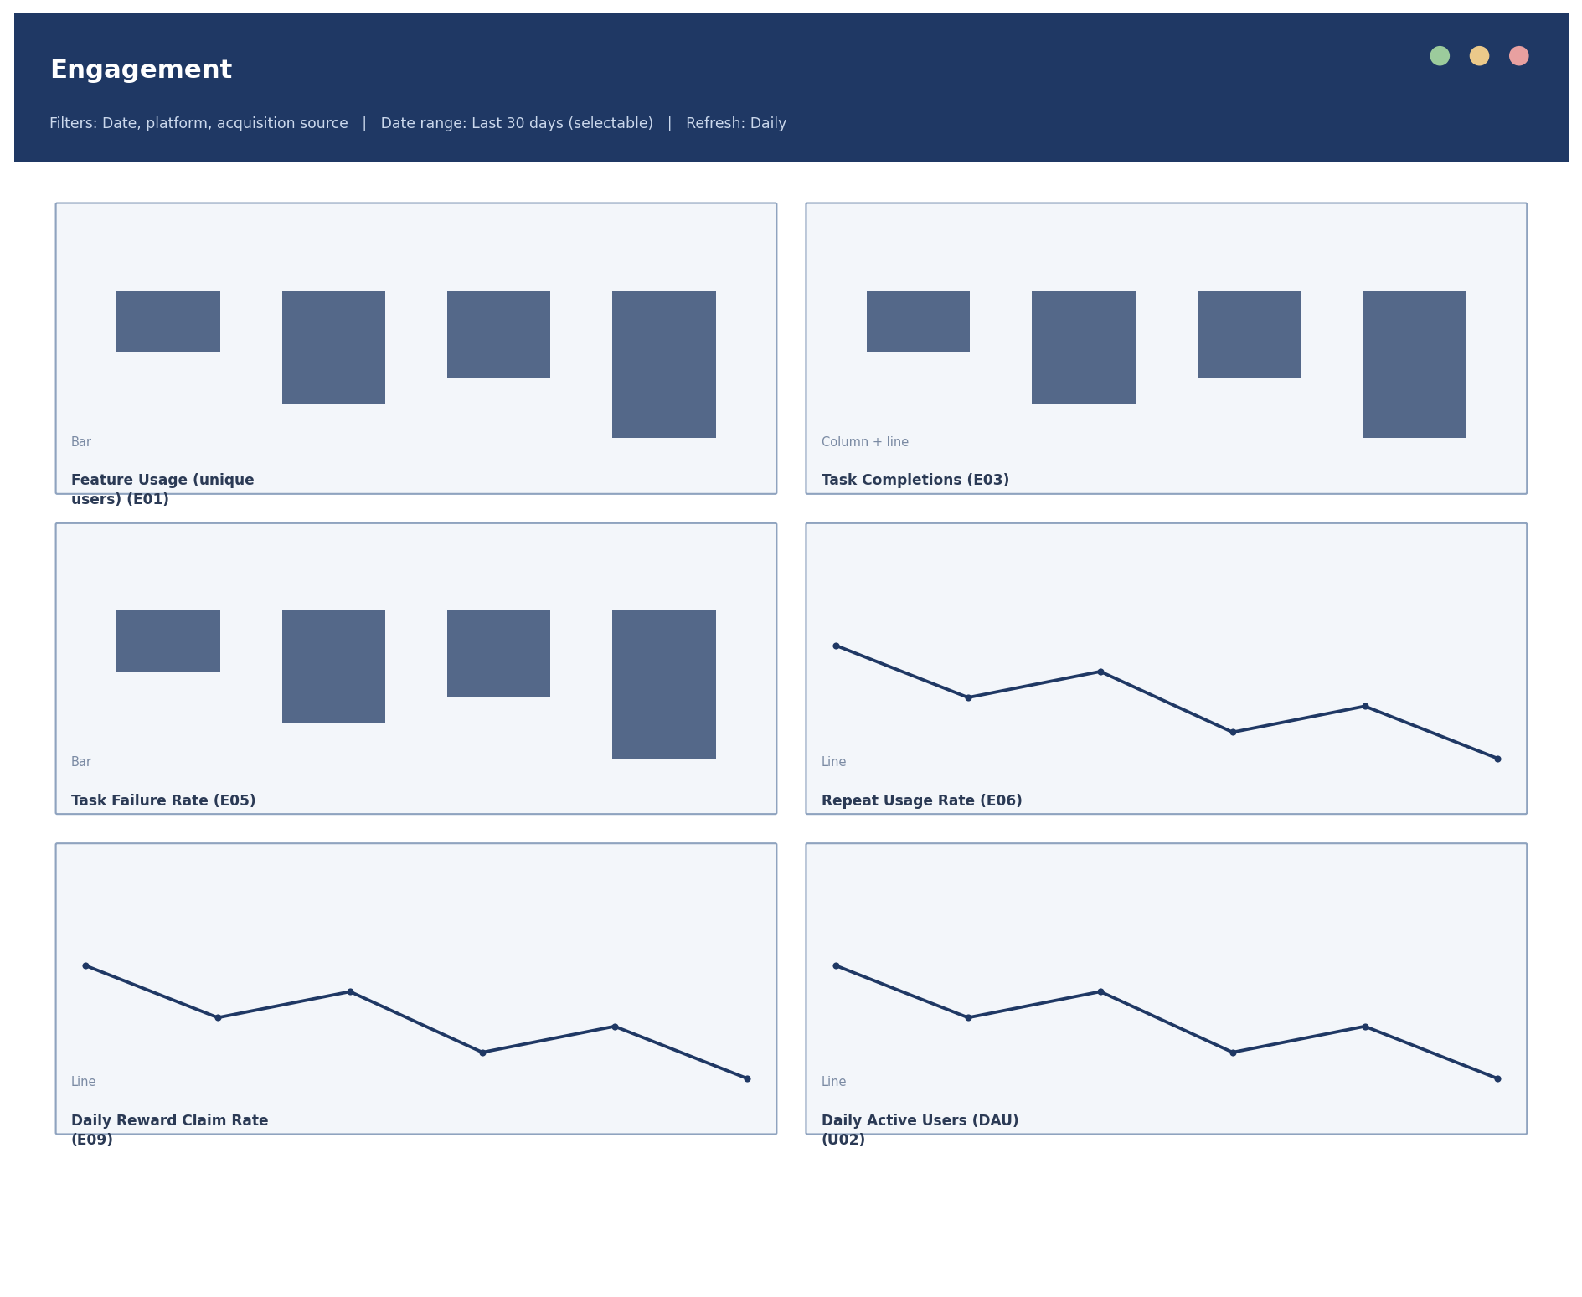
Figure 4 - Dashboard 3 - Engagement wireframe. Full specification for each panel is in the Dashboard_Blueprint sheet of the Analytics Design Workbook.

Dashboard 4 - Rewards
Reward credits by feature and unit, reward status mix, reversal rate trend, and the activity-to-credit rate that flags when completed work is not being paid out.
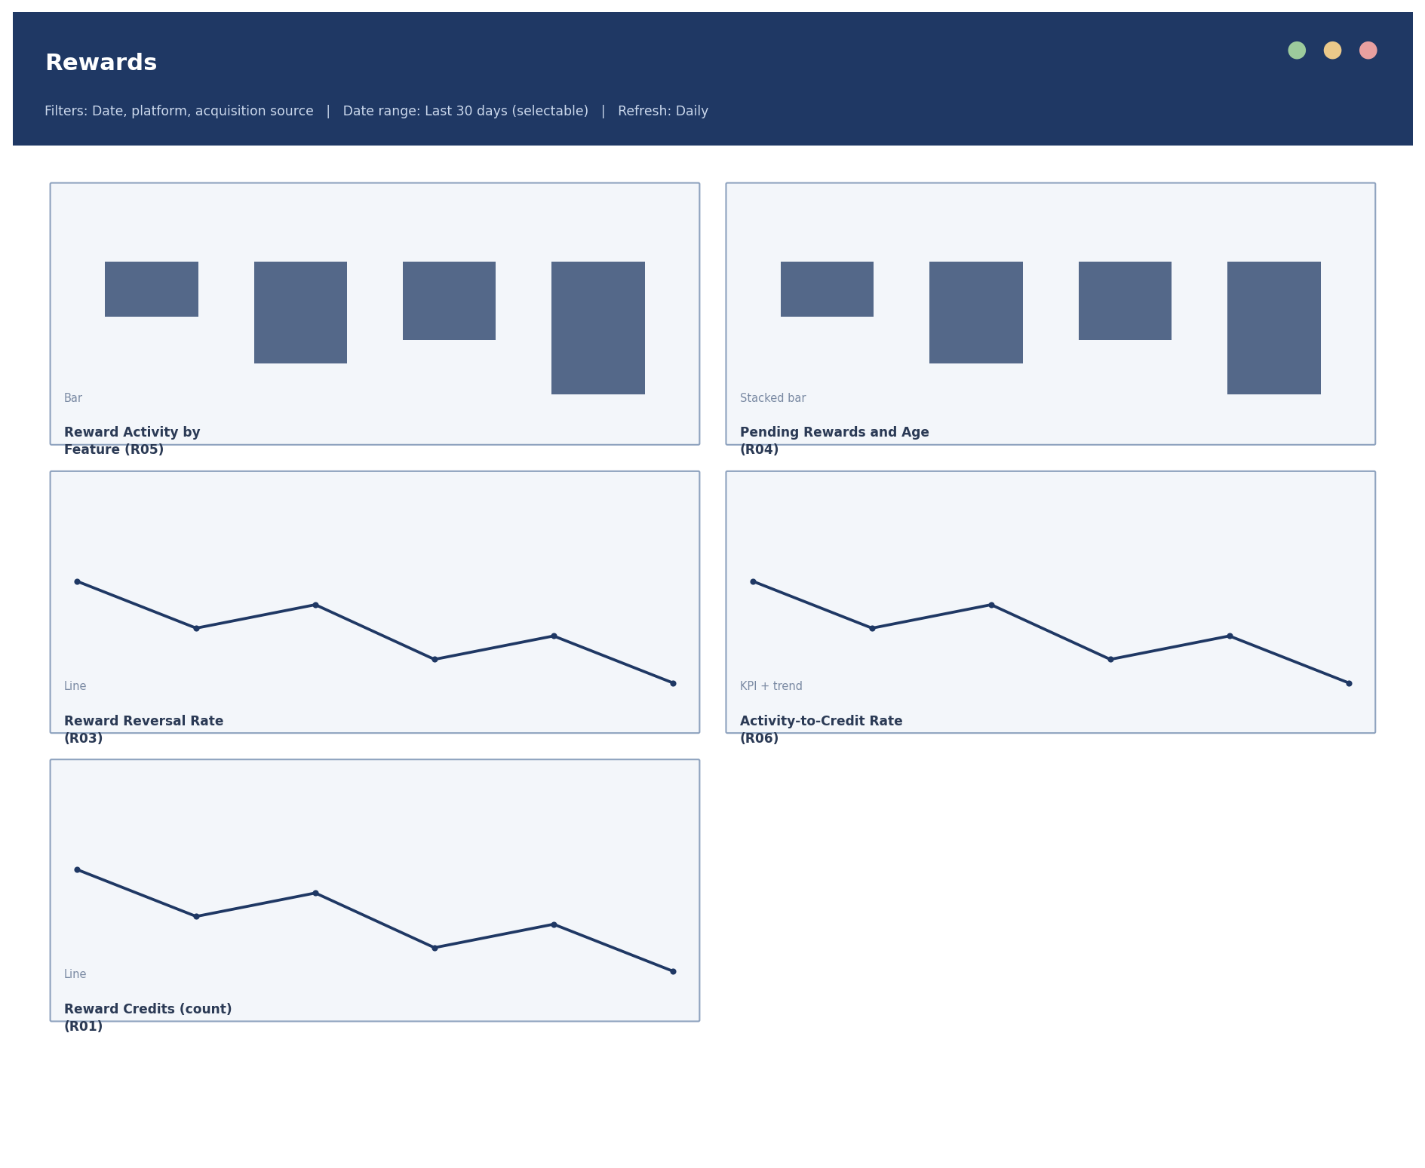
Figure 5 - Dashboard 4 - Rewards wireframe. Full specification for each panel is in the Dashboard_Blueprint sheet of the Analytics Design Workbook.

Dashboard 5 - Wallet
Transaction mix by type, credit and redemption volume by unit, reversal rate, and failed-transaction rate.
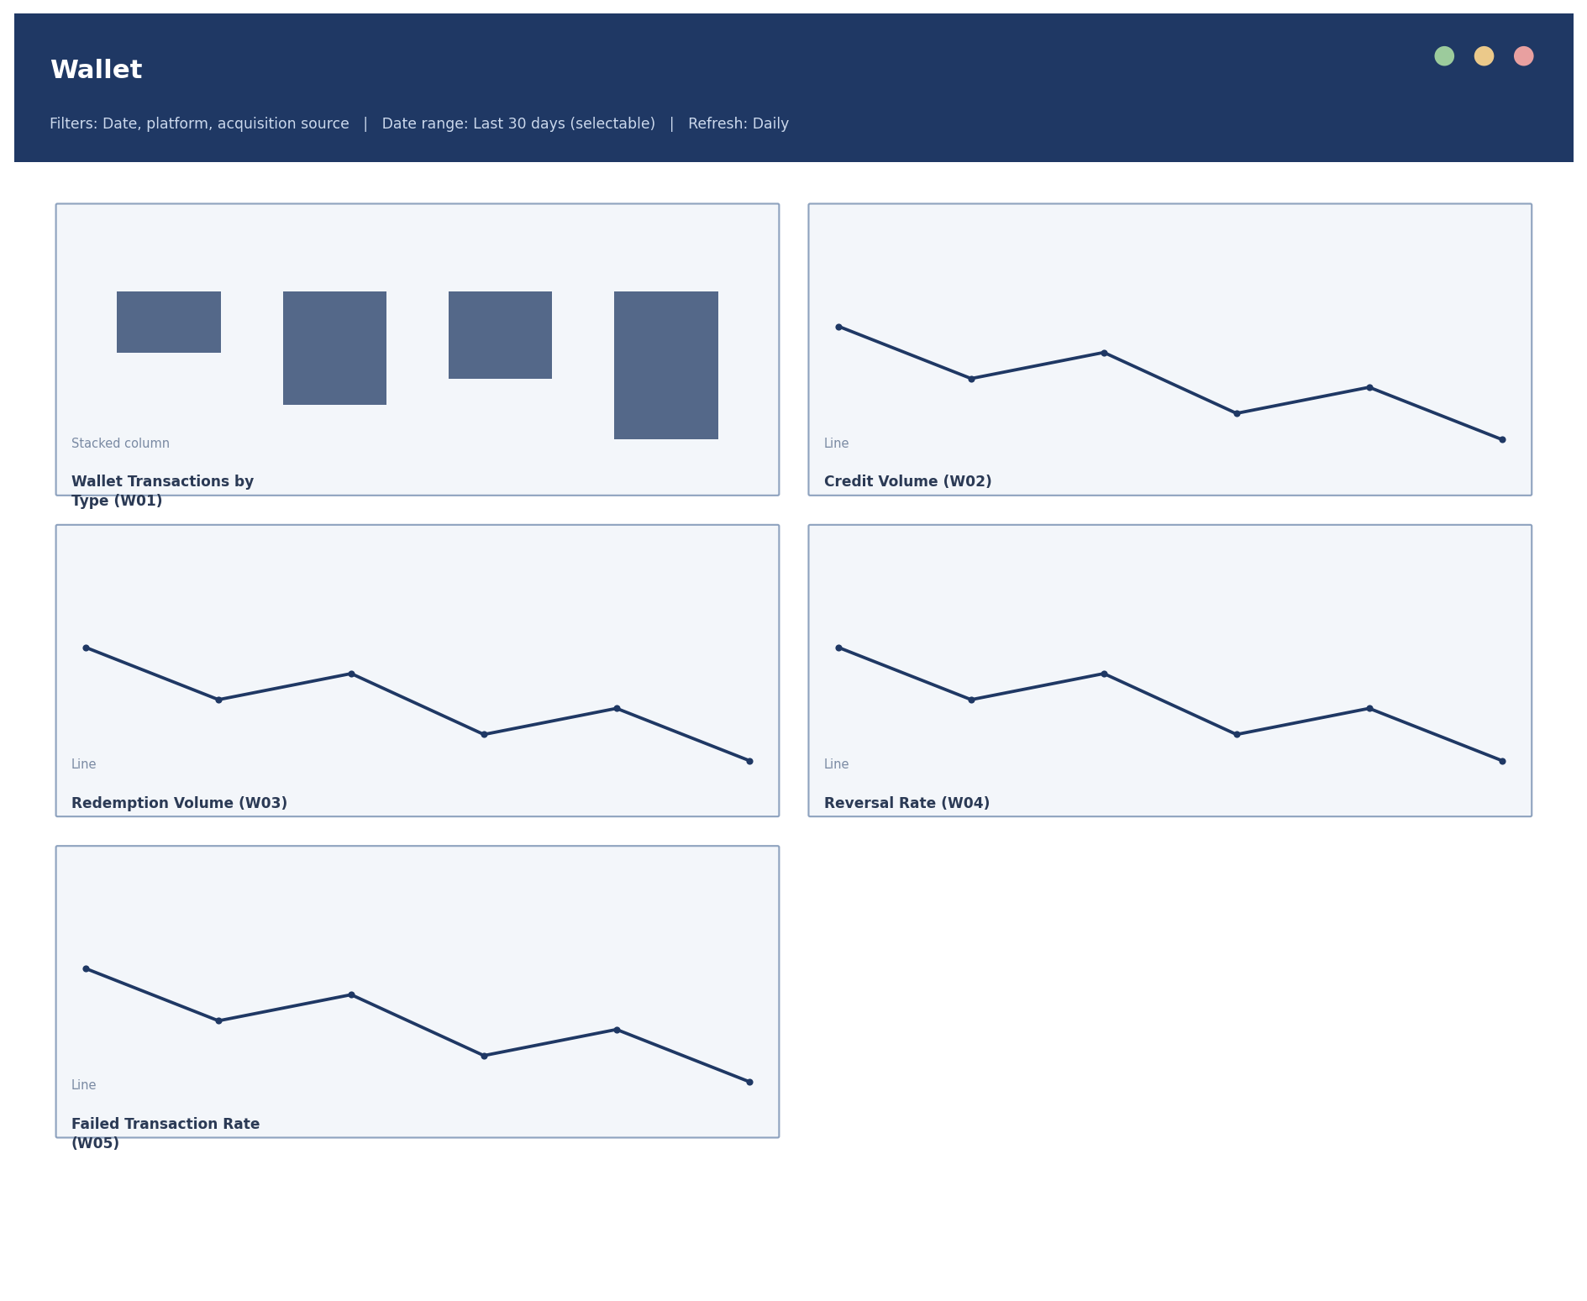
Figure 6 - Dashboard 5 - Wallet wireframe. Full specification for each panel is in the Dashboard_Blueprint sheet of the Analytics Design Workbook.

Dashboard 6 - Withdrawals
Requests and status breakdown, processing time, pending queue size and age, method distribution, and volume.
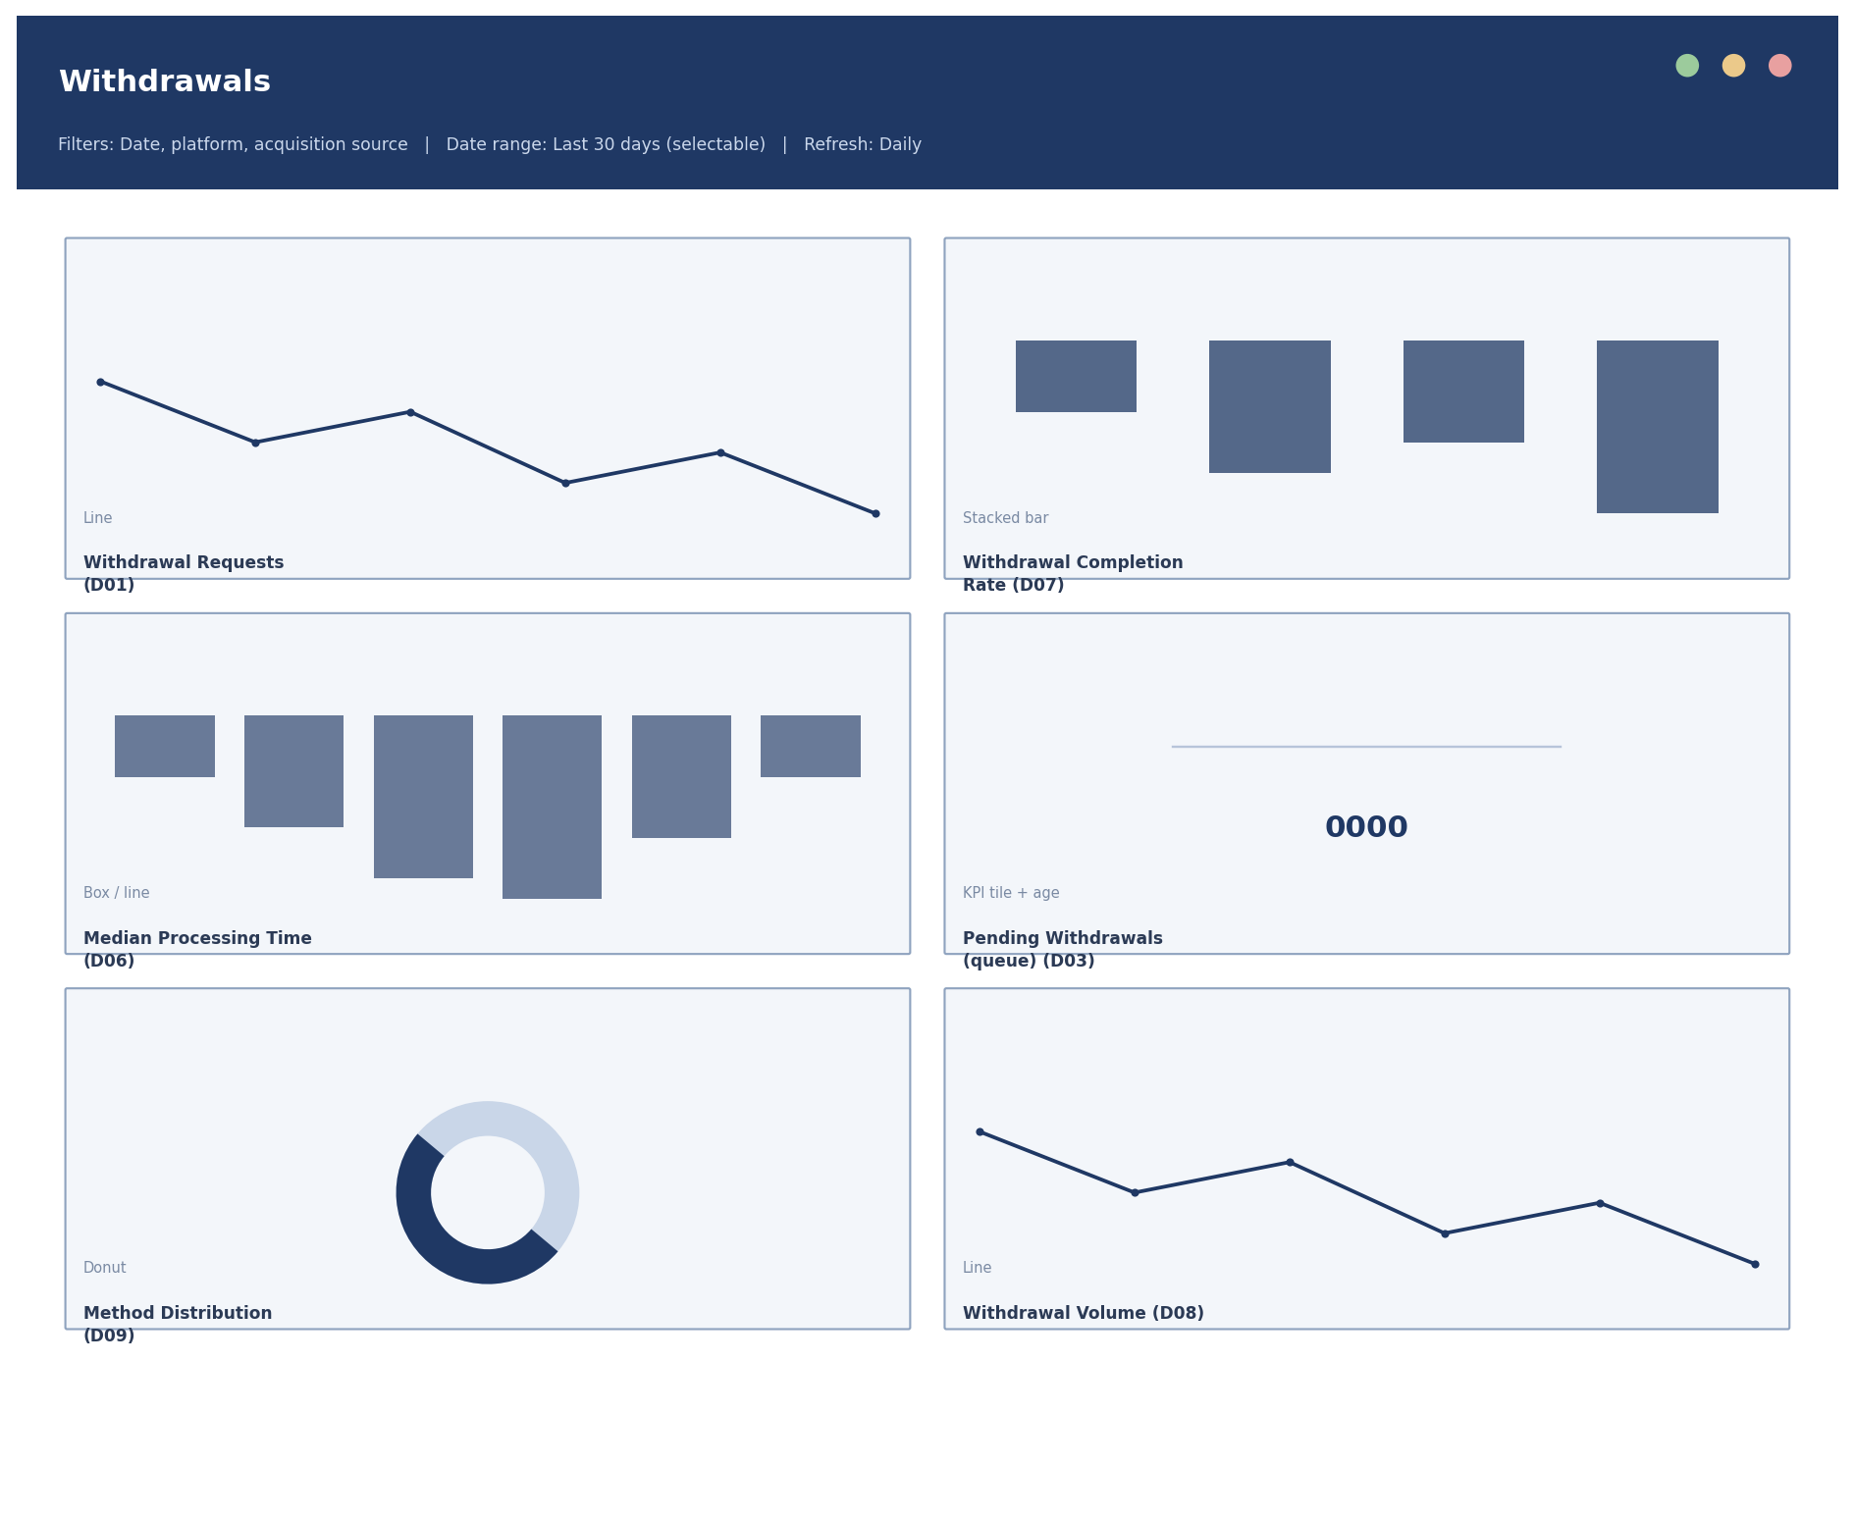
Figure 7 - Dashboard 6 - Withdrawals wireframe. Full specification for each panel is in the Dashboard_Blueprint sheet of the Analytics Design Workbook.

Dashboard 7 - Referrals
The full funnel from created through converted, plus creation and registration trends, activation rate, and time-to-activation.
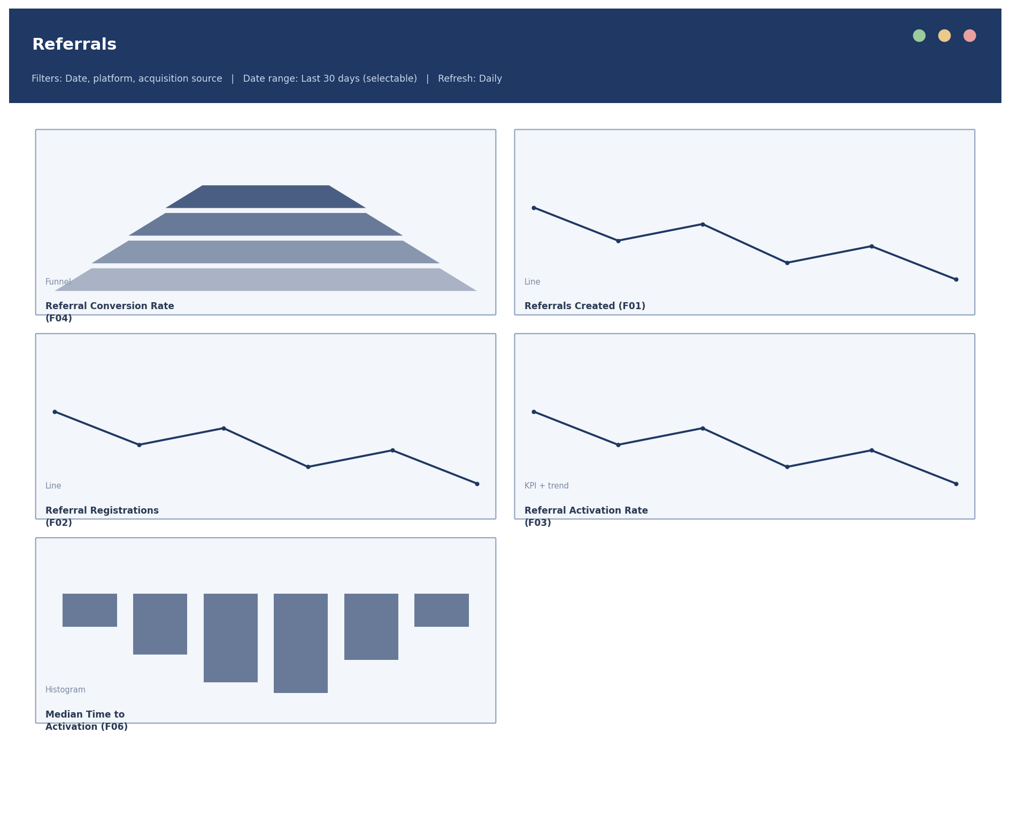
Figure 8 - Dashboard 7 - Referrals wireframe. Full specification for each panel is in the Dashboard_Blueprint sheet of the Analytics Design Workbook.

Notes on implementation
- None of these dashboards can be built against real data until the Critical-priority items in the Implementation Backlog are resolved (stable transaction ID, referrer link, agreed reward units, and the core event set).
- The data-trust panel on the Executive Overview dashboard is deliberately included as a first-class panel, not an afterthought - given the data quality issues found even in the simulated sample (see the Data Quality Audit), no dashboard should launch without a visible indicator of whether the underlying data can currently be trusted.
- Layouts assume a standard widescreen desktop dashboard; a responsive/mobile layout was not designed, since the brief specifies this as a dashboard specification rather than a production build.

