VELOOP Rewards - Data Pipeline & Operating Model Proposal
Work Package O | Version 0.2 (revised 10 October 2026; first issued 28 September 2026)
This is a PROPOSED architecture pattern, not a description of VELOOP's actual infrastructure. Assumption A005 records that the real technology stack is unverified.

1. Design principle
The brief specifically warns against recommending expensive infrastructure merely because it sounds professional. This proposal follows a standard, well-understood event pipeline pattern that scales from a small developing product to a much larger one without requiring a redesign - the same nine stages apply whether daily event volume is in the thousands or the millions; only the technology used to implement each stage needs to change with scale.

2. Architecture diagram
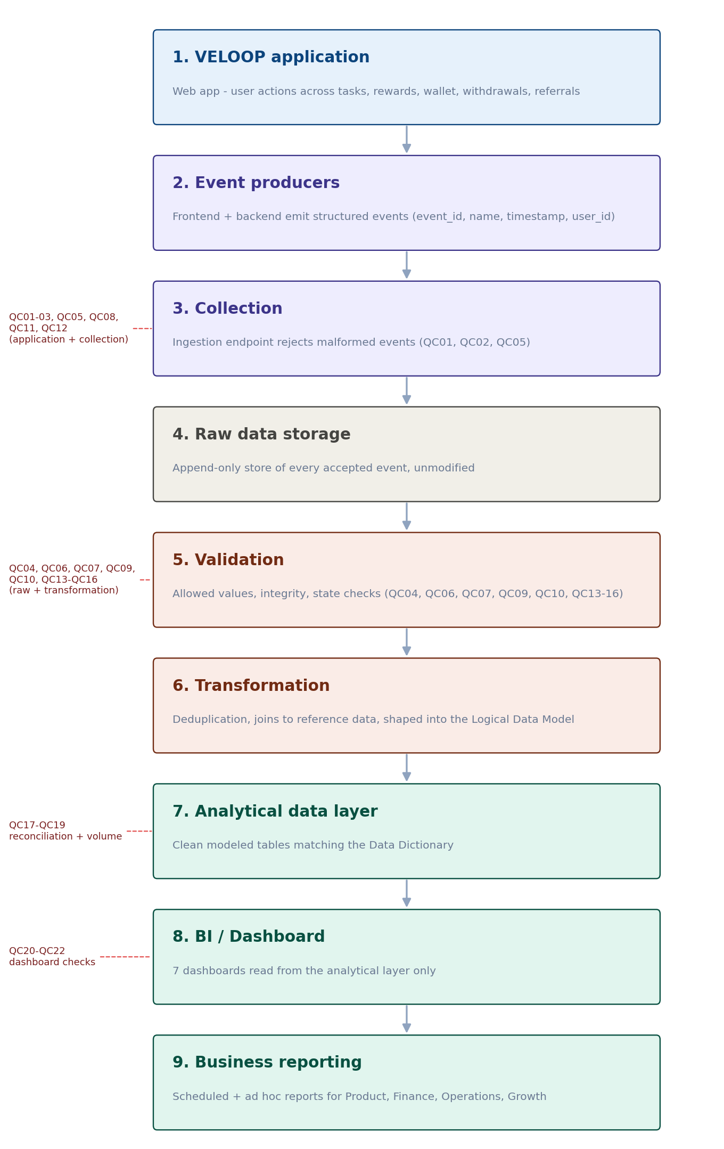
Figure 1 - Proposed VELOOP data pipeline, nine stages, with the Data Quality Control Framework rules (QC01-QC22) mapped to the stage where each runs.

3. Pipeline stages
Stage | What happens here
1. VELOOP Application | Web app emits events as users interact with tasks, rewards, wallet, withdrawals, referrals
2. Event producers | Frontend and backend emit structured events with the envelope: event_id, event_name, timestamp, user_id, schema_version
3. Collection | Events are received by an ingestion endpoint; malformed or unparseable events are rejected at this point (QC01, QC02, QC05); application-level rules QC03, QC08, QC11 and QC12 run before events reach this stage
4. Raw data storage | Every accepted event is stored as-is, unmodified, for replay and audit purposes
5. Validation | Allowed values, referential integrity, and state-transition checks run against the raw layer (QC04, QC06, QC07, QC09, QC10, QC13-QC16); invalid records are quarantined, not silently dropped
6. Transformation | Valid events are deduplicated (by event_id / transaction_id), joined to reference data (Users, Tasks, Feature Registry), and shaped into the entities in the Logical Data Model
7. Analytical data layer | Clean, modeled tables - matching the Data Dictionary - that the KPI Catalogue's formulas are written against
8. BI / Dashboard | The 7 dashboards in the Dashboard Blueprint read from the analytical layer only, never from raw or partially-validated data
9. Business reporting | Scheduled and ad hoc reports for Product, Finance, Operations and Growth stakeholders, built on the same analytical layer

4. Source systems and event producers
Event producers are the VELOOP web application's frontend (for user-initiated actions like task_viewed, feature_opened) and backend services (for validated, business-meaning events like task_completed, reward_credited, wallet_transaction_created). Third-party providers (ad networks, survey/offer/game providers) are treated as external event sources feeding in through the external_callback_received event, kept structurally separate from VELOOP's own event stream so a provider outage or error does not get misread as a VELOOP-caused failure.

5. Collection and storage
- Collection: a single ingestion endpoint (or small number of endpoints by domain) receiving the event envelope described in the Event Tracking Plan; rejects malformed structure before storage.
- Raw layer: an append-only store retaining every accepted event exactly as received, enabling reprocessing if a downstream transformation bug is found later without needing to re-instrument the application.
- Quality checks: the 22 controls in the Data Quality Control Framework are applied at the layer indicated for each rule (application, collection, raw, transformation, or analytics layer) - not all in one place, since catching a problem earlier is always cheaper than catching it later.

6. Transformation and analytical layer
Transformation is where the raw event stream becomes the entities defined in the Logical Data Model: Users, Tasks, Task_Activity, Rewards, Wallet_Transactions, Withdrawals, Referrals, Feature_Events, plus the Feature_Registry lookup. This is also where deduplication happens - using event_id for general events and the transaction_id / idempotency_key pair for wallet entries - and where the reconciliation checks (QC17, QC18) run before the analytical layer is refreshed.

7. Refresh, monitoring and failure handling
Concern | Proposed approach
Refresh frequency | By KPI need: Critical operational metrics (withdrawal queue, DAU) refresh daily or better; strategic KPIs (MAU, retention) refresh daily on a rolling window
Freshness monitoring | Dashboard shows last successful refresh time; a stale refresh is visibly flagged (QC20)
Volume monitoring | Daily event counts compared to trailing average, to catch a broken or disconnected event producer early (QC19)
Failure handling | Rejected and quarantined records are logged with a reason, not silently dropped, so a spike in rejections is itself a signal worth investigating
Ownership | Engineering owns event emission and schema; Data Analyst owns the transformation and analytical layer; both share responsibility for the reconciliation checks

8. What this proposal deliberately avoids
- No specific vendor or product names are recommended, since the actual technology stack is unverified (Assumption A005) and a developing product's infrastructure choice should follow team capability and budget, not this document.
- No numeric performance targets (uptime %, refresh latency in seconds) are invented, in keeping with the brief's prohibition on fabricated company statistics.

