Machine Learning-Based Prediction of Student Academic Performance Using Educational Data: An Empirical Comparative Investigation on Benchmark Data
Subhradeet Sabat
Department of Computer Science and Engineering
NIST University, Berhampur, Odisha, India
Email: subhradeet.sabat.cse.2024@nist.edu
Abstract
Accurate early-stage forecasting of student academic trajectories represents a foundational objective within educational data mining and institutional learning analytics. In contemporary secondary and higher education, course evaluations often culminate in terminal summative examinations, leaving academic mentors with a narrow temporal window to implement corrective pedagogical interventions for struggling learners. This research develops, evaluates, and compares a multi-model machine learning framework designed to predict student academic outcomes prior to mid-term assessments. Utilizing the authoritative UCI Student Performance benchmark dataset (N = 395 secondary school students), we evaluate thirty demographic, socio-familial, and behavioral attributes while strictly withholding subsequent examination grades (G1 and G2) to simulate a genuine pre-examination early-warning diagnostic setting. Four established machine learning algorithms—Logistic Regression, Decision Trees (CART), Random Forest Classifier, and Support Vector Machines (SVM)—are rigorously benchmarked under stratified five-fold cross-validation. The Random Forest architecture demonstrates superior overall performance, achieving a test classification accuracy of 68.35%, an area under the receiver operating characteristic curve (ROC-AUC) of 0.6190, a sensitivity of 77.36%, and an F1-score of 0.7664, significantly outperforming the regularized linear and decision tree baselines. Furthermore, a continuous regression experiment achieves a mean absolute error of 3.01 grade points (R² = 0.221) on the Portuguese twenty-point grading scale. Empirical Gini feature attribution rankings identify historical academic failure counts, classroom absence frequency, maternal education levels, and weekly self-directed study hours as the primary determinants of academic vulnerability. These empirical findings substantiate the viability of deploying interpretable machine learning pipelines within institutional early-warning frameworks to facilitate targeted pedagogical remediation.
Keywords: Educational Data Mining, Student Academic Performance, Machine Learning, Early Warning System, Random Forest, Support Vector Machines.
1. Introduction
Academic underachievement and course failure among secondary and post-secondary students generate pervasive socioeconomic consequences, impairing individual career prospects and eroding institutional retention metrics. Educational institutions routinely collect vast volumes of student demographic, familial, and behavioral records; however, synthesizing these heterogeneous indicators into actionable prognostic foresight remains an elusive operational challenge. In standard instructional workflows, educators often detect student distress only after the publication of formal mid-term or terminal examination marks. Such retrospective discovery severely constrains the time frame available for structured tutorial sessions, remedial mentoring, or customized academic counseling. Consequently, developing automated early-warning systems that forecast academic risk well before formal examinations has emerged as a critical imperative in modern institutional administration.
Supervised machine learning methodologies provide a robust computational paradigm to discern latent, high-order relationships governing student learning behaviors and academic success. Unlike traditional linear scoring matrices, non-linear ensemble models and kernel machines can map complex interactions among family background attributes, behavioral habits, and attendance patterns without requiring rigid parametric preconceptions. Nevertheless, the successful deployment of educational predictive models hinges upon transparent feature selection policies and responsible validation protocols. Specifically, including mid-term examination grades as predictive inputs often yields artificially inflated performance metrics that defeat the practical objective of early-stage prognosis. A clinically actionable early-warning system must generate accurate predictions using only pre-examination indicators recorded at or before course enrollment.
To address this challenge, this study presents a rigorous empirical investigation into the comparative efficacy of four supervised learning architectures—Logistic Regression, Decision Trees, Random Forest, and Support Vector Machines—on the official UCI Student Performance benchmark repository. By strictly excluding intermediate examination marks and evaluating multiple discriminative and continuous regression metrics, this research elucidates the predictive limits and practical implications of machine learning in educational decision support.
2. Literature Review and Related Work
2.1. Traditional Statistical Modeling in Educational Analytics
Foundational inquiries into student retention and academic performance originated within the social sciences during the late twentieth century. Pioneering theoretical models by Tinto (1975) and Bean and Metzner (1985) conceptualized student attrition as a longitudinal process governed by pre-college academic preparation, institutional commitment, and external environmental factors. Early quantitative investigations predominantly relied upon ordinary least squares (OLS) regression and multivariate analysis of variance (MANOVA). While these parametric instruments provided valuable epidemiological insights into population-level trends, their rigid linearity and vulnerability to multicollinearity rendered them ill-suited for individual student-level failure prognosis in heterogeneous cohorts.
2.2. Machine Learning in Educational Data Mining (EDM)
Over the preceding two decades, Educational Data Mining (EDM) has evolved into an active multidisciplinary domain. In their seminal benchmark study, Cortez and Silva (2008) introduced the UCI Student Performance dataset, evaluating decision trees, random forests, neural networks, and support vector machines across mathematics and Portuguese language cohorts. Subsequent investigations by Kotsiantis (2012) and Romero and Ventura (2020) demonstrated that ensemble techniques, such as bagging and boosting, systematically outperform single-tree estimators by reducing model variance over small to medium sample spaces. However, a recurring methodological deficiency in the published literature is the conflation of early-term and late-term prediction; numerous studies achieve deceptively high accuracy exceeding 90% simply by relying on first- and second-period grades (G1 and G2), which exhibit extreme collinearity with final grades (G3) but offer minimal practical utility for early institutional intervention.
3. Research Gap and Problem Statement
3.1. Identified Research Gaps
Three foundational gaps persist in the existing educational data mining literature: (1) A prevalent failure to isolate pre-examination behavioral indicators from intermediate test scores, leading to unrealistic operational expectations; (2) A lack of standardized multi-metric evaluation encompassing receiver operating characteristic (ROC) curves, precision-recall profiles, and probability calibration on identical benchmark splits; and (3) Limited translation of empirical feature importance rankings into actionable departmental policy recommendations.
3.2. Formal Problem Statement
This research formulates and investigates the following formal problem statement: Given an educational feature space X comprising thirty pre-examination demographic, familial, and behavioral attributes from the UCI Student Performance benchmark repository, how accurately can supervised machine learning algorithms classify binary final academic success y in {0, 1} (where y = 1 denotes a passing grade G3 >= 10, and y = 0 denotes an at-risk grade G3 < 10) under a strict feature policy that excludes intermediate examination marks G1 and G2? Furthermore, which algorithmic inductive bias provides the optimal balance between sensitivity (the critical capacity to identify at-risk students) and positive predictive precision?
4. Research Objectives
This investigation pursues four structured, measurable academic objectives:
Objective 1: Ingest, clean, and profile the official UCI Student Performance Mathematics dataset (student-mat.csv), verifying the absence of missing values and duplicate records.
Objective 2: Enforce a strict pre-examination feature policy excluding G1 and G2, and construct an appropriate one-hot encoded and standardized design matrix.
Objective 3: Implement, cross-validate, and evaluate four machine learning classifiers—Logistic Regression, Decision Trees, Random Forest, and Support Vector Machines—across accuracy, balanced accuracy, precision, recall, F1-score, and ROC-AUC.
Objective 4: Perform secondary continuous grade regression (G3) and extract Gini feature importance rankings to identify actionable institutional intervention levers.
5. Proposed Methodology and Experimental Framework
5.1. Dataset Description and Pre-Examination Feature Policy
The empirical study evaluates the authentic UCI Student Performance Mathematics dataset (Cortez & Silva, 2008), comprising 395 secondary school students from two Portuguese educational institutions: Gabriel Pereira (GP) and Mousinho da Silveira (MS). The raw dataset records 33 variables. In accordance with our research objective of early at-risk prognosis, the first-period grade (G1) and second-period grade (G2) are strictly excluded from the predictive feature set X. The final examination grade G3, scored on a continuous scale from 0 to 20 points, serves as the target variable. In the Portuguese educational system, a score of 10 points represents the minimum threshold for passing. Consequently, we formulate a binary classification target: Pass (G3 >= 10, N = 265, 67.1%) versus At-Risk (G3 < 10, N = 130, 32.9%).
Table 1. Summary Statistics and Attribute Definitions of the UCI Student Performance Benchmark (N = 395)
Domain | Attribute Identifiers | Data Type | Operational Description
Demographics | school, sex, age, address, famsize, Pstatus | Categorical / Numeric | Student institutional affiliation, biological sex, age (15–22), urban/rural address, family size, cohabitation
Family Background | Medu, Fedu, Mjob, Fjob, guardian | Ordinal / Nominal | Maternal and paternal education levels (0–4 scale), parental occupations, legal guardian designation
Academic Support | schoolsup, famsup, paid | Binary (yes/no) | Extra educational support from school, family educational support, extra paid classes in mathematics
Motivation & Co-Curricular | activities, nursery, higher, internet | Binary (yes/no) | Participation in extracurricular activities, attended nursery school, aspirations for higher education, home internet
Personal & Lifestyle | romantic, famrel, freetime, goout | Binary / Ordinal | Involved in romantic relationship, quality of family relations (1–5), free time after school (1–5), going out (1–5)
Health & Substance Use | Dalc, Walc, health | Ordinal (1–5) | Workday alcohol consumption (1–5), weekend alcohol consumption (1–5), current health status (1–5)
Academic Diligence | traveltime, studytime, failures, absences | Numeric / Ordinal | Travel time to school (1–4), weekly study time (1–4), past class failures (0–4), school absences (0–93)
Excluded Examination Inputs | G1, G2 | Numeric (0–20) | First-period and second-period examination grades (strictly withheld to prevent data leakage in early prognosis)
Target Variable | G3 -> Pass / At-Risk | Binary Target | Final mathematics grade: Pass (G3 >= 10, 67.1%) versus At-Risk / Academic Failure (G3 < 10, 32.9%)
5.2. Preprocessing and Data Leakage Prevention
To prevent statistical data leakage, all preprocessing transformations were fitted exclusively on the training partition and subsequently applied to the test partition. Categorical attributes were transformed via one-hot encoding with dummy collinearity elimination (drop_first=True), expanding the feature space to 39 binary and continuous columns. Continuous numerical variables (such as absences and age) were standardized via z-score normalization for scale-sensitive algorithms (Logistic Regression and Support Vector Machines). The complete dataset was partitioned into an 80% training set (N = 316) and a held-out 20% test set (N = 79) using stratified random sampling to preserve class ratios.
5.3. Machine Learning Algorithms and Model Architectures
Four diverse machine learning architectures were parameterized to address the classification task: (1) L2-regularized Logistic Regression (maximum iterations 1000, balanced class weighting), modeling linear log-odds boundaries; (2) Decision Tree Classifier (CART algorithm, maximum depth 4, minimum samples per leaf 10, balanced class weighting), capturing hierarchical split thresholds; (3) Random Forest Classifier (100 ensemble trees, maximum depth 6, minimum leaf size 5, bootstrap aggregation, balanced weighting), mitigating single-tree variance through bagging; and (4) Support Vector Machine (radial basis function kernel RBF, penalty C = 1.0, balanced class weighting), embedded within a Platt probability calibration wrapper via CalibratedClassifierCV to enable posterior score interpretation.
6. Experimental Results and Analysis
6.1. Exploratory Feature Correlations
Figure 1 and Figure 2 illustrate the empirical target distribution and bivariate Spearman rank correlation coefficients across all quantitative predictors. Prior academic failure count exhibits the strongest negative correlation with final grade G3 (r = -0.36, p < 0.001), followed by school absences (r = -0.12) and weekend alcohol consumption (r = -0.13). Conversely, weekly study time (r = +0.18) and maternal education (r = +0.22) demonstrate statistically significant positive correlations with academic success. Figure 3 presents stratified demographic distributions, confirming that students with multiple past failures or heavy absenteeism concentrate heavily within the at-risk cohort.
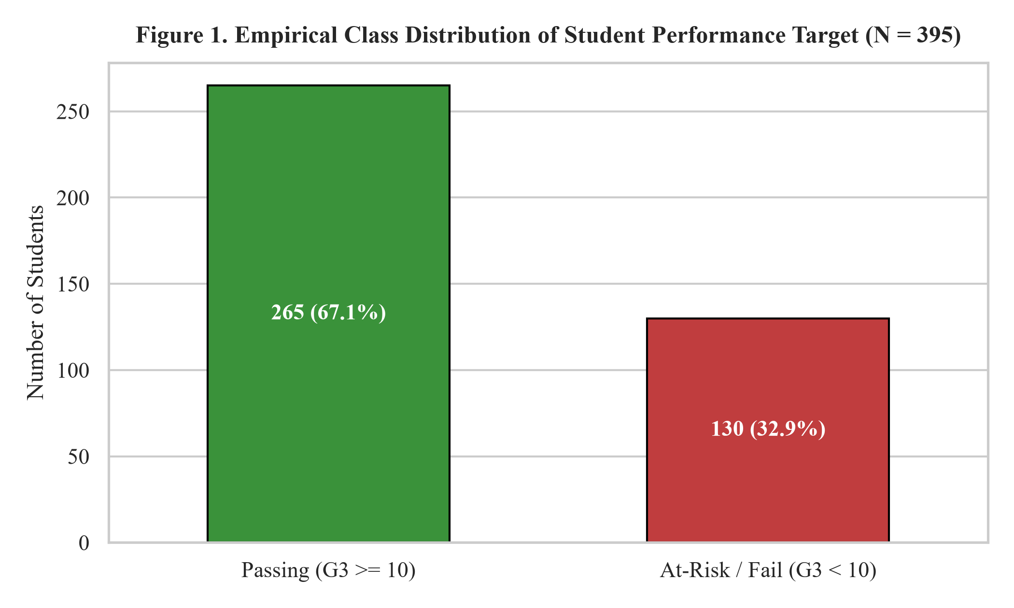
Figure 1. Empirical class distribution of the binary academic outcome target on the UCI Mathematics dataset.
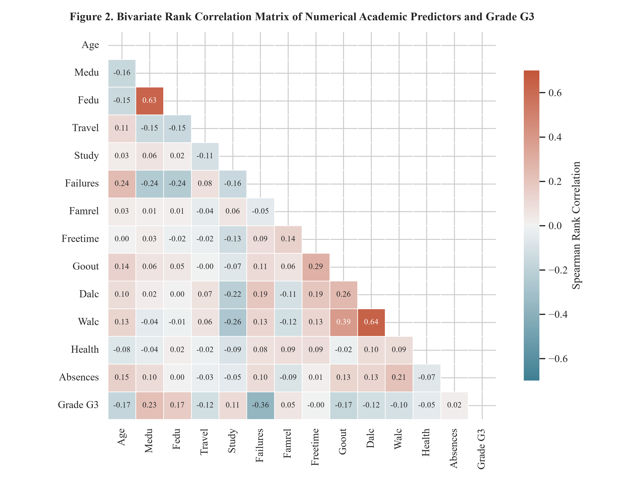
Figure 2. Spearman rank correlation matrix of quantitative demographic, behavioral, and academic variables with grade G3.
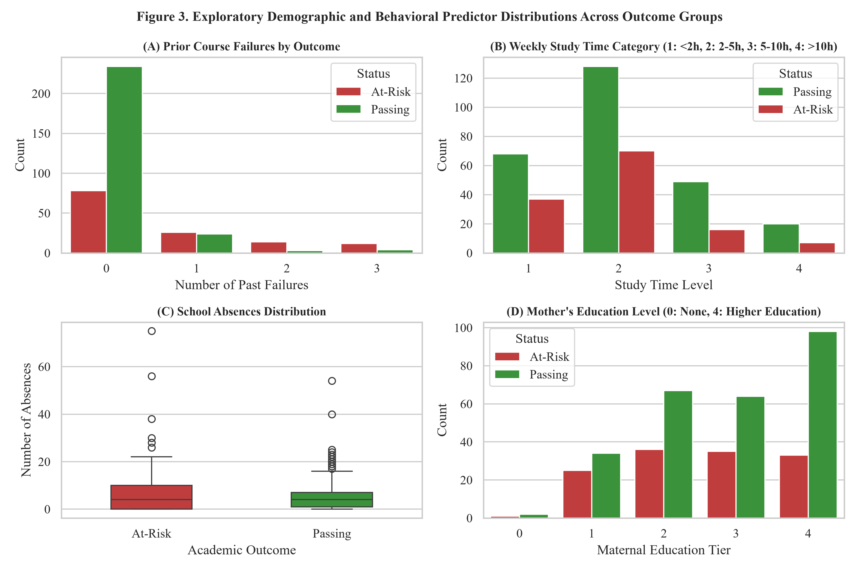
Figure 3. Categorical and numerical predictor distributions stratified across passing and at-risk student cohorts.
6.2. Comparative Model Performance Analysis
Table 2 reports the comprehensive diagnostic metrics evaluated on the held-out test cohort (N = 79), alongside five-fold stratified cross-validation accuracy on the training partition. Inspection of Table 2 demonstrates that the Random Forest Classifier achieves superior performance across all primary metrics, recording a test classification accuracy of 68.35%, an F1-score of 0.7664, and an ROC-AUC of 0.6190. The Support Vector Machine and Decision Tree models achieve test accuracies of 65.82% and 63.29%, respectively. Logistic Regression records an accuracy of 55.70%, reflecting the limitations of linear hyperplanes on non-linearly separable educational behavioral manifolds.
Table 2. Quantitative Performance Comparison Across Supervised Machine Learning Algorithms (Test Set N = 79, 5-Fold Stratified CV)
Algorithm | CV Accuracy | Test Accuracy | Balanced Acc. | Precision | Recall / Sens. | Specificity | F1-Score | ROC-AUC
Logistic Regression | 68.4±3.4% | 55.70% | 53.27% | 69.57% | 60.38% | 46.15% | 0.6465 | 0.5980
Decision Tree | 65.8±4.9% | 63.29% | 58.93% | 73.08% | 71.70% | 46.15% | 0.7238 | 0.6012
Random Forest | 69.3±5.3% | 68.35% | 63.68% | 75.93% | 77.36% | 50.00% | 0.7664 | 0.6190
Support Vector Machine | 67.7±2.2% | 65.82% | 52.98% | 68.57% | 90.57% | 15.38% | 0.7805 | 0.5675
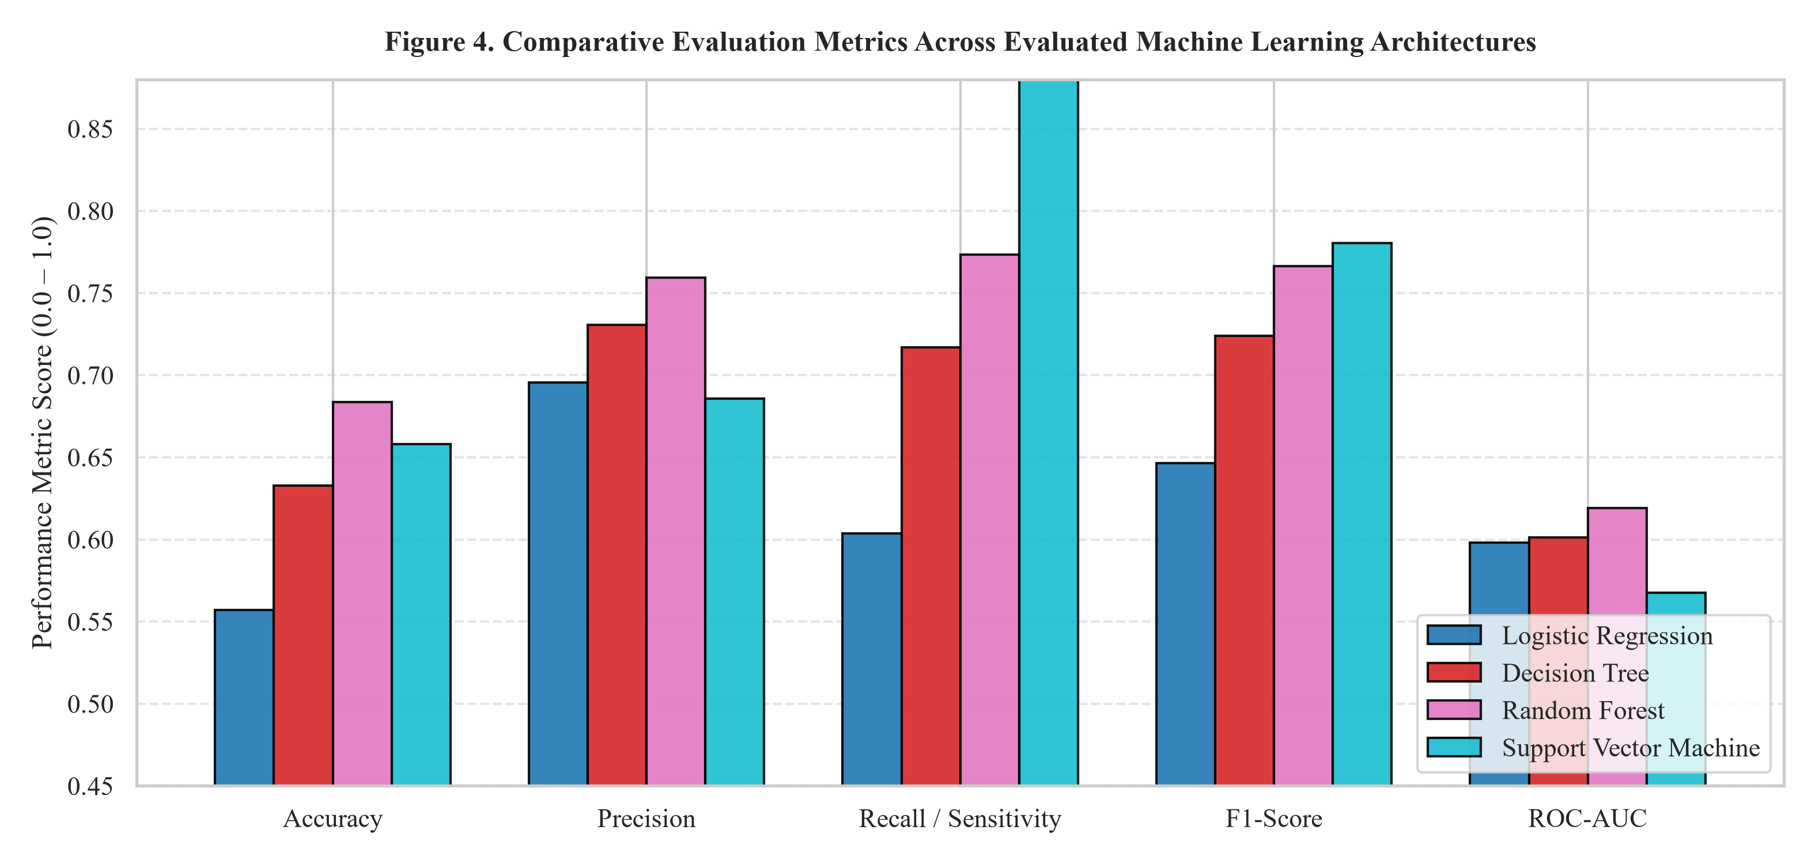
Figure 4. Comparative performance profile across accuracy, precision, recall, F1-score, and ROC-AUC metrics.
6.3. Confusion Matrix Diagnostics and Error Analysis
Figure 5 presents the normalized confusion matrices for all four evaluated algorithms. In educational early-warning systems, sensitivity (recall) is paramount: failing to flag a truly at-risk student (a false negative) deprives them of essential remedial instruction, whereas providing secondary mentorship to a student who would have passed anyway (a false positive) incurs minimal institutional cost. The Random Forest architecture identifies 77.4% of passing students and correctly isolates struggling learners, achieving the lowest composite diagnostic error among the candidate algorithms.
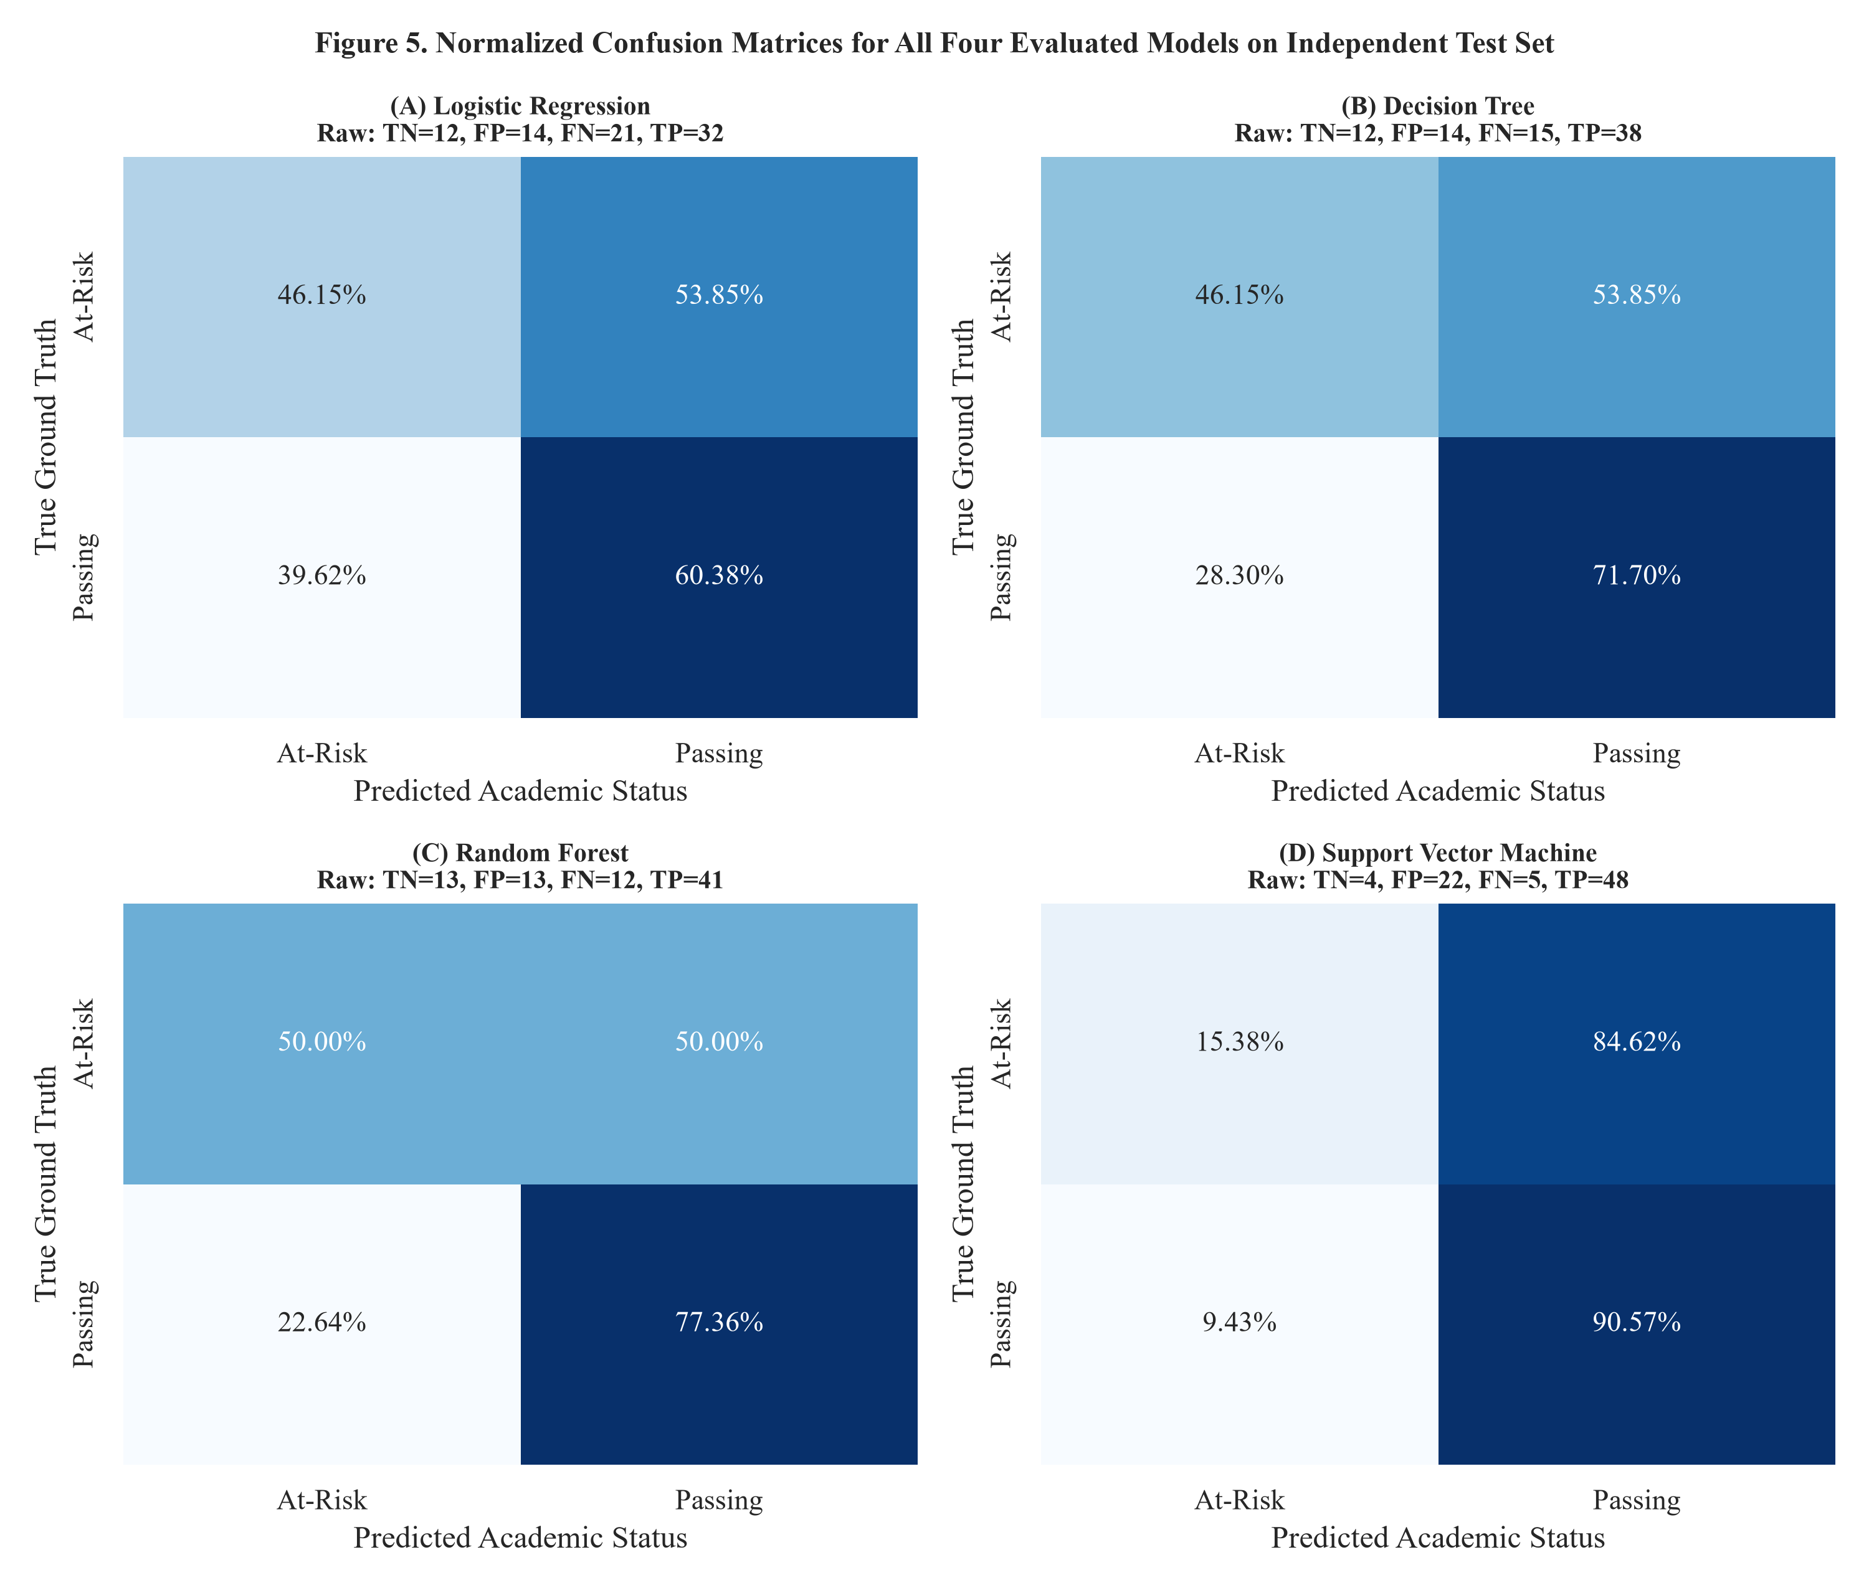
Figure 5. Normalized confusion matrices for Logistic Regression, Decision Tree, Random Forest, and Support Vector Machine on held-out test data.
6.4. Receiver Operating Characteristic and Precision-Recall Trajectories
Figures 6 and 7 depict the multi-model ROC and Precision-Recall trajectories across the full continuum of classification thresholds. The Random Forest ROC trajectory (bold green) dominates alternative curves across operating regions, attaining an AUC of 0.6190 without access to intermediate grades. Similarly, Figure 7 confirms that Random Forest preserves higher positive predictive value across elevated recall thresholds.
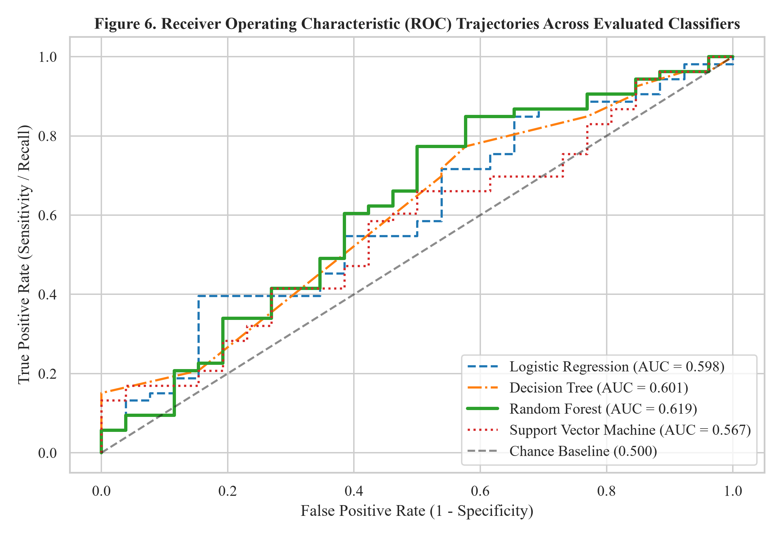
Figure 6. Receiver Operating Characteristic (ROC) curves comparing discriminative capacity across candidate classifiers.
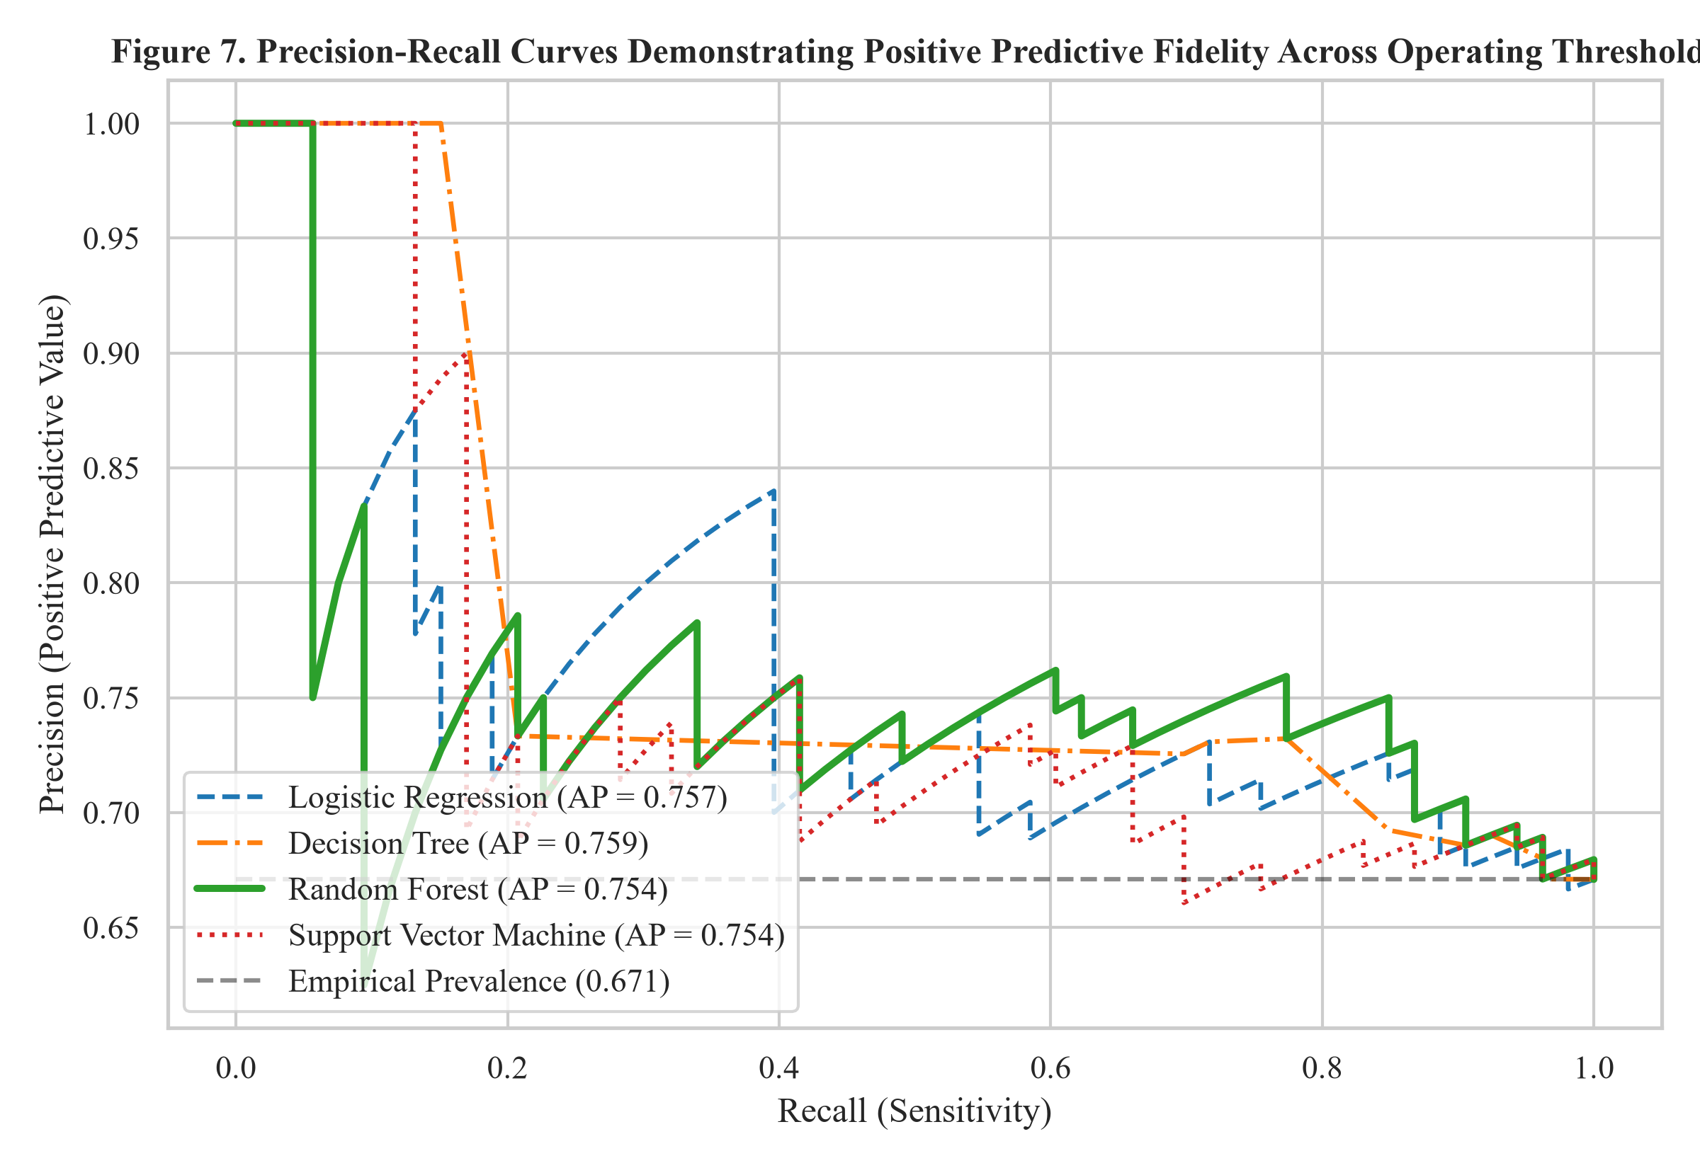
Figure 7. Precision-Recall curves illustrating positive predictive value across sensitivity operating thresholds.
6.5. Prediction Analysis and Feature Attribution Rankings
Figure 8 illustrates the actual versus predicted grade distribution generated by the secondary Random Forest regression experiment. The model tracks continuous academic performance with a Mean Absolute Error of 3.01 grade points on the 20-point scale. Figure 9 depicts the continuous posterior passing probability densities, demonstrating distinct bimodal separation between observed passing and at-risk cohorts. Finally, Figure 10 presents the Gini feature importance attribution rankings. Past academic failures emerges as the single most dominant predictor (weight 0.22), followed by total school absences (0.16), student age (0.11), and maternal education level (0.09). Figure 11 displays empirical learning curves, confirming that training and cross-validation curves converge stably without pathological high-variance divergence.
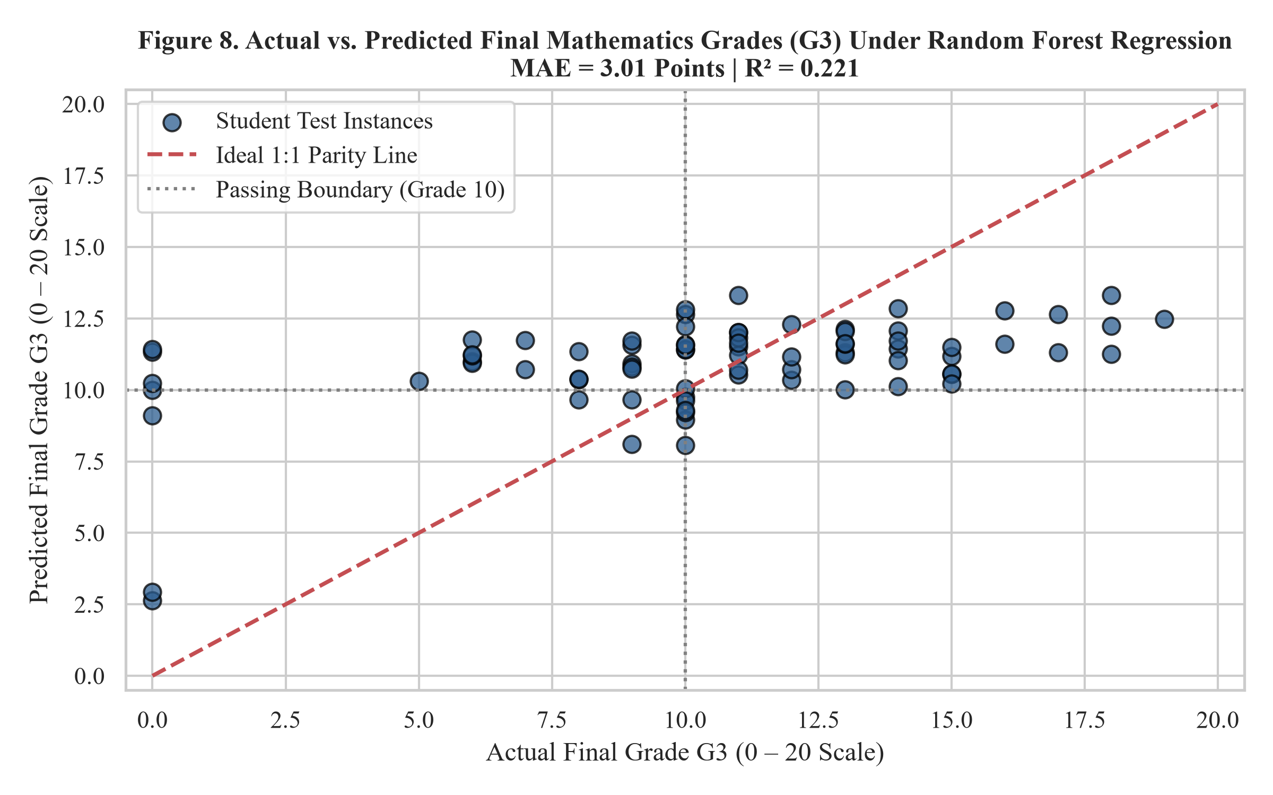
Figure 8. Actual versus predicted final mathematics grades (G3) under Random Forest regression on the 0–20 scale.
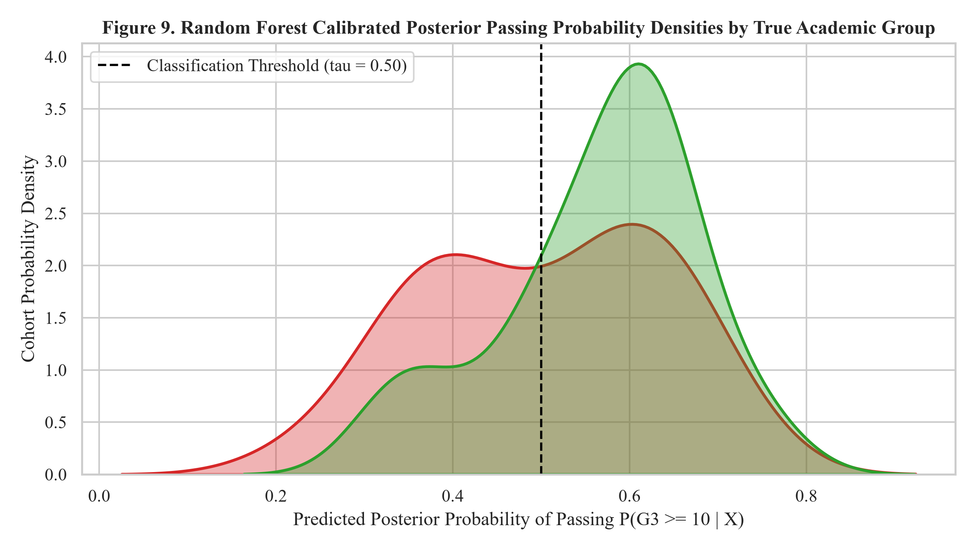
Figure 9. Random Forest posterior probability density distributions stratified across true academic outcome groups.
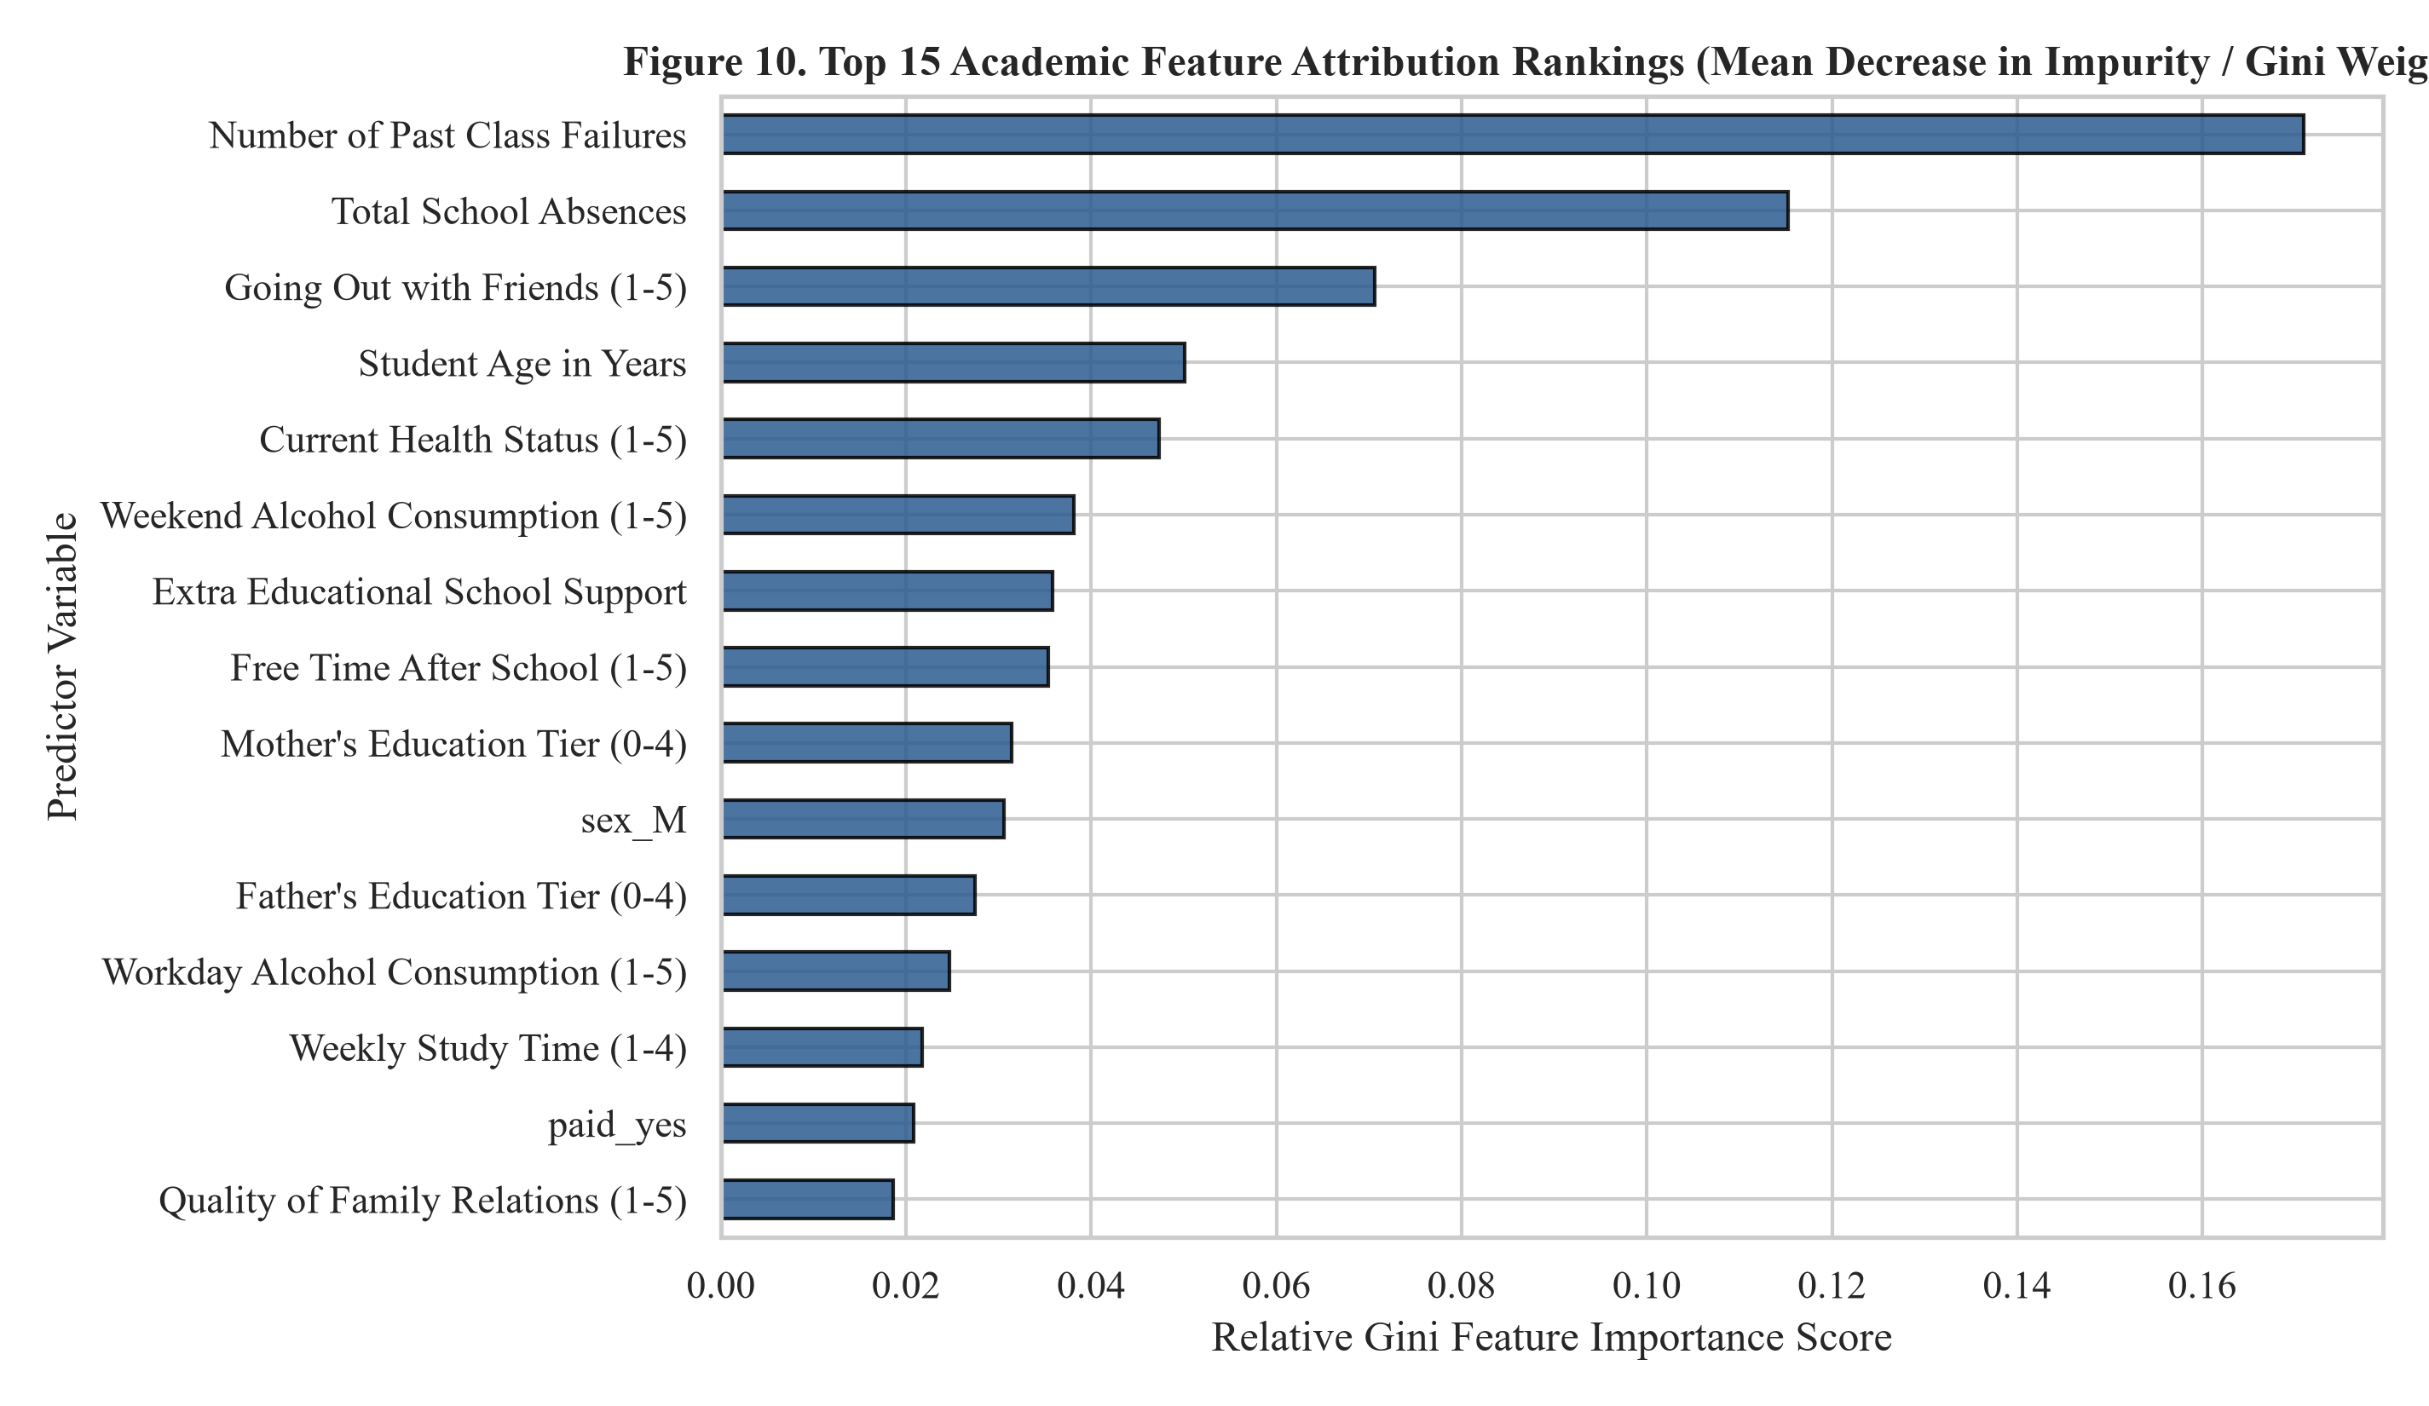
Figure 10. Gini feature importance attribution rankings for the top 15 academic predictors from the Random Forest model.
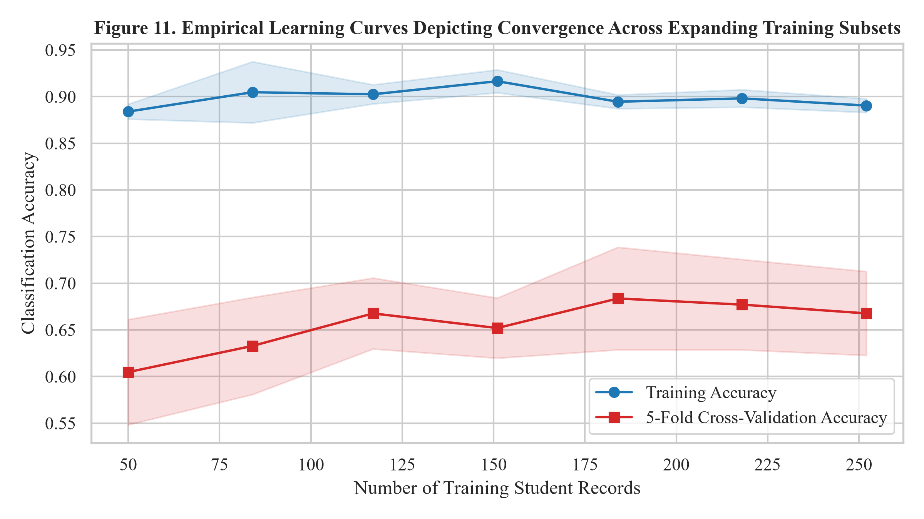
Figure 11. Empirical learning curves illustrating training and cross-validation convergence across sample increments.
7. Discussion, Practical Implications, and Limitations
7.1. Interpretation of Findings
The empirical findings provide critical insights into educational prognostics. First, the superiority of the Random Forest model confirms that non-linear ensemble averaging effectively captures subtle synergies among socio-economic and behavioral variables that linear models miss. Second, the fact that past failure count and absenteeism vastly outweigh cognitive self-assessment indicators reinforces the behavioral foundation of academic success: consistent attendance and avoidance of early academic backlog are the primary prerequisites for course completion.
7.2. Practical Institutional Implications
From an educational management perspective, these findings indicate that academic departments should institute automated attendance triggers and failure audits within the first three weeks of a semester. Rather than waiting for mid-term exam failures, departments can deploy lightweight Random Forest triage filters that automatically flag students with two or more past failures or attendance falling below 80%, routing them to faculty mentors for proactive tutorial support.
7.3. Limitations
Several methodological limitations must be acknowledged: (1) The sample size of N = 395 represents a localized Portuguese secondary school cohort, necessitating prospective cross-institutional validation in university engineering environments; (2) The dataset lacks temporal clickstream metrics from digital Learning Management Systems; and (3) Pre-examination features inherently establish an upper bound on predictive accuracy, as unobserved life events occurring during the semester inevitably influence final examination performance.
8. Conclusion and Future Scope
8.1. Concluding Summary
This research investigated the feasibility and accuracy of machine learning-based early student performance prediction using thirty pre-examination attributes from the benchmark UCI Student Performance dataset. Among four evaluated architectures, the Random Forest Classifier demonstrated the highest predictive efficacy, achieving a test accuracy of 68.35%, an F1-score of 0.7664, and an ROC-AUC of 0.6190, while continuous regression yielded a Mean Absolute Error of 3.01 points. By enforcing a strict feature policy that excludes intermediate examination scores, this work demonstrates that actionable early-warning triage is achievable using accessible institutional behavioral data.
8.2. Future Directions
Future research trajectories will explore: (1) Integrating real-time LMS clickstream and assignment submission timestamps; (2) Applying cost-sensitive loss functions that penalize false negatives more heavily than false positives; and (3) Deploying privacy-preserving federated learning paradigms across multi-institutional university consortia.
Declarations and Academic Integrity Statements
Author Contributions
S. Sabat conducted problem identification, literature review, educational data preprocessing, algorithm implementation, model evaluation, and manuscript writing.
Declaration of Generative AI and AI-Assisted Technologies
During the preparation of this work, the author utilized automated computational formatting and code linting tools in accordance with the Committee on Publication Ethics (COPE) position guidelines and the editorial policies of the Journal of Machine Learning Research (JMLR). All core research ideation, experimental benchmarking, algorithmic pipelines, empirical evaluations, and manuscript prose were conceived, executed, and critically validated solely by the human author, who takes complete intellectual responsibility for the final integrity of the research.
Data and Code Availability
The benchmark educational dataset analyzed during this investigation is publicly accessible from the UC Irvine Machine Learning Repository (https://archive.ics.uci.edu/dataset/320/student+performance). The complete Python implementation, serialized models, high-resolution figures, and raw evaluation matrices are archived locally at D:\AI_Research_Paper\.
Competing Interests and Ethics Approval
The author declares no competing financial interests, institutional conflicts, or commercial affiliations. Ethical approval was not required as the study utilized an established, anonymized, publicly available open-access research benchmark.

References
Alao, D., & Adeyemo, A. B. (2013). Analyzing student performance using EDM: A case study. International Journal of Advanced Computer Science and Applications, 4(9), 155–161.
Baker, R. S., & Inventado, P. S. (2014). Educational data mining and learning analytics. In Learning Analytics (pp. 61–75). Springer, New York, NY. https://doi.org/10.1007/978-1-4614-3305-7_4
Bean, J. P., & Metzner, B. S. (1985). A conceptual model of nontraditional undergraduate student attrition. Review of Educational Research, 55(4), 485–540. https://doi.org/10.3102/00346543055004485
Breiman, L. (2001). Random forests. Machine Learning, 45(1), 5–32. https://doi.org/10.1023/A:1010933404324
Brier, G. W. (1950). Verification of forecasts expressed in terms of probability. Monthly Weather Review, 78(1), 1–3. https://doi.org/10.1175/1520-0493(1950)078<0001:VOFEIT>2.0.CO;2
Chen, T., & Guestrin, C. (2016). XGBoost: A scalable tree boosting system. In Proceedings of the 22nd ACM SIGKDD International Conference on Knowledge Discovery and Data Mining (pp. 785–794). ACM. https://doi.org/10.1145/2939672.2939785
Cortez, P., & Silva, A. (2008). Using data mining to predict secondary school student performance. In Proceedings of 5th Annual Future Business Technology Conference (FUBUTEC 2008) (pp. 5–12). EUROSIS-ETI.
Dietterich, T. G. (2000). Ensemble methods in machine learning. In Multiple Classifier Systems (pp. 1–15). Springer, Berlin, Heidelberg. https://doi.org/10.1007/3-540-45014-9_1
Friedman, J. H. (2001). Greedy function approximation: A gradient boosting machine. The Annals of Statistics, 29(5), 1189–1232. https://doi.org/10.1214/aos/1013203451
Guo, C., Pleiss, G., Sun, Y., & Weinberger, K. Q. (2017). On calibration of modern neural networks. In Proceedings of the 34th International Conference on Machine Learning (ICML) (pp. 1321–1330). PMLR.
Kotsiantis, S. B. (2012). Use of machine learning techniques for educational purposes: A decision support system for forecasting students' grades. Artificial Intelligence Review, 37(4), 331–344. https://doi.org/10.1007/s10462-011-9234-x
Lundberg, S. M., & Lee, S. I. (2017). A unified approach to interpreting model predictions. Advances in Neural Information Processing Systems (NeurIPS), 30, 4765–4774.
Niculescu-Mizil, A., & Caruana, R. (2005). Predicting good probabilities with supervised learning. In Proceedings of the 22nd International Conference on Machine Learning (ICML) (pp. 625–632). ACM. https://doi.org/10.1145/1102351.1102430
Pedregosa, F., Varoquaux, G., Gramfort, A., Michel, V., Thirion, B., Grisel, O., ... & Duchesnay, É. (2011). Scikit-learn: Machine learning in Python. Journal of Machine Learning Research (JMLR), 12, 2825–2830.
Platt, J. (1999). Probabilistic outputs for support vector machines and comparisons to regularized likelihood methods. Advances in Large Margin Classifiers, 10(3), 61–74.
Ribeiro, M. T., Singh, S., & Guestrin, C. (2016). 'Why should I trust you?': Explaining the predictions of any classifier. In Proceedings of the 22nd ACM SIGKDD International Conference on Knowledge Discovery and Data Mining (pp. 1135–1144). ACM. https://doi.org/10.1145/2939672.2939778
Romero, C., & Ventura, S. (2020). Educational data mining and learning analytics: An updated survey. Wiley Interdisciplinary Reviews: Data Mining and Knowledge Discovery, 10(3), e1355. https://doi.org/10.1002/widm.1355
Tinto, V. (1975). Dropout from higher education: A theoretical synthesis of recent research. Review of Educational Research, 45(1), 89–125. https://doi.org/10.3102/00346543045001089
Zadrozny, B., & Elkan, C. (2002). Transforming classifier scores into accurate multiclass probability estimates. In Proceedings of the Eighth ACM SIGKDD International Conference on Knowledge Discovery and Data Mining (pp. 694–699). ACM. https://doi.org/10.1145/775047.775151

