MI-Grad-CAM Model for Myocardial Infraction Detection from ECG Signals: A Deep Learning Approach
A Project
Submitted in partial fulfillment of the requirements for
the award of the Degree of
BACHELOR OF COMPUTER APPLICATION
By
SUBHRADIP HALDER
ROLL NO-12023054006384 AND REGISTRATION NO-
YUVRAJ KUMAR
ROLL NO-12023054006429 AND REGISTRATION NO-
SUBHOJIT ROY CHOWDHURY
ROLL NO-12023054006383 AND REGISTRATION NO-
SHUBHAM KUMAR
ROLL NO-12023054006324 AND REGISTRATION NO-
UDDIPAN SAHA
ROLL NO- 12023054006419 AND REGISTRATION NO-

DEPARTMENT OF COMPUTER APPLICATION
INSTITUTE OF ENGINEERING & MANAGEMENT
2026

DECLARATION CERTIFICATE
This is to certify that the work presented in the thesis entitled “MI-Grad-CAM MODEL FOR MYOCARDIAL INFRACTION DETECTION FROM ECG SIGNALS: A DEEP LEARNING APPROACH” in partial fulfillment of the requirement for the award of degree of Bachelor of Computer Application of Institute of Engineering & Management is an authentic work carried out under my supervision and guidance.
To the best of my knowledge the content of this thesis does not form a basis for the award of any previous Degree to anyone else.
Prof. Manab Kumar Das
Dept. of Computer Application
Institute of Engineering & Management

Prof. Dr. Rupam Bhattacharya
Head of the Department
Dept. of Computer Application
Institute of Engineering & Management

CERTIFICATE OF APPROVAL
The foregoing thesis entitled “MI-GRIDNET MODEL FOR MYOCARDIAL INFRACTION DETECTION FROM ECG SIGNALS: A DEEP LEARNING APPROACH” is hereby approved as a creditable study of research topic and has been presented in satisfactory manner to warrant its acceptance as prerequisite to the degree for which it has been submitted.
It is understood that by this approval, the undersigned do not necessarily endorse any conclusion drawn or opinion expressed therein, but approve the thesis for the purpose for which it is submitted.

(Internal Examiner) (External Examiner)

Acknowledgements
We would like to express our special thanks of gratitude to our Guide Manab Kumar Das who has helped us a lot in this project, his valuable suggestions helped us to solve tough challenges and without his help this project could not have been completed in time. Secondly, we would like to thank all our respected faculty members and our friends who helped us a lot in finalizing this project within the given time frame.

Name of Student: SUBHRADIP HALDER
Enrollment Number: 12023054006384
Name of Student: YUVRAJ KUMAR
Enrollment Number: 12023054006429
Name of Student: SUBHOJIT ROY CHOWDHURY
Enrollment Number: 12023054006383
Name of Student: SHUBHAM KUMAR
Enrollment Number: 12023054006324
Name of Student: UDDIPAN SAHA
Enrollment Number: 12023054006419

Contents
Abstract ................................................................................................................. v
Chapter 1
1.1 Introduction .................................................................................................... 1
Chapter 2
2.1 Literature Survey ........................................................................................... 2
Chapter 3
3.1 Proposed Methodology .................................................................................. 4
3.2 Proposed Algorithm ..................................................................................... 5
3.3 Resptive Images ........................................................................................... 7
Chapter 4
4.1 Creating Website… ......................................................................................... 11
Chapter 5
5.1 Results and Discussion .................................................................................... 12
Chapter 6
6.1 Conclusions ................................................................................................... 14
6.2 Future Work .................................................................................................. 15

Abstract
Myocardial infarction (MI) is a major cause of cardiovascular mortality, making early and accurate detection essential for effective treatment. Electrocardiography (ECG) is a widely used non-invasive diagnostic tool; however, manual interpretation requires significant expertise. This study proposes LeadFusion-Net, a deep learning–based framework for automated detection and severity assessment of myocardial infarction using ECG images.
The system begins with ECG image collection followed by preprocessing steps including grayscale conversion, grid-line removal, noise reduction, resizing, and normalization. Each ECG image is segmented into 12 leads, and the dataset is divided into training, validation, and testing sets. The proposed model combines Convolutional Neural Networks (CNN) for spatial feature extraction and Long Short-Term Memory (LSTM) networks for learning temporal ECG patterns. An attention mechanism highlights important leads, while focal loss improves performance under class imbalance.
Lead-wise predictions are fused to compute an MI Severity Index, supported by rule-based ensemble decision logic. Explainable AI using Grad-CAM provides visual interpretation of important ECG regions. Experimental results demonstrate improved performance over conventional CNN models, showing the effectiveness of LeadFusion-Net for accurate, interpretable, and AI-assisted cardiac diagnosis.
Keywords: ECG Image, Deep Learning, Myocardial Infarction Detection, CNN-LSTM, Explainable AI, LeadFusion-Net.

Chapter 1

1.1 Introduction
Cardiovascular disorders have become one of the major health concerns worldwide, significantly affecting patients with chronic heart conditions. Continuous monitoring and accurate diagnosis of cardiac abnormalities remain challenging, especially when symptoms vary over time. Manual interpretation of electrocardiogram (ECG) signals is time-consuming and requires high clinical expertise, making early detection difficult in many cases. With the rapid advancement of artificial intelligence, machine learning and deep learning techniques have emerged as effective solutions for analyzing large volumes of medical data and assisting healthcare professionals in identifying cardiac abnormalities more efficiently.
Myocardial infarction (MI), a leading cause of heart attacks, occurs when blood flow to a part of the heart is blocked, preventing oxygen supply to the heart muscle and resulting in tissue damage. ECG analysis plays a crucial role in detecting such abnormalities, as waveform variations in ECG signals reflect underlying cardiac conditions. Automating ECG interpretation can therefore support faster and more reliable diagnosis.
In this study, a deep learning–based framework named LeadFusion-Net is proposed for automated myocardial infarction detection and severity assessment using ECG images. The proposed approach begins with preprocessing ECG reports through grayscale conversion, grid-line removal, noise reduction, and normalization. Each ECG image is segmented into 12 individual leads to preserve clinically significant information. A hybrid CNN–LSTM architecture is employed, where CNN extracts spatial waveform features and LSTM captures temporal dependencies across ECG signals. An attention mechanism emphasizes diagnostically important leads, and lead-wise predictions are fused using ensemble decision logic to improve reliability.
The proposed system utilizes ECG image datasets consisting of normal, myocardial infarction, and abnormal cases. By combining deep learning prediction, lead-level analysis, and explainable visualization techniques, the model aims to provide accurate, interpretable, and AI-assisted support for early cardiac diagnosis.

Chapter 2

2.1 Literature Survey
Over the past few years, significant research has been carried out in the field of heart disease prediction using machine learning and deep learning techniques. With the rapid advancement of computational power and availability of medical datasets, researchers have increasingly focused on developing intelligent systems that can assist in early diagnosis of cardiovascular diseases. Since heart-related conditions often require timely detection, automated systems have become an important area of study.
Earlier studies mainly relied on traditional machine learning algorithms such as Logistic Regression, Support Vector Machines (SVM), K-Nearest Neighbors (KNN), Decision Trees, and Random Forest. These methods were commonly applied to structured clinical datasets containing patient information such as age, blood pressure, cholesterol levels, and other medical parameters. Many of these models achieved satisfactory accuracy; however, their performance largely depended on feature selection and manual preprocessing of data. In addition, traditional models often struggled when handling complex patterns in high-dimensional data.
With the development of deep learning, researchers began exploring its application in medical image analysis. Convolutional Neural Networks (CNNs), in particular, proved to be highly effective in recognizing patterns in images. Since ECG signals can be represented visually as waveform images, CNN-based approaches became a natural choice for automated ECG interpretation. Several studies have shown that deep learning models can extract subtle features from ECG signals that may not be easily visible to the human eye.
Recent research has demonstrated that CNN-based systems can successfully classify ECG signals into categories such as normal rhythm, arrhythmia, and myocardial infarction. In some studies, hybrid models combining CNN with recurrent architectures such as Long Short-Term Memory (LSTM) networks have also been proposed to capture both spatial and temporal characteristics of ECG signals. These advanced approaches have achieved high accuracy and improved reliability compared to conventional methods.
Moreover, multi-class classification of heart conditions has gained attention in recent years. Instead of limiting the system to binary classification (normal vs abnormal), researchers have expanded models to detect multiple cardiac conditions simultaneously. This approach provides more detailed diagnostic information and increases the practical usefulness of automated systems in clinical settings.
Despite these advancements, challenges still remain. Variations in ECG signal quality, noise interference, and differences in patient-specific characteristics can affect model performance. Therefore, proper preprocessing and robust model training are essential for achieving consistent results.
From the existing literature, it is clear that deep learning, particularly CNN-based architectures, offers promising potential in the field of heart disease detection. Building upon these findings, the present project aims to develop a multi-class ECG classification system that can distinguish between Normal, Myocardial Infarction, and Abnormal Heartbeat conditions. By combining preprocessing techniques with deep learning, the proposed system seeks to contribute to the ongoing efforts of improving automated cardiac diagnosis.

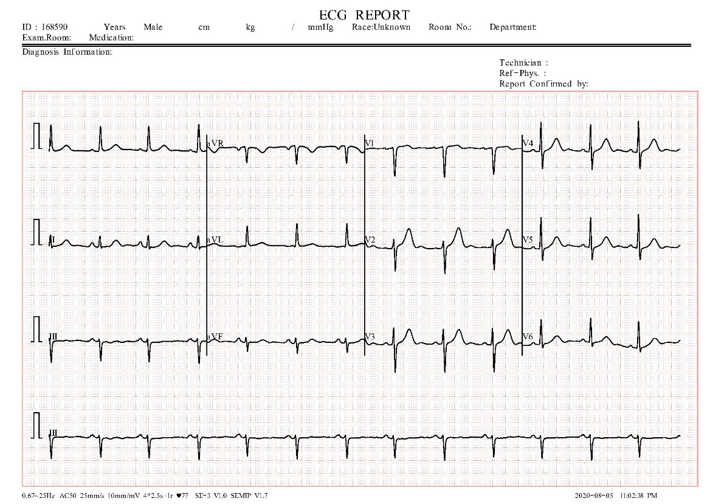
Fig. 1. ECG image for normal case

Chapter 3

3.1 Proposed Methodology
This project proposes an automated framework for detecting myocardial infarction (MI) from ECG images using deep learning and lead-level fusion analysis. Initially, ECG images are preprocessed through grayscale conversion, grid-line removal, noise reduction, resizing, and normalization to enhance signal quality. Each ECG image is then segmented into 12 individual leads to preserve important cardiac information.
The segmented lead images are divided into training, validation, and testing datasets and processed using the proposed LeadFusion-Net model. The architecture combines Convolutional Neural Networks (CNN) for spatial feature extraction and Long Short-Term Memory (LSTM) networks to capture temporal ECG patterns, while an attention mechanism highlights diagnostically important regions. Lead-wise predictions are fused to compute an MI Severity Index, and a rule-based ensemble decision improves diagnostic reliability. Model performance is evaluated using standard metrics, and Grad-CAM visualization provides interpretability by highlighting significant ECG regions influencing predictions.

3.2 Proposed Algorithm
Step 1: ECG Image Dataset Loading
1.1 Load ECG image dataset containing Normal, Myocardial Infarction (MI), and Abnormal cases.
1.2 Read the corresponding CSV file containing image labels and metadata.

Step 2: Image Pre-processing and Lead Segmentation
2.1 Image Pre-processing
2.1.1 Convert ECG images into grayscale format.
2.1.2 Remove background grid lines using OpenCV morphological operations and filtering techniques.
2.1.3 Reduce noise and enhance ECG traces for clearer waveform extraction.
2.1.4 Resize images to a fixed dimension suitable for model input.
2.1.5 Normalize pixel intensity values within the range [0,1].
2.2 ECG Lead Segmentation
2.2.1 Detect individual ECG lead regions using bounding box localization.
2.2.2 Segment each ECG image into 12 individual leads.
2.2.3 Store lead-wise segmented images for further analysis.

Step 3: LeadFusion-Net Model for Classification
3.1 Dataset Preparation
3.1.1 Split dataset into Training (80%), Validation (10%), and Testing (10%).
3.1.2 Encode labels into three classes: Normal, MI, and Abnormal.

3.2 LeadFusion-Net Architecture
3.2.1 Input Layer: Preprocessed ECG lead image.
3.2.2 CNN Feature Extraction (Spatial Learning)
- Multiple Conv2D layers with ReLU activation
- Max-Pooling layers for dimensionality reduction
- Extraction of spatial waveform features such as P wave, QRS complex, and T wave.
3.2.3 Feature Reshaping
- Convert CNN feature maps into sequential format.
3.2.4 LSTM Layer (Temporal Learning)
- LSTM learns sequential dependencies and temporal relationships within ECG signals.
3.2.5 Attention Layer
- Assigns higher weights to diagnostically important leads and waveform regions.
3.2.6 Classification Layer
- Dense layer with Softmax activation for multi-class prediction.
3.2.7 Loss Function: Focal Loss (handles class imbalance).
3.2.8 Optimizer: Adam optimizer.

3.3 Model Training and Evaluation
3.3.1 Train the model for multiple epochs using batch training.
3.3.2 Evaluate performance using Accuracy, Precision, Recall, and F1-Score.
3.3.3 Validate performance using unseen ECG test samples.
3.3.4 Generate confusion matrix for classification analysis.

Step 4: Lead Fusion and Severity Analysis
4.1 Lead-Wise Prediction Fusion
4.1.1 Generate predictions for all 12 ECG leads individually.
4.1.2 Combine lead outputs to form a prediction matrix.

4.2 MI Severity Index Calculation
4.2.1 Count total leads classified as MI.
4.2.2 Compute MI Severity Index:
$$\text{MI Severity Index}=\frac{\text{MI Leads}}{12}×100$$
4.2.3 Severity Levels:
- 0–25% → Mild
- 26–50% → Moderate
- 50% → Severe

4.3 Ensemble Decision Strategy
4.3.1 Apply rule-based logic: if ≥ 4 leads indicate MI, classify as MI likely.
4.3.2 Combine deep learning prediction and rule logic using weighted fusion:
$$\text{Final Output}=0.7×\text{DL Model}+0.3×\text{Rule Decision}$$

Step 5: Explainable AI Visualization
5.1 Apply Grad-CAM to generate heatmaps.
5.2 Highlight important ECG regions influencing model decisions.

Step 6: Final Output
- Predicted Class (Normal / MI / Abnormal)
- Confidence Score
- MI Severity Level
- Grad-CAM Visualization

3.3 About Data Set
The dataset utilized in this study consists of ECG reports representing Normal, Myocardial Infarction (MI), and Abnormal cardiac conditions, where each report includes the standard 12-lead configuration (Leads I, II, III, aVR, aVL, aVF, and V1–V6). To prepare the data for automated analysis, all ECG images underwent a preprocessing pipeline designed to enhance signal quality. This included grid-line removal, noise suppression, and waveform enhancement using OpenCV-based image processing techniques to improve the visibility of clinically relevant ECG patterns.
Following preprocessing, each ECG report was segmented into its corresponding 12 individual leads, enabling lead-wise analysis consistent with clinical diagnostic practice. The segmented lead images were resized to a uniform resolution to ensure compatibility with deep learning input requirements and to maintain dataset consistency. A structured naming convention, Class(x)_lead_y.jpg, was adopted, where x denotes the ECG record index and y represents the lead number (1–12). All segmented images were manually verified and labeled to support supervised training and evaluation within the proposed LeadFusion-Net framework.
3.3.1 Dataset Normalization
During the labeling process, a subset of segmented leads was identified as clearly exhibiting myocardial infarction characteristics based on visible ECG waveform abnormalities. To ensure reliable model training and reduce class imbalance, a balanced distribution of lead samples was maintained across the dataset. Normal leads were selected from both healthy ECG reports and non-MI leads present within MI and abnormal reports. This strategy enabled the creation of a well-structured dataset suitable for supervised learning, allowing the model to effectively learn discriminative patterns among Normal, MI, and Abnormal classes while improving classification stability and generalization performance.

3.4 Data Preprocessing

3.5 Data Sgmentation
In image segmentation each ECG signal is split into 12 district leads as our research study deal with this lead individually to improve the accuracy than traditional CNN model. ECG image splitting is shown in Fig.6
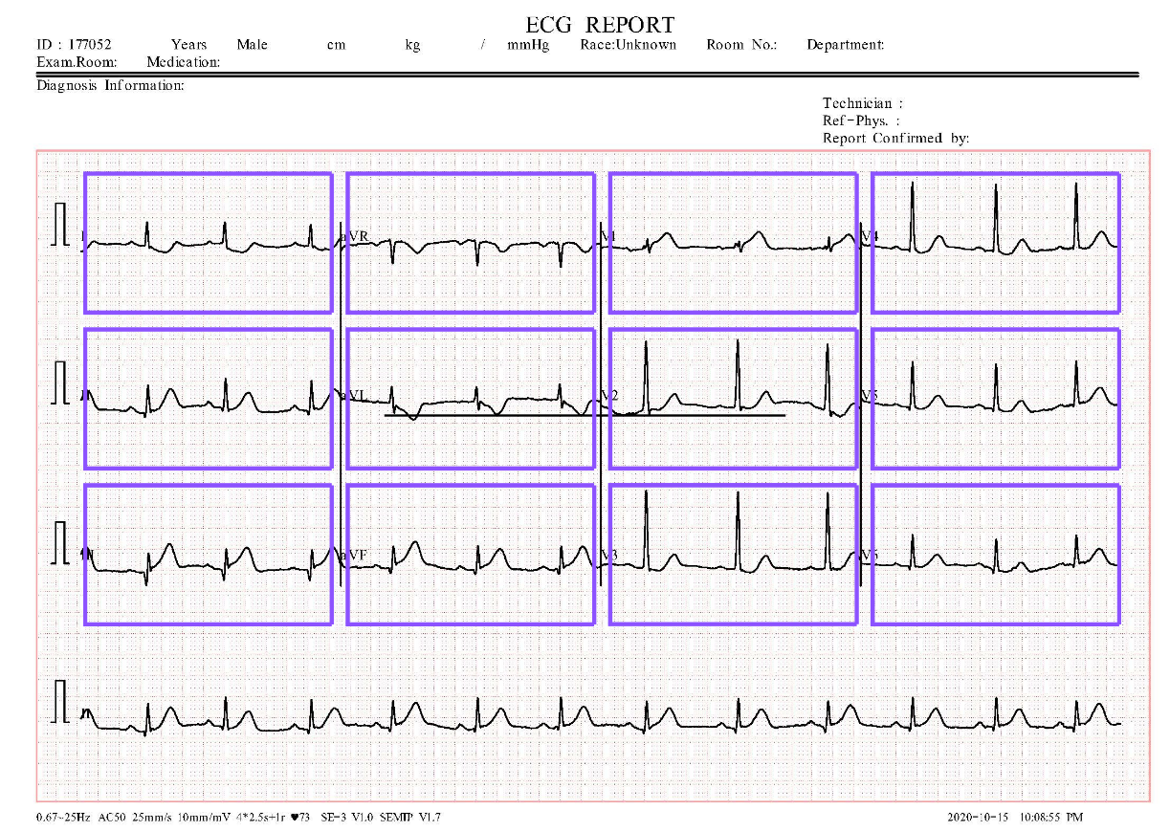
Fig. 7. Segmented ECG image

3.5 Confident Matrix for Lead Prediction

Chapter 4

4. Result and Discussions

