**COUPON HUB**

### Project Report for

**Internet and Web Technology Lab**

### Submitted by

**ANTARYAMI SAHOO (A1, 21)**

**SUBHRANSHU SAHOO (A1, 29)**

**SRUTI PANDEY (A1, 28)**

**ARUNIMA MOHAPATRA (A2, 26)**

Guided By

**Mr. Devpriya Panda**



**DEPARTMENT OF COMPUTER SCIENCE AND ENGINEERING**

**SILICON INSTITUTE OF TECHNOLOGY**

**SILICON HILLS, BHUBANESWAR – 751024, ODISHA, INDIA**

**December, 2023**

**Table of Content**

1. Abstract
2. Introduction
3. System Analysis

3.1 Objective

3.2 Scope

3.3 Functionalities of the System

3.4 Tools & Environment

3.5 Software Design Paradigm Applied

1. Technical Specification

4.1 HTML

4.2 CSS

4.3 JavaScript

4.4 JSP

4.5 Oracle/ MySQL

4.6 Apache Tomcat

1. System Design

5.1 Use Case Diagram

5.2 Flow Diagram

5.3 ERD

5.4 Table Structure/Relational Model

1. Sample Coding (Optional)
2. Implementation Screen Shot
3. Conclusion and Future Work
4. Bibliography
5. ABSTRACT

In today's digital shopping world, everyone wants to save money. That's where Coupon Hub steps in! It is like a cool club where we all share coupons to help each other save money when shopping online or in stores.

At Coupon Hub, we are all about making it easy for folks to find, share, and use coupons. Our website is super easy to use. You can add your own coupons, give them ratings about the coupon. It is like a big team effort to help everyone save!

This concerted effort fosters a collaborative space, empowering community members to make astute, well-informed decisions while navigating their purchasing journeys.

But we are not just about coupons. We are about creating a fun place where everyone can join in. You can talk to others, share tips, and learn how to make smart choices when buying stuff.

Oh, and we are always updating! So, you will always find the latest deals. Plus, we work with brands to bring you special offers just for being part of our community.

Coupon Hub is not just a place for saving money—it is a place where we all help each other shop smarter and have a blast doing it!

1. INTRODUCTION

Are you a part of the community who believes in think retail therapy! Or delas with their tough days by treating them to something nice? Or do you belong to the section where people strictly monitor their spending and getting their hands on anything which helps them save their hard-earned money? But the problem arises when you want to be a little bit of both. And if it is possible then how? Well, ‘**COUPON HUB**’ may help you discover the answer of this prevailing question! You know what they say: The first impression is the last. And to make that lasting first impression let us tell you the sole motive of our website: ‘**To optimize spending and maximize saving**’. Do not worry helping you save your money is and will always be our primary objective but along with that we also hope that this community driven platform may instil a sense of membership in you.

Users visiting our website can browse through the coupons and redeem the coupons which suits to their requirement and liking. Along with that users can also share their unused coupons on the same space. So whether you are a giver or a taker, Coupon hub is a one stop solution for your optimized online shopping spree.

Hold on now we are not done yet. The feature that makes our website more reliable and distinct is the fact that the signed in users will be able to rate and leave comments on the coupons to save other users from redeeming invalid and fake coupons and helping them make a judicious and informed decision while buying a coupon.

Still uncertain about the promises we made? No worries! As you will delve further into this report you will be getting more and more clear idea of our website, about its working, creation and the objectives it aims to achieve. So join us on the journey of creating a shared ecosystem where users can discover, share, and redeem coupons seamlessly.

3) SYSTEM ANALYSIS

* 1. Objective:

The objectives of the Coupon Hub project are centred around creating a user-friendly and collaborative coupon-sharing platform that enables users to make informed purchasing decisions, enhances community engagement, and simplifies the process of discovering and redeeming valuable discounts.

3.2 Scope:

Coupon Hub is a collaborative coupon-sharing platform which aims at providing:

1. **User friendly interface**
2. **Promote dynamic coupon sharing** where users can share as well as redeem the coupon of their interest.
3. **Encourage the sense of community** by asking users to rate and leave a comment to help the new users.
4. **Technological scope** which involves using HTML5, CSS and JavaScript for designing the front-end and using eclipse and Apache Tomcat for back-end.

3.3 Functionalities:

At Coupon Hub's website, users can effortlessly upload coupons, rate deals, and engage in lively discussions for a vibrant community experience. With powerful search tools and personalized profiles, tailored savings are just a click away. Exclusive partnerships and mobile accessibility guarantee access to unique deals on-the-go, while a savings tracker and an array of educational resources empower users to make informed and resourceful spending decisions.

* 1. Tools and Environment:

The project utilizes standard web technologies like HTML, CSS and JavaScript for Front-end development. JSP powers the backend operations, while Oracle serves as the database system, ensuring a robust and secure environment for data management. The Apache tomcat server is used to data management. The Apache tomcat server is used to host the webapp on localhost environment.

* 1. Software Design Paradigm Applied:

Our website embodies a sophisticated software design paradigm that amalgamates various methodologies for optimal functionality and user experience. Employing a component-based architecture enables us to break the site into reusable elements, ensuring streamlined development and simplified updates. Through the Model-View-Controller (MVC) pattern, we compartmentalize data, presentation, and logic, enhancing code organization and system manageability.

Leveraging a microservices architecture enhances scalability and fault isolation, while a user-centric design approach ensures the site is intuitive and responsive to user preferences. This integrated paradigm forms the backbone of our website, ensuring robustness, scalability, and a superior user experience.

4) TECHNICAL SPECIFICATION:

4.1. HTML:

The Hyper Text Markup Language or HTML is the standard [markup language](https://en.wikipedia.org/wiki/Markup_language) for documents designed to be displayed in a [web browser](https://en.wikipedia.org/wiki/Web_browser). It defines the content and structure of [web content](https://en.wikipedia.org/wiki/Web_content). [Web browsers](https://en.wikipedia.org/wiki/Web_browser) receive HTML documents from a [web server](https://en.wikipedia.org/wiki/Web_server) or from local storage and [render](https://en.wikipedia.org/wiki/Browser_engine) the documents into multimedia web pages. HTML describes the structure of a [web page](https://en.wikipedia.org/wiki/Web_page) [semantically](https://en.wikipedia.org/wiki/Semantic_Web) and originally included cues for its appearance.

4.2. CSS:

Cascading Style Sheets (CSS) is a [style sheet language](https://en.wikipedia.org/wiki/Style_sheet_language) used for specifying the [presentation](https://en.wikipedia.org/wiki/Presentation_semantics) and styling of a document written in a [markup language](https://en.wikipedia.org/wiki/Markup_language) such as [HTML](https://en.wikipedia.org/wiki/HTML) . CSS is designed to enable the [separation of content and presentation](https://en.wikipedia.org/wiki/Separation_of_content_and_presentation), including [layout](https://en.wikipedia.org/wiki/Page_layout), [colors](https://en.wikipedia.org/wiki/Color" \o "Color), and [fonts](https://en.wikipedia.org/wiki/Typeface). This separation can improve content [accessibility](https://en.wikipedia.org/wiki/Accessibility); provide more flexibility and control in the specification of presentation characteristics; enable multiple [web pages](https://en.wikipedia.org/wiki/Web_page) to share formatting by specifying the relevant CSS in a separate .css file, which reduces complexity and repetition in the structural content; and enable the .css file to be [cached](https://en.wikipedia.org/wiki/Cache_(computing)) to improve the page load speed between the pages that share the file and its formatting.

* 1. . JavaScript:

JavaScript, often abbreviated as JS, is a [programming language](https://en.wikipedia.org/wiki/Programming_language) and core technology of the [World Wide Web](https://en.wikipedia.org/wiki/World_Wide_Web), alongside [HTML](https://en.wikipedia.org/wiki/HTML) and [CSS](https://en.wikipedia.org/wiki/CSS). JavaScript is a [high-level](https://en.wikipedia.org/wiki/High-level_programming_language), often [just-in-time compiled](https://en.wikipedia.org/wiki/Just-in-time_compilation) language that conforms to the [ECMAScript](https://en.wikipedia.org/wiki/ECMAScript) standard. It has [dynamic typing](https://en.wikipedia.org/wiki/Dynamic_typing), [prototype-based](https://en.wikipedia.org/wiki/Prototype-based_programming) [object-orientation](https://en.wikipedia.org/wiki/Object-oriented_programming), and [first-class functions](https://en.wikipedia.org/wiki/First-class_function). It is [multi-paradigm](https://en.wikipedia.org/wiki/Programming_paradigm), supporting [event-driven](https://en.wikipedia.org/wiki/Event-driven_programming), [functional](https://en.wikipedia.org/wiki/Functional_programming), and [imperative](https://en.wikipedia.org/wiki/Imperative_programming) [programming styles](https://en.wikipedia.org/wiki/Programming_paradigm). It has [application programming interfaces](https://en.wikipedia.org/wiki/Application_programming_interface) (APIs) for working with text, dates, [regular expressions](https://en.wikipedia.org/wiki/Regular_expression), standard [data structures](https://en.wikipedia.org/wiki/Data_structure), and the [Document Object Model](https://en.wikipedia.org/wiki/Document_Object_Model) (DOM).

* 1. . JSP:

In Java, **JSP** stands for **Java Server Pages**. It is a server-side technology which is used for creating web applications. It is used to create dynamic web content. JSP consists of both HTML tags and JSP tags. In this, JSP tags are used to insert JAVA code into HTML pages. It is an advanced version of **Servlet**Technology i.e. a web-based technology that helps us to create dynamic and platform-independent web pages. In this, Java code can be inserted in HTML/ XML pages or both. JSP is first converted into a servlet by the JSP container before processing the client’s request. JSP has various features like JSP Expressions, JSP tags, JSP Expression Language, etc.

* 1. . Oracle:

In the development and execution of the Coupon Hub project, Oracle Database serves as a vital component in managing and organizing data efficiently. The utilization of Oracle enhances the reliability, scalability, and performance of the system's data storage and retrieval processes. Oracle Database is employed to securely store and manage data relevant to the Coupon Hub platform. This includes information about coupons, user accounts, and other essential aspects. of the application.

5) SYSTEM DESIGN

5.1. Use-Case Diagram

ADMINNN

Approve Coupons

View User Details

View Coupons

Share Coupons

Redeem Coupon

User Login

USER

5.2. Flow Diagram



COUPON HUB

SIGNUP

LOGIN

NO

YES

Validate

View Coupons

Redeem Coupon

Contribute Coupon

LOGOUT

5.3. ER Diagram



**Coupons**

**Shares**

**Orders**

**USERS**

5.4. Table Structure

USERS

USER-ID

Id

PHONE-NO

NAME

ORDERS

OID CID USER_ID CREATED_AT

CID UID CODE ORG TYPE TITLE PRICE EDATE PHOTO TC STATUS

COUPONS

PASSWORD

EMAIL

6) Sample Coding

connection.jsp

*<%@ page language="java" contentType="text/html; charset=ISO-8859-1"*

*pageEncoding="ISO-8859-1" import="java.sql.*"%>*

*<!DOCTYPE html>*

*<html><body>*

*<%!*

*Connection con = null;*

*Statement smt = null;*

*Statement smt1 = null;*

*ResultSet rs = null;*

*public void jspInit() {*

*try {*

*Class.forName("oracle.jdbc.driver.OracleDriver");*

*con = DriverManager.getConnection("jdbc:oracle:thin:@localhost:1521:xe", "system", "123456");*

*smt = con.createStatement(ResultSet.TYPE_SCROLL_INSENSITIVE, ResultSet.CONCUR_READ_ONLY);*

*smt1 = con.createStatement(ResultSet.TYPE_SCROLL_INSENSITIVE, ResultSet.CONCUR_READ_ONLY);*

*} catch (Exception ee) {*

*ee.printStackTrace();*

*}*

*}*

*public void jspDestroy() {*

*try {*

*smt.close();*

*smt1.close();*

*con.close();*

*} catch (Exception ee) {*

*ee.printStackTrace();*

*}*

*}%>*

*</body></html>*

coupons.jsp

*<%@ page language="java" contentType="text/html; charset=ISO-8859-1"*

*pageEncoding="ISO-8859-1"%>*

*<!DOCTYPE html>*

*<%@ include file = "conn.jsp" %>*

*<%*

*String qry = "select * from Coupons where status=1";*

*System.out.println(qry);*

*rs = smt.executeQuery(qry);*

*%>*

*<%@ include file = "header.jsp" %>*

*<html lang="en">*

*<head>*

*<meta charset="UTF-8" />*

*<meta name="viewport" content="width=device-width, initial-scale=1.0" />*

*<title>Coupon Cards</title>*

*<link rel="stylesheet" href="styles/card.css" />*

*</head>*

*<body>*

*<div class="main">*

*<%*

*while(rs.next())*

*{*

*%>*

*<a href="checkOut.jsp?id=<%=rs.getLong("cid")%>">*

*<div class="cards">*

*<div class="image">*

*<img src="photo/<%=rs.getString("photo")%>" alt="" />*

*</div>*

*<div class="title">*

*<h2><%=rs.getString("title")%></h2>*

*</div>*

*<div class="desc">*

*<p><%=rs.getString("tc")%></p>*

*</div>*

*</div>*

*</a>*

*<%*

*}*

*%>*

*</div>*

*<%@ include file = "footer.jsp" %>*

*</body>*

*</html>*

7) Implementation Screenshot

Home Page-

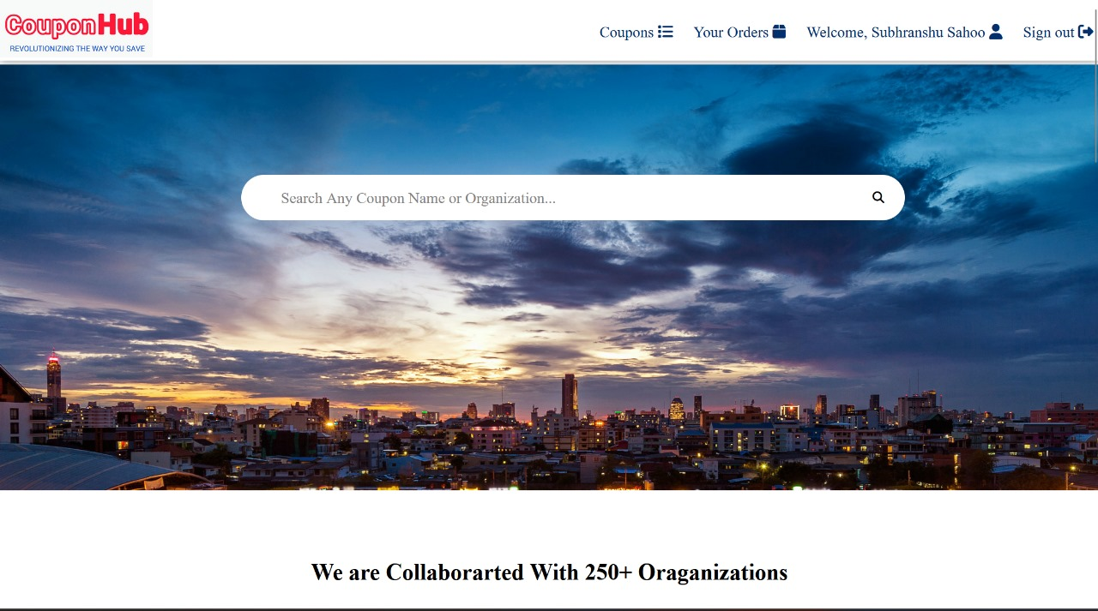

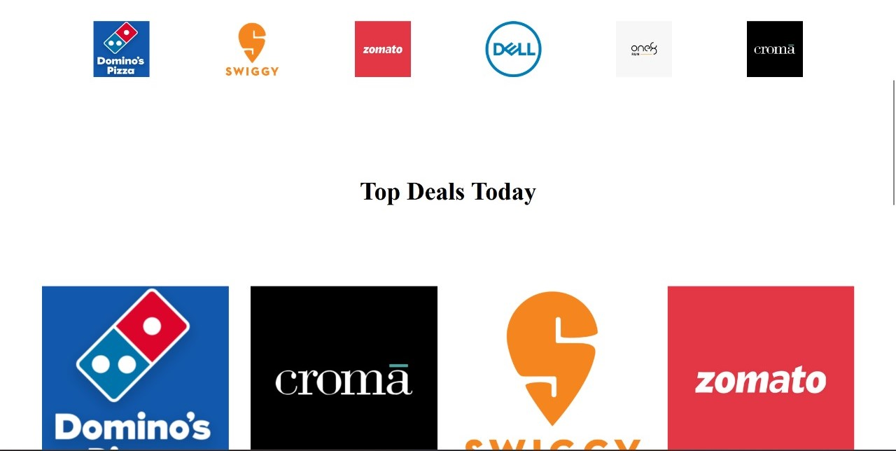

Sign Up Page-

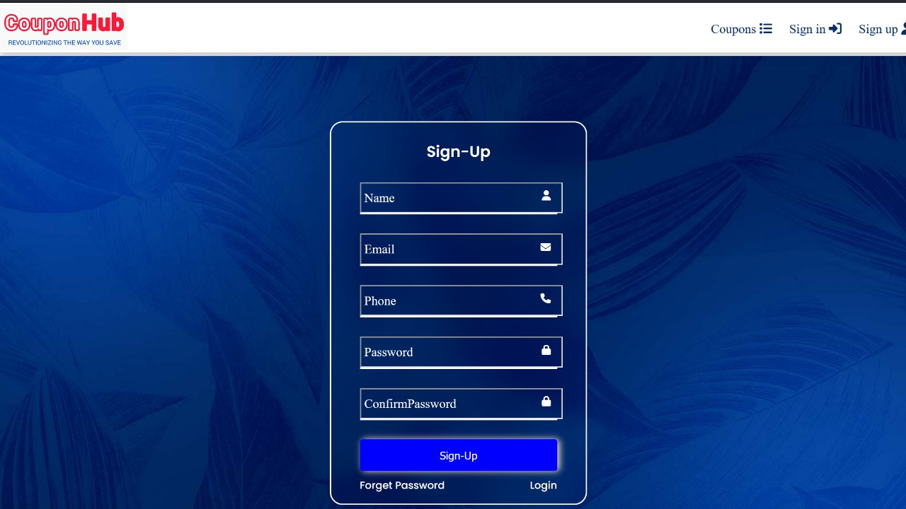

Coupon Form-

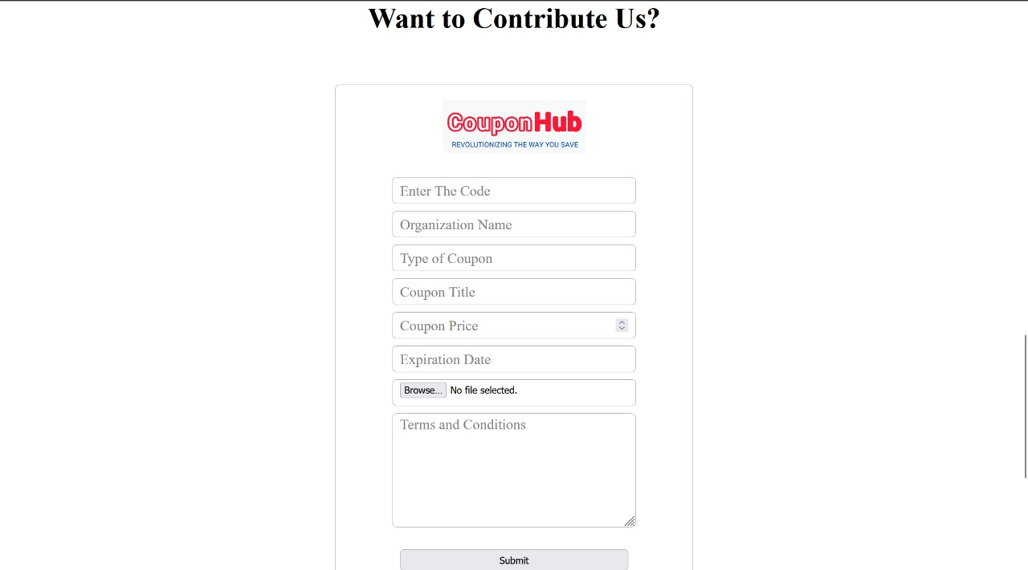

Order-

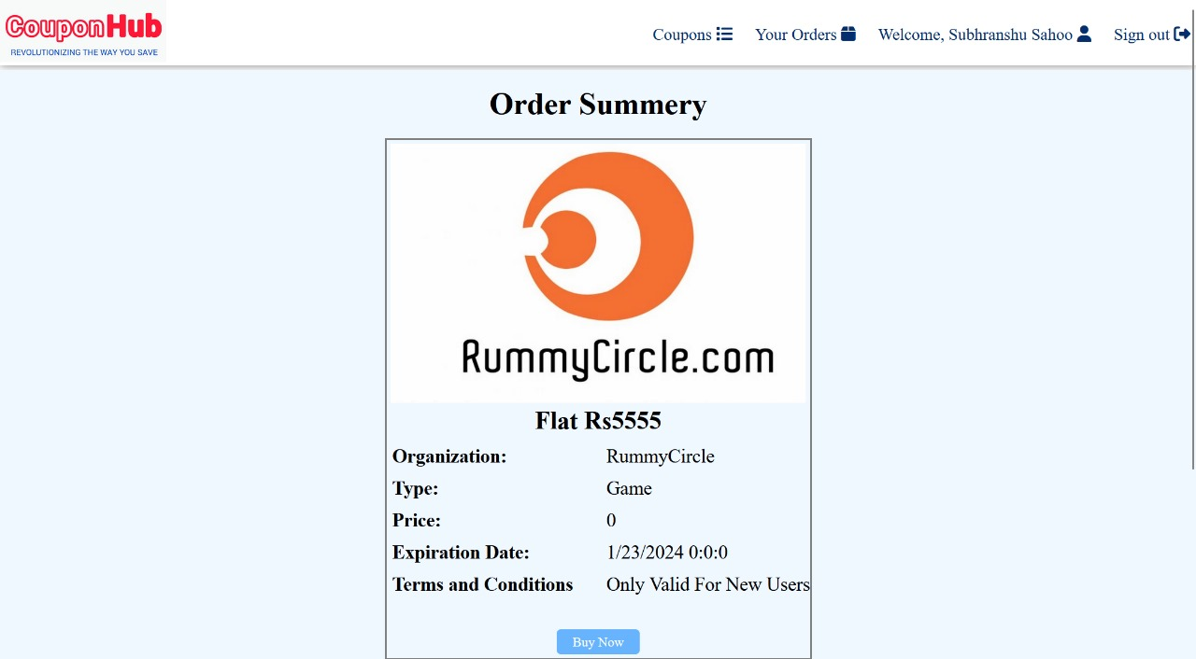

History-

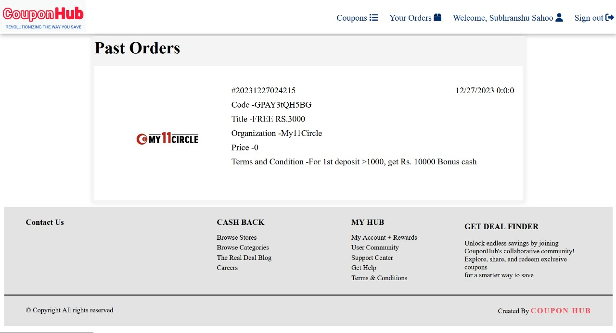

8) Conclusion:

In conclusion, our website embodies a thoughtful fusion of smart design techniques aimed at delivering an exceptional user experience. We are always ready to evolve and grow with your needs, ensuring we are constantly improving. Our dedication to making things user-friendly drives us to keep refining and adding features, all to make your time on our website enjoyable and hassle-free. Your satisfaction remains our top priority, and we will continue striving to offer you the best online experience possible!

Future Work:

Looking ahead, our website is poised for exciting developments to elevate your experience. We are planning to introduce a chat section where users can interact, share tips, and exchange coupons seamlessly, fostering a vibrant community spirit. Additionally, we aim to launch a segmented coupon system, offering both free and premium coupons, catering to various user preferences and needs.

Moreover, we are exploring collaborations with prominent payment platforms like Google Pay, PhonePe, and Paytm to facilitate secure coupon purchases, enhancing convenience and trust in transactions. Our strategic partnerships with leading brands such as Nike and Adidas are in the pipeline, enabling us to offer exclusive deals and discounts directly from these companies. This collaboration not only benefits users with enticing offers but also supports these brands in boosting their sales.

The future of our website is centered around enhancing user interaction, offering diverse coupon options, and forging strong partnerships with trusted brands and payment platforms. Through these initiatives, we aim to create a more engaging, secure, and value-driven platform for our users while fostering growth and success for our partner brands.

9) BIBLIOGRAPHY:

**Website:**

w3schools: <https://www.w3schools.com/>

Stack Overflow: <https://stackoverflow.com/>

**Documentation:**

MDN Web Docs: <https://developer.mozilla.org/en-US/>

Oracle Basics(<https://docs.oracle.com/>)

**Book:**

Tomcat- A Minimalistic User’s Guide