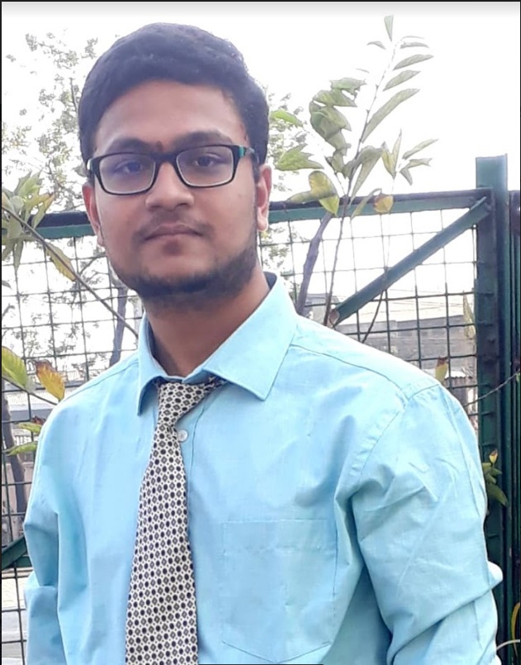

**Achievements**

* JEE Advanced – All India Rank: 5556 (2022)
* JEE Mains – All India Rank: 12943 (2022)
* West Bengal JEE – Rank: 843 (2022)
* Jagadish Bose National Science Talent Search (JBNSTS) Scholarship for 2021-22.
* Google's Machine Learning Crash course with Tensorflow APIs
* IBM Quantum Challenge: Spring 2023

|  |  |  |
| --- | --- | --- |
| **Subhranil Nandy** | **Email** | iamsubhranil.nandy@gmail.com |
| **Phone** | 91-9123771737 |
| **Address** | 50A/2, R.K.Street, Uttarpara, Hooghly, PIN-712258 |

|  |  |
| --- | --- |
|  | https://www.linkedin.com/in/subhranil-nandy-23817b253/ |
|  | https://github.com/iamsubhra |



**Education**

* Studying B.Tech IT 2nd Year 3rd Semester (1st Sem SGPA-8.5, 2nd Sem SGPA-9.7).
* ISC (Physics, Chemistry, Mathematics, Computer Science and English) (12th Standard) – 96.5% (2022)
* ICSE (10th Standard) – 96.6% (2020)

**Other Details**

**Strengths:**

Hardworking, Punctual and Result Oriented.

**Date of Birth:**

2nd January 2004

**Languages Known:**

English (Written & Spoken)

Hindi (Written & Spoken)

Bengali (Written & Spoken)

**Marital Status:**

Unmarried

**Extracurricular:**

Synthesizer Rendition, Singing and Swimming