Lab 5: Data Visualisation with Python
Updated lab using Matplotlib, Pandas and optional Plotly

Before you start
Create a new folder for this practical. Save the supplied CSV file as company_sales_data.csv in the same folder as your notebook or Python file. Use the explicit Matplotlib Axes approach for the main exercises: fig, ax = plt.subplots().

Task 1: Load and inspect the data
Read the CSV file using Pandas. Display the first five rows, the column names and summary statistics as shown below. Briefly state what each row represents.
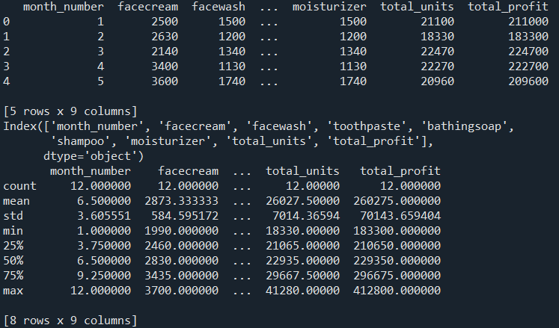

Task 2: Total profit line chart
Create a line chart showing total profit across months. Include a meaningful title, axis labels, marker points, a light grid, and a readable figure size, as seen below. Save the chart as profit_by_month.png.
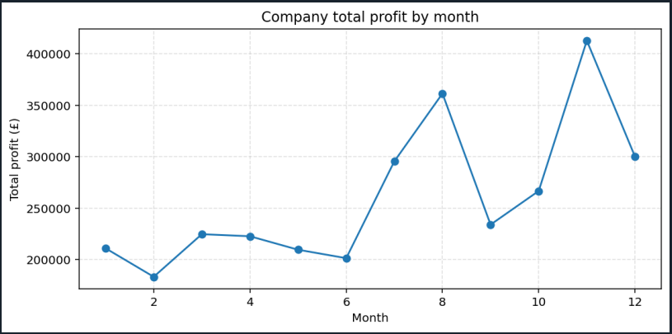

Task 3: Product comparison using a bar chart
For month 10, compare sales of facecream, facewash, toothpaste, bathingsoap, shampoo and moisturizer. Choose a vertical or horizontal bar chart and justify your choice in a comment or markdown cell.

Task 4: Multiple series line chart
Plot monthly sales for at least three products on the same axes. Add a legend using readable location names such as loc="best" or loc="upper left".

Task 5: Histogram - understanding distributions and bins
Generate 100 reproducible numerical values and create histograms using 5, 10 and 20 bins. Compare how the choice of bins changes the appearance of the distribution.
- Create a histogram with 10 bins.
- Create a second histogram with 5 bins or 20 bins.
- Label the x-axis Value and the y-axis Frequency.
- Compare how the choice of bins changes what you see.

Task 6: Box plot - compare distributions
Create box plots for the monthly sales of toothpaste, shampoo and bathingsoap. Label the three boxes clearly. Compare their medians and spread in two or three sentences.
Use figsize=(8, 4).

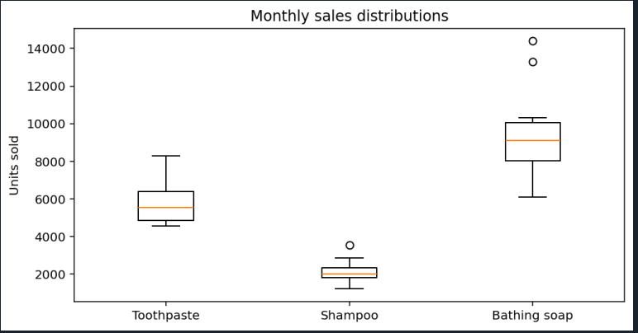

Task 7: Relationship between two products
Create a scatter plot comparing toothpaste and bathing soap sales. Use colour to encode month number and add a colour bar. Write one sentence interpreting the plot.
figsize=(7, 4).
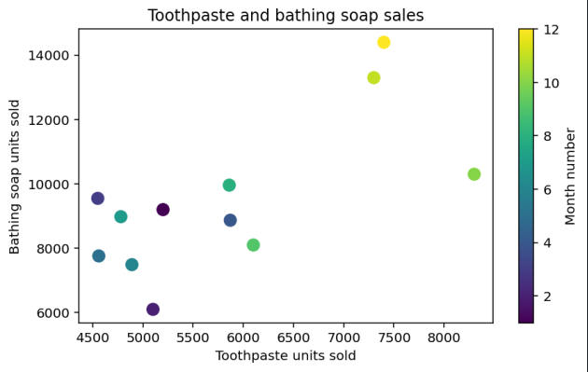

Task 8: Subplots - two related views
Create a figure with two subplots side by side. In the first, plot total profit by month. In the second, plot toothpaste sales by month. Give each subplot its own title and axis labels, use a readable figure size, and call fig.tight_layout(). In a short note, explain one advantage of viewing these two related time patterns side by side.
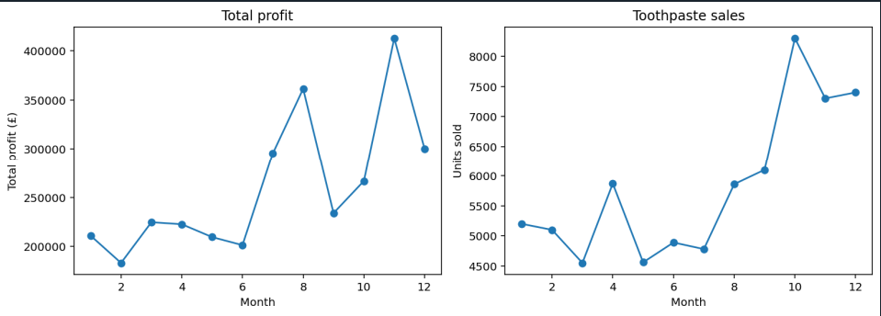

Task 9: Error bars and uncertainty
Using the following values, create a bar chart with error bars representing one standard deviation. Your y-axis label or caption must state what the error bars mean. Use yerr=sd and capsize=5. The error bars represent ±1 standard deviation.
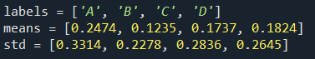
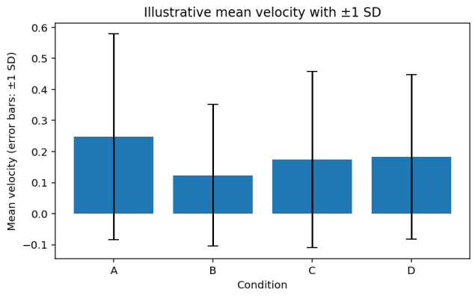
Answer: How would the meaning of the error bars change if the supplied values represented standard errors or 95% confidence intervals rather than standard deviations??

Task 10: Pie chart – choosing and using proportions
Using the sales data for one selected month, calculate the sales of the six products as parts of that month's total product sales.
Create a pie chart using:
- meaningful labels;
- autopct;
- startangle;
- explode to highlight one slice.
Reflection/check
Would a pie chart or a bar chart make it easier to compare the exact product sales? Briefly justify your answer.

Task 11: Dates and time-series plotting
Create a time-series line chart using Python date values and format the date labels.
- Plot the values against the dates.
- Format major date labels using mdates.DateFormatter("%b %Y").
- Use fig.autofmt_xdate() to improve label positioning.
- Add title and axis labels.
Starter data/code
import datetime
import matplotlib.dates as mdates
import matplotlib.pyplot as plt
dates = [
datetime.date(2026, 1, 10),
datetime.date(2026, 2, 10),
datetime.date(2026, 3, 10),
datetime.date(2026, 4, 10)
]
values = [12, 18, 15, 21]

Reflection/check
What does DateFormatter control?
What does fig.autofmt_xdate() change?

Task 12: Grouped box plots with a Pandas DataFrame
Create a long-format DataFrame containing a group column and a numerical value column, then make grouped box plots.
- Use df.boxplot(column="Value", by="Group", grid=False).
- Add your own title and axis labels.
- Use plt.suptitle("") if you want to remove the automatic overall title produced by grouped DataFrame.boxplot().
Starter data/code
import numpy as np
import pandas as pd
import matplotlib.pyplot as plt
rng = np.random.default_rng(42)
data = {
"Group": ["Group 1"] * 100 + ["Group 2"] * 100 + ["Group 3"] * 100,
"Value": np.concatenate([
rng.normal(50, 10, 100),
rng.normal(65, 12, 100),
rng.normal(55, 15, 100)
])
}
df = pd.DataFrame(data)

Reflection / check
What does column="Value" specify?
What does by="Group" specify?

Task 13: Optional challenge – inset Axes

Using any one of your earlier plots:
- create a main Axes;
- add an inset using ax.inset_axes();
- display a related or zoomed view in the inset;
- Briefly explain why the inset adds useful information.

Task 14: Grouped and stacked bar exercise if time allows
Create a grouped bar chart comparing toothpaste, shampoo and bathingsoap sales for months 1–4. Then create a stacked version.
Which version makes individual product comparisons easier, and which better emphasises the combined total?

