Team Application Exercises (tAPP-2)
Week 2: Repetition, Functions, Variable Management and Data Structures
Instructions: Work on Problem 1 individually first and apply the concepts from the pre-reading material. Then discuss your solution with your team and agree on one team answer. Follow the same process for the remaining problems. Swap one selected team solution with another team for feedback. Problem 5 may be used as an extra problem if time is limited.

Problem 1 - Parsons Puzzle: Repetition
The program below should ask the user to enter a message and repeat that message the number of times requested. It should then ask for another message and continue until the user enters a blank message. The six lines are not in the correct order. Enter the numbers 1-6 to show the correct order.
n = int(input("How many times should it be repeated? "))
for i in range(n):
print(message)
while message != "":
message = input("Enter a message (blank to quit): ")
message = input("Enter another message (blank to quit): ")

Problem 2 - Parsons Puzzle: Palindrome
The program below determines whether a string entered by the user is a palindrome. A palindrome reads the same forwards and backwards. The eleven lines are not in the correct order. Enter the numbers 1-11 to show the correct order. The first line has already been identified.
 | is_palindrome = False
 | if is_palindrome:
 | else:
 | i = 0
 | if line[i] != line[len(line) - i - 1]:
1 | line = input("Enter a string: ")
 | print(line, "is not a palindrome")
 | i = i + 1
 | is_palindrome = True
 | while i < len(line) // 2 and is_palindrome:
 | print(line, "is a palindrome")

Problem 3 - Parsons Puzzle: Functions and a Tuple
When the program runs, it should ask for the user's name and age. The get_data() function returns both values in a tuple. The message() function should display "Hi" followed by the name when age is 10 or below; otherwise it should display "Hello" followed by the name. The program must actually run when executed. Rearrange the fourteen lines into the correct order. The first line has already been identified.
 | def main():
 | if age <= 10:
 | return data_tuple
 | print("Hi", username)
 | username = input("Enter your user name: ")
 | message(username, age)
1 | def get_data():
 | def message(username, age):
 | age = int(input("Enter your age: "))
 | data_tuple = (username, age)
 | username, age = get_data()
 | print("Hello", username)
 | else:
 | main()

Problem 4 - Debugging Code
The program below should display a menu, generate an addition or subtraction question, collect the user's answer, and display whether the answer is correct. However, the code contains errors.
Identify the lines that contain errors. For each error, state what is wrong and write the corrected line. Count only errors that prevent the program from running correctly or cause it to produce incorrect behaviour.

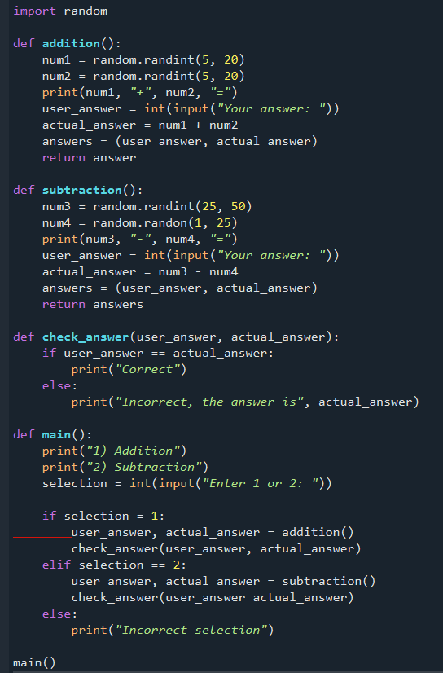

Problem 5 - Complete a Function (Extra Problem)
This program asks the user to choose a low and high number, generates a random number between them and stores it in comp_num. The user then makes a first guess.
Complete check_answer(comp_num, guess). If the guess is correct, display "Correct, you win". Otherwise, keep asking until the user guesses correctly. After each incorrect guess, tell the user whether the guess was too low or too high. Use a variable called try_again for the new guess. Use correct indentation.

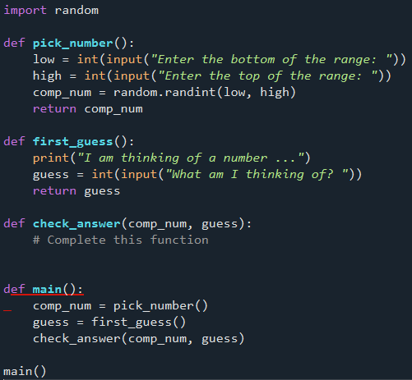

Problem 6 - Side Effects and Data Structures
Both versions below are intended to add a score to a list. Read the code carefully, then answer the questions.
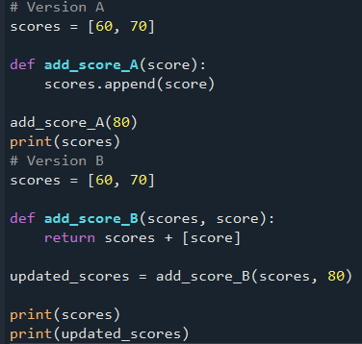

a) What does Version A print?
b) What does Version B print on each of its two print() lines?
c) Which version modifies the original list outside the function?
d) Which version avoids that side effect by returning a new list?
e) As a team, explain why Version B may be easier to reason about and test.

