tAPP 5: Data Visualisation

Team instructions: Attempt the questions alone. Then discuss each task as a team and agree on one answer. Be prepared to justify your choice. Focus on chart selection, interpretation, debugging and visualisation decisions rather than simply recalling syntax.
Task 1 — Choose the most appropriate chart
Match each scenario to the most appropriate chart type. Give one sentence explaining each choice.
Scenario | Dataset / question
A | Monthly attendance figures for a class over 12 months
B | Number of students enrolled in five degree programmes
C | Distribution of marks for 200 students
D | Relationship between hours studied and assessment mark

1. Bar chart
2. Histogram
3. Line chart
4. Scatter plot
Team justification: Why is each chart appropriate for the question being asked?
Task 2 — Bar chart or histogram?
You have the individual marks of 150 students and want to show how the marks are distributed across ranges such as 0–39, 40–49, 50–59, 60–69 and 70+. Which visualisation is most appropriate?

A. Bar chart
B. Histogram
C. Pie chart
D. Scatter plot
Task 3 — Identify the problem in the code
A student writes the following code:

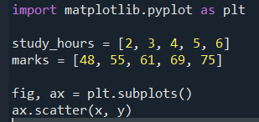

A. scatter() cannot be used with numerical data
B. x and y have not been defined
C. set_xlabel() and set_ylabel() cannot be used with scatter plots
D. plt.show() must appear before the scatter plot
Team follow-up: Rewrite the incorrect line so the code works.

Task 4 — Pie chart judgement
A university wants to compare the number of students enrolled in 12 different degree programmes. A student proposes a pie chart. Which is the best response?
A. A pie chart is ideal because it can display any number of categories
B. A pie chart is suitable because all categories are numerical
C. A bar chart would probably be clearer because there are many categories and precise comparison matters
D. A scatter plot would be better because each programme is a separate observation

Task 5 — What do these error bars mean?
A student creates the following chart but does not explain what errors it contains:
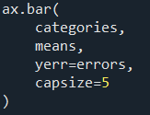

A. The error bars must represent standard deviation
B. The error bars must represent standard error
C. The error bars automatically represent 95% confidence intervals
D. The graph is incomplete because the reader needs to know what the error bars represent
Task 6: Grouped or stacked bars?
A company wants to compare sales of three products across five regions. Viewers should be able to compare the individual product sales within each region as accurately as possible. Which chart is preferable?

A. Grouped bar chart
B. Stacked bar chart
C. Pie chart
D. Histogram
Task 7: Multiple Axes
What layout is created by the following code?
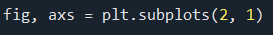

A. Two plots side by side
B. Two plots stacked vertically
C. One plot containing two lines
D. A 2 × 2 grid
Team follow-up: What changes if the code is fig, axs = plt.subplots(1, 2)?

Task 8: Legend location
Which of the following places the legend in the upper-left corner?
A. ax.legend(loc=1)
B. ax.legend(loc=2)
C. ax.legend(loc=3)
D. ax.legend(loc=4)

Task 9
What is the purpose of the following code?

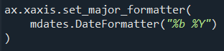

A. It converts numerical values into dates
B. It changes the way date labels are displayed
C. It sorts the dates into chronological order
D. It rotates the x-axis labels automatically
Team follow-up: What is fig.autofmt_xdate() mainly used for?

Task 10
What is the main purpose of the following code?

A. To create a second Figure
B. To place a smaller Axes inside the main Axes
C. To convert a 2D chart into a 3D chart
D. To change the axis limits of the main chart
Team follow-up: Give one reason why an inset Axes might be useful.

Task 11 — Predict the output: pie chart with explode
Consider the following code. Which description best matches the output?
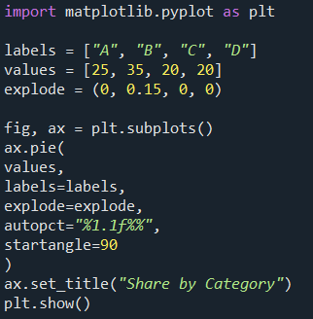

A. A four-slice pie chart in which slice B is separated from the centre and percentages are displayed
B. A four-slice pie chart in which all four slices are separated from the centre
C. A pie chart showing only category B because its explode value is non-zero
D. A bar chart with category B highlighted

Team follow-up: What would change if explode were set to (0, 0, 0, 0)?

