Explaining ECG Arrhythmia Classifiers with PermFIT Permutation Feature Importance
Group: [group name] · Case study: Explainable Machine Learning – ECG arrhythmia detection
Name | Student ID | Name | Student ID
[name] | [ID] | [name] | [ID]
[name] | [ID] | [name] | [ID]

1. Introduction
An electrocardiogram (ECG) records the electrical activity of the heart. It is the cheapest and most widely used test for arrhythmia, an abnormal heart rate or rhythm. Every heartbeat has three parts: the P-wave (the atria depolarise), the QRS complex (the ventricles depolarise) and the T-wave (the ventricles repolarise). Reading ECGs by hand is slow and error-prone: in a national cohort of about 550,000 patients, roughly one in three ECGs was misinterpreted (Wu et al., 2018). Machine learning (ML) can classify beats automatically. However, accurate models such as support vector machines (SVMs) and random forests are black boxes: they do not say why a beat was called abnormal, and this limits clinicians’ trust (Arrieta et al., 2020).
We use the MIT-BIH Arrhythmia Database (Moody and Mark, 2001): 48 half-hour, two-channel recordings from 47 subjects, annotated beat by beat by cardiologists. We classify eight beat classes: normal (N), left and right bundle branch block (L, R), premature ventricular contraction (V), atrial premature beat (A), fusion of ventricular and normal beat (F), fusion of paced and normal beat (f) and paced beat (/).
The study answers two questions:
- Predictive: how accurately do an SVM and a random forest classify the eight beat classes, and how much of that accuracy remains when the model is tested on patients it has never seen?
- Exploratory: which parts of the heartbeat do the models rely on, measured with PermFIT permutation feature importance (Mi et al., 2021)? Do the two models agree with each other and with cardiology, where most diagnostic information lies in the QRS complex?
Our hypothesis is that the slices covering the QRS complex (slices 5–7 of 11) receive the highest importance.

2. Methods

2.1 Data and preprocessing
Beats were extracted from both ECG channels with the WFDB and BioSPPy Python packages. Each beat is a 275-sample window (0.76 s at 360 Hz) centred on the detected R-peak. It is standardised to zero mean and unit variance (z-score), which removes amplitude differences between patients and leads, and labelled with the cardiologist annotation found within ±10 samples of the peak. Beats of other classes, or with no matching annotation, were removed. This left 149,768 beats; each heartbeat appears once per channel. The record number is stored with every beat, so the data can be split by patient. The data are highly imbalanced: normal beats make up 76% and fusion beats (F) only 0.5% (Figure 2).

2.2 Validation protocols and class balancing
- Beat hold-out: a random 75/25 split of all beats (112,326 training, 37,442 test). Beats from the same patient appear in both sets, so the test score can be inflated by data leakage (Jones et al., 2020).
- Patient hold-out: all beats of records 104, 113, 119, 208 and 210 are kept for testing (14,482 beats), and the other 43 records are used for training (as in Jones et al., 2020). These five patients have no L, R or A beats.
In each training set, every class is resampled with scikit-learn’s bootstrap resample (Pedregosa et al., 2011) to the mean size of the seven abnormal classes: 3,874 beats per class for beat hold-out (30,992 in total) and 4,423 per class for patient hold-out (35,384). Test sets keep the real class distribution. While integrating the code we found and fixed a bug in the provided patient-split code. It built the list of training rows once per held-out patient and joined the five copies, so the training set contained every beat about five times, including the test patients’ beats. This is why the handout reports 25,789 beats per class.

2.3 Classifiers
Support vector machine (Tasks 2–4). An SVM separates classes with the boundary that has the widest margin. With a radial basis function (RBF) kernel it compares each beat with stored support beats through a Gaussian similarity, so the boundary can curve. Two parameters control it. C is the penalty for misclassified training beats: a higher C fits the training data more tightly. gamma is the width of the similarity; scikit-learn’s default ‘scale’ sets it to 1/(275 × variance of the data). Eight classes are handled one-vs-one. For beat hold-out we use SVC(kernel=‘rbf’) with the default C = 1. For patient hold-out the same SVM is preceded by a StandardScaler, which rescales every time point to unit variance, and uses max_iter = 10,000.
Random forest (Task 5). A random forest of 300 decision trees. Each tree is trained on a bootstrap sample and, at every split, chooses among a random subset of the 275 time points; the forest predicts by majority vote. It is a useful contrast to the SVM: a tree asks threshold questions about single time points, while the RBF SVM compares the shape of the whole beat. The number of time points tried per split (max_features) and the minimum leaf size were chosen by grid search (Table 1): 3-fold stratified cross-validation on an 8,000-beat subset of the beat hold-out training data, scored by macro-F1. The test sets were never used for tuning. The SVM row is included for reference only; Section 4 discusses it.
Table 1. Grid search, 3-fold stratified cross-validation, macro-F1 (mean ± s.d.). The chosen setting is shaded.
Model | Parameters | CV macro-F1
SVM | {C: 1} | 0.928 ± 0.002
SVM | {C: 10} | 0.955 ± 0.003
SVM | {C: 100} | 0.960 ± 0.001
Random Forest | {max_features: sqrt, min_samples_leaf: 1} | 0.954 ± 0.001
Random Forest | {max_features: sqrt, min_samples_leaf: 3} | 0.950 ± 0.004
Random Forest | {max_features: 0.1, min_samples_leaf: 1} | 0.954 ± 0.001
Random Forest | {max_features: 0.1, min_samples_leaf: 3} | 0.950 ± 0.003

2.4 Evaluation metrics
We report accuracy and the per-class precision, recall and F1-score. Their macro average gives every class equal weight despite the imbalance. For patient hold-out the macro average uses only the five classes present in the test set (N, V, F, f, /), because recall is undefined for absent classes. Row-normalised confusion matrices show where the beats of each true class are assigned.

2.5 Explainability: PermFIT
Permutation feature importance measures how much a fitted model’s error increases when one input feature is destroyed. If the model relies on that feature, breaking its link with the label harms the predictions. It is model-agnostic and gives a global explanation for the whole dataset. PermFIT (Mi et al., 2021) adds K-fold cross-fitting, so every beat is scored by a model that did not see it during training. Here the features are 11 consecutive slices of 25 samples. Slices 1–4 cover the PR interval, 5–7 the QRS complex (the R-peak lies in slice 6) and 8–11 the ST segment and T-wave.
- Split the training set into K = 5 folds, stratified on the beat class.
- For each fold k, fit a new model on the other four folds.
- For every beat i in fold k and every slice j, perturb slice j and compute the importance
M̂_{ij} = Σ_{c} ( Y_{ic} − p̂_{c}(X_{i}^{(j)}) )² − Σ_{c} ( Y_{ic} − p̂_{c}(X_{i}) )²
where Y_{i} is the one-hot label of beat i, p̂(·) the predicted class probabilities and X_{i}^{(j)} the beat with slice j perturbed. A positive value means the prediction got worse.
- The importance of slice j is the mean over all beats, M̄_{j}; the spread across the five folds is shown as error bars. As instructed, variance and p-values are not estimated.
Perturbation. Following the case study, the main method randomly shuffles the 25 samples inside the slice, separately for every beat. This destroys the shape of the slice but keeps its mean and variance. As a sensitivity check we also set the slice to zero, replaced it by its own mean (a flat line), and swapped it with the same slice of another random beat (classic permutation importance). The three extra methods reuse the same fitted fold models. Probabilities. An SVM gives no probabilities, so its scores were calibrated with Platt scaling (Platt, 1999; scikit-learn’s CalibratedClassifierCV with ensemble=False), which keeps the SVM’s decision boundary. For the random forest, the probability is the fraction of tree votes. We also report the drop in accuracy (percentage points, pp) caused by perturbing each slice, which is easier to interpret. All random steps use seed 42.

3. Results

3.1 Experimental setup
Table 2. Experiments and their rationale.
Experiment | Training data | Test data | Rationale
E1 – SVM, beat hold-out (Task 2) | 30,992 beats, 48 records | 37,442 beats | Standard protocol; an optimistic upper bound because of leakage
E2 – SVM, patient hold-out (Task 3) | 35,384 beats, 43 records | 14,482 beats, 5 unseen records | Realistic test on new patients; E1 − E2 shows the leakage effect
E3 – PermFIT on the E1 and E2 SVMs (Task 4) | 5 stratified folds of each training set (≈24.8k / 6.2k and 28.3k / 7.1k beats per fold) | Held-out fold | Which parts of the beat does the SVM use?
E4 – Random forest + PermFIT, both protocols (Task 5) | As E1–E3 | As E1–E3 | Do performance and explanation depend on the classifier?
E5 – Four perturbation methods | Same fold models as E3–E4 | Held-out fold | Does the explanation depend on how a slice is destroyed?

3.2 The data
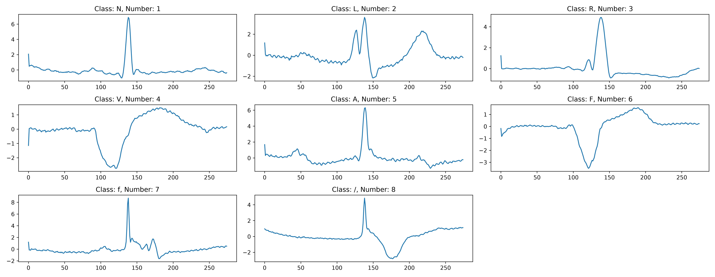
Figure 1. One preprocessed beat of each class (Task 1). Beats are 275 samples long and centred on the R-peak (sample 137). The classes differ most in the width and shape of the QRS complex.
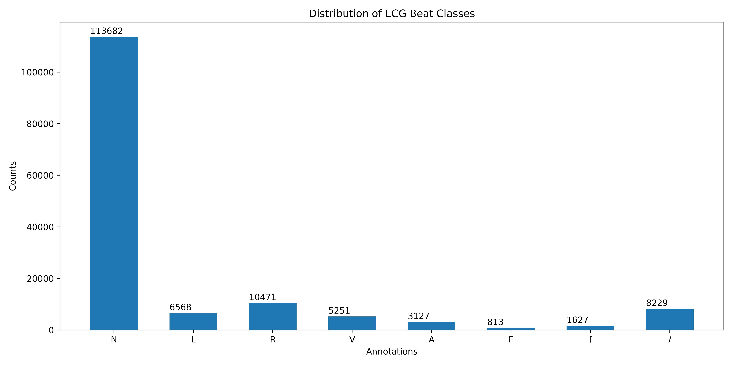
Figure 2. Beats per class in the preprocessed data (both channels). Normal beats dominate; F and f are rare.

3.3 Classification (Tasks 2, 3 and 5)
Table 3. Test-set performance. Macro scores average the classes present in the test set. The last two columns show the recall of the two fusion classes.
Model | Protocol | Accuracy | Macro precision | Macro recall | Macro F1 | Recall F | Recall f
SVM (Task 2) | Beat hold-out | 0.938 | 0.763 | 0.953 | 0.815 | 0.932 | 0.950
SVM (Task 3) | Patient hold-out | 0.866 | 0.843 | 0.692 | 0.694 | 0.452 | 0.125
Random forest | Beat hold-out | 0.968 | 0.850 | 0.954 | 0.893 | 0.890 | 0.930
Random forest | Patient hold-out | 0.836 | 0.791 | 0.581 | 0.529 | 0.003 | 0.004

On the beat hold-out, both models exceed 93% accuracy, and every class reaches a recall of at least 0.89. Precision on rare classes is low: the SVM labels 818 normal test beats as F, so the precision of F is only 0.17 (F1 = 0.29). The training data are balanced, but the test data are 76% normal, so even a small false-positive rate on N outweighs a rare class. On the patient hold-out, accuracy falls by 7.2 percentage points for the SVM (93.8% → 86.6%) and by 13.2 points for the random forest (96.8% → 83.6%). Macro-F1 falls from 0.815 to 0.694 and from 0.893 to 0.529. N, V and paced beats are still recognised well (recall ≥ 0.91, ≥ 0.97 and ≥ 0.97), but the fusion classes collapse. Figure 3 shows that unseen F beats are assigned to N and V, the two beat types they are a fusion of. Unseen f beats are scattered over almost all classes. The random forest is the better model when patients are shared between training and test, but the worse one on new patients.
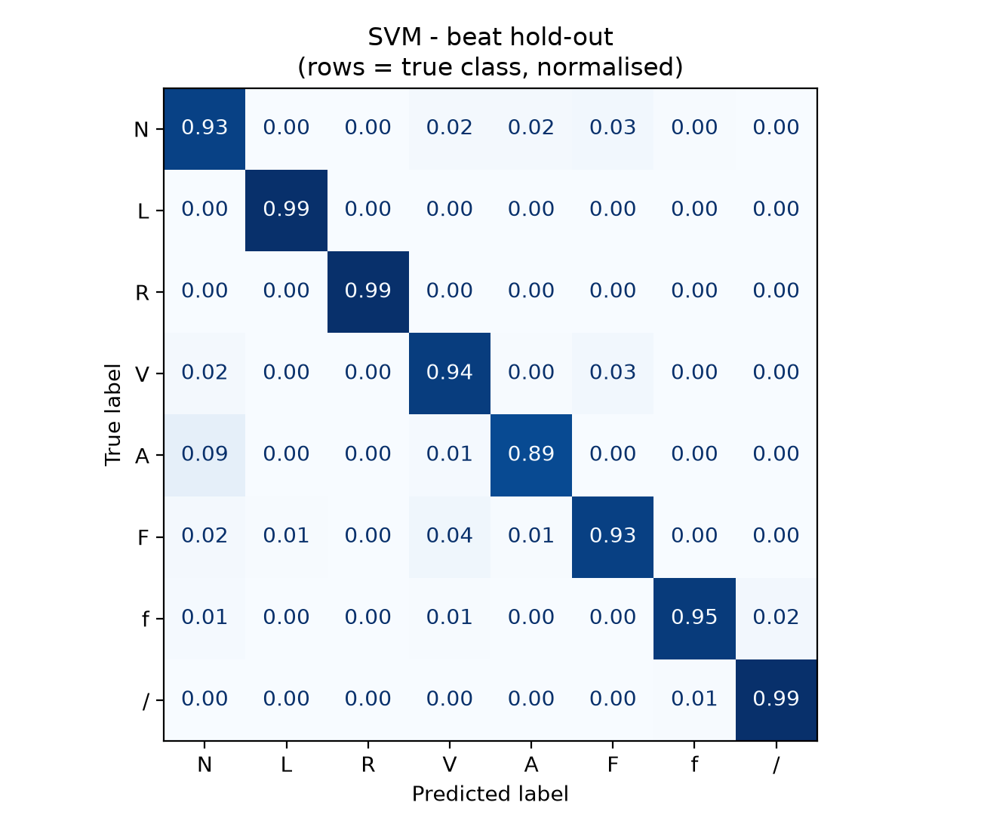 | 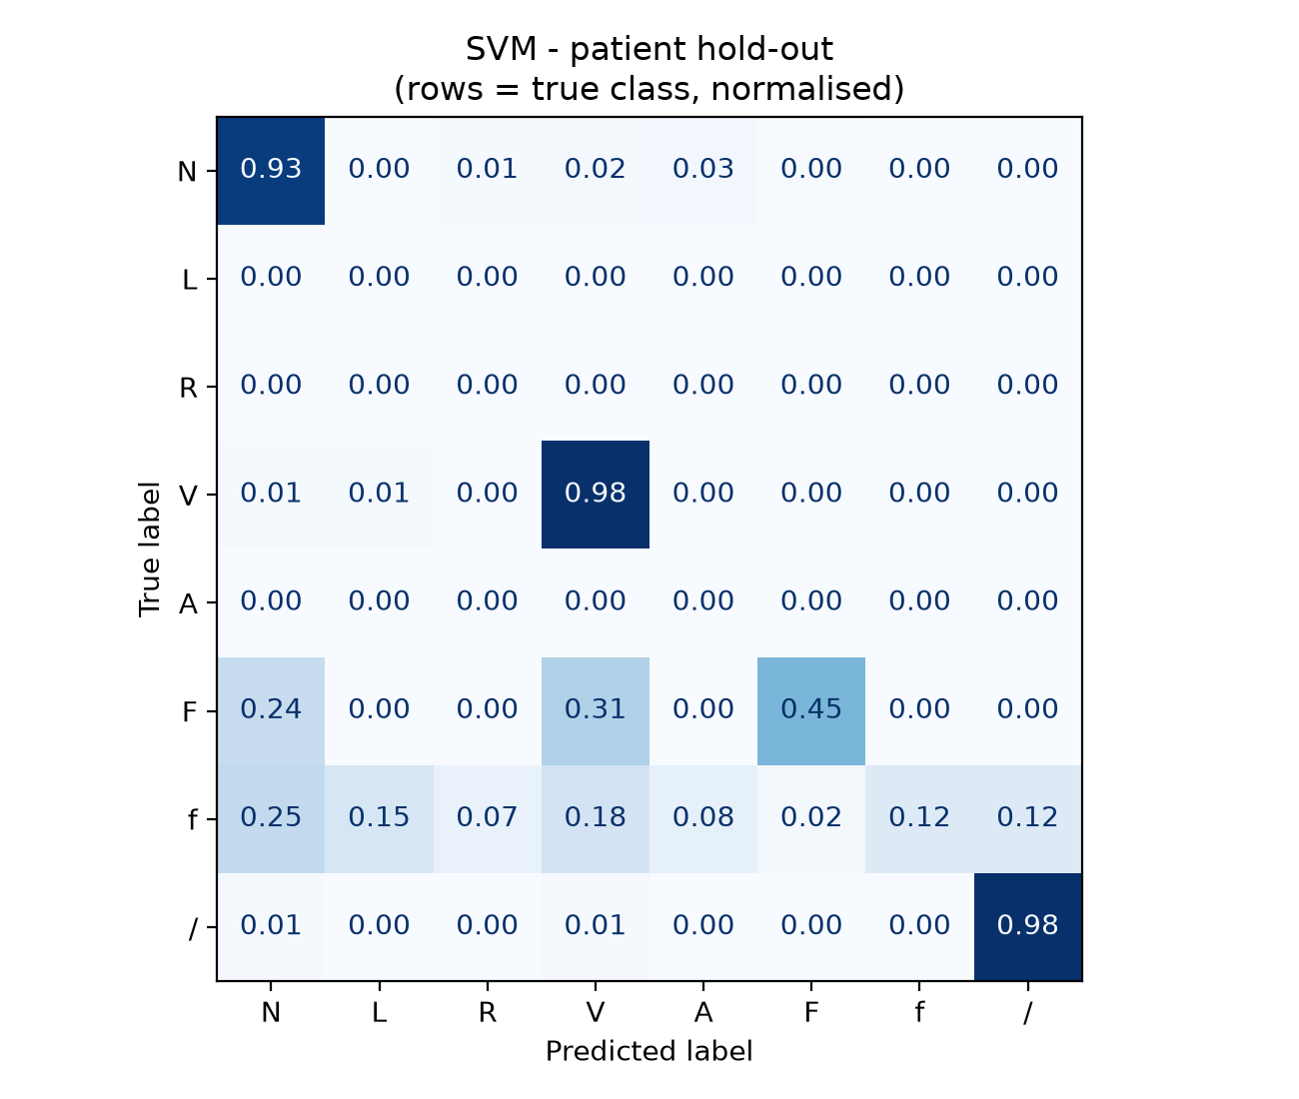
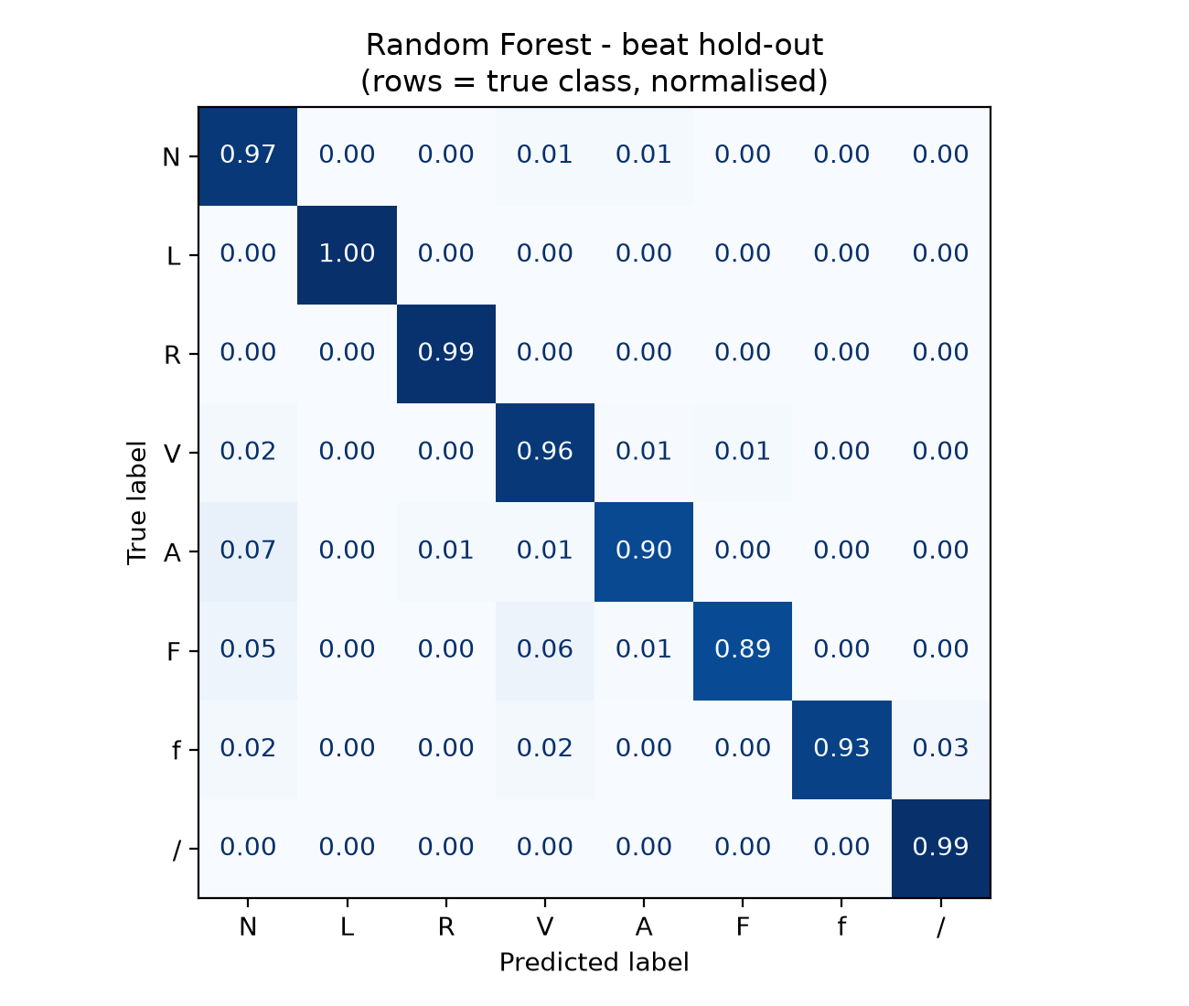 | 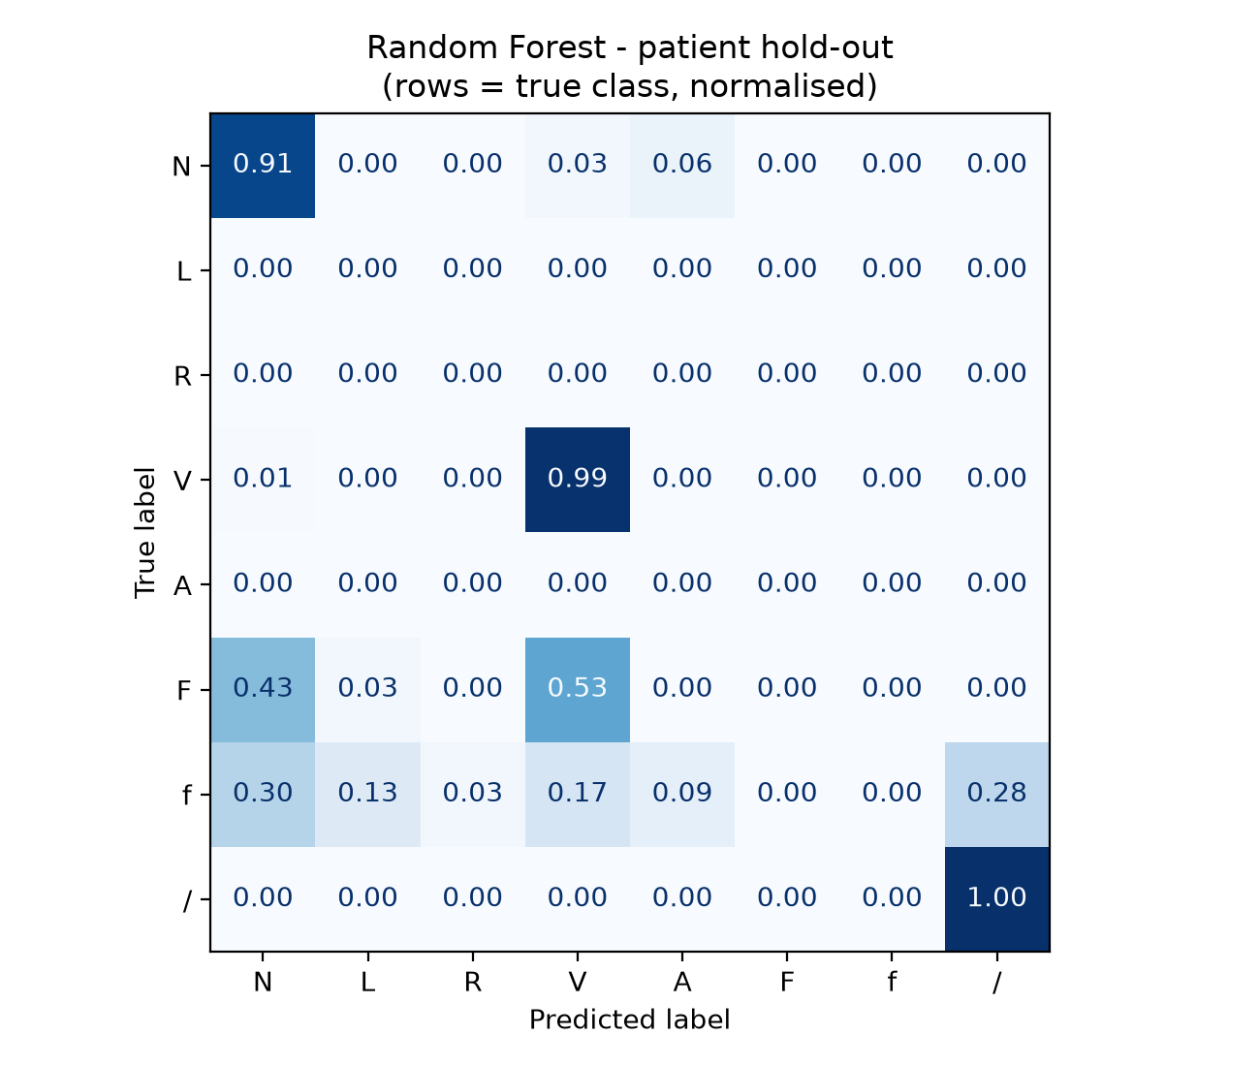
Figure 3. Row-normalised confusion matrices (rows = true class). Left: beat hold-out; right: patient hold-out (L, R and A are absent from that test set). Top: SVM; bottom: random forest.

3.4 PermFIT explanation of the SVM (Task 4)
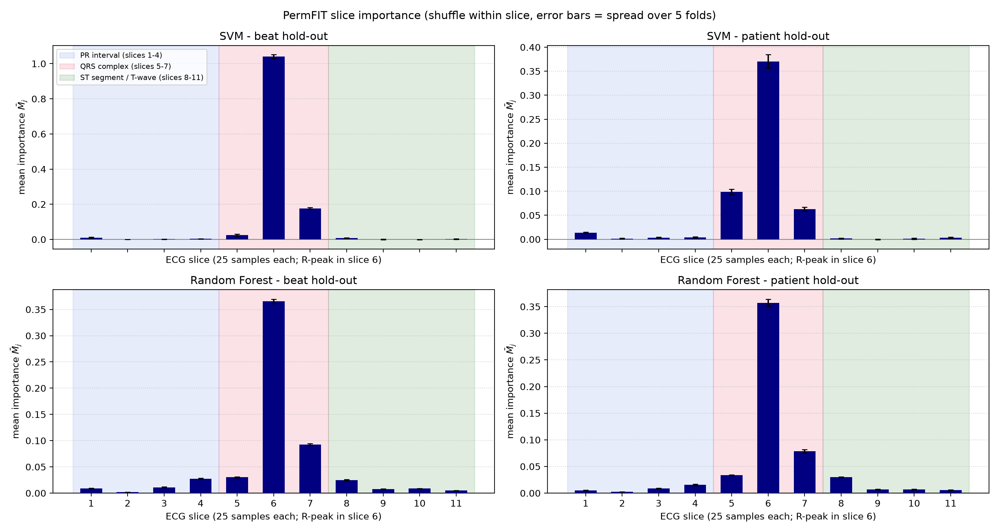
Figure 4. PermFIT slice importance (shuffle within slice) for both models and both protocols. Shading marks the PR interval (blue), the QRS complex (red) and the ST segment / T-wave (green). Error bars = standard deviation over the 5 folds.
Table 4. PermFIT mean importance M̄_{j} per slice (shuffle within slice), the share of positive importance in the QRS slices, and the drop in accuracy when slice 6 is shuffled.
Slice (region) | SVM, beat | SVM, patient | RF, beat | RF, patient
1 (PR) | 0.009 | 0.014 | 0.009 | 0.005
2 (PR) | 0.000 | 0.001 | 0.002 | 0.002
3 (PR) | 0.001 | 0.004 | 0.011 | 0.008
4 (PR) | 0.003 | 0.004 | 0.027 | 0.015
5 (QRS) | 0.025 | 0.099 | 0.030 | 0.034
6 (QRS) | 1.040 | 0.370 | 0.365 | 0.357
7 (QRS) | 0.176 | 0.063 | 0.093 | 0.079
8 (ST/T) | 0.007 | 0.002 | 0.025 | 0.030
9 (ST/T) | 0.000 | 0.000 | 0.008 | 0.007
10 (ST/T) | -0.001 | 0.001 | 0.009 | 0.007
11 (ST/T) | 0.002 | 0.003 | 0.005 | 0.006
QRS share (slices 5–7) | 98.2% | 94.9% | 83.7% | 85.3%
Accuracy drop, slice 6 | 57.8 pp | 20.4 pp | 24.8 pp | 20.5 pp

For both SVMs, slice 6, which contains the R-peak, dominates. Shuffling it raises the squared error by 1.040 (beat hold-out model) and 0.370 (patient hold-out model), and lowers accuracy by 57.8 and 20.4 percentage points. The QRS slices 5–7 together hold 98.2% and 94.9% of the total importance; the PR and ST/T slices contribute very little. The small error bars show that the result is stable across folds. Two details stand out. First, the patient hold-out SVM gives more weight to slice 5, the onset of the QRS complex (0.099 against 0.025). Second, slice 1 is the fourth most important slice for both SVMs, even though it contains no physiological event. It does contain the edge artefact described in Section 4.

3.5 SVM versus random forest (Task 5)
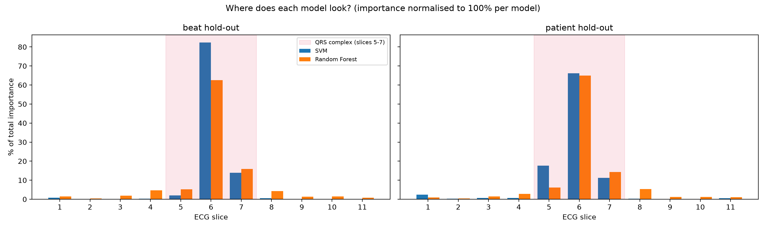
Figure 5. Share of total importance per slice for the SVM and the random forest, for each protocol.
The random forest also ranks slices 6, 7 and 5 highest under both protocols, but its importance is less concentrated: 83.7% and 85.3% falls in the QRS slices. Instead it uses slices 4 and 8, the end of the PR segment and the start of the ST segment just around the QRS complex. Their importance is 0.027 and 0.025 for the random forest against 0.003 and 0.007 for the SVM (beat hold-out). Its profile is almost identical for the two protocols (Pearson r = 0.999 between them), and slice 1 is unimportant to it.
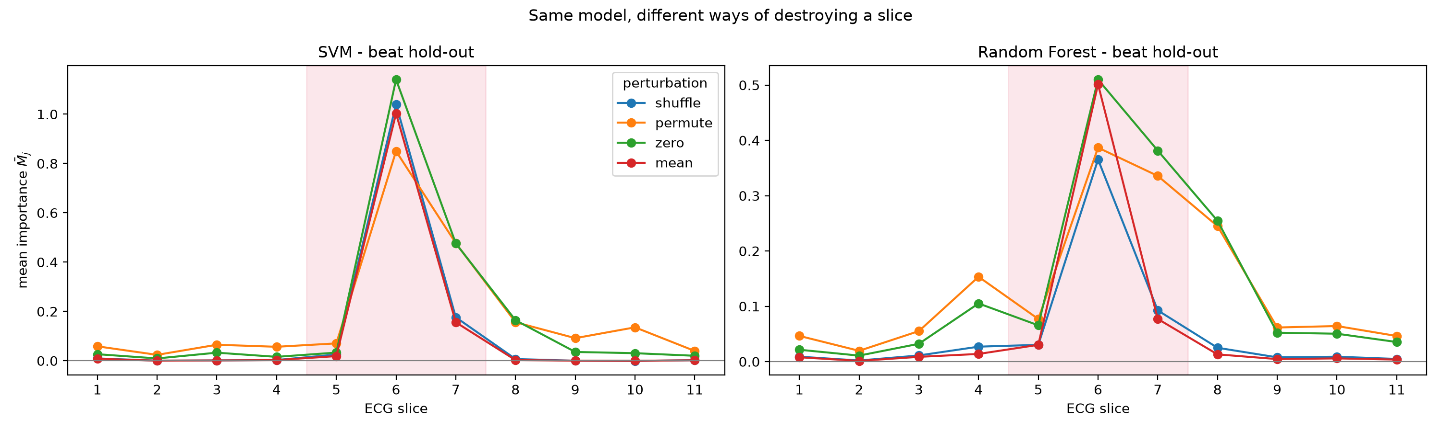
Figure 6. Mean importance per slice under four perturbation methods (beat hold-out models).
The choice of perturbation changes the picture (Figure 6). Shuffling and mean replacement give almost the same profile, because both keep the slice’s average level and only destroy its shape. Setting the slice to zero, or swapping it with another beat, also changes the level, and then the ST segment becomes important too. For example, zeroing slice 8 lowers the random forest’s accuracy by 19.6 points, and the QRS share drops to 83% (SVM) and 63% (random forest). Under every one of the 16 combinations of model, protocol and perturbation, slice 6 remains the most important slice.

4. Discussion
Accuracy depends strongly on the validation protocol. The beat hold-out scores (94–97% accuracy) overstate how well the models would work in practice. On unseen patients accuracy is 84–87% and macro-F1 0.53–0.69, so reporting the beat hold-out alone would mislead. The loss comes mostly from the fusion classes. They are rare and come from very few patients: 92% of all F beats come from records 208 and 213, and 70% of all f beats from record 104. Records 208 and 104 are test patients, so the patient hold-out model learns F mainly from a single person (record 213) and f from only two (records 217 and 102). F and f beats also mix the shapes of other classes by definition. Together, this means the models cannot learn a patient-independent pattern for these two classes. This agrees with Jones et al. (2020) and shows why patient-level validation is needed. The duplication bug we fixed in the patient split would have hidden part of this effect, because it put the test patients’ beats into the training set.
Both models rely mainly on the QRS complex, which supports our hypothesis. Between 84% and 98% of the importance lies in slices 5–7, and the R-peak slice is the most important in every experiment. This matches cardiology. Bundle branch blocks, ventricular beats and paced beats change the width and shape of the QRS complex, so a model that looks there is using clinically meaningful evidence. This is the kind of explanation that can increase clinicians’ trust in a black-box classifier.
The explanation also exposed a fault in the data. The SVMs give slice 1 the fourth-highest importance. The preprocessing cuts 274 samples and pads one zero at the start of each beat, and after standardisation this zero becomes a spike whose height depends on the beat’s mean and variance. The SVM partly uses this artefact, which has no physiological meaning. Without an explanation method this would have gone unnoticed. Fixing the window to 275 real samples is a simple improvement.
The two classifiers look at the same region in different ways. The random forest spreads importance to the edges of the QRS complex (slices 4 and 8), which fits trees that ask threshold questions about single time points, such as the onset or end of the QRS. The RBF SVM measures the similarity of the whole beat and concentrates on the R-peak region. The random forest wins on the beat split but generalises worse to new patients. This suggests that it also learns fine, patient-specific details, which the global PermFIT profile cannot show. The two SVMs differ in their preprocessing (the Task 3 model adds a per-time-point StandardScaler), so the differences between their profiles cannot be put down to the protocol alone. The random forest has the same settings under both protocols, and its explanation barely changes between them.
PermFIT explains what a model uses, not whether this generalises. Inside PermFIT, cross-validated accuracy on the training data is 96–99%, compared with 84–87% on unseen patients. One reason is that upsampling copies rare-class beats, so copies of the same beat can fall in both a training fold and a test fold. Grouping the PermFIT folds by patient would give a more honest picture. The method also has general limits (lecture notes; Mi et al., 2021). It is global, so it cannot explain a single beat. Neighbouring slices are correlated, so importance can be shared between them. Fixed 25-sample slices do not follow the actual wave boundaries of each beat. And, as Figure 6 shows, the result depends on how a slice is perturbed, so more than one perturbation should be reported.
Future work. The grid search (Table 1) suggests that a larger C (C = 100: CV macro-F1 0.960 against 0.928 for the default C = 1) would improve the SVM. Tasks 2 and 3 kept the default so that the explained models are exactly the ones evaluated. Further steps are class-specific PermFIT (for example, which slices separate V from N), local explanations of individual beats with LIME or SHAP, patient-grouped cross-validation, and a one-dimensional CNN.
Conclusion. Both an SVM and a random forest classify ECG beats with high accuracy when patients are shared between training and test, but performance drops markedly on unseen patients, mainly for fusion beats. PermFIT shows that both models base their decisions on the QRS complex, in line with clinical knowledge. It also revealed that the SVM uses a preprocessing artefact. This shows that explainability is useful both for building trust and for debugging the pipeline.

References
Arrieta, A.B. et al. (2020) ‘Explainable Artificial Intelligence (XAI): concepts, taxonomies, opportunities and challenges toward responsible AI’, Information Fusion, 58, pp. 82–115.
Jones, Y., Deligianni, F. and Dalton, J. (2020) ‘Improving ECG classification interpretability using saliency maps’, in 2020 IEEE 20th International Conference on Bioinformatics and Bioengineering (BIBE), pp. 675–682.
Mi, X., Zou, B., Zou, F. and Hu, J. (2021) ‘Permutation-based identification of important biomarkers for complex diseases via machine learning models’, Nature Communications, 12, 3008.
Moody, G.B. and Mark, R.G. (2001) ‘The impact of the MIT-BIH Arrhythmia Database’, IEEE Engineering in Medicine and Biology Magazine, 20(3), pp. 45–50.
Pedregosa, F. et al. (2011) ‘Scikit-learn: machine learning in Python’, Journal of Machine Learning Research, 12, pp. 2825–2830.
Platt, J. (1999) ‘Probabilistic outputs for support vector machines and comparisons to regularized likelihood methods’, in Advances in Large Margin Classifiers. MIT Press, pp. 61–74.
Wu, J. et al. (2018) ‘Impact of initial hospital diagnosis on mortality for acute myocardial infarction: a national cohort study’, European Heart Journal: Acute Cardiovascular Care, 7(2), pp. 139–148.

Appendix A – Code and reproducibility
All code is in the submitted folder; README.md lists every file. walkthrough.ipynb runs Tasks 1–5 in order with short explanations and shows every result inline (outputs saved). Running bash run_all.sh rebuilds every figure and table from the raw MIT-BIH files with fixed random seeds. The main pieces are:
- 00_preprocess.ipynb, 01_split_resample.ipynb: the course notebooks with fixes (data paths, NumPy 2 compatibility, the patient-split bug).
- task1.py, task2_svm.py, task3.py: the team members’ scripts for Tasks 1–3, with small fixes marked ‘# FIX’.
- task4_permfit.py, task5_compare_classifiers.py, tune_hyperparameters.py: PermFIT, the random forest comparison and the grid search; ecg_utils.py holds the shared PermFIT and evaluation code.

Appendix B – Contributions
Member | Contribution
[name] | Task 1 – data inspection (task1.py)
[name] | Task 2 – beat hold-out SVM (task2_svm.py)
[name] | Task 3 – patient hold-out SVM (task3.py)
[name] | Task 4 – PermFIT; Task 5 – random forest comparison; code integration
[all] | Report writing and review

