**Day 1**

PICORV32A PREP DONE

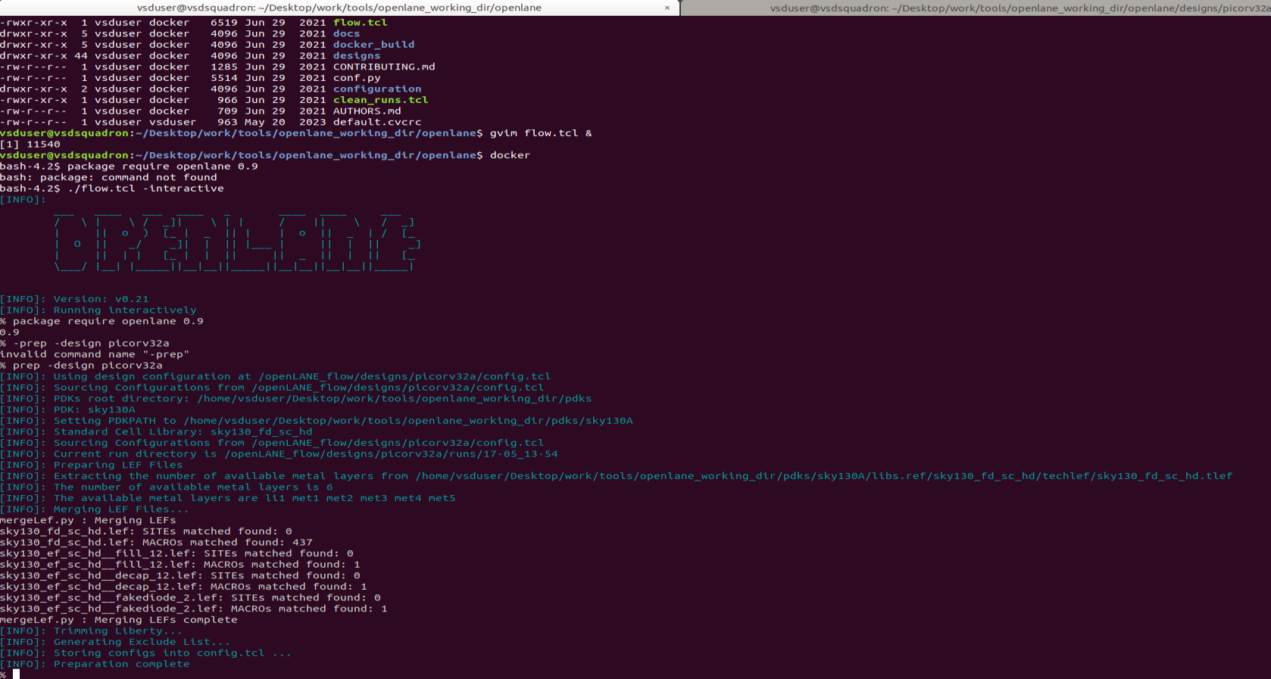

FIG 1. 1

Run_synthesis done

FIG 1. 2

Synthesis and ABC runs have completed.

**TASK 1 : To find flop ratio.**

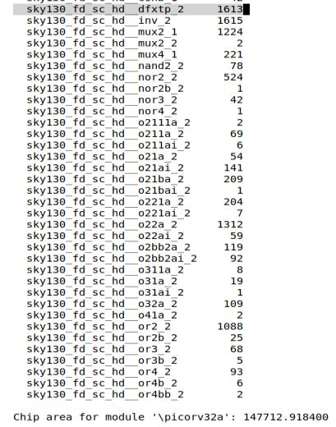

FIG 1. 3

**Design name: picorv32a.**

Chip module area : 147712.918400

Flop ratio = no of DFFs (D flip-flop)/Total no of cells.

Total no of cells = 14876 (as seen in FIG 1.2).

No of DFFs (count of **sky130_fd_sc_hd__dfxtp_2**) = 1613 (as seen in FIG 1.3).

Flop ratio = 1613/14876 = 0.1084296853993009 = 10.84 %

Results path: /home/vsduser/Desktop/work/tools/openlane_working_dir/openlane/designs/picorv32a/runs/17-05_13-54/results



Synthesized netlist:

/home/vsduser/Desktop/work/tools/openlane_working_dir/openlane/designs/picorv32a/runs/17-05_13-54/results/synthesis/picorv32a.synthesis.v



Run directory structure:

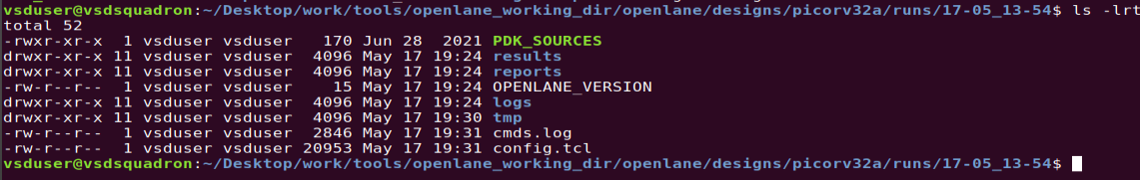

Yosys report path:

/home/vsduser/Desktop/work/tools/openlane_working_dir/openlane/designs/picorv32a/runs/17-05_13-54/reports/synthesis/1-yosys_4.stat.rpt



OpenSTA report path:

/home/vsduser/Desktop/work/tools/openlane_working_dir/openlane/designs/picorv32a/runs/17-05_13-54/reports/synthesis/2-opensta.timing.rpt



Search for fossi dial up for skywater 130nm pdk details

https://www.youtube.com/results?search_query=fossi+dial+up